- Assign Permanent MR #

  - Type “Assign Permanent MR#” in the Search Form field in the Forms & Data widget.
  - Click on Assign Permanent MR# in the drop down menu.
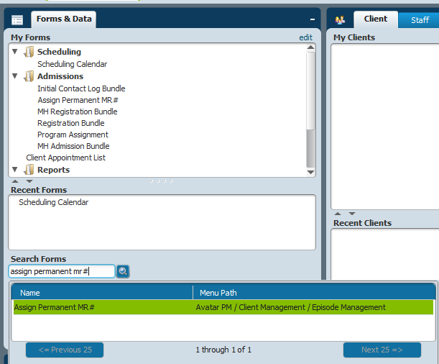

  - Search client by typing in their “P” number or Lastname,Firstname.
  - Click on client in the search results. Then click Select.
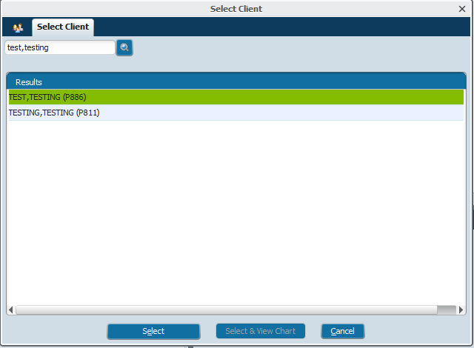

  - Click on Assign Permanent MR #.

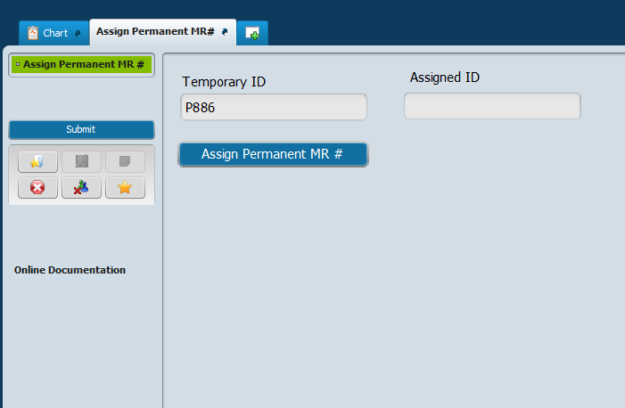

  - Click Yes when prompted to “Auto Assign Next ID Number”.

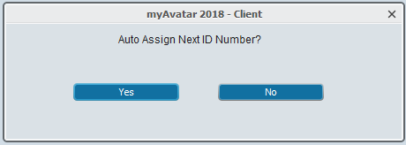

  - Then click Submit.

