CDCI Billing Status Request Guide
(QM Disallowance/Contract Providers)

Log in to MyAvatar by entering “Username” which is your employee’s number and your “Password”. Click on Sign In
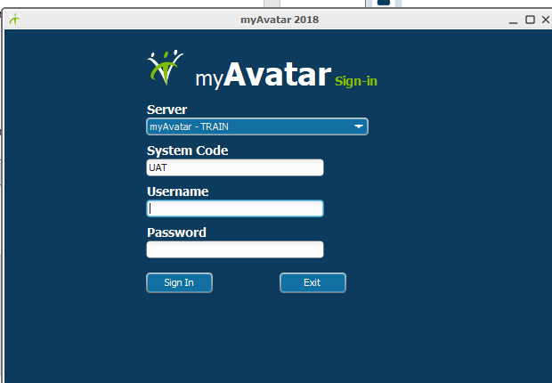

Start by searching for the “Spreadsheet Edit Service Information” form in the “Search Forms” bar. Double click on the form name to open the form.
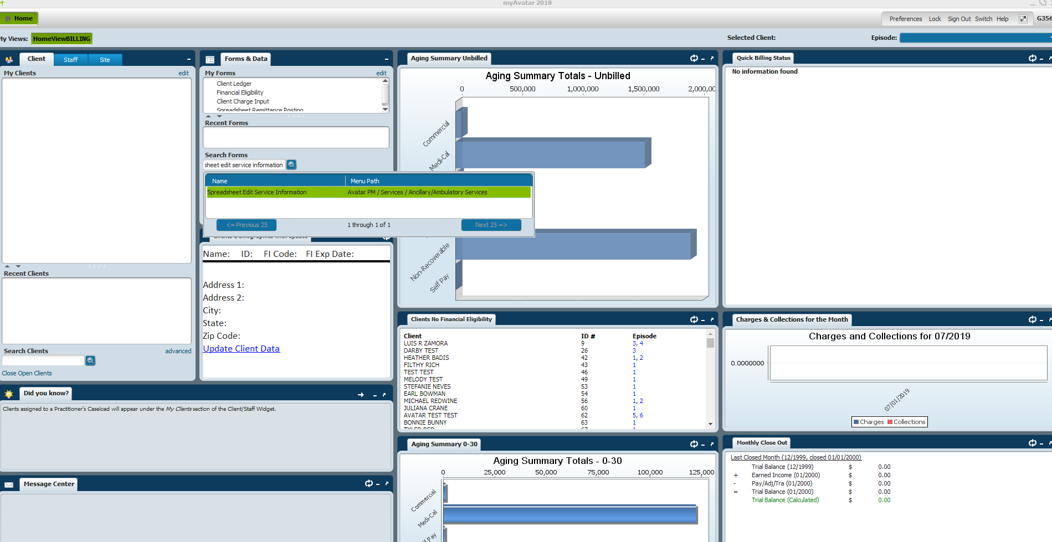

The form will open to this:
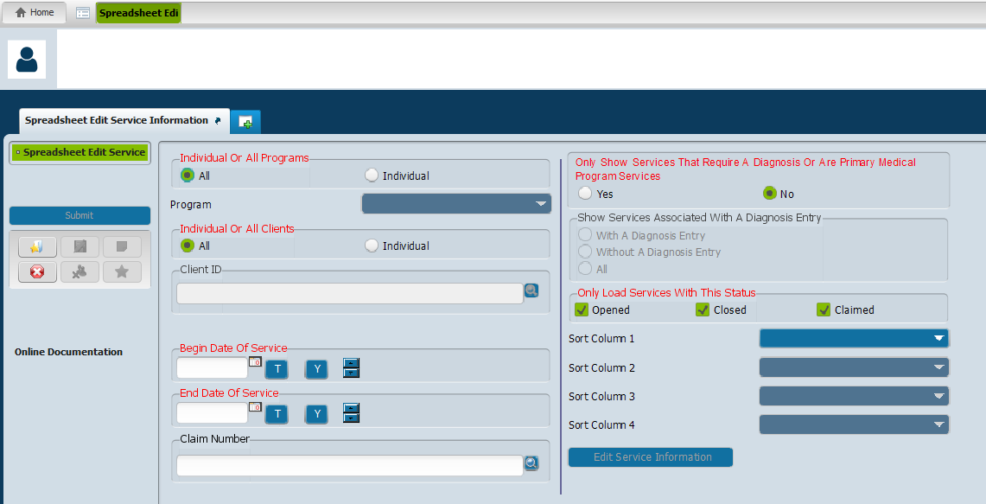
Here, you will enter in the information that is requested from QM or the contract providers from the E-Mail that was sent to be able to view the service information.

- For the first section:
Individual or All Programs
-Select: “Individual”
- Then from the drop down box, select the corresponding reporting unit that is on the CDCI.
- In the next section:
Individual or All Clients
-Click on individual
4) Type in “Begin Date of Service”
5) Type in “End Date of Service”
6) In the section “Only Show Services That Require A Diagnosis or Are Primary Medical Program Service”, leave this area alone; it auto populates to answer “No”
7) In the section “Only Load Services With This Status”, leave this area alone; it auto populates to select all three status: Opened, Closed and Claimed.
8) Once all the information has been entered, click on “Edit Service Information”

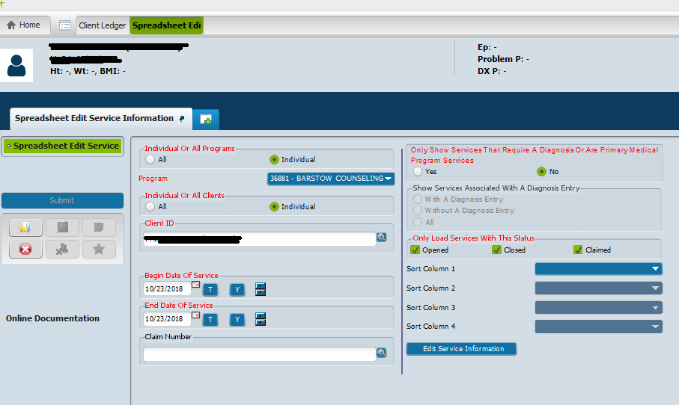

**Once the form opens, this is where you are able to view and verify: Date of Service, Client, Program (Reporting Unit), Service Code, Practitioner, Duration, Location, Cost of Service, etc.

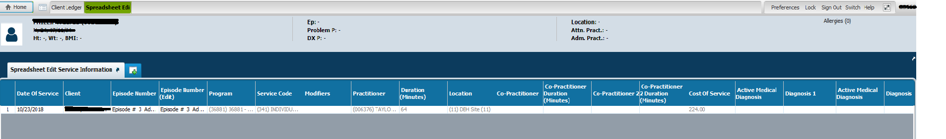

**Once the service is found, go to the client ledger to determine what the billing status of the service.
To go to the Client Ledger, you can either go back to “Home” and search for the form, or click the green plus sign 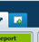 to select the next form.
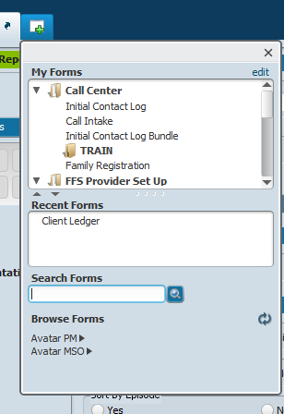
Green plus button

Type form name

The form will open up:
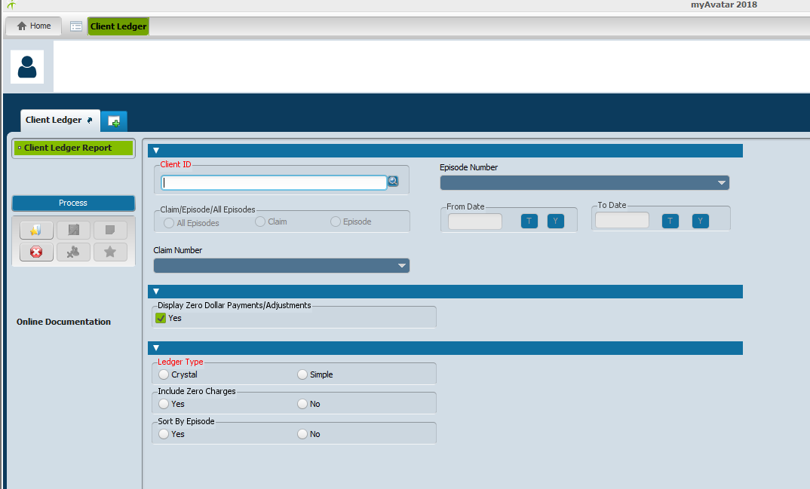
Type client’s information” You can search my last name, first name (No space between last name(,)first name). You can search by “Date of Birth” 00/00/0000, “Social Security Number” 000-00-0000, and by client’s number. A list of clients will come up, double click on client you are searching.
Click enter, or search
“Claim/Episode/All Episodes” is now showing red. Select an option
“From Date” and “To Date” will pre-populate, you can change the date range
“Ledger Type” select what type of report you need.by selecting “Crystal” or “Simple”
Click on Process
The report opens up. Here you can check for client’s date of service, if the claim line has been processed, paid or is still unbilled.

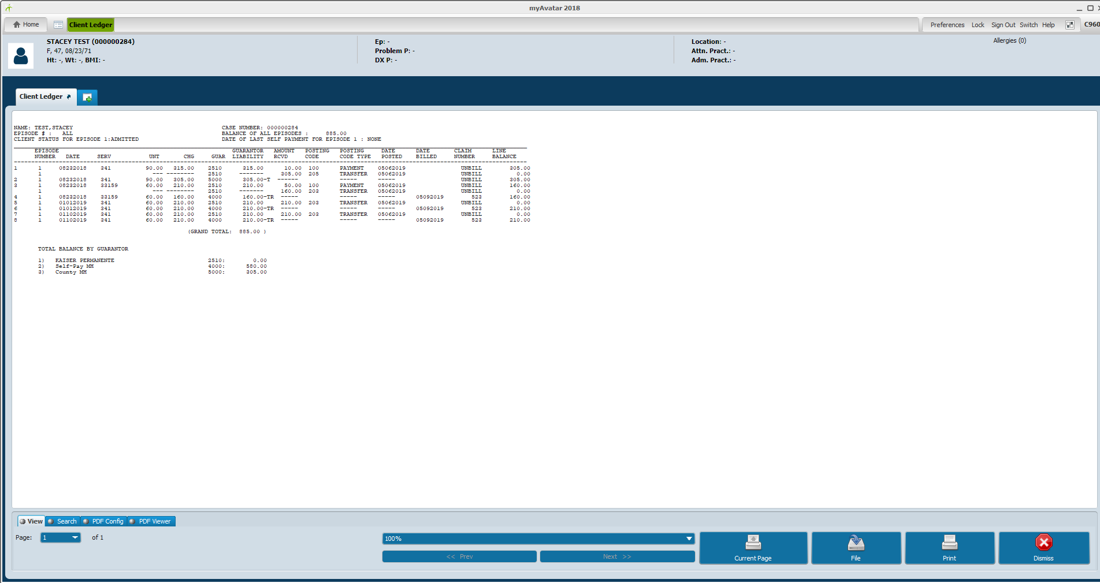
Once you have reviewed the ledger, click on the red X Dismiss this will bring you back to the form and will ask the following question
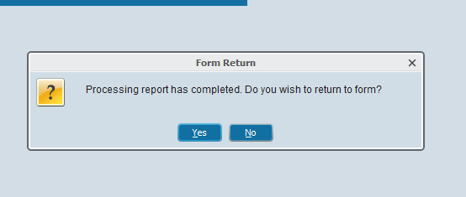
If you are done reviewing the report click “no”, if you still want to remain on the form click “yes”
This will conclude the QM Disallowance/ Contract Providers E-Mail Status Request.

