From the “HomeViewBILLING” screen (aka Home), type client’s name under “Search Clients” (red arrow).

Double click client name to select and move to the Client Chart overview.

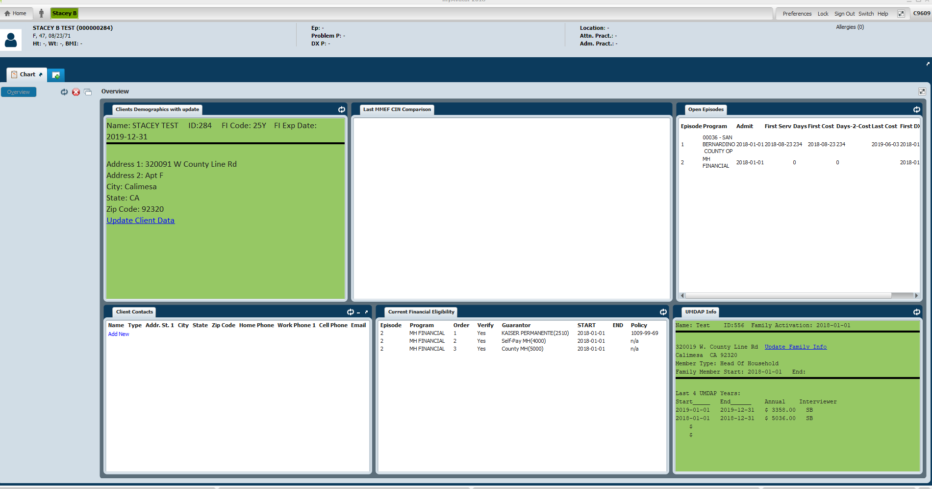

On the “Clients Demographics with update” widget (blue arrow) verify client’s address. If address needs to be updated click on “Update client Data” link.
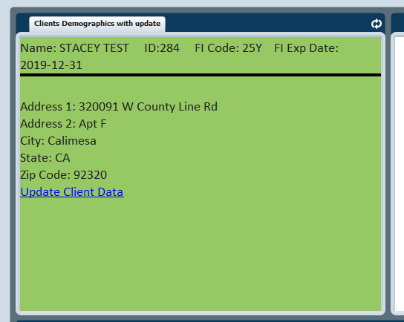

To verify client’s insurance eligibility; you can either go back to “Home” and search for the form, or click the green plus sign to select the next form (red arrow).
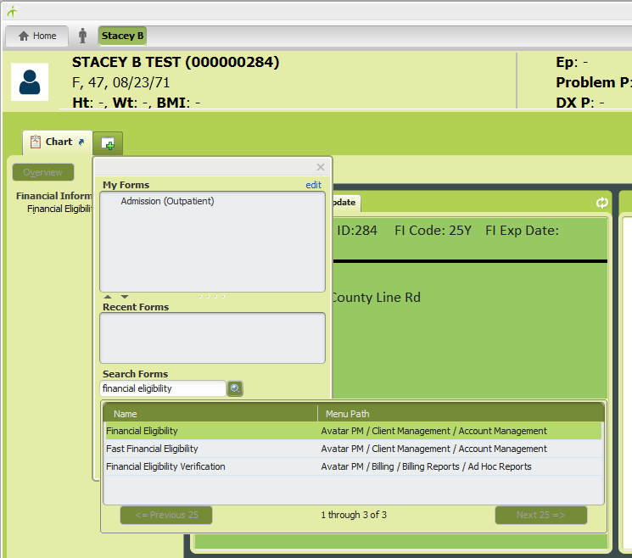
Search Forms for “Financial Eligibility” and double click to open the Financial Eligibility Episodes. Click on the appropriate financial episode “MH Financial” or “SUD Financial” found in the “Program” column and click “OK” or double click to open the Financial Eligibility form.

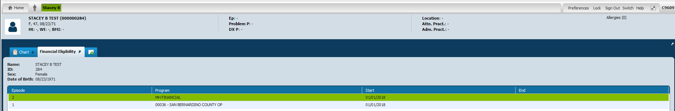
Click on “Guarantor Selection” (red arrow) to move to the Guarantor Information portion of the form. Double click on the guarantor you are verifying (blue arrow) and allow a moment for information to populate in the fields below. For each guarantor to verify, they have to be selected individually from the Guarantor Information table.
Note: “Billing Policy #” field must be completed with the insurance ID/policy or Medicare MBI Number. This field populates in box 1.a in the CMS1500 form.
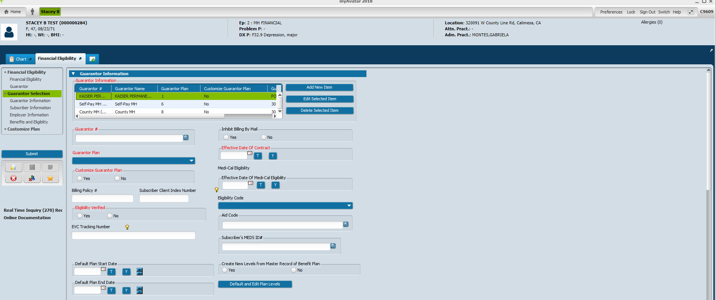

Check “Subscriber Information” section to verify eligibility for the date of service.

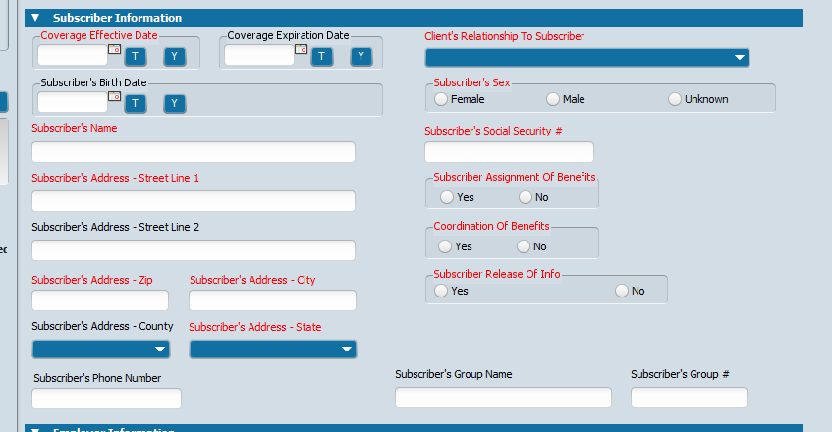
To verify guarantor’s address and insurance ID number, go to “Client Ledger Report” by clicking the green plus sign to search for or select the next form (red arrow). Search Forms for “Client Ledger Report” and double click to open the Client Ledger Report form.

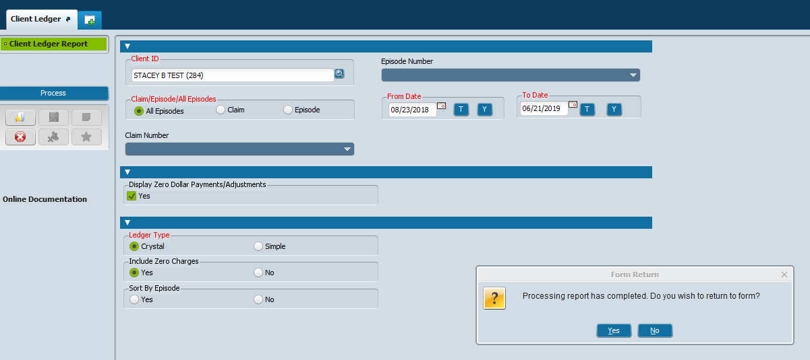
All fields with red font are required in order to process the report. The form will not populate the client ID when you move from the client chart. See above information for which selections to make. When selecting the “To Date”, use the “T” button to populate today’s date so all information up to “today” will be captured. Click the “Process” button on the left side to run the Client Ledger report. The report will open in a new window.

Items in blue font are all hyperlinks that can be selected to obtain more detailed information. Click on “Guarantor Name” to verify guarantor’s ID #, name and address.
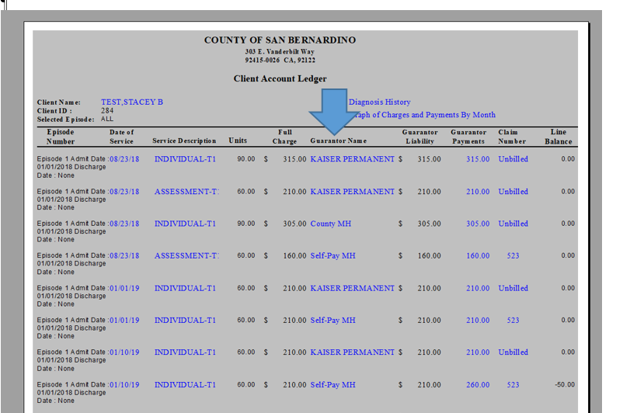

Once you click on Guarantor Name, an additional tab will open with the details. In the “Guarantor Data” box is the guarantor’s information. The Subscriber information is in the “Subscriber Data” box.

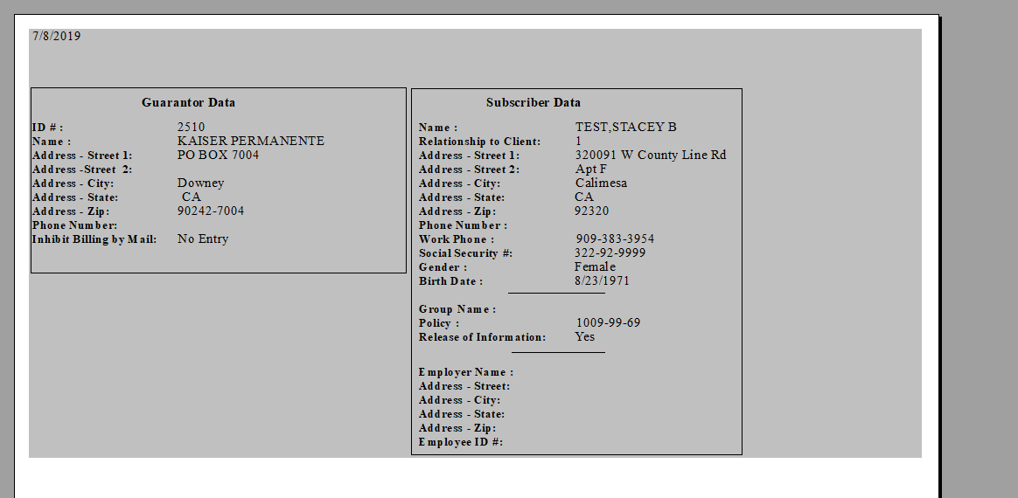
Click on the Date of Service to verify the clinic location the service was performed at.
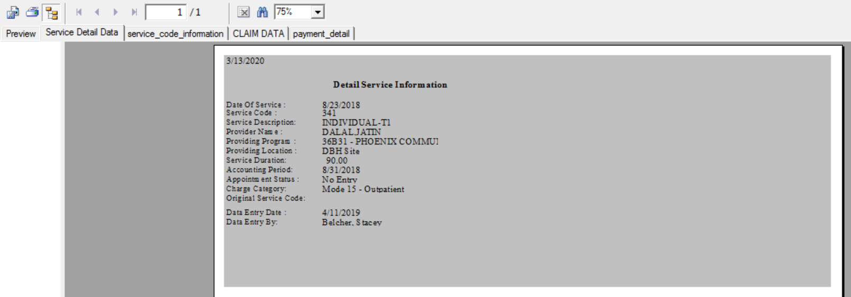

To verify practitioner NPI, certification status, or sites certified utilize the Practitioner Enrollment form.
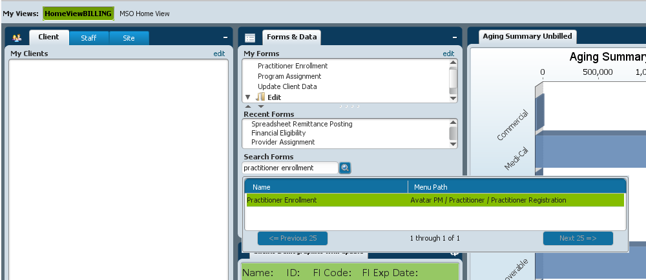

Enter the Staff ID number in the pop-up box. Double click the name or click the “select” box to open.

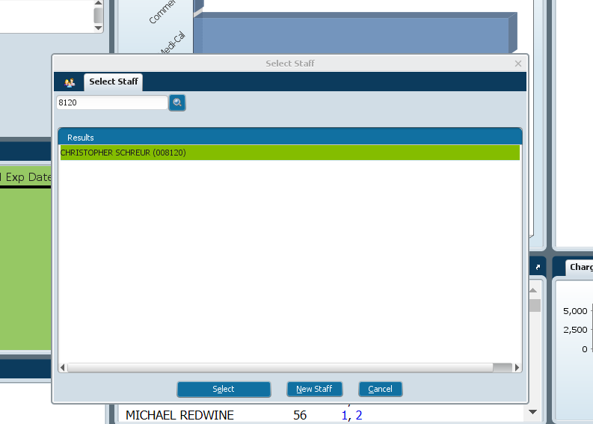
NPI# is in first section “Practitioner Enrollment” (red arrow)
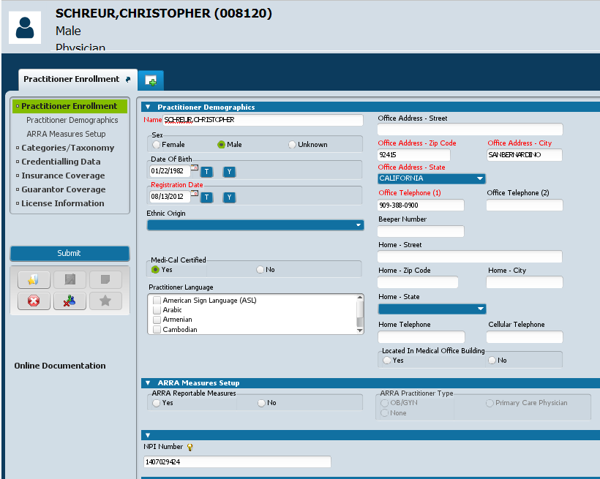

Select “Guarantor Coverage” from the list on the left. Verify in “Guarantor Coverage” table.
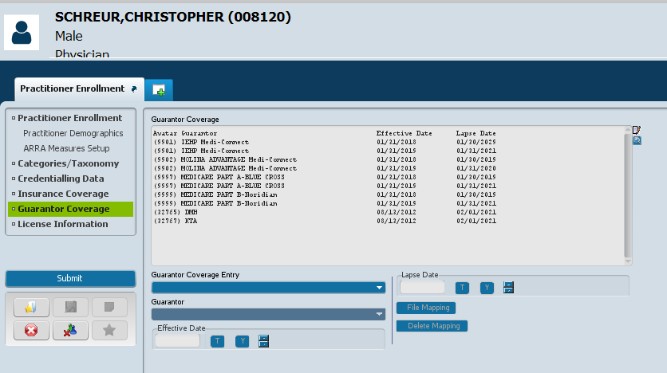
Additional Steps:

- Verify coverage using available portals: IEHP (Commercial, Medi-Connect, or Medi-Cal), Medslite or Meds Stoplight (Medi-Cal), and/or Noridian (Medicare)
- It may be necessary to contact the insurance company to verify the insurance company ID number and billing address for claims to be sent to.
- Once guarantor information is verified, notify the FI unit of any changes with guarantors or guarantor’s information.

