Note: Steps may be different for Family Bills (Self-Pay UMDAP) than it is for Self-Pay Bills (Self-Pay no UMDAP). It’s important to know which type of bill you are verifying so you follow the correct step. Family bill will print with the Family ID and Self-Pay bill will print with the Client ID. The Family ID or Client ID will print in the “Account Number” field on the patient bill.
Patient Bill Sample

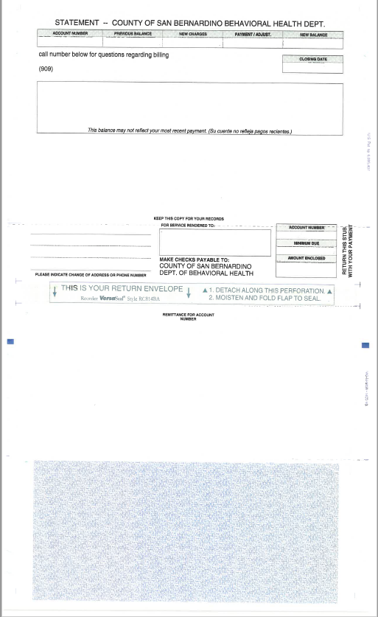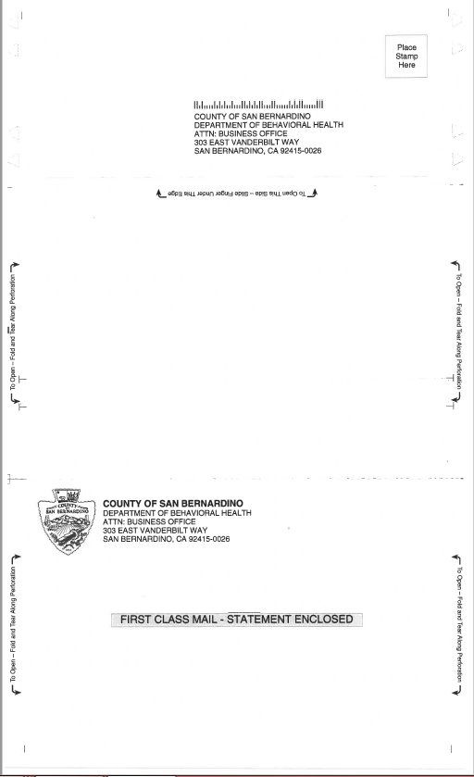
1st Step: Verify client name and address
Family bill: Avatar: From “HomeViewBILLING” search forms for Family Registration or select Family Registration from “My Forms” or “Recent Forms” if available (red arrow). Pop-up window “Select Family” (blue arrow) will require entry of the Family ID or Family name to search and open the Family Registration form. Double click on name in “Results” or single click name to select and then click on “Select” button.
(For Self-Pay bill see page 5)
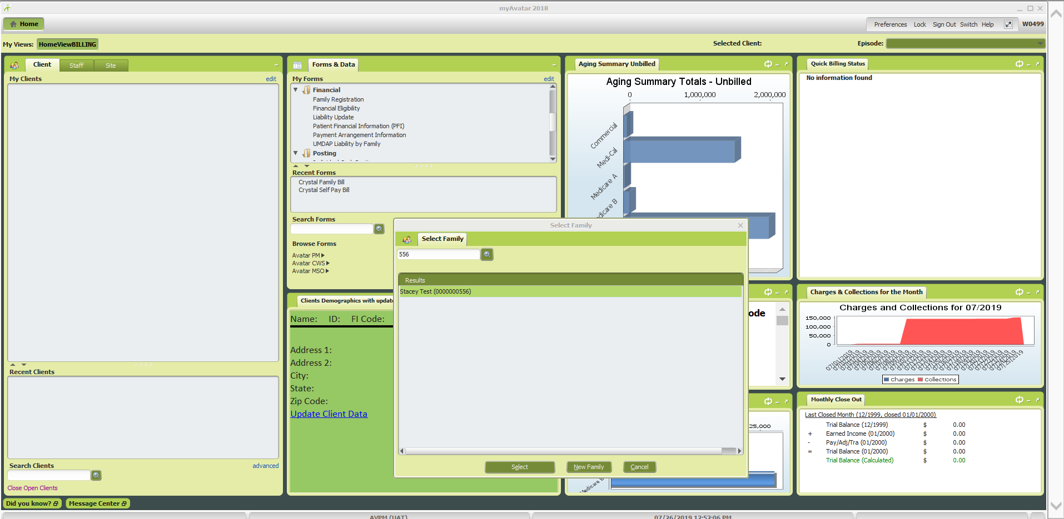
First section of Family Registration form contains the Family Billing address (red arrow). Verify address and click on “Family Members” on the form menu on the left side (blue arrow) to move to the form section that contains the family members. This will allow you to verify bill accuracy when the services rendered were for a family member other than the name the bill is addressed to. (See “For Services Rendered To:” section on the bill)

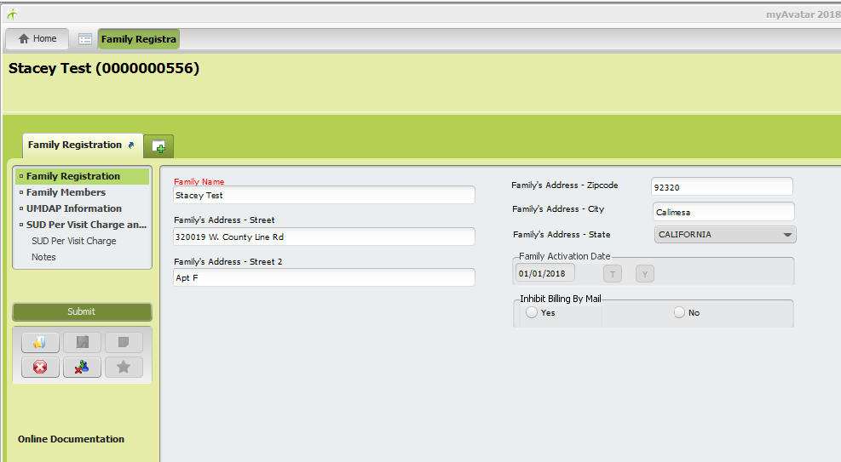
Double click on name of family member to populate the information in the fields below the “Family Membership Information” table. Allow a few moments for the data to fill in. The family member that has “Head of Household” in the Type of Family Member field (red arrow) is considered the RP (Responsible Party) for the bill. After this is verfied, move to page 7 for Step 2 for Family bill.

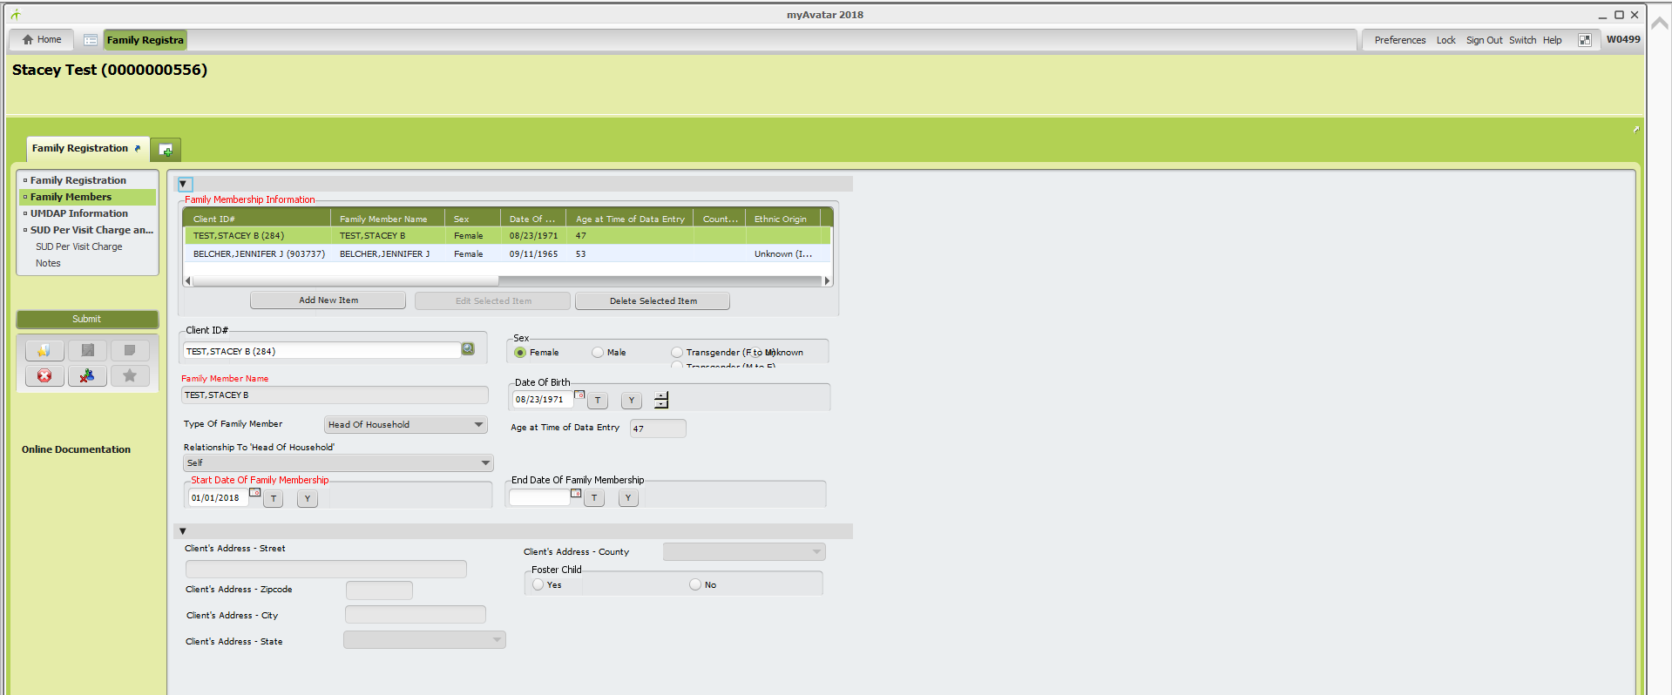
1st Step: Verify client name and address
Self-Pay Bill: Avatar: From “HomeViewBILLING” search client ID, name, DOB (include forward slash mm/dd/yyyy), or SS# (included dashes xxx-xx-xxxx) in the “Search Clients” field (red arrow). Double click to select which will populate the client name in the “Recent Clients” window. Next, with client’s name highlighted, double click the client name (blue arrow) to open the Client Chart “Overview”.

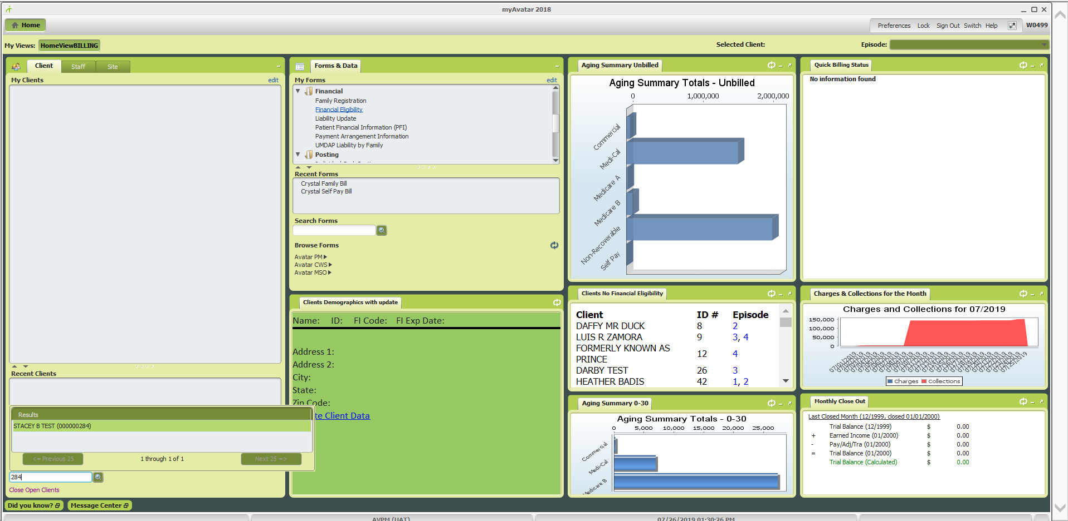
The client chart overview contains various widgets that provide a quick view of some client account information. Some widgets also contain shortcuts within them to other forms (see blue hyperlinks). The clients billing address for the Self-Pay bill can be verified in the “Clients Demographics with Update” widget (red arrow).
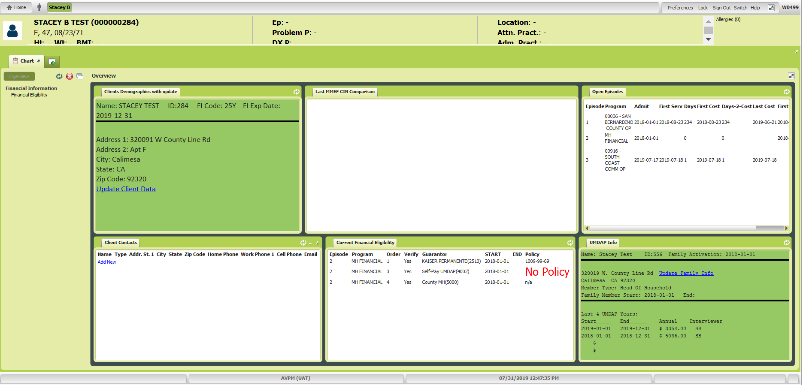
2nd Step: Verify billed amount and if applicable, payment arrangement amount
Family bill: If the “Minimum Due” amount on the bill, is less than the “New Balance”, verify the payment arrangement amount. While you are still in the Family Registration form, click on “UMDAP Information” from the form menu on the left (red arrow) to move to the UMDAP Information section of the form.
(For Self-Pay bill see page 12)

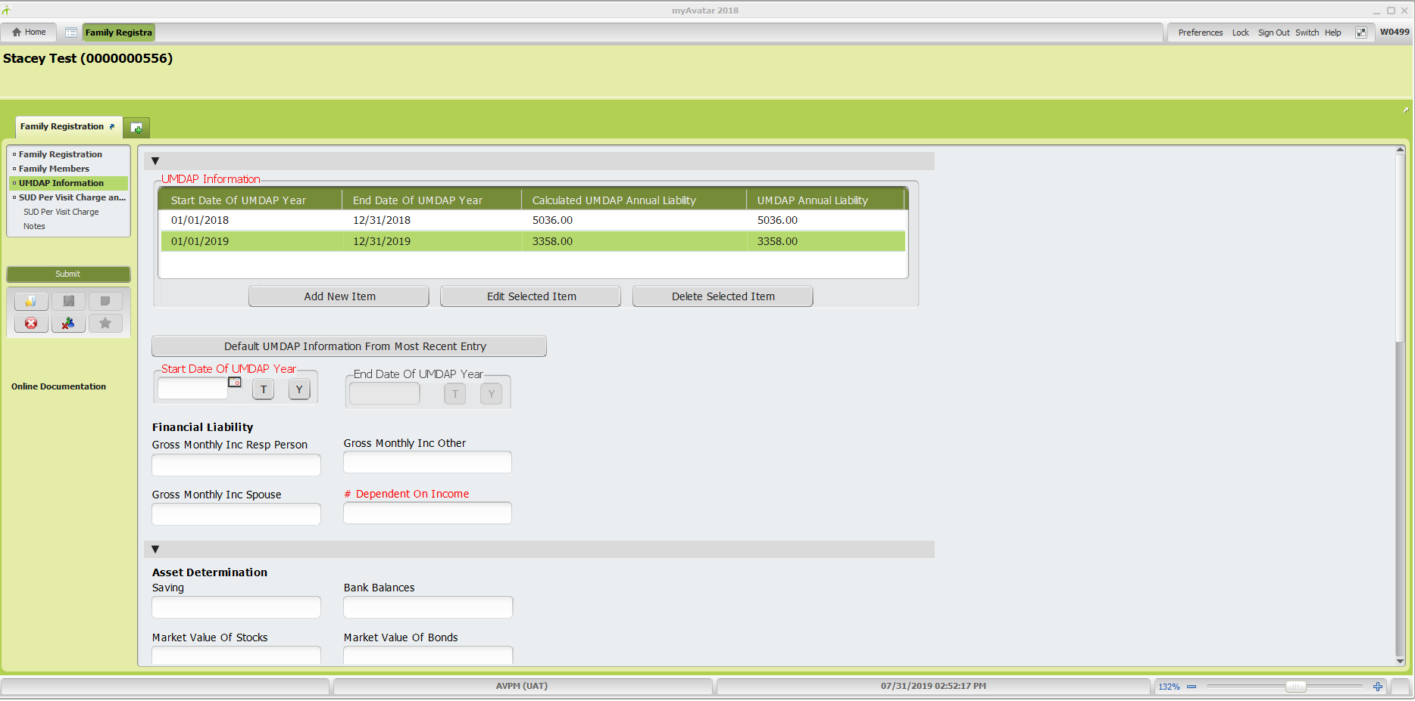

Using the scroll bar on the right (blue arrow), scroll down to the “Total” section of the UMDAP Information.
Confirm the payment arrangement amount in the “Agree Monthly Payments To Satisfy Above Liability” field (red arrow).

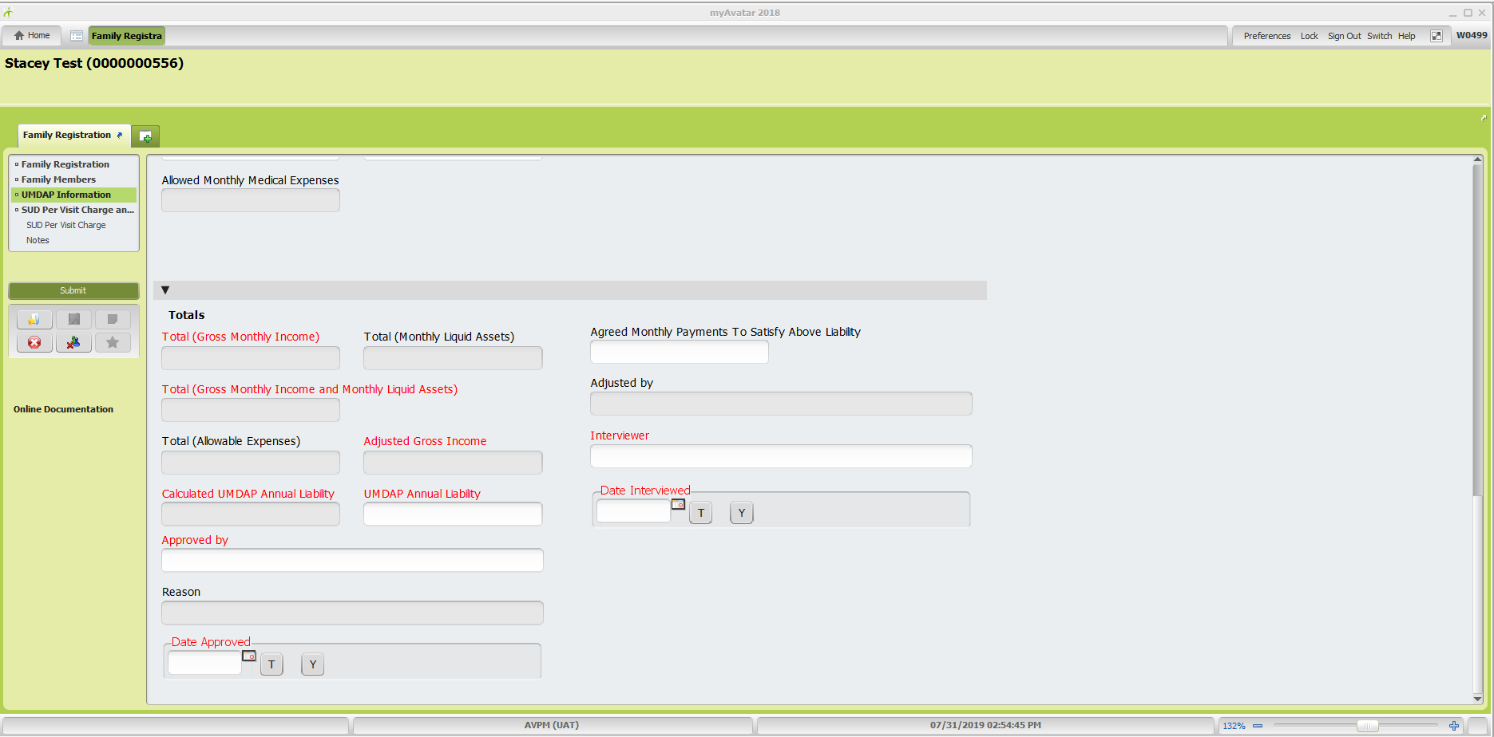

For SUD clients, there is a Per Visit Charge. To verify the charge amount is correct, Click on “SUD Per Visit Charge and Notes on the left. 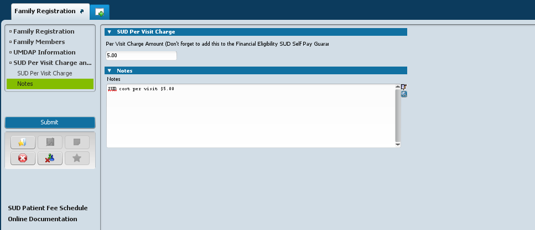

SUD charge is based on Adjusted Gross Income and number of dependents which is in the UMDAP information section. The SUD Patient Fee Schedule (red arrow on previous page) is a hyperlink that will open the fee schedule and you can verify the per visit charge.

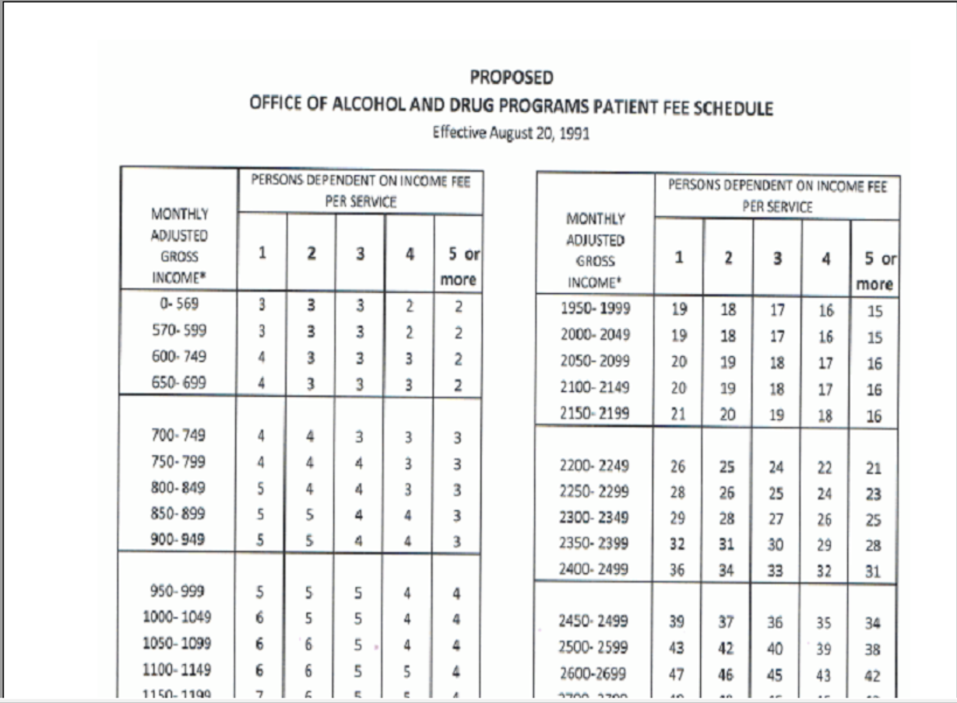
To verify the “New Balance”, click on the green + on the second tab (red double arrow) to open “My Forms”. Click on Client Ledger from the “My Forms” list or use “Search Forms” (blue arrows) and enter Client Ledger. If “Search Forms” is used, double click from the drop down menu to select and open
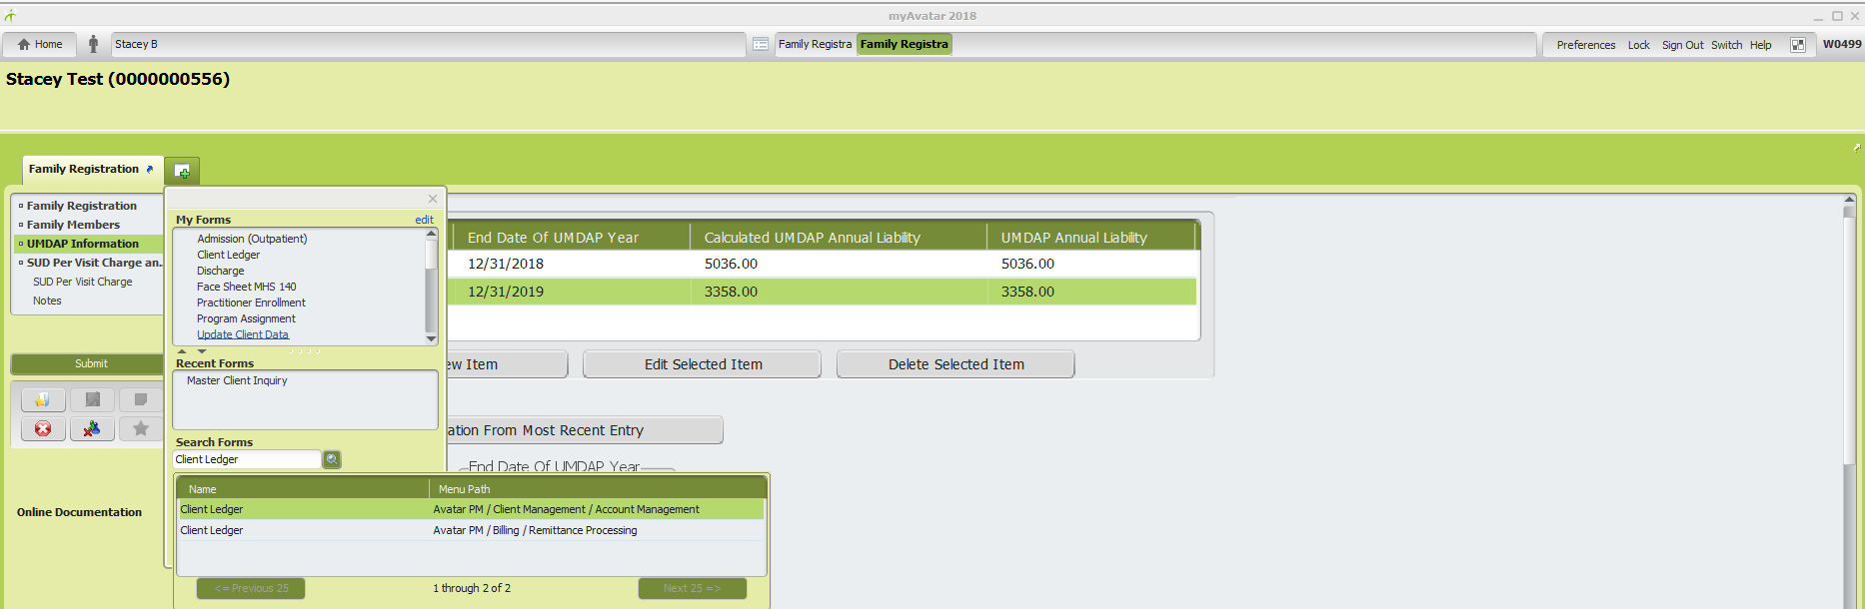
Client Ledger Report form:
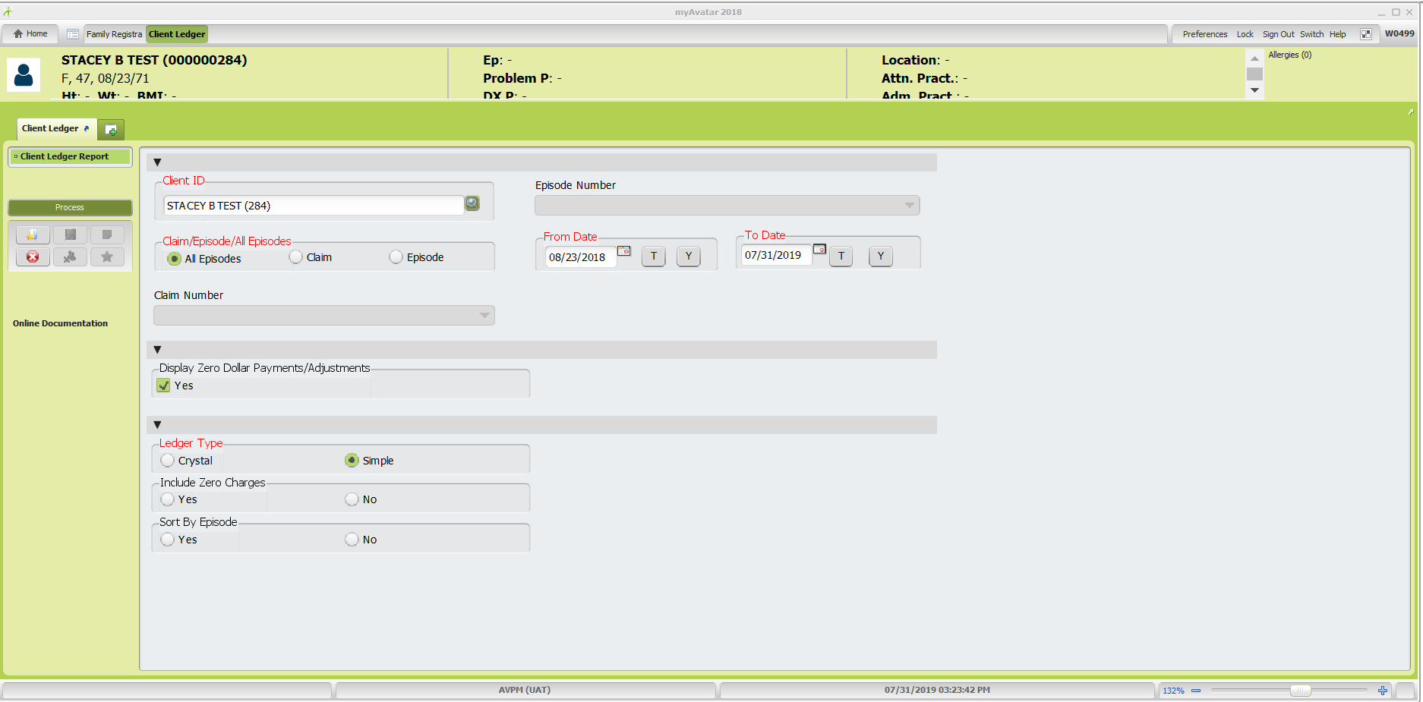
Fields in red are required entries in order to run the Client Ledger Report:
- Client ID: Enter client ID or client name
- Claim/Episode/All Episodes: Typically, you will select “All Episodes”. Note: If client has combination of SUD, FFS, Contract Provider, and/or MH episodes and you select “All Episodes” the client ledger report will combine all the transactions and summary information for guarantor balances.
- Ledger Type: Select “Simple”
- From Date: Will prepopulate with first claim date. Can leave as is or change if needed.
- To Date: Click “T” button to populate today’s date
Click “Process” button (red arrow-previous page) to run report. Client Ledger Report will open in a new window.

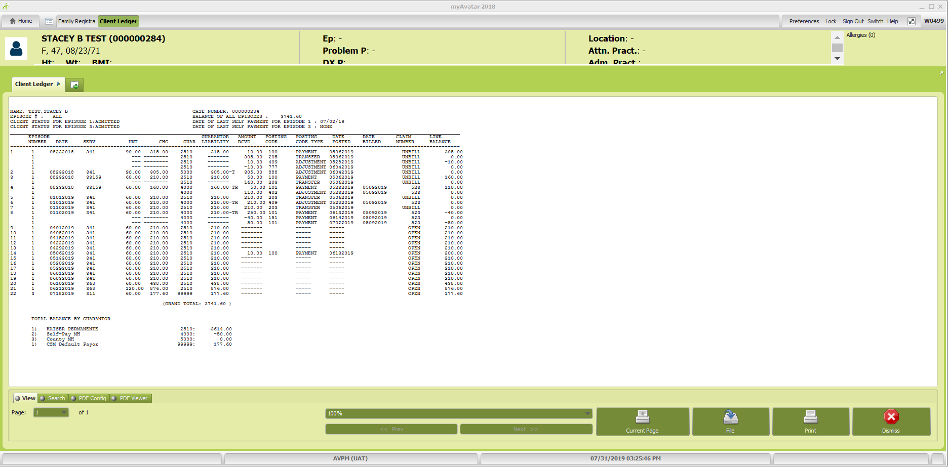

Verify balance of Self-Pay or Self-Pay UMDAP Guarantor (whichever is applicable) in the “Total Balance By Guarantor” section (blue arrow-previous page) to match to the “New Balance” on the patient bill. If there’s a discrepancy between the two, review line items in Client Ledger Report to identify any new payments that have posted after the billing cycle closed or any recent adjustments or transfers that may be affecting guarantor balance. Bill can be modified by hand to reflect any recent payments or adjustments not included in the billing cycle. If unable to confirm correct balance with Client Ledger, take necessary steps to review other account information such as guarantor effective and expiration dates, etc. until resolution is reached.

2nd Step: Verify billed amount and if applicable, payment arrangement amount
Self-Pay Bill: If the “Minimum Due” amount on the bill, is less than the “New Balance”, verify the payment arrangement amount. While you are still in the Client Chart “Overview”, click on the green + on the second tab (red double arrow) to open “My Forms”. Click on Payment Arrangement Information from the “My Forms” list or use “Search Forms” (blue arrow) and enter Payment Arrangement Information. If “Search Forms” is used, double click from the drop down menu to select and open.

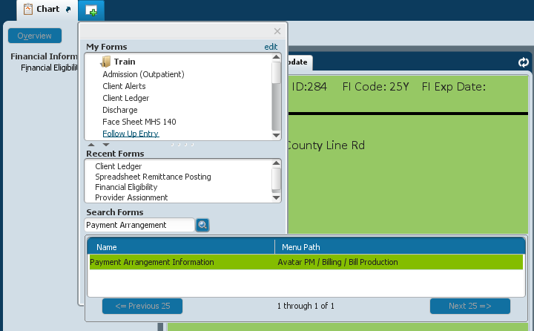

Confirm the payment arrangement amount in “Min. Payment Amount” field.
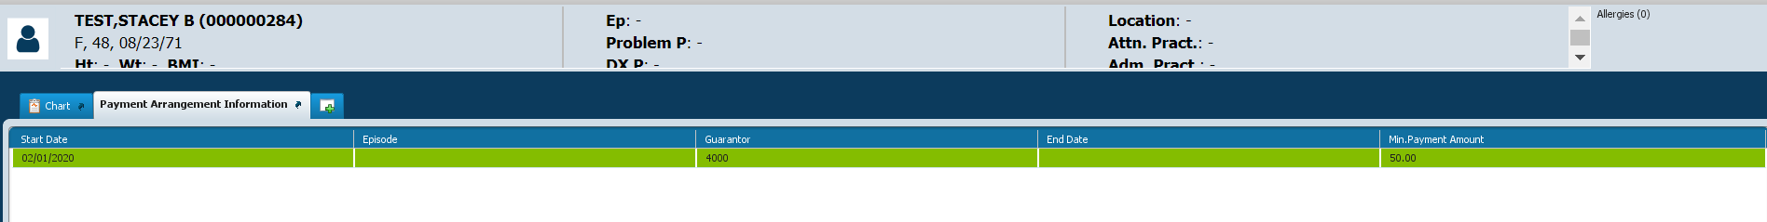

To verify the “New Balance”, click on the green + on the second tab (red double arrow) to open “My Forms”. Click on Client Ledger from the “My Forms” list or use “Search Forms” (blue arrows) and enter Client Ledger. If “Search Forms” is used, double click from the drop down menu to select and open.
Fields in red are required entries in order to run the Client Ledger Report:
- Client ID: Enter client ID or client name
- Claim/Episode/All Episodes: Typically, you will select “All Episodes” Note: If client has combination of SUD, FFS, Contract Provider, and/or MH episodes and you select “All Episodes” the client ledger report will combine all the transactions and summary information for guarantor balances.
- Ledger Type: Select “Simple”
- From Date: Will prepopulate with first claim date. Can leave as is or change if needed.
- To Date: Click “T” button to populate today’s date
Click “Process” button (red arrow) to run report. Client Ledger Report will open in a new window.

Verify balance of Self-Pay or Self-Pay UMDAP Guarantor (whichever is applicable) in the “Total Balance By Guarantor” section (red arrow) to match to the “New Balance” on the patient bill. If there’s a discrepancy between the two, review line items in Client Ledger Report to identify any new payments that have posted after the billing cycle closed or any recent adjustments or transfers that may be affecting guarantor balance. Bill can be modified by hand to reflect any recent payments or adjustments not included in the billing cycle. If unable to confirm correct balance with Client Ledger, take necessary steps to review other account information such as guarantor effective and expiration dates, etc. until resolution is reached.
Guidelines for patient bills that should not be mailed out:
- If client currently has IEHP or Molina Medi-Connect, unless the balance is from the prior period when they didn’t have IEHP or Molina Medi-Connect
- Insurance with Medi-Cal (full scope), unless the balance owed is from the prior period when they didn’t have Medi-Cal (full scope). Doesn’t apply if they have share of cost (SOC) Medi-Cal.
- Medicare with Medi-Cal (full scope), unless the balance owed was from the prior period they didn’t have Medi-Cal (full scope). Doesn’t apply if they have share of cost (SOC) Medi-Cal.
- Clients with services in “special” programs where the services aren’t billable to the clients. See “Cheat Sheet – Client Charges for Special Programs Billing” (internal Business Office document) to verify who charges are billable to.
\\dbh-fs01\Administrative_Services\Business Office\BILLER MONTHLY STATS\Cheat Sheets

