Remittance Advice (RA)
Processing payments:
Log in to MyAvatar by entering “Username” which is your employee’s number and your “Password”. Click on Sign In
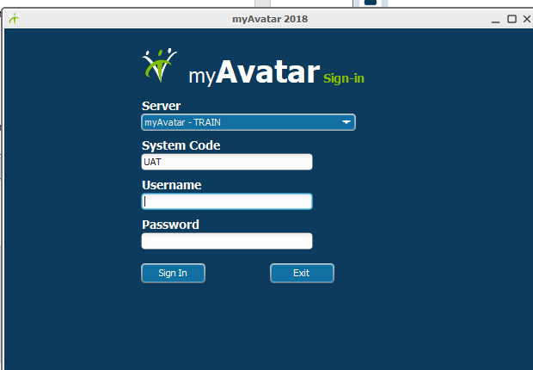
Start by selecting the form you need
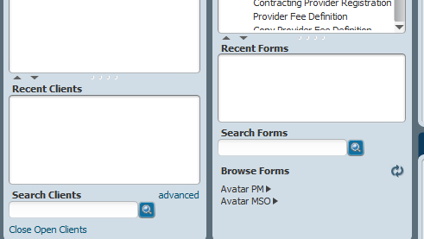
Type form name

Select the form by clicking on the form once. Type in Financial Eligibility and double click on the highlighted green. 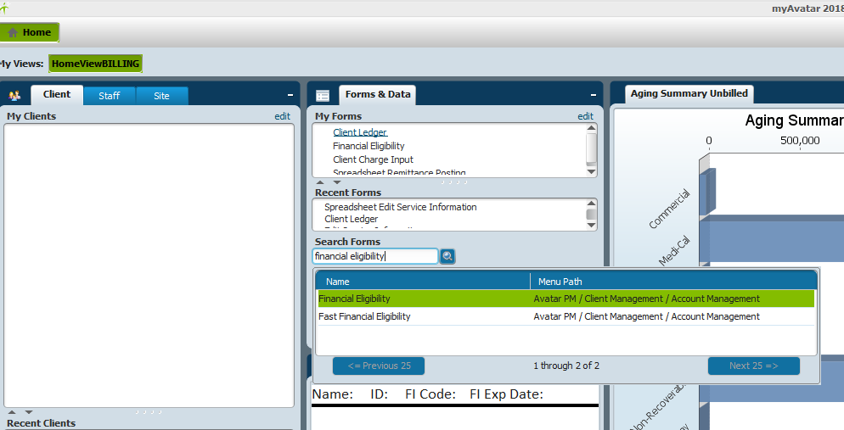
This form will open up which needs for you to type in a client. You will type in the client and double click in order to select the client and to open up the Financial Eligibility form.
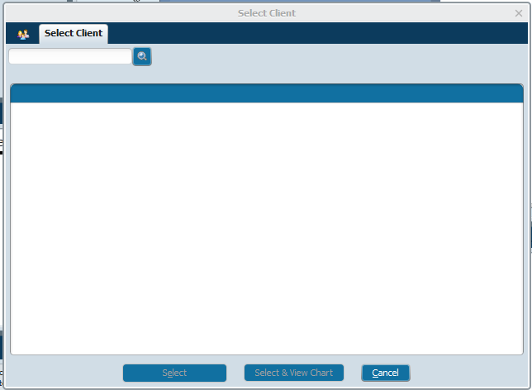

Financial Eligibility form will open up and you will double click on “MH FINANCIAL”.

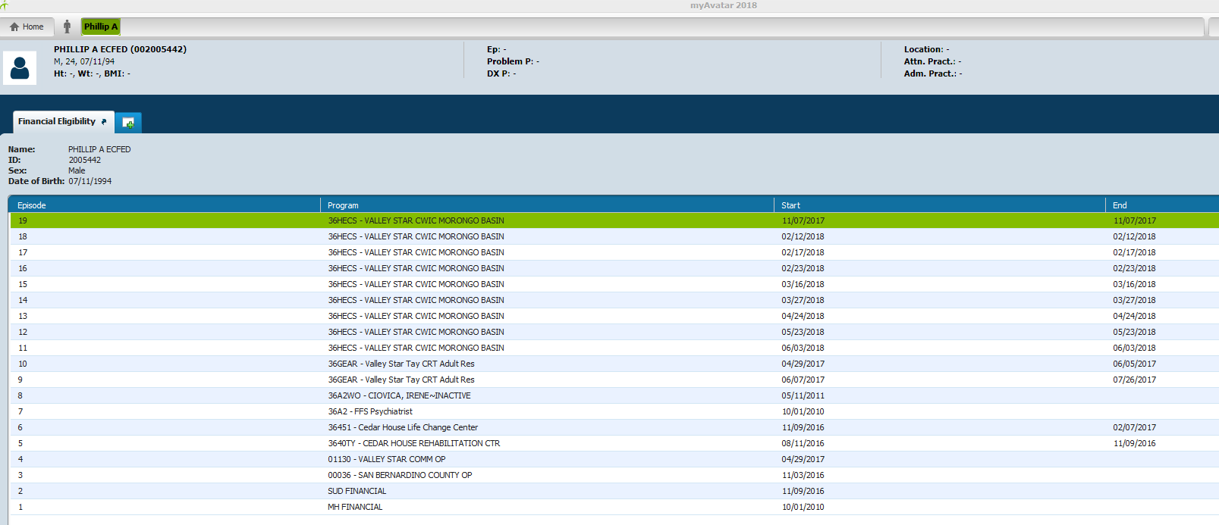
After you double click on “MH FINANCIAL”, you will be able to see who the guarantors are and what order they are in.
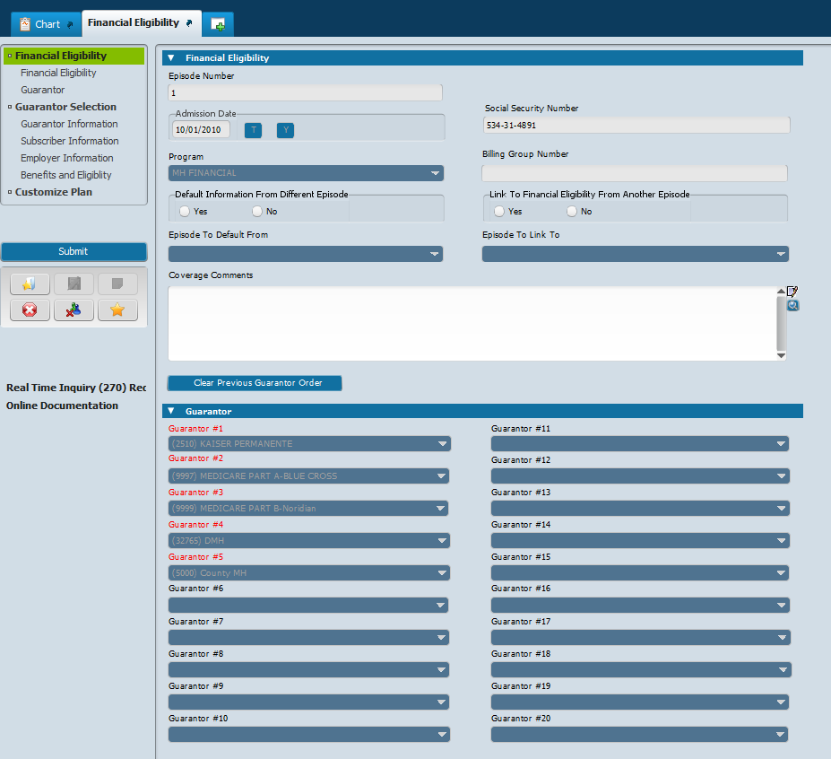

You till then need to open another window to go to the Client Ledger.
To go to the next form , you can either go back to “Home” and search for another form, or click the green plus sign 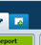 to select the next form
Green plus button

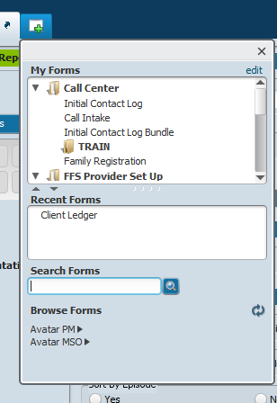
Type form name

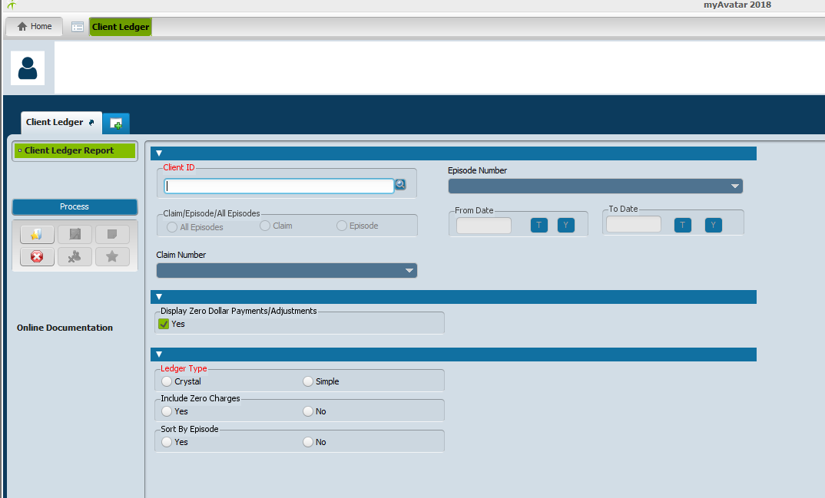
Type client’s information” You can search my last name, first name (No space between last name(,)first name). You can search by “Date of Birth” 00/00/0000, “Social Security Number” 000-00-0000, and by client’s number. A list of clients will come up, double click on client you are searching.
Click enter, or search
“Claim/Episode/All Episodes” is now showing red. Select an option
“From Date” and “To Date” will pre-populate, you can change the date range
“Ledger Type” select what type of report you need.by selecting “Crystal” or “Simple”
Click on Process

The report opens up. Here you can check for client’s date of service, if the claim line has been processed, paid or is still unbilled, also check for the Guarantors.

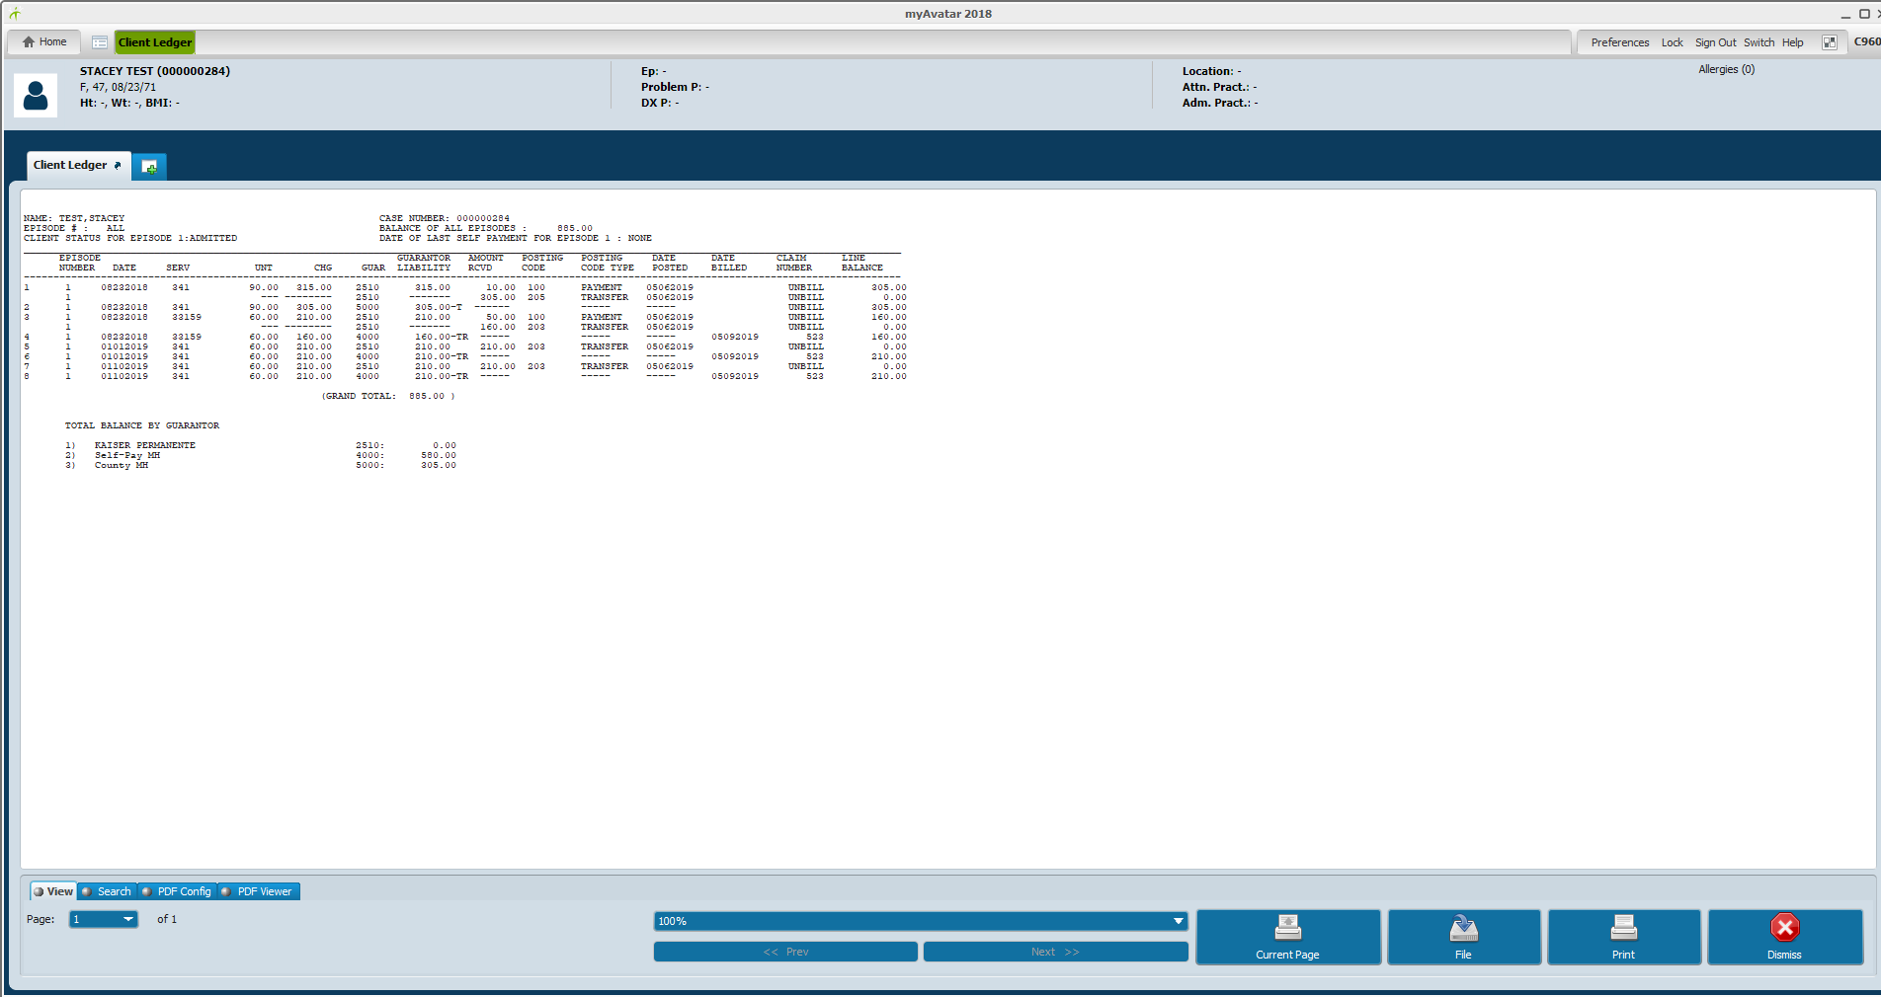
Once you have reviewed the ledger, click on the red X Dismiss this will bring you back to the form and will ask the following question
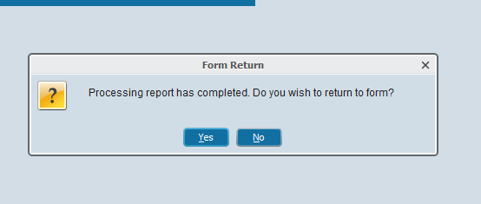
If you are done reviewing the report click “no”, if you still want to remain on the form click “yes”

To go to the next form , you can either go back to “Home” and search for another form, or click the green plus sign to select the next form

Green plus button

Type form name

Spreadsheet Remittance Posting
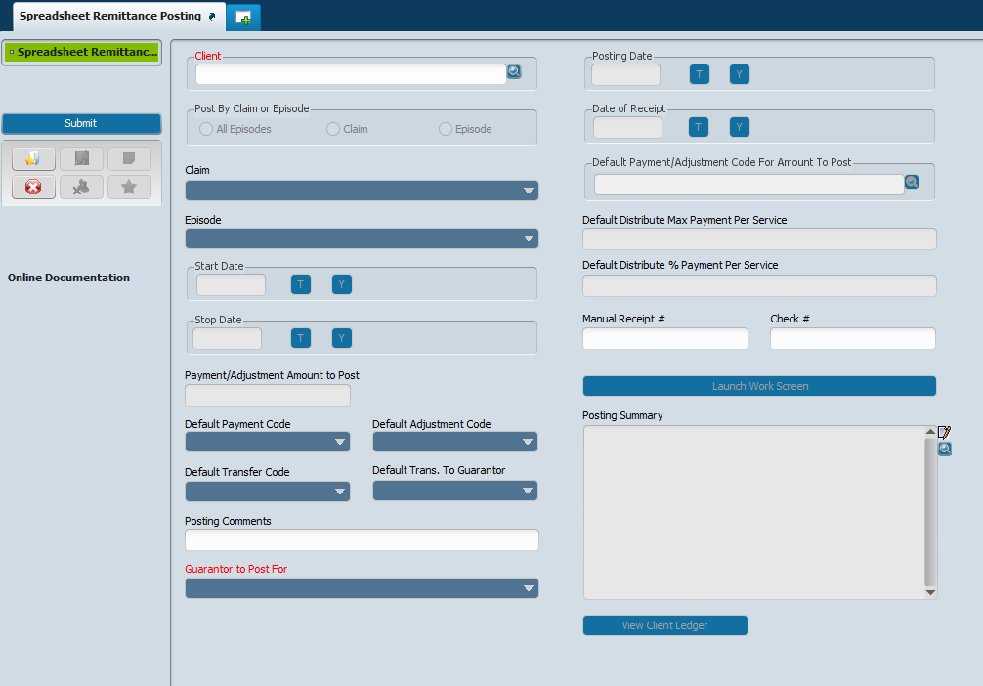
Search “Client”, type client’s information” You can search my last name, first name (No space between last name(,)first name). You can search by “Date of Birth” 00/00/0000, “Social Security Number” 000-00-0000, and by client’s number. A list of clients will come up, double click on client you are searching.
Under “Posting by Claim or Episode” select claim,
Under “Claim” click the arrow down and select the date of service and guarantor
The “Guarantor to Post For” will default to the guarantor you selected under “claim”
For “Posting Date” and “Date of Receipt” click on “T” this is for today’s date
Now click on “Launch Work Screen”
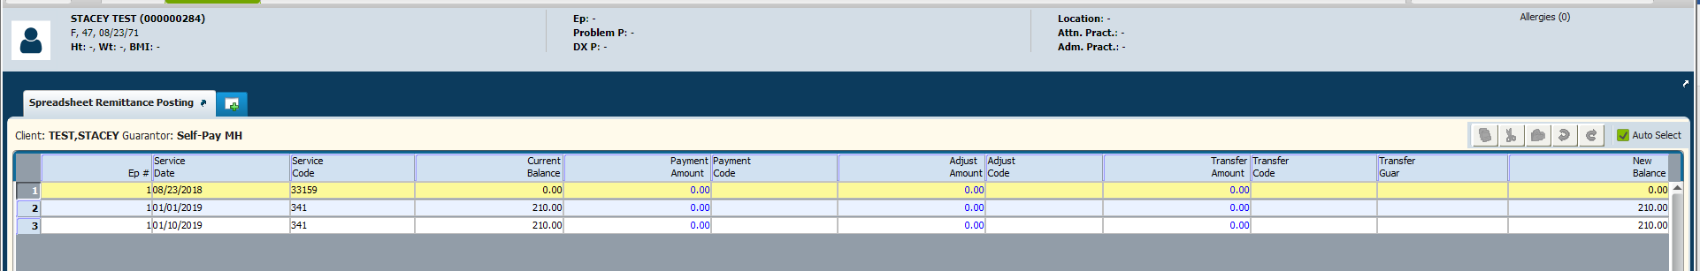
Click on the “Date of Service” payment needs to be posted on, add the payment amount, select a payment code, add the transfer amount, select the transfer code and select transfer guarantor. Once you have completed the spreadsheet click on “Accept”.
Before you submit check the “View Client Ledger” to make sure the postings and/or adjustments were done correctly. At this point, you can make any necessary changes to the spreadsheet.
Once you have confirmed the entries click on “submit”.
Check the “Client’s Ledger” to ensure the payments and transfers were accepted.

