ADDING A NEW FFS PROVIDER

New Provider - Provider will contact DBH to advise they are interested in applying to become a DBH contracted Medi-Cal FFS Provider for either Outpatient or Inpatient services.
Provider Relations – After speaking with Provider and answering questions, will email to Provider an application packet based on their services for either Outpatient or Inpatient credentialing.
Re-Credentialing Providers - Provider Relations will automatically email application packet to FFS Provider starting at 90 Day/60 Day/30 Day intervals.
The Provider needs to mail back the original copies of the application with all necessary documents to Provider Relations. Provider applications are stamp dated on the date they are received. For new Providers applying, this stamp date will be the start date of their credential. For re-credentialing Providers, the stamp date is the date we received the application. The start date of the re-credential is the date the previous credential expired. If the application is mailed in after the credential has expired, the stamp date for re-credentialing Providers is the date that the re-credential will begin. We do not back date expired credentials). Providers need to return the application to Provider Relations with enough time to process the application prior to its expiration date. Providers can email a copy of the application in for the review process to begin, but the original must be mailed in for the file. We will use the stamp date of the first copy we receive as the date the application was submitted.
A DBH Provider File is created where all documents are filed into

Entering Providers:
Adding a New Provider
Form #1 – Practioner Enrollment
From the Desktop - My Views – MSO Home View
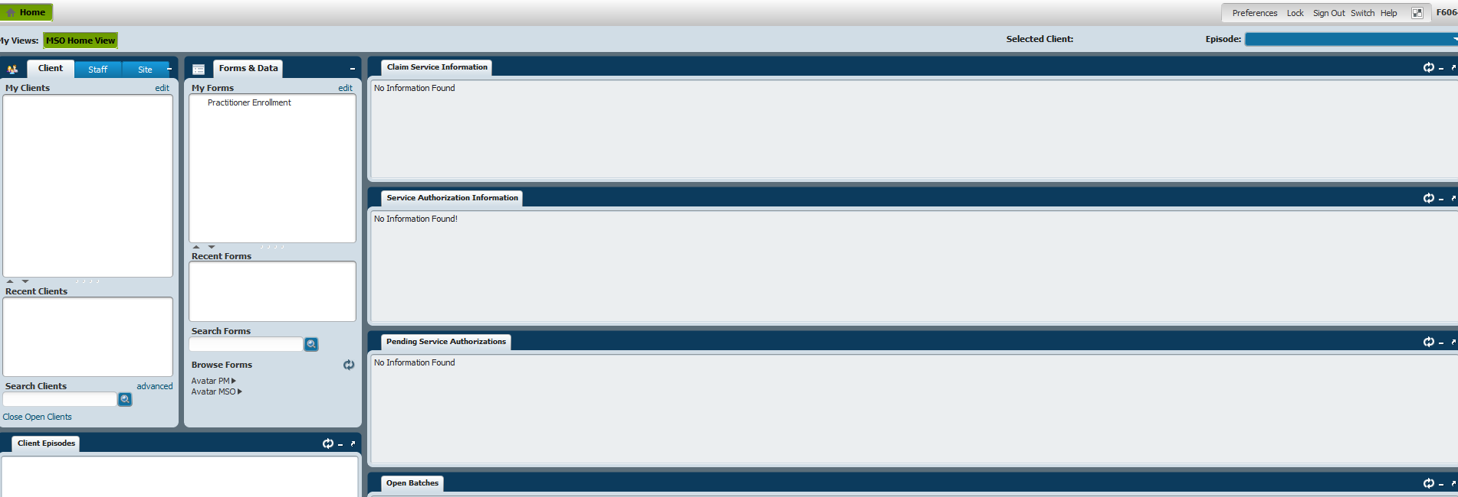
Under Forms & Data – Scroll down and click on Practioner Enrollment
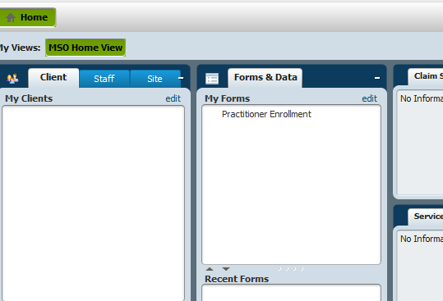
Once you click on Practioner Enrollment, the box below will appear:
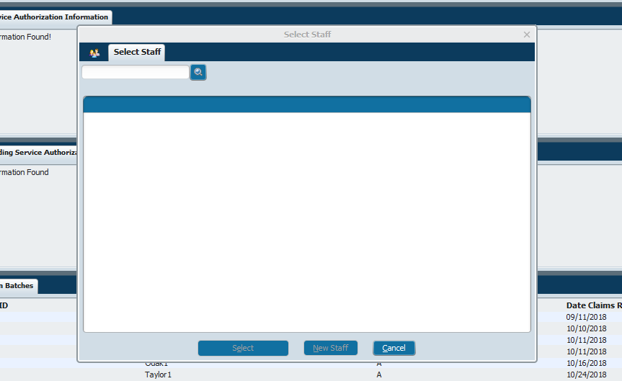
You want to type in the last name of the Provider on the blank bar below where it states “Select Staff” (You are searching for the Provider to see if they are in the system). In this example below, I typed in Barton. Barton is a Provider that is in the system so her name appeared.
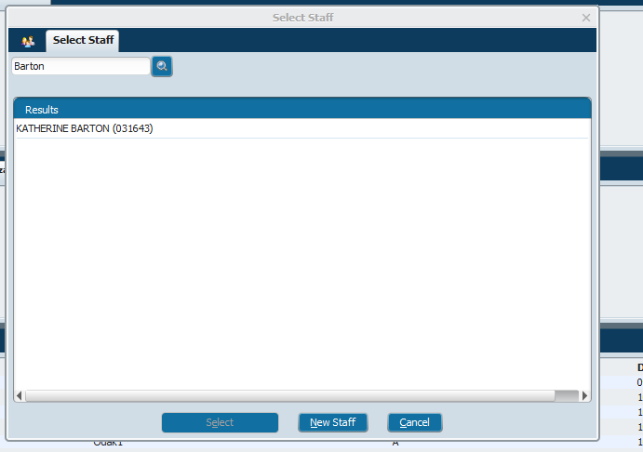
If the Provider is not in the system, you will need to add the Provider.
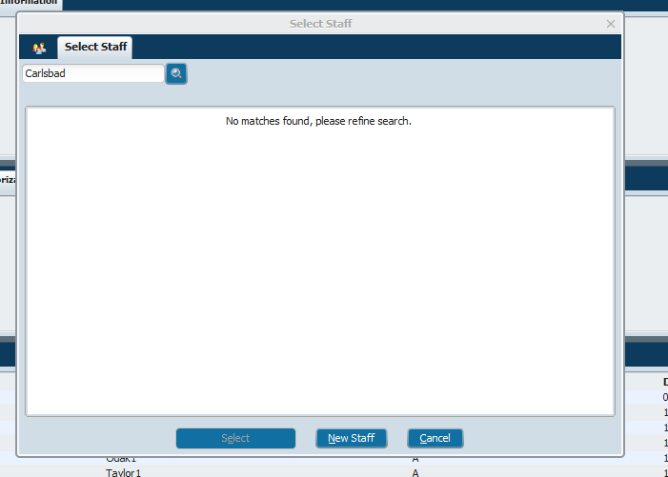
Click on tab at bottom that says NEW STAFF.
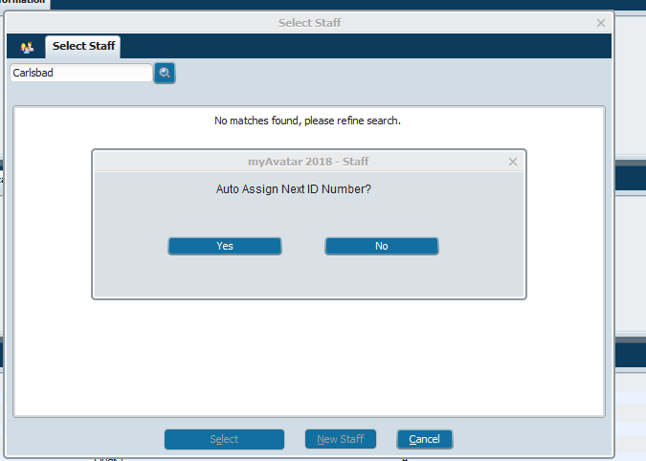
You want to Auto Assign Next ID Number. Click YES.
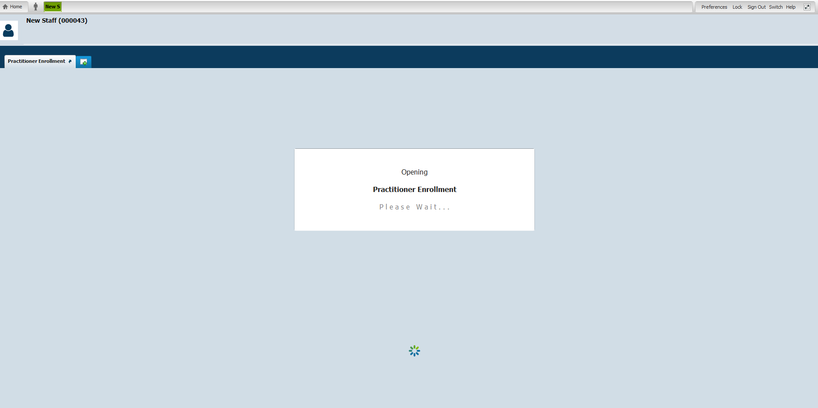
The NEW STAFF page will open. You will want to add the Provider’s demographic information here:
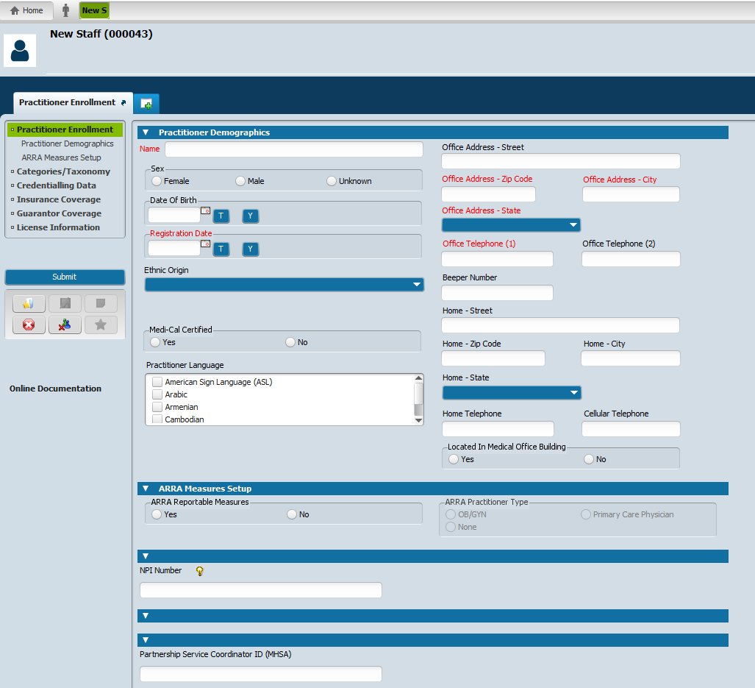
Under Practioner Demographics, complete the following sections:
Last Name,First Name (Do not put a space between the coma and the first name)
Sex
Date of Birth
Registration Date: Date stamped on Provider’s application – Date received by DBH
Answer YES to Medi- Cal Certified
Practioner Language – English as well as all other languages Provider speaks
Office Address – street (top right): Add the Provider’s office mailing address
Office Telephone #
Add NPI #
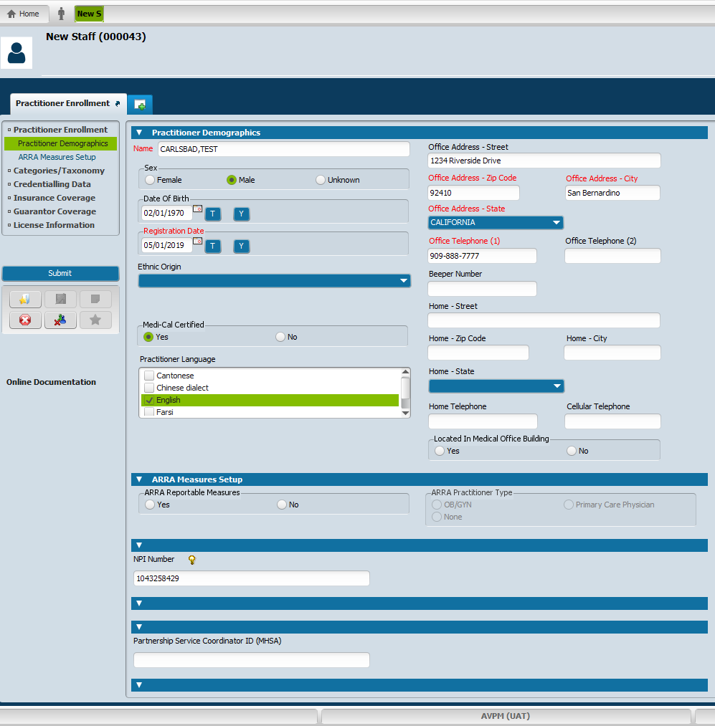
Once you have entered in all information, go to left side of the screen and click on CATEGORIES/TAXONOMY tab.
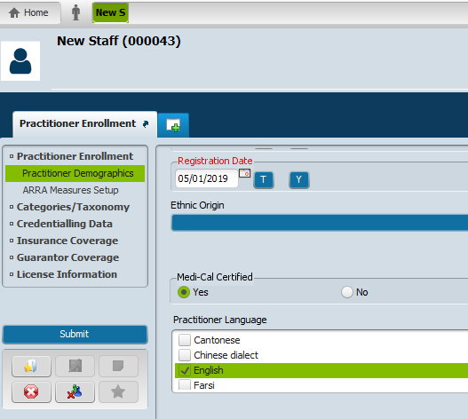

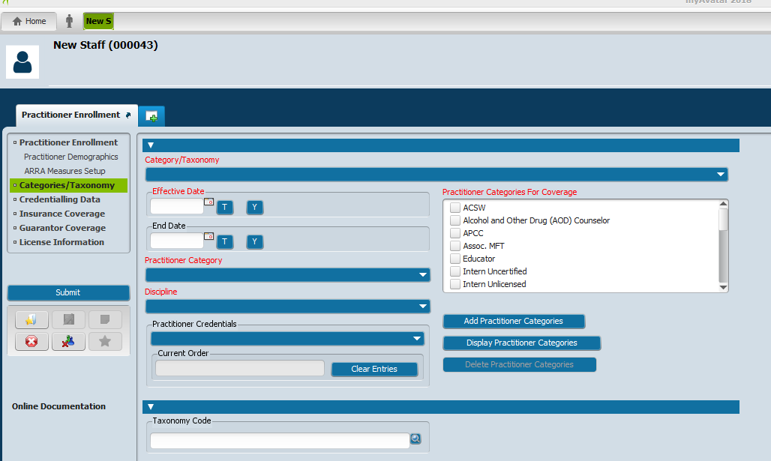

Under CATERGORIES/TAXONOMY section -
Use drop down arrow on blue bar and click on CREATE NEW
Add the following Information:
Effective date – Registration date/Stamped date of when Provider packet was received
End date – 3 years from the registration date (i.e. if received on 05/01/2019 then end date would be 05/01/2022).
Practioner Category – Provider’s Discipline (i.e., MD, PhD, LCSW etc…)
Discipline – Discipline of Provider (i.e., Psychiatrist, LCSW etc…)
Practitioner Categories For Coverage – Click on discipline (i.e., Psychiatrist, LCSW etc…)
Taxonomy Code – Type in Taxonomy Code. Double click on results chosen.
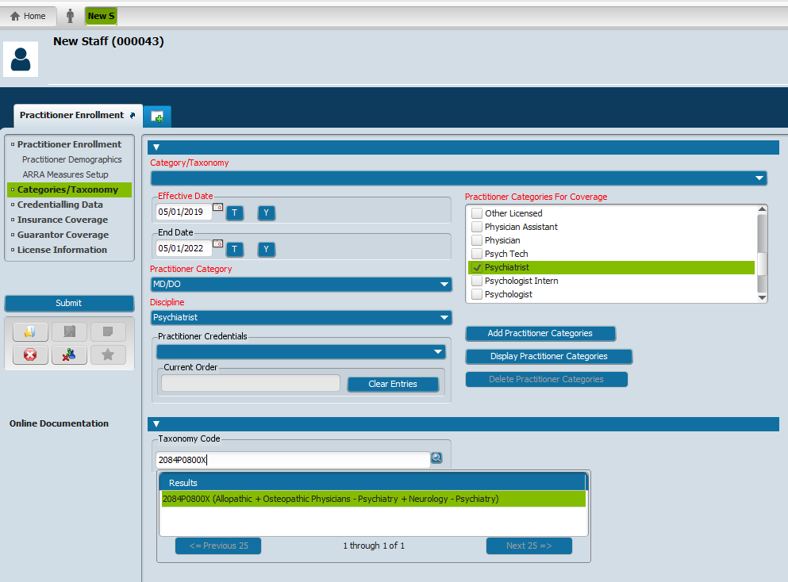
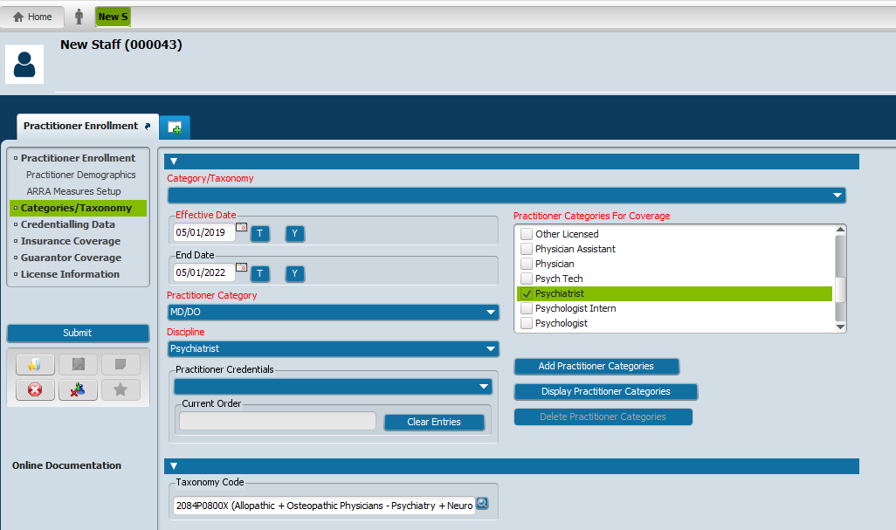
Once all entered, go to top left of screen and click on CREDNTIALING DATA tab.
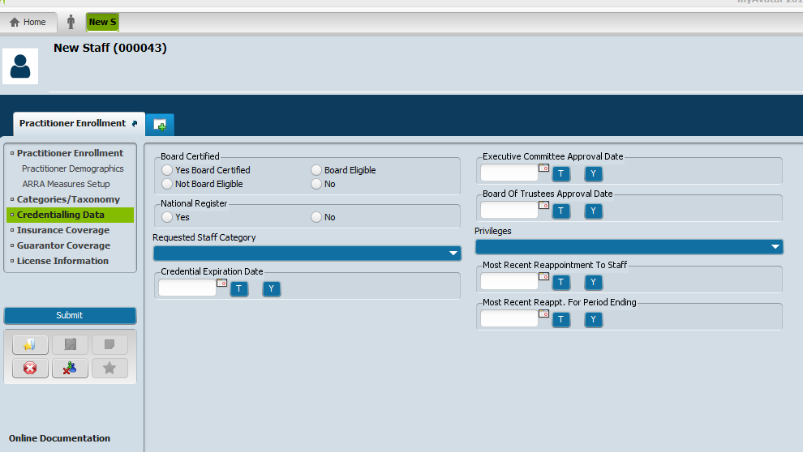
Enter the following information:
Board Certified – YES BOARD CERTIFIED
National Register – YES
Credential Expiration Date – The 3 year date from the Registration Date/Stamped Date
Executive Committee Approval Date – Date that Dr. Frausto or Tamara signed the approval letter.
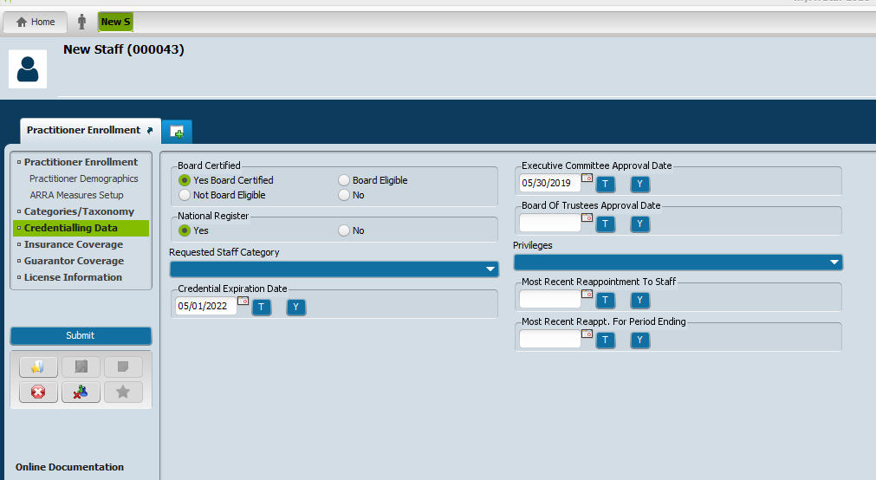
Go to top left of screen and click on INSURANCE COVERAGE tab –
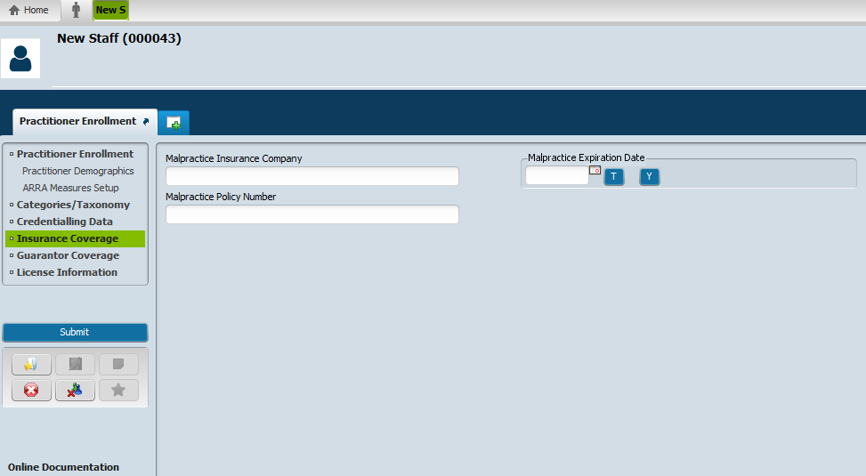
Enter Malpractice Insurance Company Name
Enter Malpractice Policy Number
Enter Malpractice Expiration Date
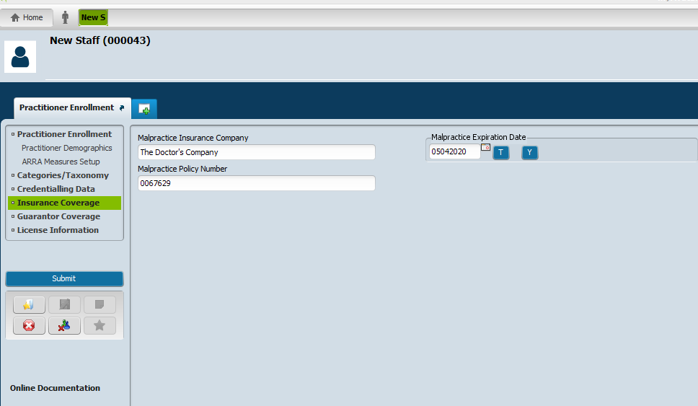
Go to top left of screen and click on GUARANTOR COVERAGE –
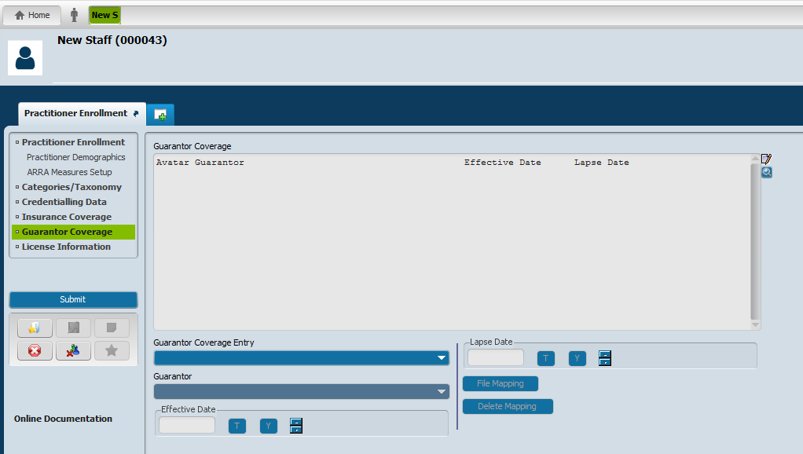
Click on Blue bar on the drop down arrow under GUARANTOR COVERAGE ENTRY. Click on CREATE NEW.
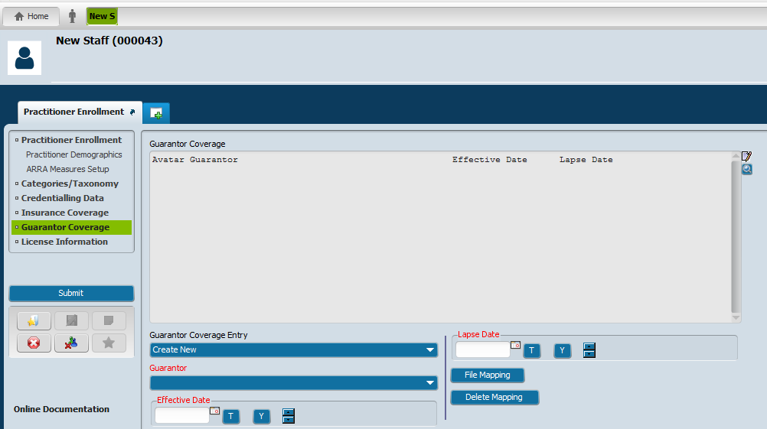
Click on Blue bar on the drop down arrow under GUARANTOR. Scroll down until you find DBH for Medi-Cal # 32765. Click on it.
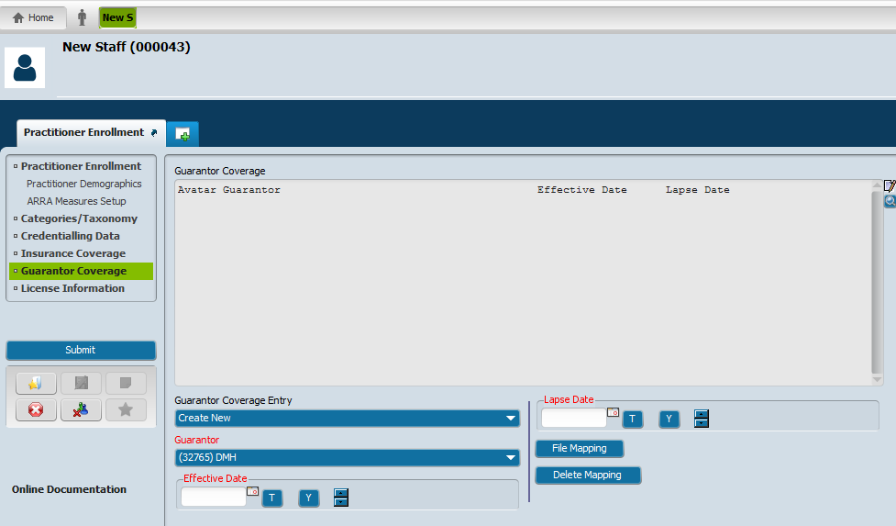
Enter the EFFECTIVE DATE – Registration Date/Stamped Date.
Enter the LAPSE DATE – 12/31/2050 (always this date)
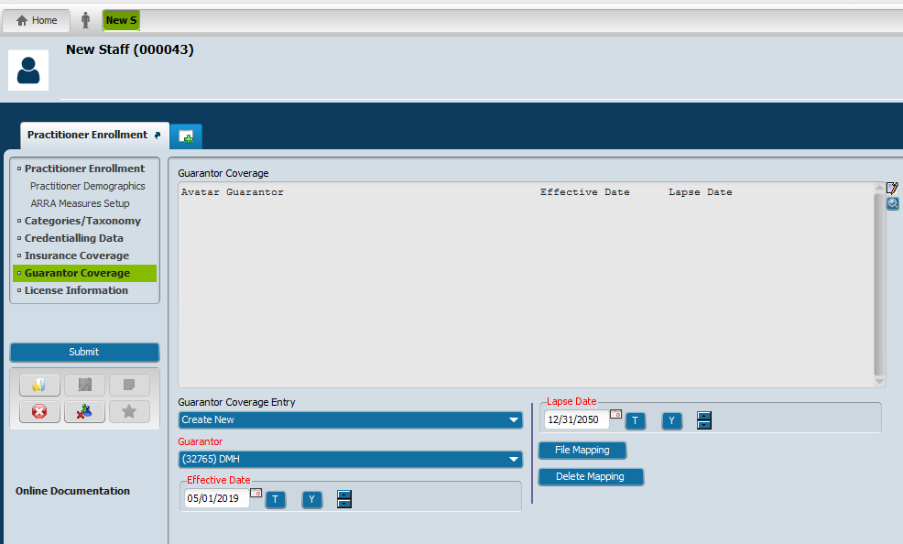
Click on the FILE MAPPING tab (below the lapse date box) – This will save your entry for DBH Medi-Cal 32765
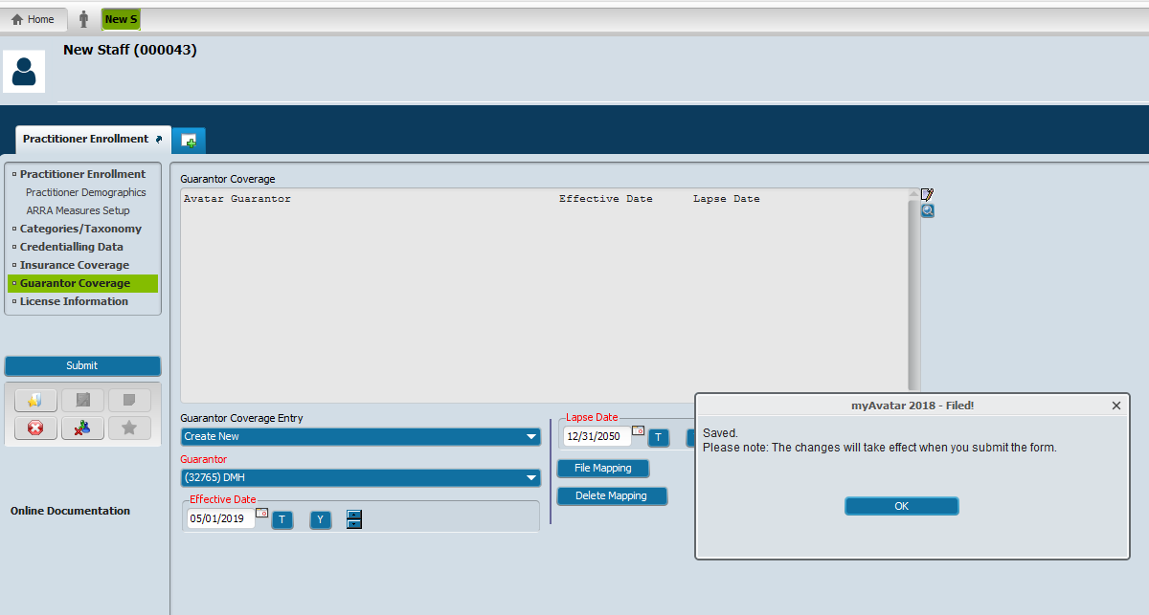
Click on OK
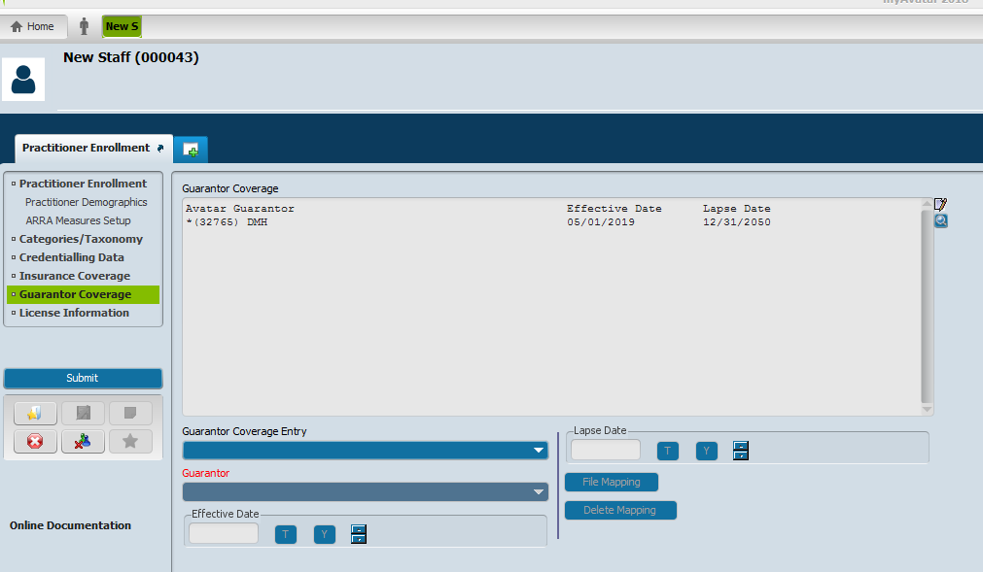
DBH Medi-Cal 32765 is now created and saved as a Guarantor.
CREATE NEW again. You will now add the COUNTY BUCKET – COUNTYMH5000.

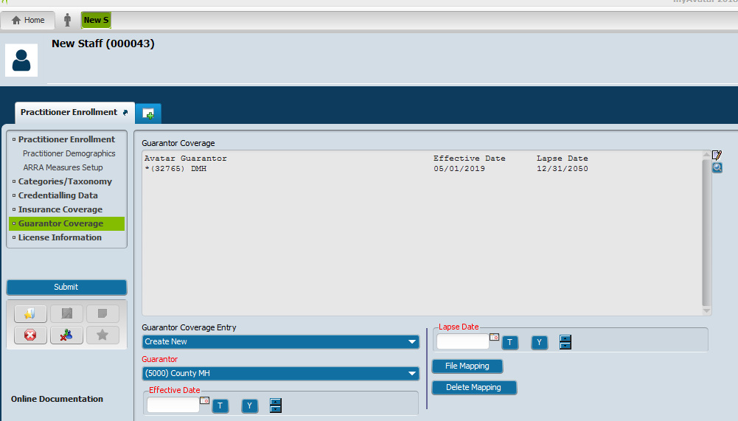
You will enter the same dates as the previous entry under EFFECTIVE DATE and LAPSE DATE.
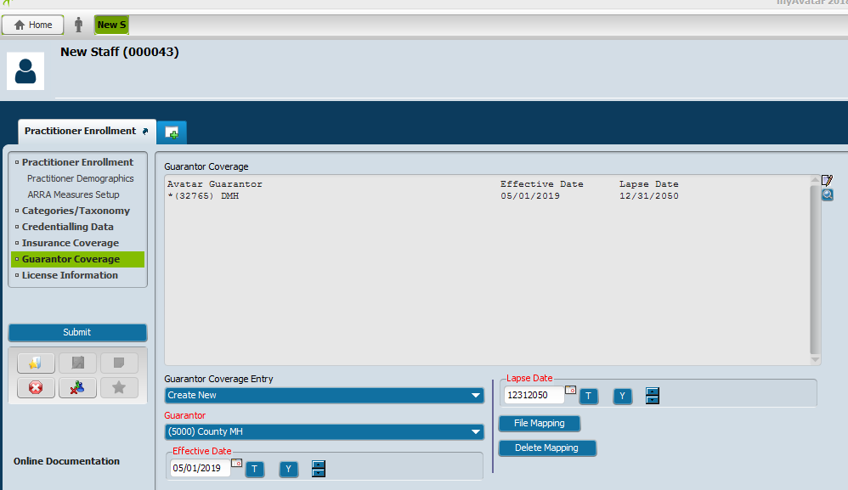
Click on FILE MAPPING tab to save the entry.
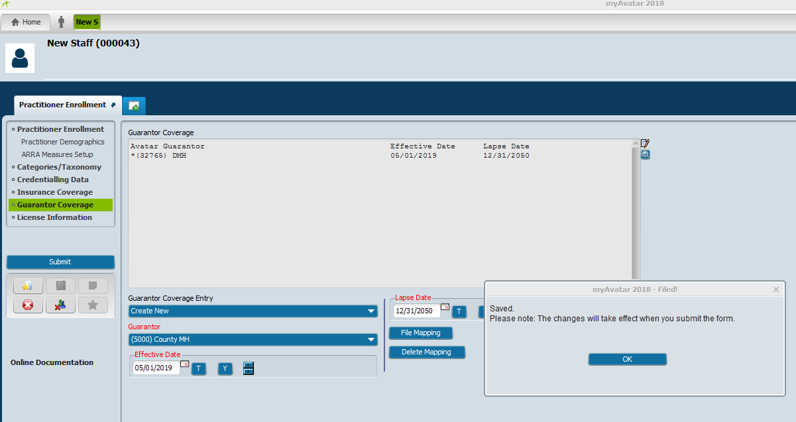
Click OK.
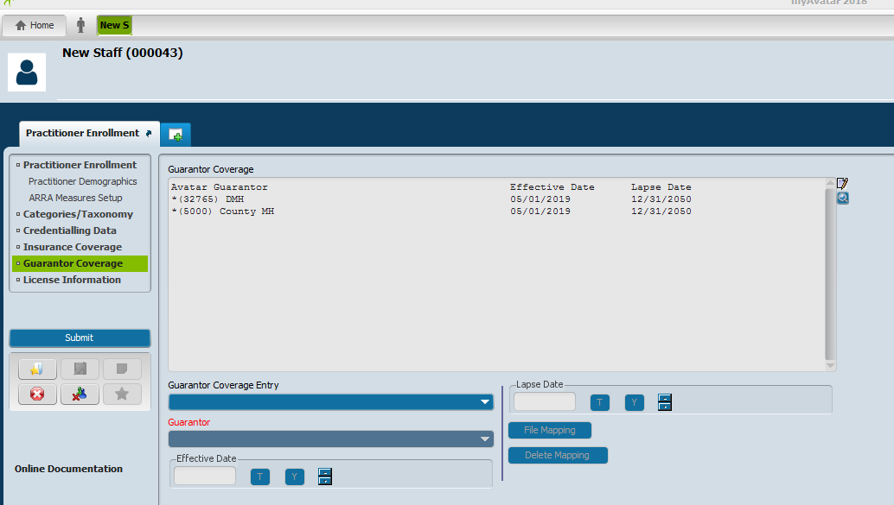
The COUNTY BUCKET is now saved as a GUARANTOR.
Go to the top left of the screen and click on LICENSE INFORMATION tab.
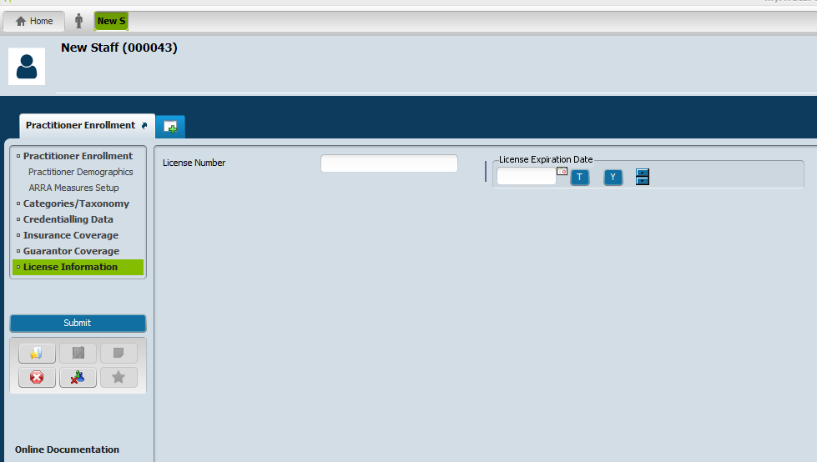
Enter the Provider’s Professional License information here.

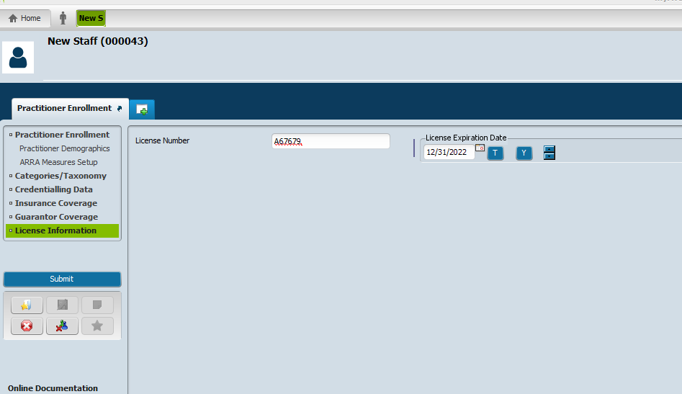
Once all sections on left top right under PROVIDER ENROLLMENT have been completed, click on SUBMIT located on left side under your entry list box.
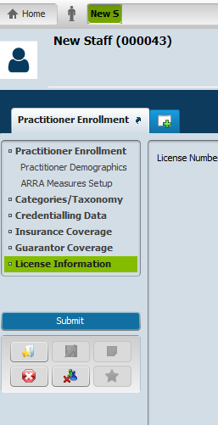

FORM #2 – APPLYING CONTRACTING PROVIDER
Under Search Forms, Type in APPLYING CONTRACTING PROVIDER
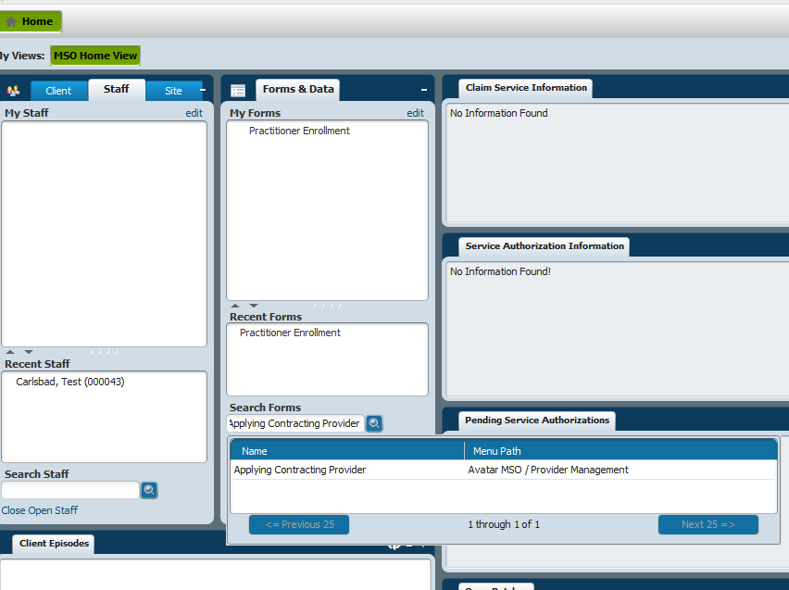
Search for your provider again using Provider’s first name or last name. If the Provider’s name does not come up, under Select provider box, click on NEW PROVIDER tab at bottom.
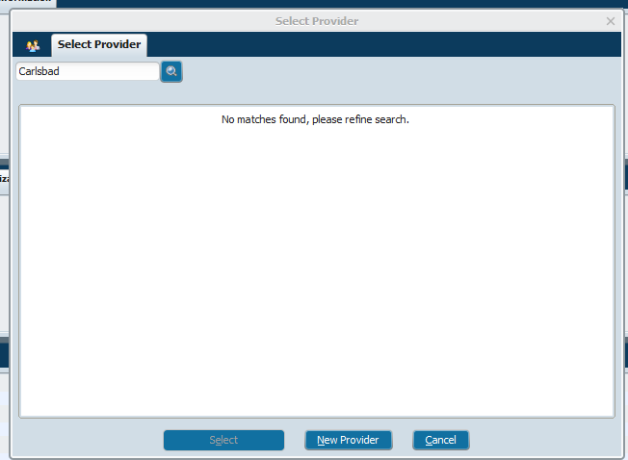
It will ask you if you want to Auto Assign Next ID Number. Click YES.
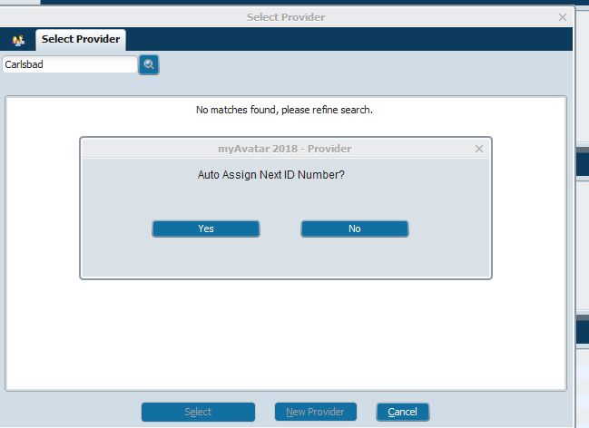
The next screen to appear will allow you to begin entering the Applying Contracting Provider’s information.
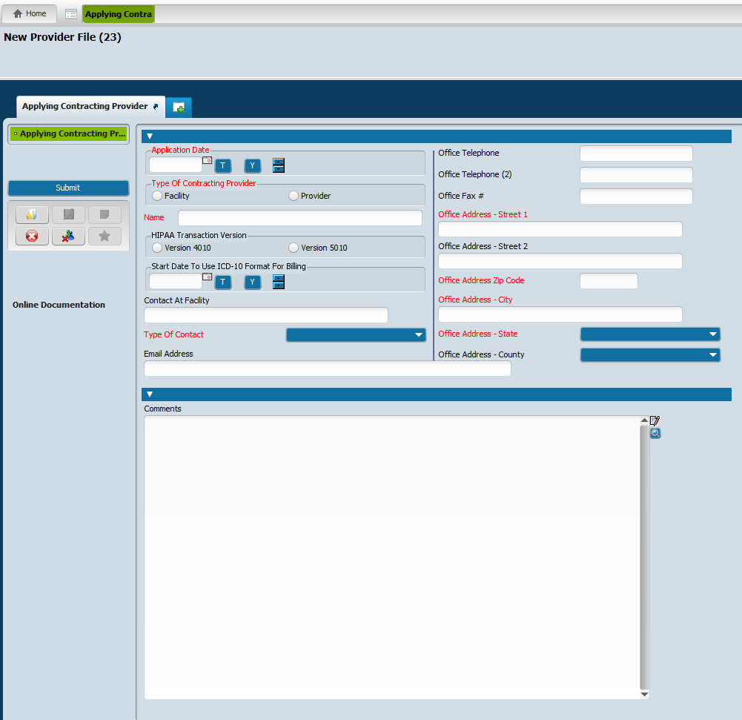
Enter the following information:
Application Date: Date DBH stamped the application.
Type of Contracting Provider: FACILITY
Name: Provider’s LAST NAME,FIRST NAME (no space)
Start date to use ICD-10 for billing: Effective Date of the Credential (If a new Provider it will be the DBH stamped date of the application. If a re-credential, it will be the date the Provider’s credential becomes renewed. That renewal date will either be the expiration date of the previous credential on file with DBH, or if it has expired, it will be the date the application was received and stamped in by DBH.)
Type of Contact: FAX
Email Address: BILLER’S EMAIL ADDRESS
Office Address: PROVIDER’S MAILING ADDRESS
Click on SUBMIT (Blue box on left of screen)
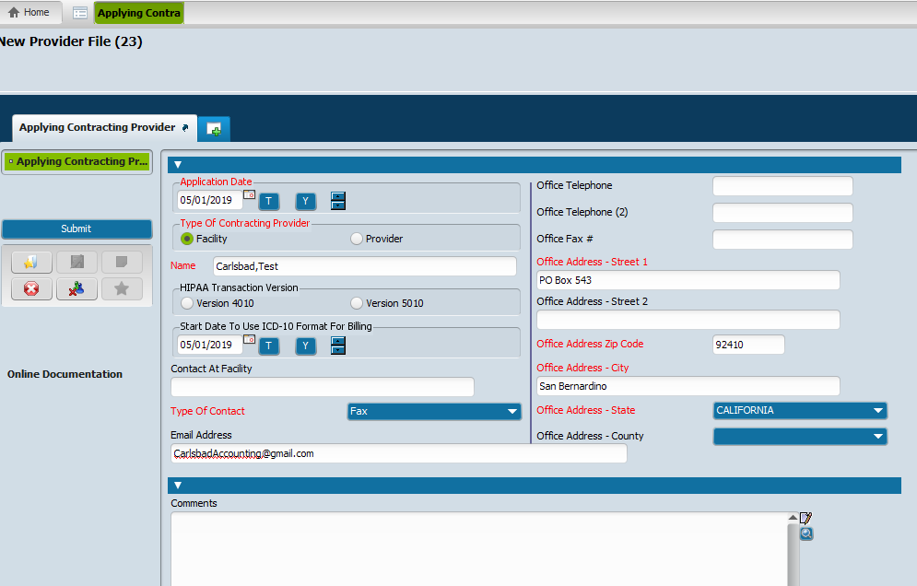

FORM #3 – CONTRACTING PROVIDER REGISTRATION
NOTE: We will only complete the top 3 of the 6 forms within this section

Under Search Forms, Type in CONTRACTING PROVIDER
The box below will appear.
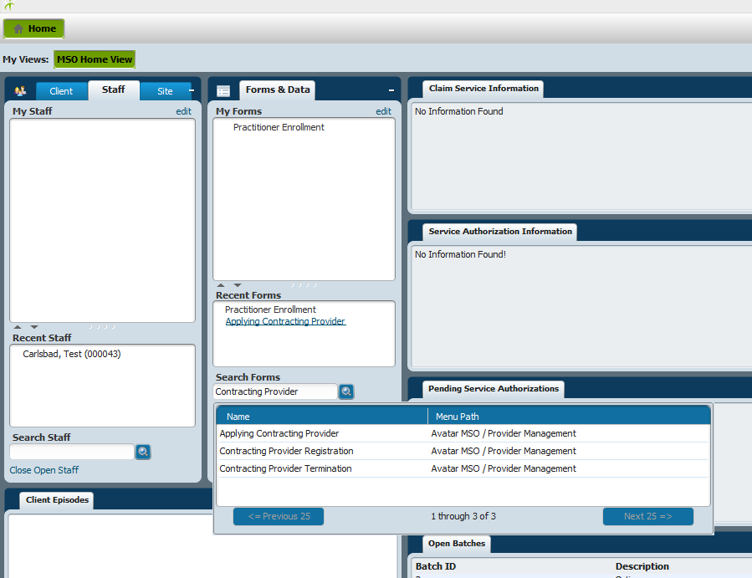
Scroll down to CONTRACTING PROVIDER REGISTRATION and double click on it.
Search for your Provider under SELECT STAFF field and chose your Provider by double clicking on Provider’s name and assigned ID number. This is the ID # that was assigned to the Provider in FORM #2 (see below).
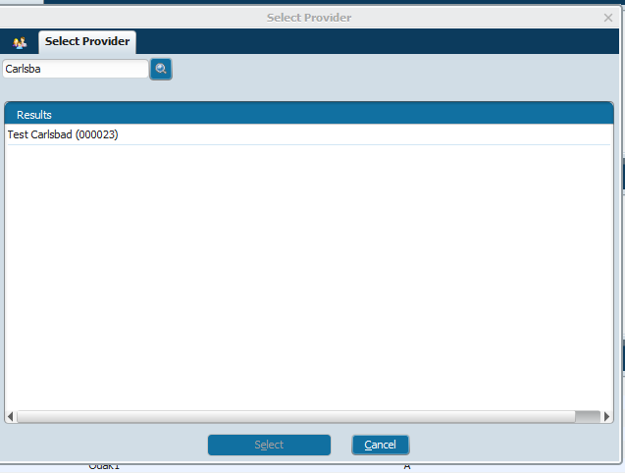
The CONTRACTING PROVIDER REGISTRATION screen will open. The screen will be pre-populated from Form #1 and Form #2 entered information.
Enter the following information:
Registration Date: STAMPED DATE on application by DBH
In Network/Out of Network: Choose IN NETWORK
Eligible Funding Source: Type in FFSMH(3) - (Double click on it to choose it)
Federal Tax ID #: Enter the PROVIDER’S TAXPAYER ID# or SS#
Primary Mailing Address – Will be pre-populated with the mailing address entered from FORM#2
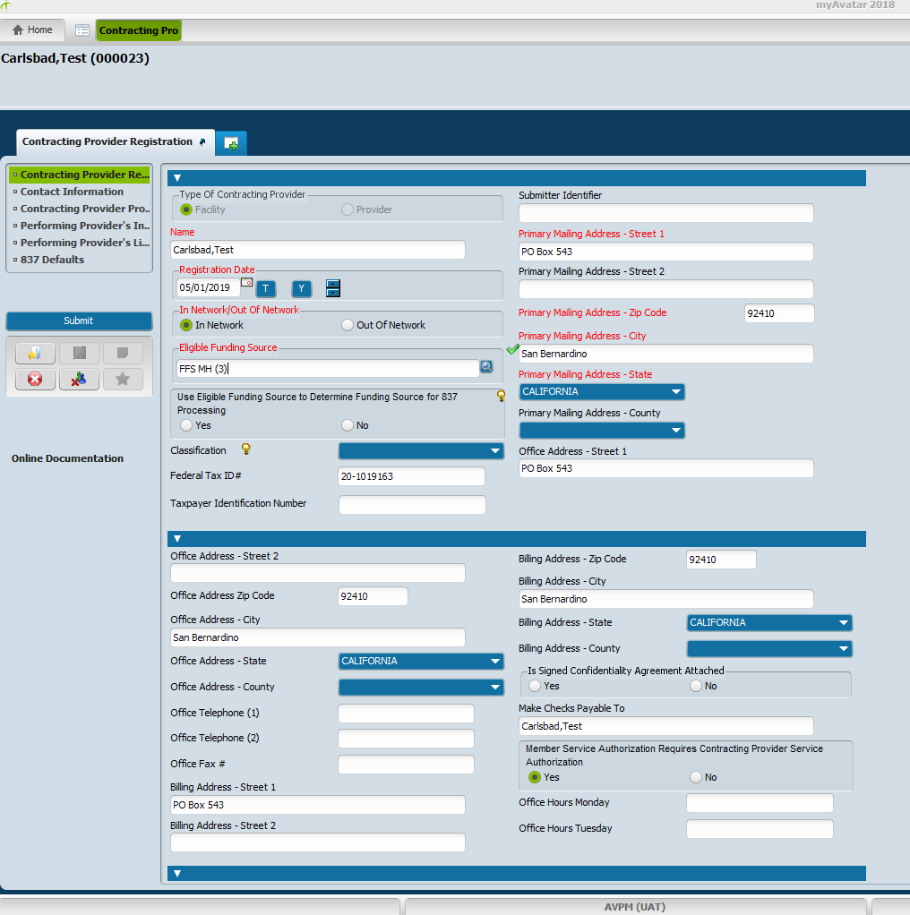
Scroll down to lower half of the CONTRACTING PROVIDER REGISTRATION screen.
On the lower half of the CONTRACTING PROVIDER REGISTRATION screen you want to:
Review the following:
Billing Address Street 1: Check and Ensure correct BILLING ADDRESS
Office Address Street 1: Check and Ensure correct TAX ADDRESS
Make Checks payable To: Check and Ensure it matches the W9
Member Service Authorization Requires Contracting Provider Service Authorization: Click YES
Vendor ID: USE SAP VENDOR CODE
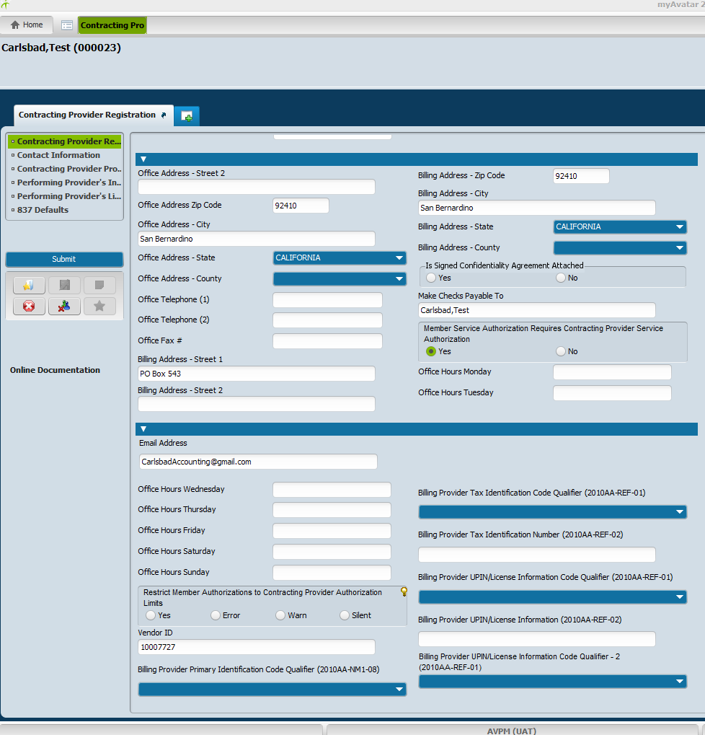

Go to left Drop Down Menu. Scroll down to CONTACT INFORMATION and click to open.
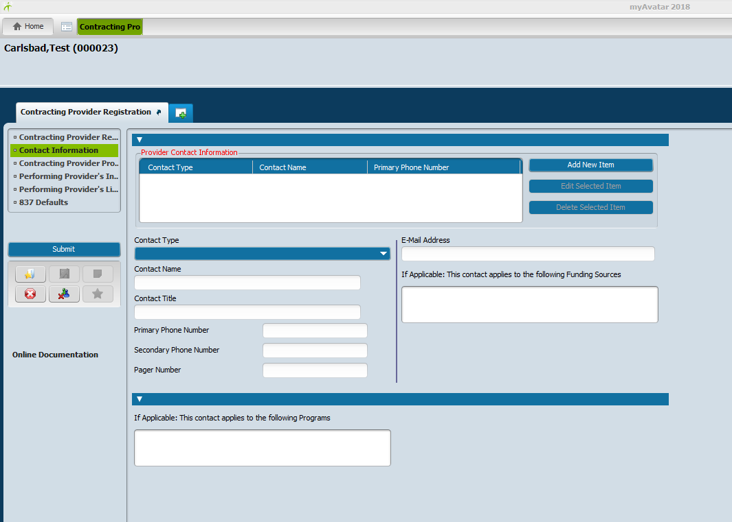
Click: ADD NEW ITEM box on upper right side of screen. A green bar will appear under the PROVIDER CONTACT INFORMAION Filed under the headings for Contact Type/Contact Name/Primary Phone number.
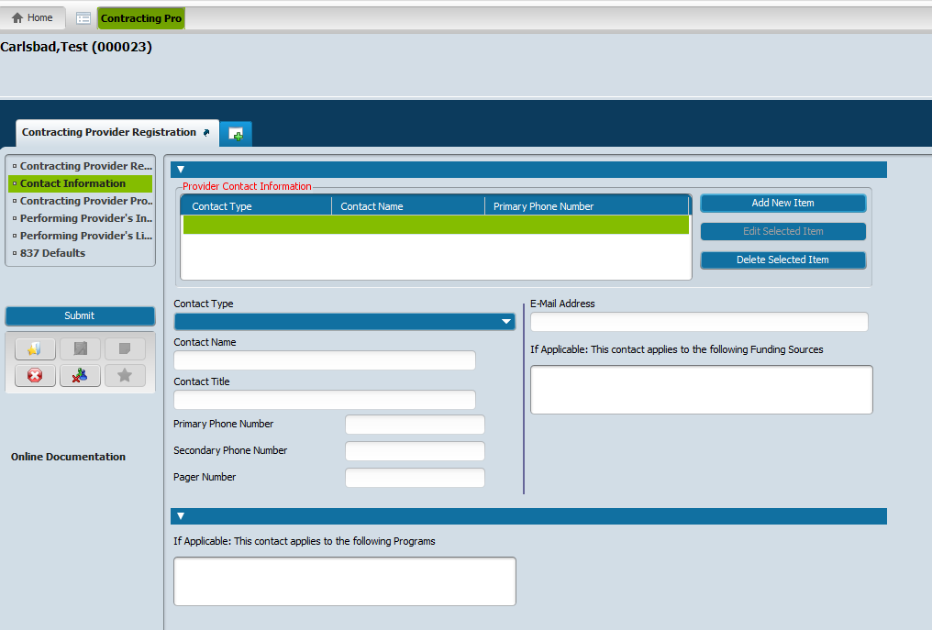
Under CONTACT TYPE, enter the following:
Contact Name: Add your Provider’s office contact information. There is no specific order.
Contact Name – Enter contact name (i.e., Office Manager’s information)
Contact title: (i.e., OFFICE MANAGER)
Primary Phone Number: (i.e., OFFICE MANAGER’S PHONE NUMBER)
Secondary Phone Number: (i.e., OFFICE MANAGER’S FAX NUMBER)
E-Mail Address: (i.e., OFFICE MANAGER’S EMAIL ADDRESS)
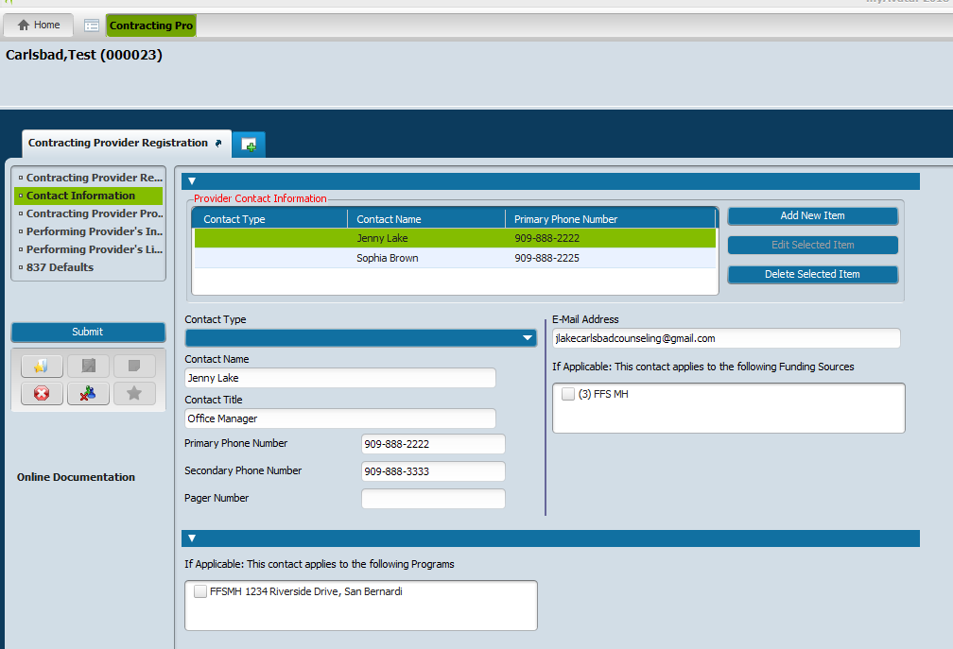
Click ADD NEW ITEM
Contact Name – Enter contact name (i.e., Office Manager’s information)
Contact title: (i.e., OFFICE MANAGER)
Primary Phone Number: (i.e., OFFICE MANAGER’S PHONE NUMBER)
Secondary Phone Number: (i.e., OFFICE MANAGER’S FAX NUMBER)
E-Mail Address: (i.e., OFFICE MANAGER’S EMAIL ADDRESS)
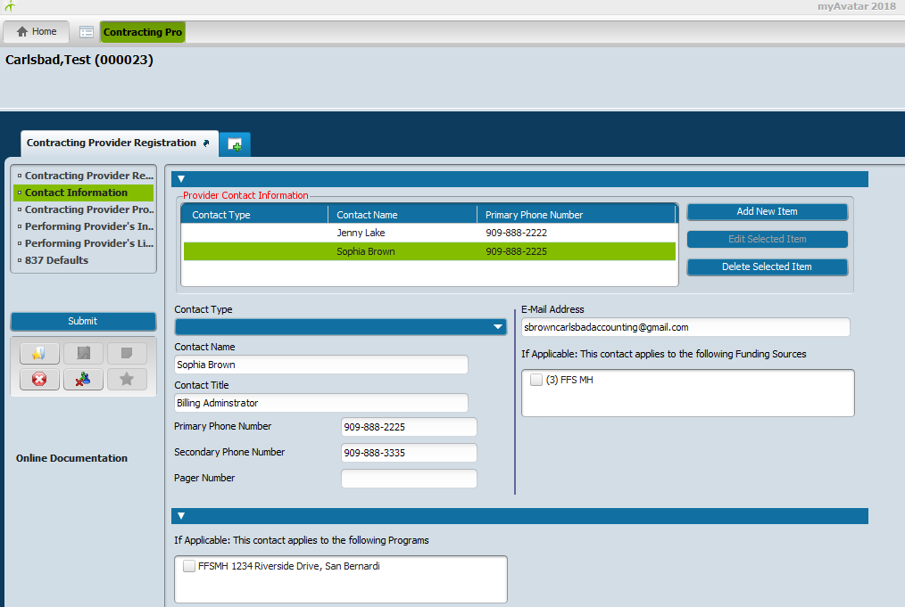
If more contacts need to be entered, continue adding them individually by doing the above steps for each individual.

Go to left Drop Down Menu. Scroll down to CONTACTING PROVIDER PROGRAM REGISTRATION and click to open.
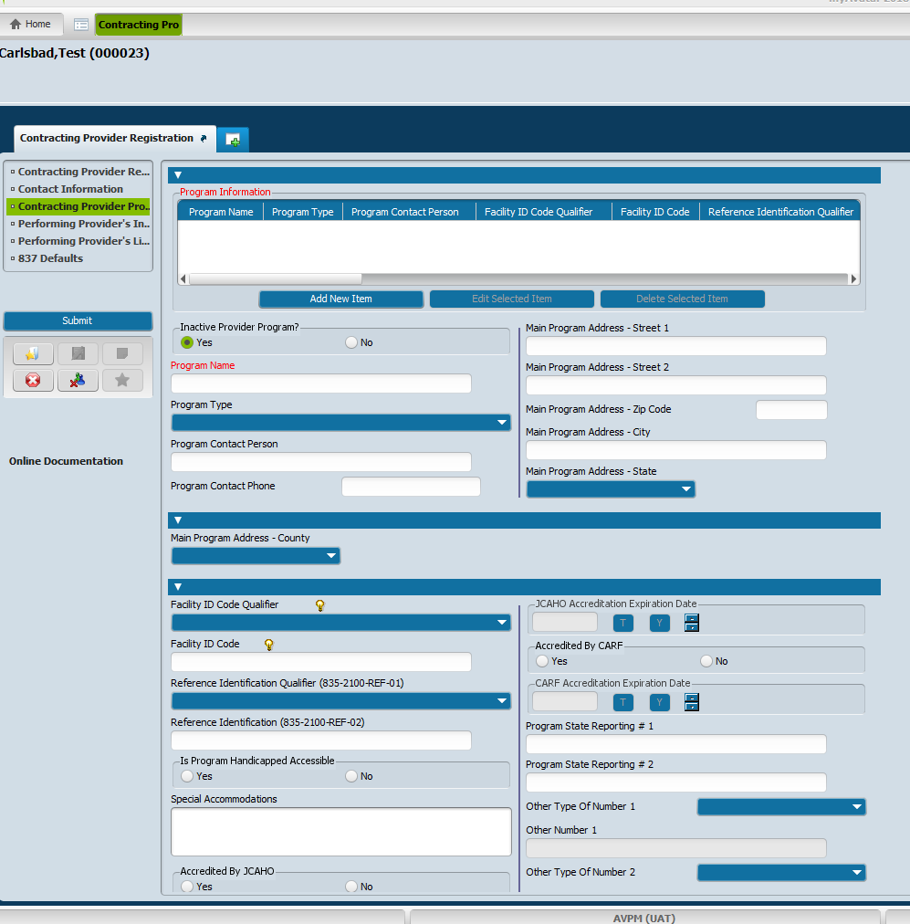
Click on: ADD NEW ITEM
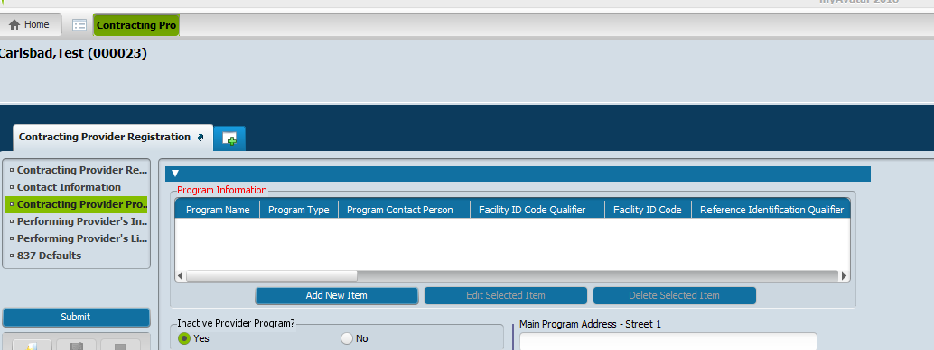
Enter the following information:
Program Name: These are the SERVICE SITES
FFSMH any service site (i.e., FFSMH 1234 Riverside Drive, San Bernardino, CA 92410)
Program Type: OUTPATIENT or INPATIENT
Is Program handicapped Accessible: If you know, click YES or NO
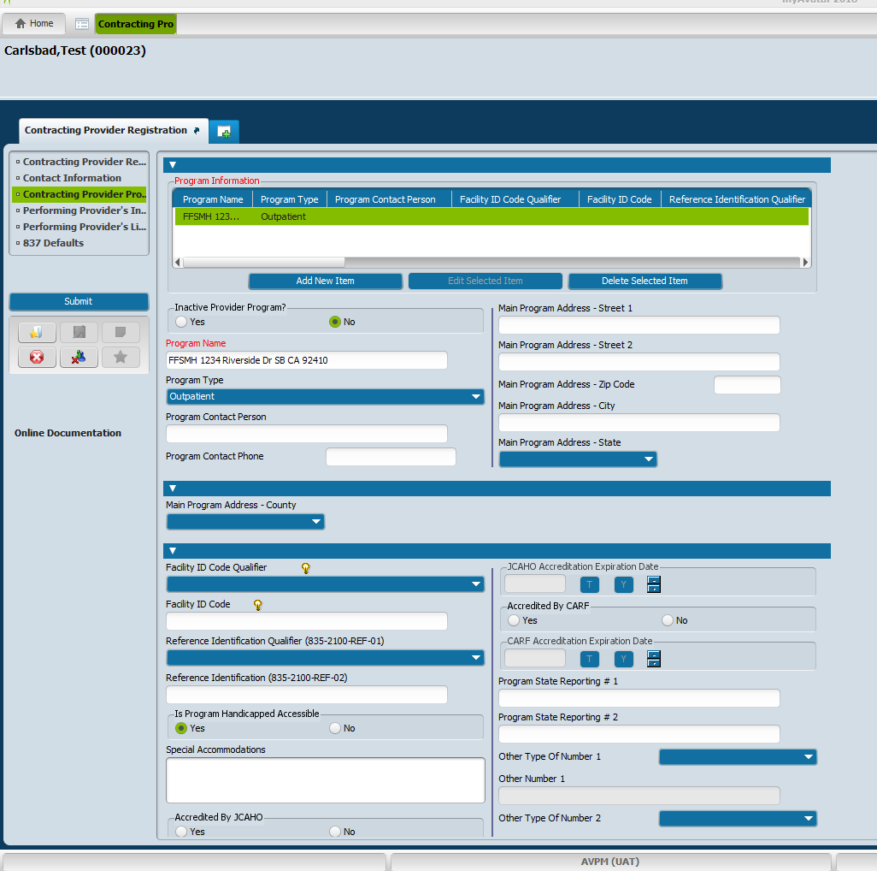
Once completed, click on SUBMIT
(NOTE: We do not complete the sections of Performing Provider’s Information, Performing Provider’s License Data or 837 Defaults.)
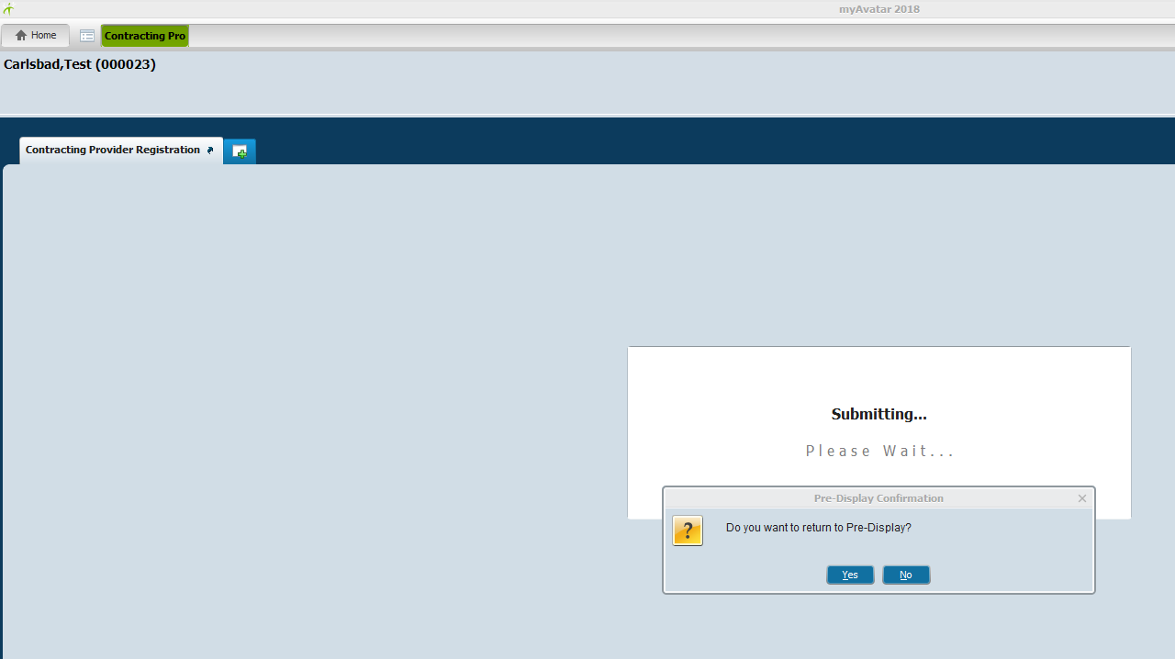
Click: YES
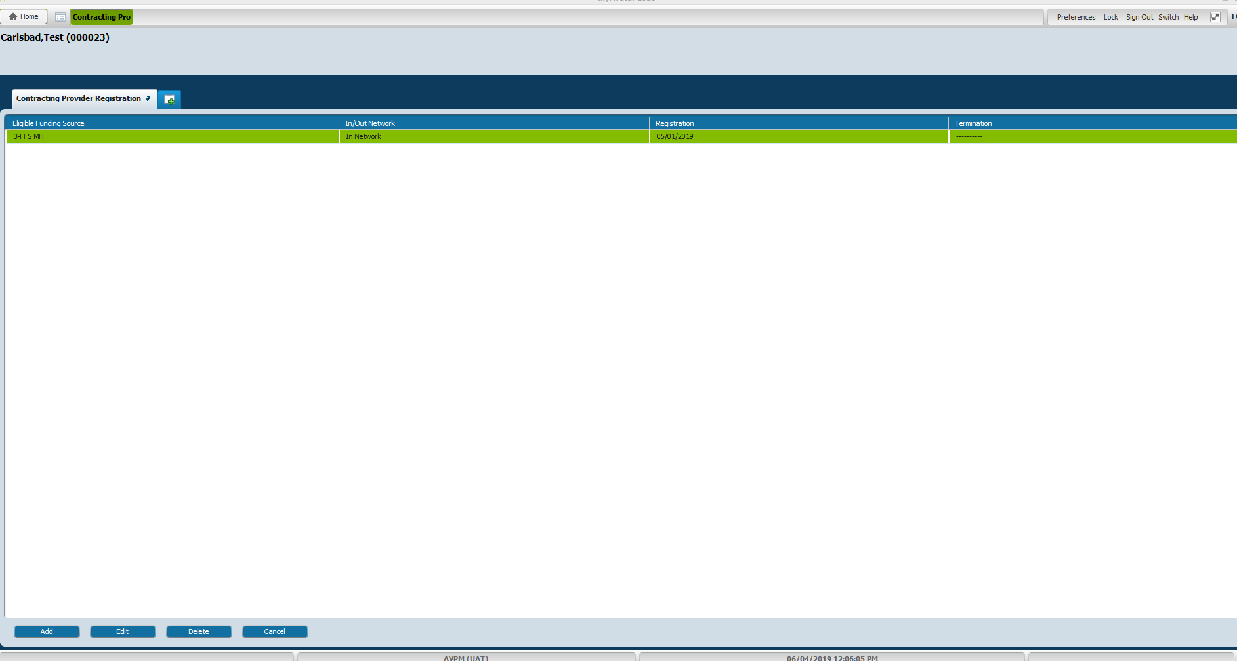
Click on top left Tab HOME
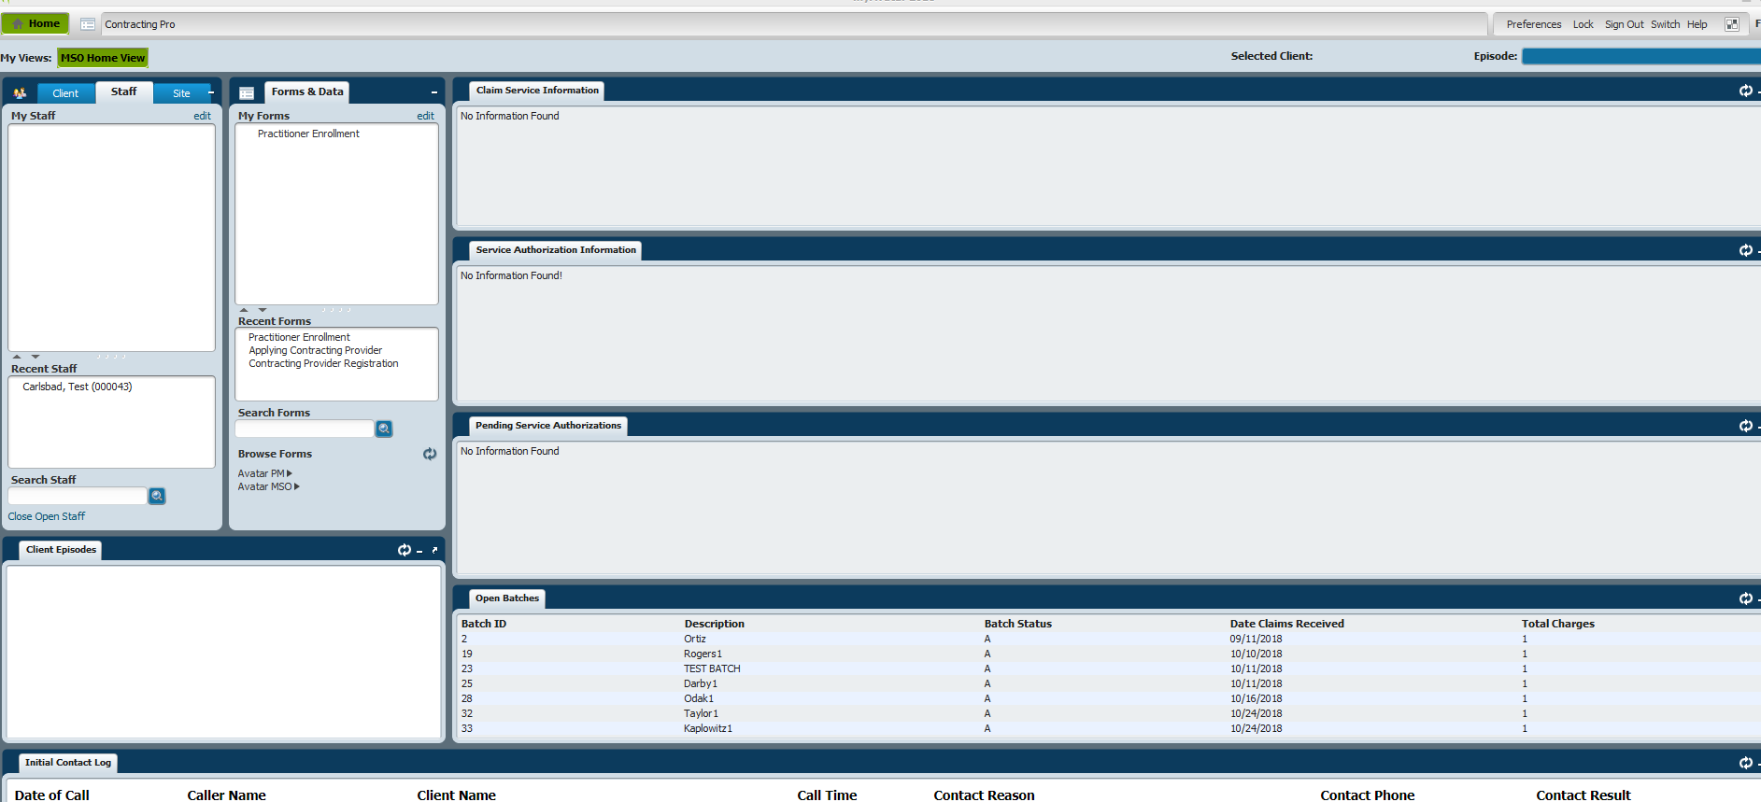

FORM #4 – PRACTIONER INFORMATION (CONFIDENTIAL)
Search Forms filed: Type in PRAC or PRACTIONER
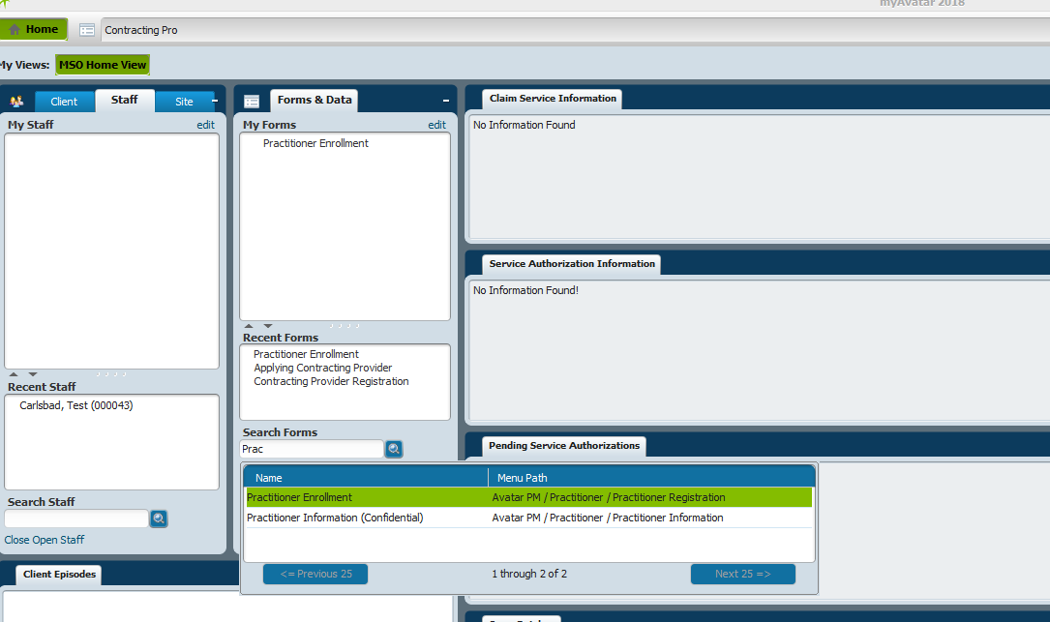
Choose PRACTIONER INFORMAION (CONFIDENTIAL). Double click on it.
Select your staff again on the SELECT STAFF field. Type in your provider’s name (i.e., Carl)
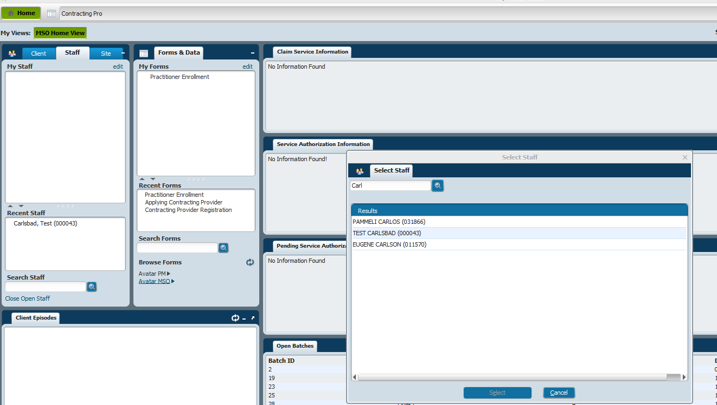
Double click on the provider’s name to choose it.
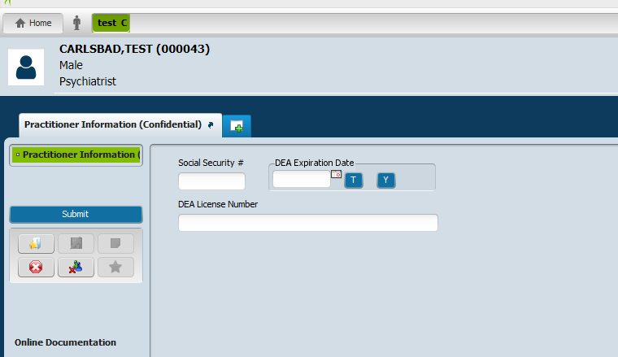
Enter the following Provider’s information:
SOCIAL SECURITY NUMBER
DEA LICENSE NUMBER
DEA EXPIRATION DATE
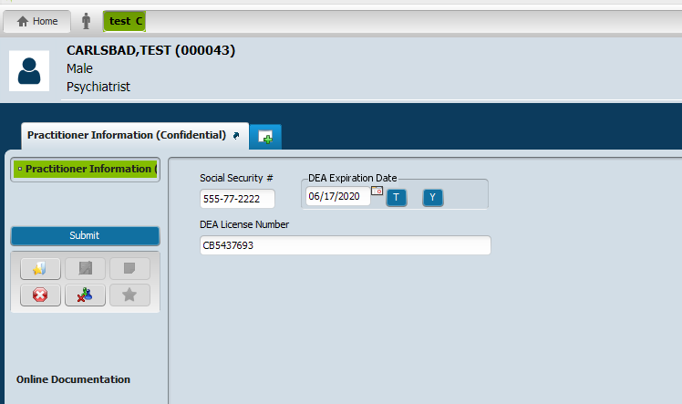
Click SUBMIT
FORM #5 – PROVIDER FEE DEFINITION (Adding Fees/Charges - Agreements) MSO
Under Search Forms field, type in Fee
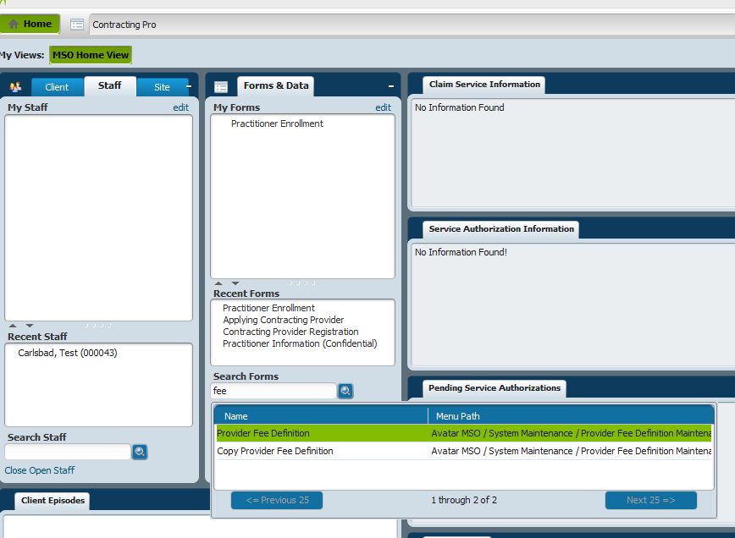
Double click on Provider Fee Definition.
LONG VERSION:
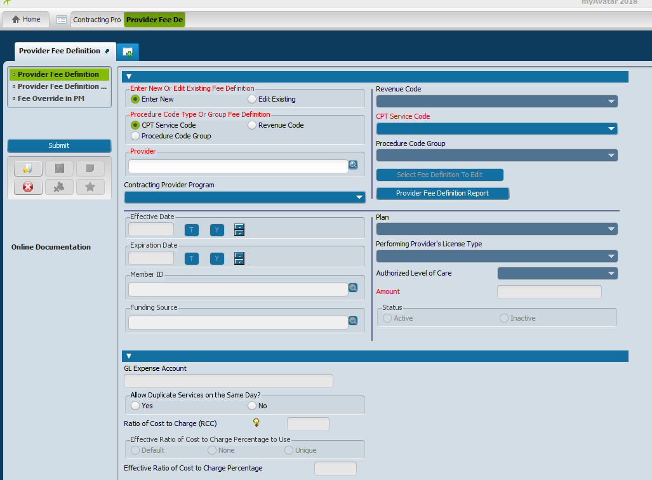
Enter New and CPT Service Code will be pre-populated already See above top left in red areas)
Under Provider filed, type in Provider’s name: Last, First (no space)
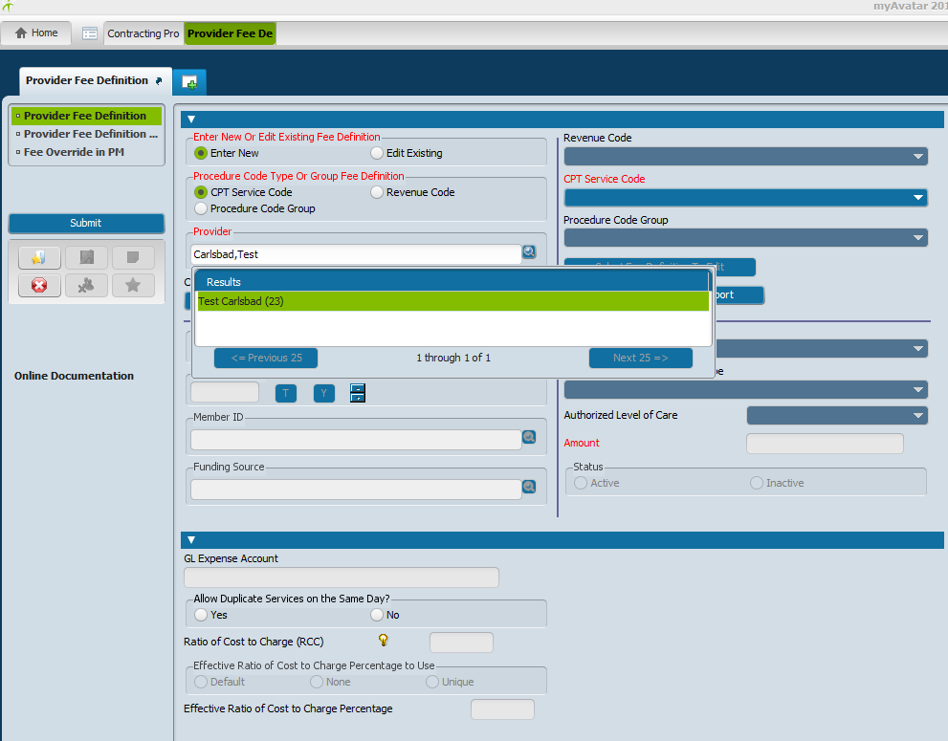
Double click on Provider’s name to choose.
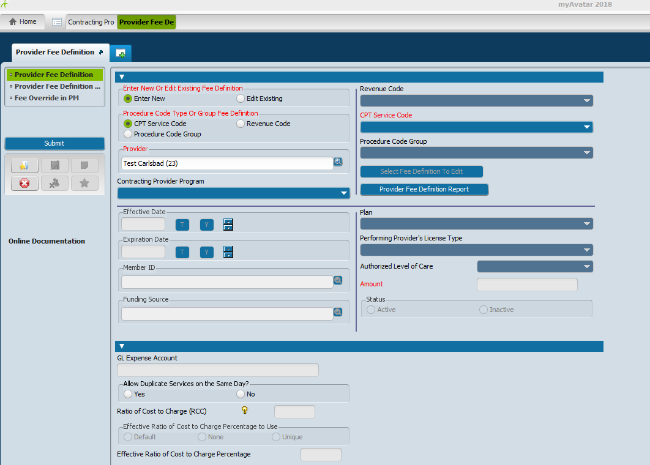
Enter the following information:
Contracting Provider Program: Click on drop down area and service site/sites will appear.
Click on the service site you are working on. (If more than one service site you will need to click on each service site individually, complete the process and then go to the next service site and redo the process, etc..).
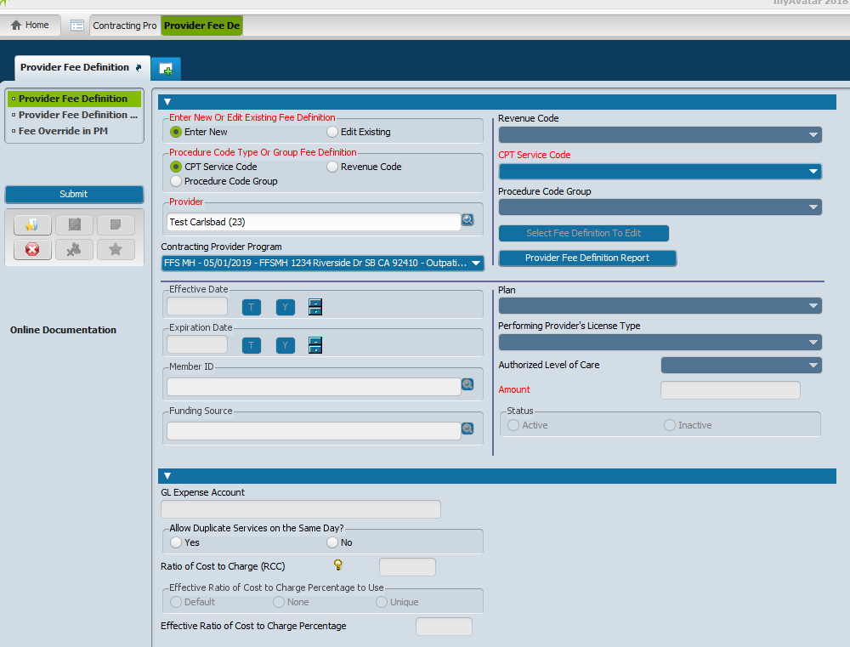
Click on CPT Service Code drop down arrow (right side of screen in red).
You will use the “FREQUENTLY USED CPT CODES WITH 2016 RATES” printout to help you add the CPT codes needed based on the discipline of the Provider.
In this example, the Provider is an Outpatient MD. CPT Codes being used will be 90792, 99213, 99303, 99312.
Use the drop down arrow under the CPT SERVICE CODE field and scroll down through e CPT Codes. Click on the first code, 90792, to choose it.
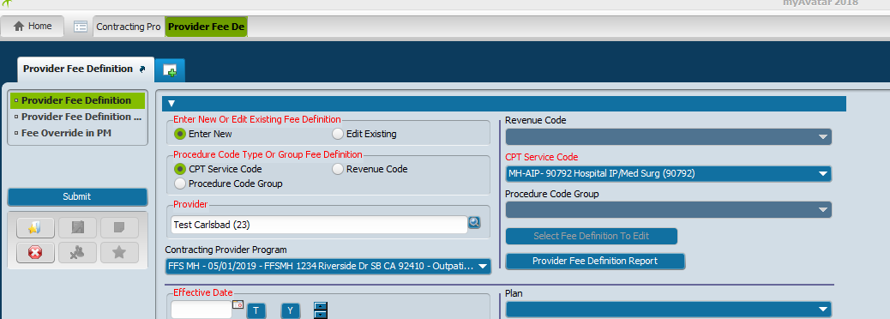
Add in the dollar amount for that CPT Code in the AMOUNT field box. Click on ACTIVE under the STATUS field.
On the left side of the screen in the EFFECTIVE DATE field add the effective date of the credential (DBH stamped application date for a new Provider or review the credential renewal date on the Approval Letter signed by Dr. Frausto or Tamara Weaver and go back three years). (For example, if the renewal date in the Approval Letter is 08/22/2022, the date you will enter going back three years is 08/22/2019).
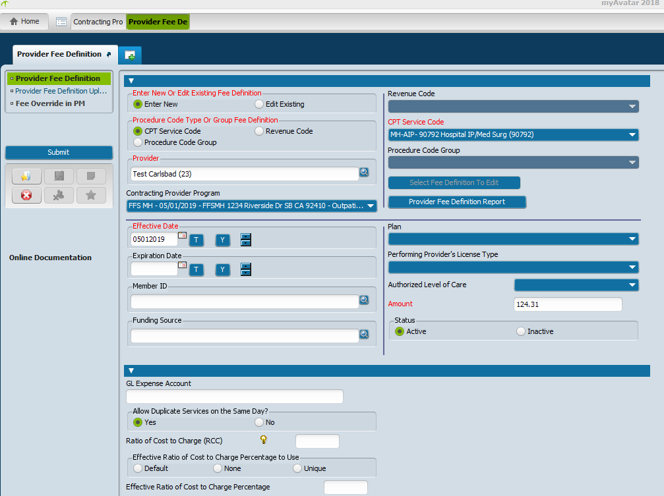
Click on SUBMIT box to add this CPT Code into the system.
The FORM RETURN box will appear. Click YES to return to the form. (You will want to return to the form to continue adding the balance of the CPT Codes and dollar amounts.)
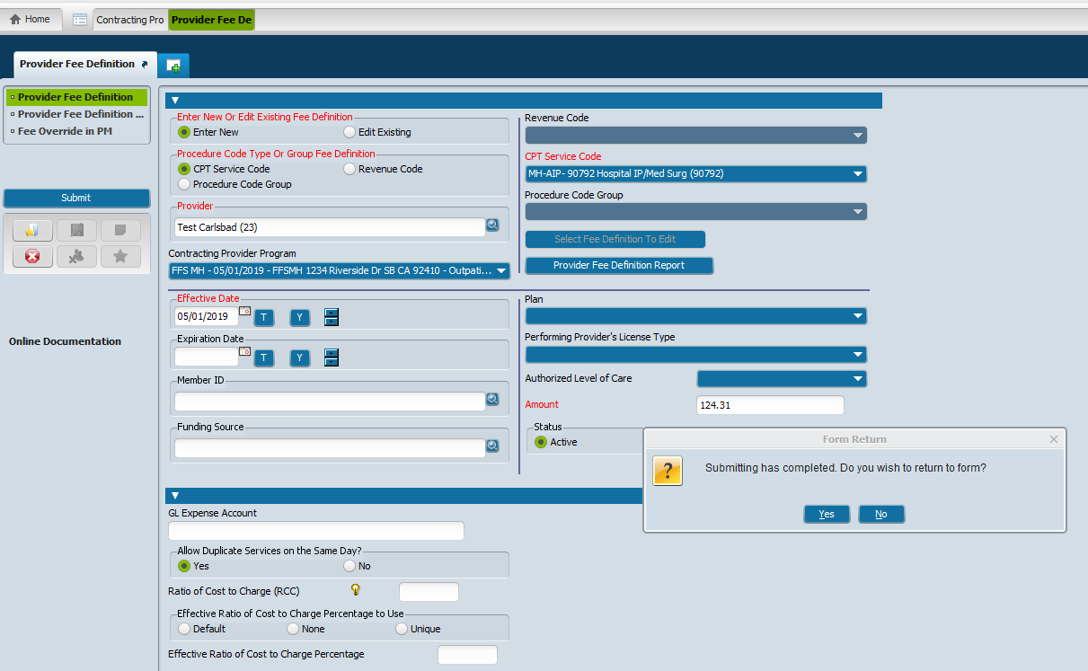
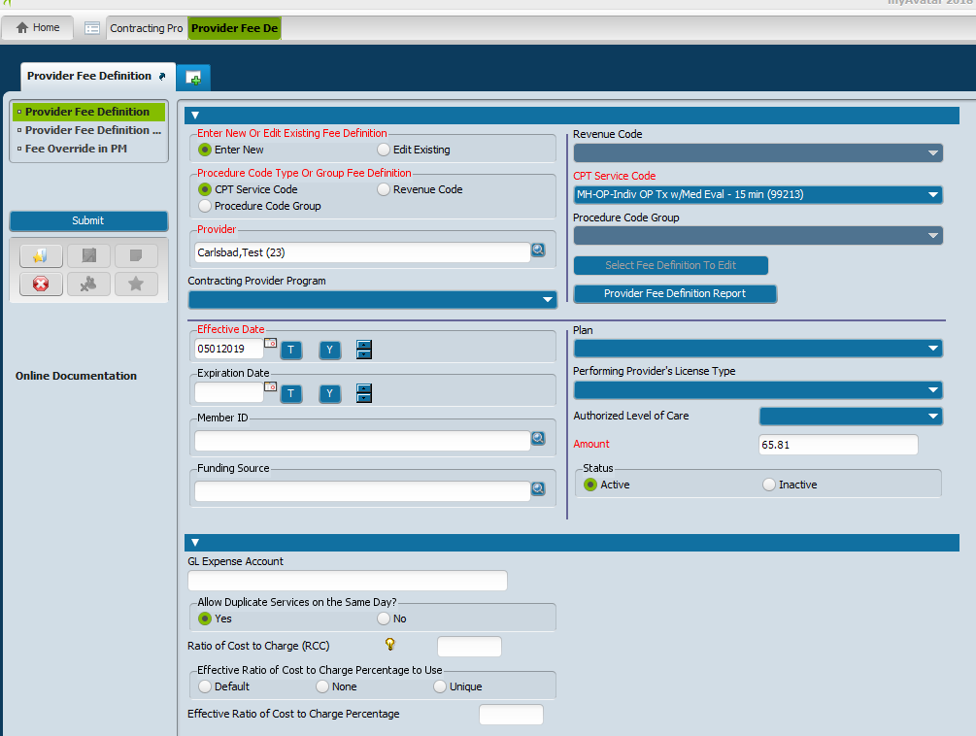
Once all CPT Codes have been entered and From Return box appears, click NO so as not to return to it.
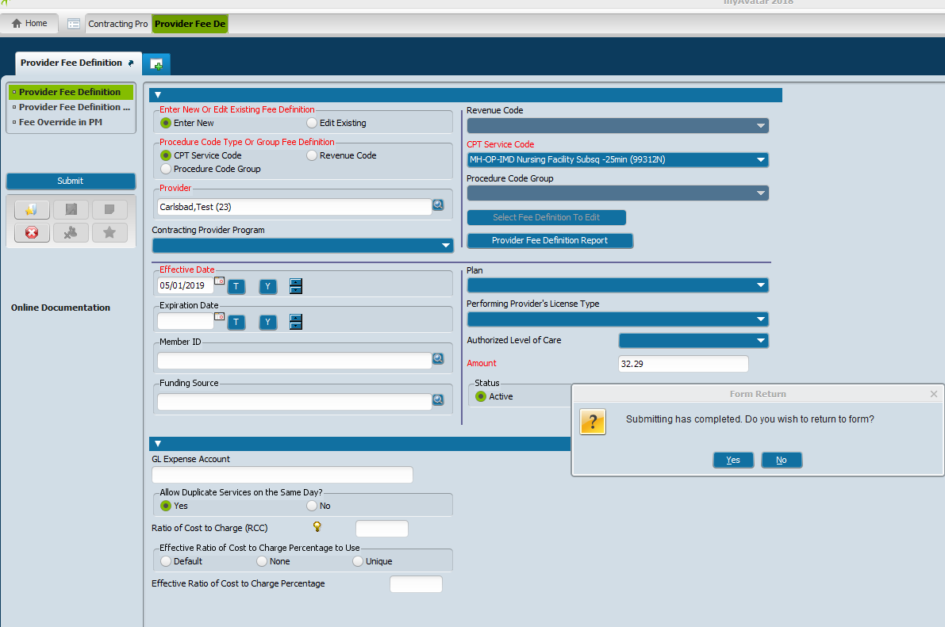
It will take you back to the HOME screen.
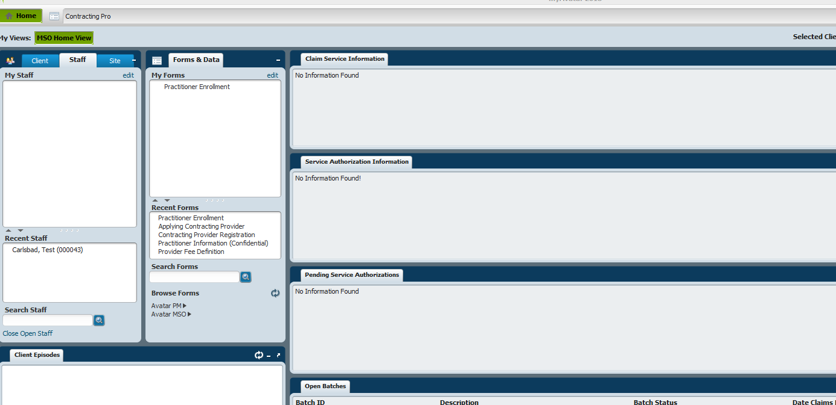
The Provider is now entered into MY AVATAR.
(NOTES: When viewing the various screen pages, if the field area is GRAYED OUT you are not able to make changes. Any fields that are in WHITE can be edited.)
05/04/2019 cmh

