Purpose: Enter a client’s initial contact source information. The information entered is documenting first contact by a new client or existing client.
Incoming Call: Call Intake Procedures….
Search Form: Initial Contact Log Bundle (Bundle contains the Call Intake form and the Initial Contact Log)
Double click on Initial Contact Log Bundle:
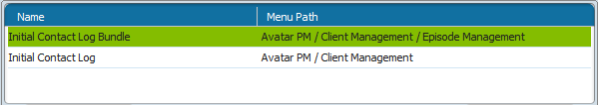
Select Client: In the Select Client screen, enter the client name or ID. Click Search.
- If the client has multiple episodes, the Episode Information pre-display shows. Select the episode and click OK.
- If the client is not in the system, Select New Client on the bottom of the screen.
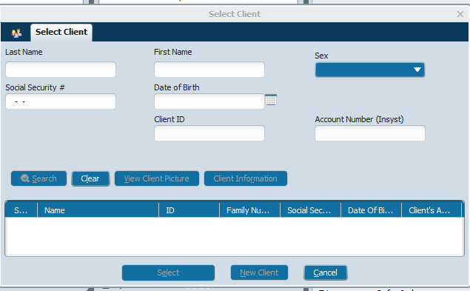

Once an existing client is selected or a new client is created. The Call Intake form will display. This will create a “P”# (Temporary #) for the new client.
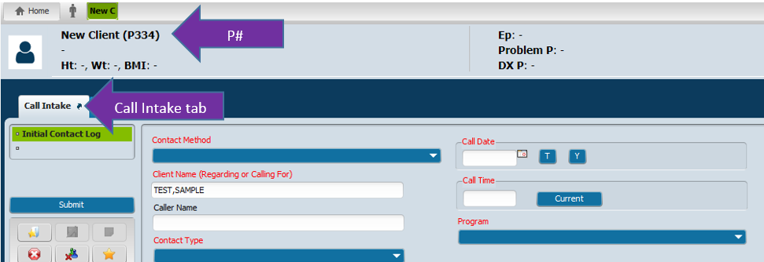
All fields displayed in RED are required in order to save and submit the information entered into the form. Complete Caller Name if not the client calling.
Click SUBMIT after all red areas are completed
Initial Contact Log fields:

- Date of Call: pre-populates
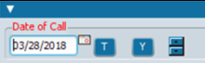
- Call Time-Click current

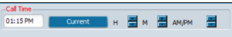

- “P”: Caller-drop down-Select previous call date

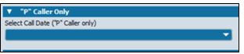

- Existing Client Only Heading: Contact name-prepopulates
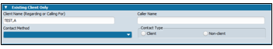
Initial Contact Log form:
All fields displayed in RED are required in order to save and submit the information entered into the form.
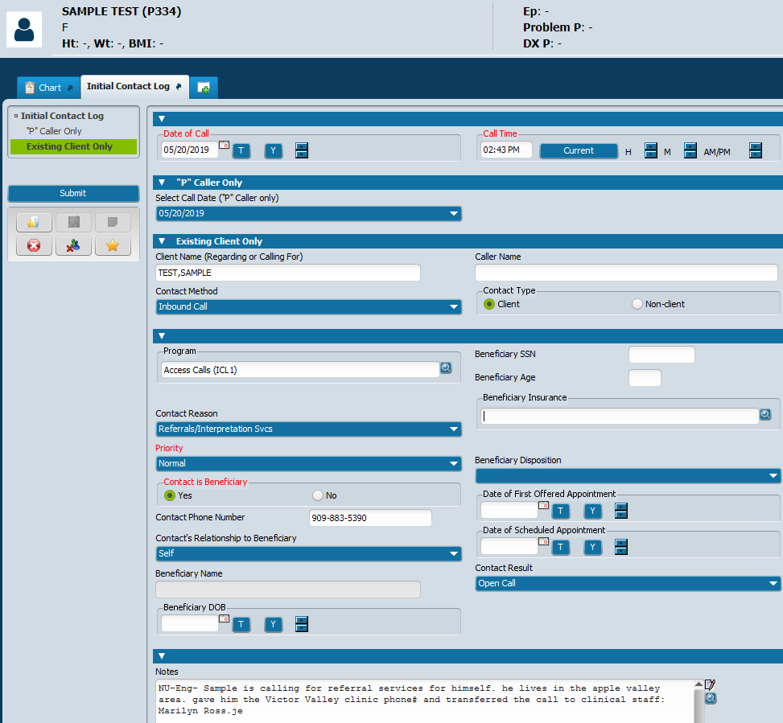
- Caller Name-if other than client
- Contact Method-drop down-Inbound
- Contact type: client or non-client
- Program: Access Calls
- Contact Reason: drop down-choose reason for call
- Priority: drop down-Normal or Urgent
- Contact if Beneficiary: Yes or No
- Contact Phone #: call back number
- Contact’s Relationship to Beneficiary-drop down
- Contact Result: drop down- Completed or Open Call
- Notes: add notes: Urgent- Language preferred-What is the client or person asking for? What did you help them with? What Clinical staff are you transferring this call to?
Click SUBMIT and transfer call to clinician.
Clerical Call logged and complete.
Clinical-Receives transferred call from Access Unit Clerical
Clerical gives Clinical name or ID# of client: All information regarding call should be in the notes by clerical (Example: P334).

Clinical uses name or ID# given to:
Search Client:
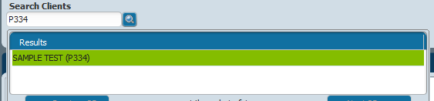

Search Forms: Initial Contact Log: to update information.
Initial contact
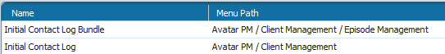
Highlight correct call:
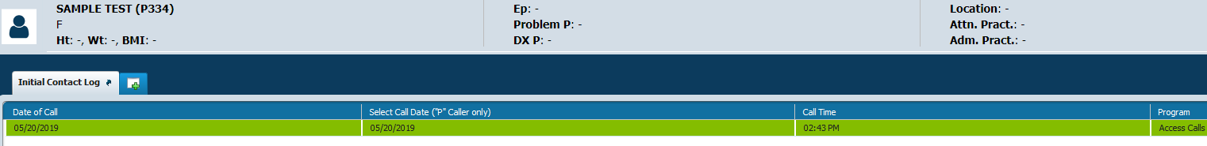
Click Edit at bottom:
Opens Initial Contact Log completed by Clerical:
Clinical adds referrals given/notes to the Notes section at bottom. Changes the Contact Result from Open to Completed.
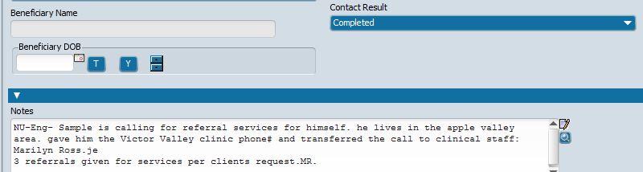
SUBMIT

