- In Search Forms enter: EOB Interface File to General Ledger
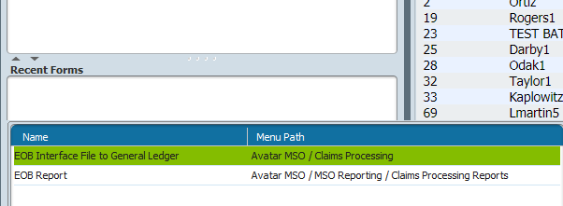
- Double click on the form: It will say Opening EOB Interface File: then form will come up. All red areas must be completed.
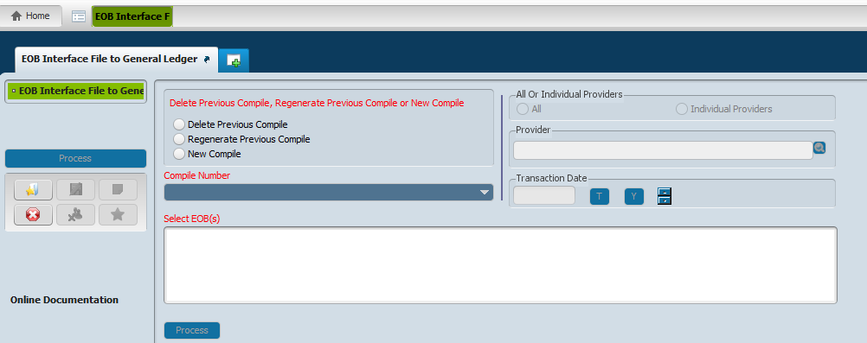
- Choose under:
- Delete Previous Compile, Regenerate Previous Compile or New Compile-New Compile
- Compile Number-prepopulates with New
- Select EOB’s-Check the providers you are processing
- All or Individual Providers-All
- Transaction Date-Todays date “T”
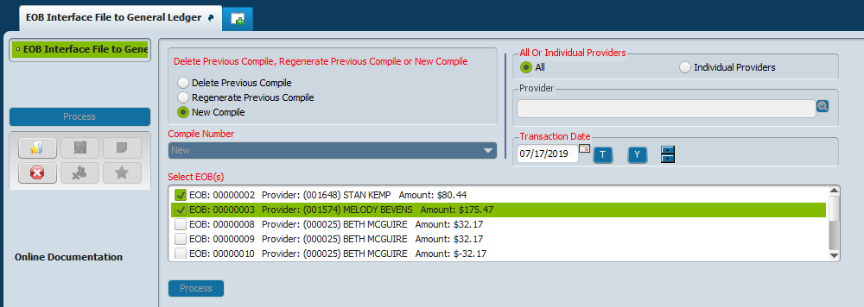

- Click Process on side of screen
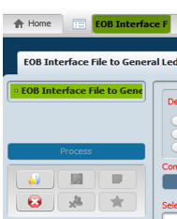

- Crystal report shows
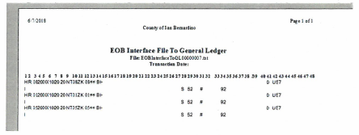

- Export the crystal report in excel format using the following method.
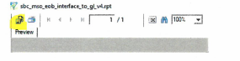

- Upon export, change the export format to Microsoft Excel:
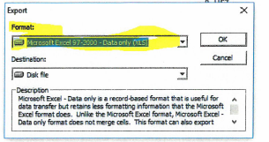

- Use the below Excel format options:
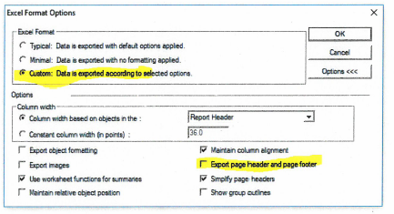

- Export to the folder of your choice on your PC.
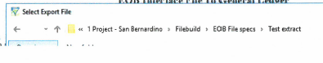
- Open the file that was just created in excel:
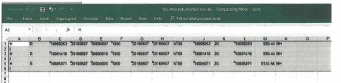

- Copy to Notebook:
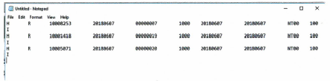

- Upload to SAP

