myAvatar - Call Center Clinical-Mini Guide
Clinical-Receives transferred call from Access Unit Clerical
Clerical gives Clinical name or ID# of client: All information regarding call should be in the notes by clerical (Example: P334). Clinical uses name or ID# given to:

Search Client:
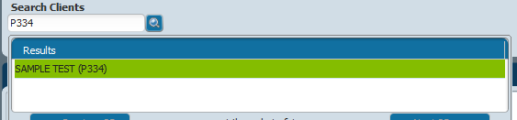

Search Forms: Initial Contact Log: to update information.
Initial contact
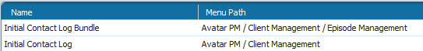
Highlight correct call:
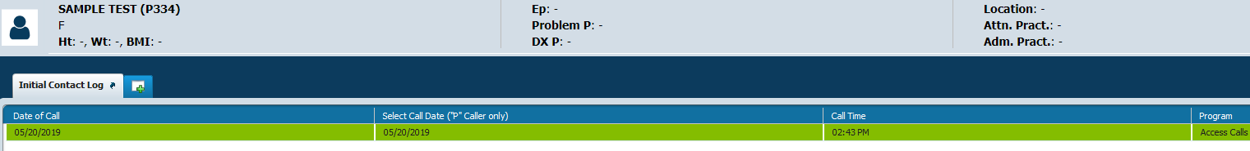
Click Edit at bottom:
Opens Initial Contact Log completed by Clerical:
Clinical adds referrals given/notes to the Notes section at bottom. Changes the Contact Result from Open to Completed.
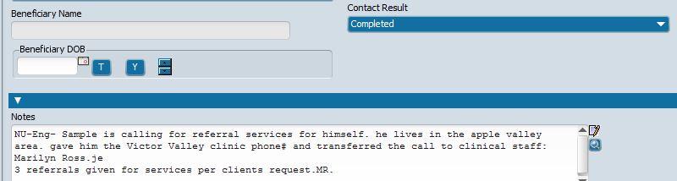
SUBMIT

