myAvatar ARMC Workflow

Created Exclusively for San Bernardino County Behavioral Health

Contents
Introduction 1
Icon glossary 1
ARMC Inpatient Workflow 2
Registration/Admission 2-3
Real Time Inquiry (270) Request 4
Client Condition - Pregnancy 4
Client Charge Input (Recording Services). 4
Discharge. 5
Financial Eligibility Record (Managing Insurance Information) 5
Edit Service Information 5
Report of Denials/Approvals 5
Rebilling Claims/Claim Follow up 5
TAR Tracking & Utilization Review. 5
Advanced Billing Failed Compliance Report. 5
Advanced Billing Rule Override (Releasing ARMC Services to Bill). 5
Payment Voucher File Creation. 5

Introduction
The purpose of this document is to provide SBC with the proposed workflow within myAvatar CalPM for San Bernardino's ARMC. Documentation has been completed within the SBOX environment.

Icon glossary
The following icons are used in this guide.

Icon | Usage
Tip | Highlights information that can save you time or make it easier to do something.
Key Information | Highlights important information that must not be missed by the user.
Best Practice | Provides a recommendation for a course of action that is either most efficient or will give the user the best results.

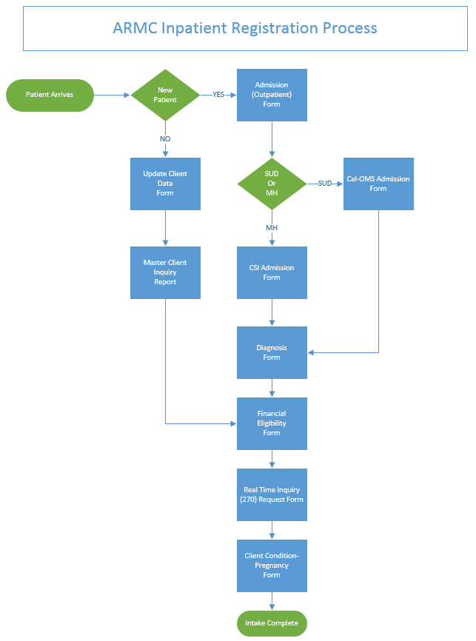

ARMC Inpatient Workflow
Whether the client is in a Crisis state or not, the below workflow would apply in order to add the clients information into myAvatar.
Registration/Admission Forms (New Client & Existing Client)
SBC’s ARMC provider would utilize the following forms during the Registration/Admission process. A “bundle” has been created called ARMC Inpatient Bundle. The bundle for ARMC consists of the Admission (Outpatient), CSI Admission, Diagnosis, and Financial Eligibility Forms. It is recommended that SBC utilize the single source financial eligibility concept. With this concept, when creating a new client record two episodes would initially be created. One for the Financial and one for the episode of care:
:

ARMC Inpatient Bundle
- Admission (Outpatient)
  - Upon accessing the form, the user will be prompted to search for existing clients. If the client does not exist then the user will create a new client record. If the client exists in the system, the user will select the client and continue. After accessing the form, the user will enter the required information to create the episode. If this is the single outpatient episode for mode 15, the program selected for the episode will be the overarching Outpatient Program. Mode 10 and 05 will have their own episode.
- CSI Admission
  - This is the second form within the bundle that captures the required CSI data for CSI reporting.
- Diagnosis
  - This is the third form within the bundle to record the clients diagnosis
- Financial Eligibility
  - This is the fourth form within the bundle to link the new episode for ARMC Inpatient to the MH Financial record. If the user is processing a new client, then follow the steps outlined under the Financial Eligibility Record section belos

Update Client Data Form
- The Update client data form will be used to update the client’s demographic information. This form will be used for existing clients or client demographic data corrections.

Master Client Inquiry
- The Master Client Inquiry report is designed to display the client’s current demographic information and episode history data. This report has been updated to display the program assignment history.

Financial Eligibility Record
Single-Source Record concept will be utilized to maintain the clients insurance information under its own "Financial" episode. There will be a "Financial" episode for Mental Health and one for Substance Abuse. After the "Financial" episode is created, the appropriate MH or SUD episodes will be "Linked" to the MH or SUD financial episode.
New Client Steps:
  - Admission (Outpatient) Form (Create the financial episode - MH or SUD).
  - Financial Eligibility - Enter client’s guarantors (Insurance Information).
  - Link new episode of care to the financial episode.
Existing Client Steps w/New episode of care:
  - Financial Eligibility - Access the financial episode and verify client’s guarantors (Insurance Information) is correct.
  - Link new episode of care to the financial episode.
Financial Eligibility Form (Recorded against the financial episode)
  - This form is designed to record the client’s insurance information. In order to check the clients eligibility for Medi-Cal via the 270/271, the Medi-Cal guarantor will need to be added at the minimum

Real Time Inquiry (270) Request Form (Eligibility Inquiry)
- Real Time Inquiry (270) Request (This function is not available until there is a LIVE system)
  - To check current Medi-Cal Eligibility, the user will process a 270 Inquiry.
  - The 271 response will be immediately returned with the eligibility information.

Client Condition - Pregnancy Form
- Use the Client Condition - Pregnancy form to record the client’s pregnancy status if applicable.

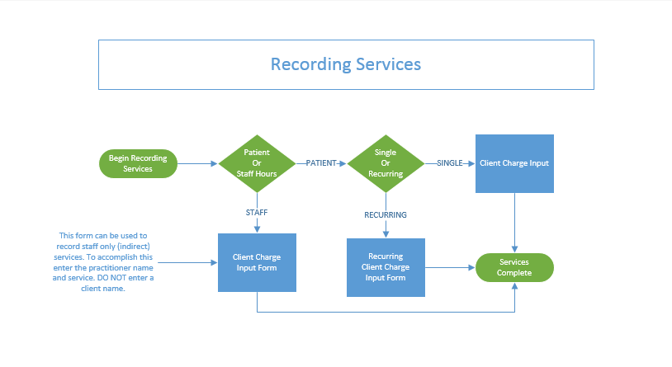

Client Charge Input (Recording Services)

Client Charge Input Form
- Use the Client Charge Input form to record services (Direct)
- Use the Client Charge Input form to record staff only (Indirect) services

Recurring Client Charge Input (Recording Multiple Services)
- Use the Recurring Client Charge Input form to record multiple services at once

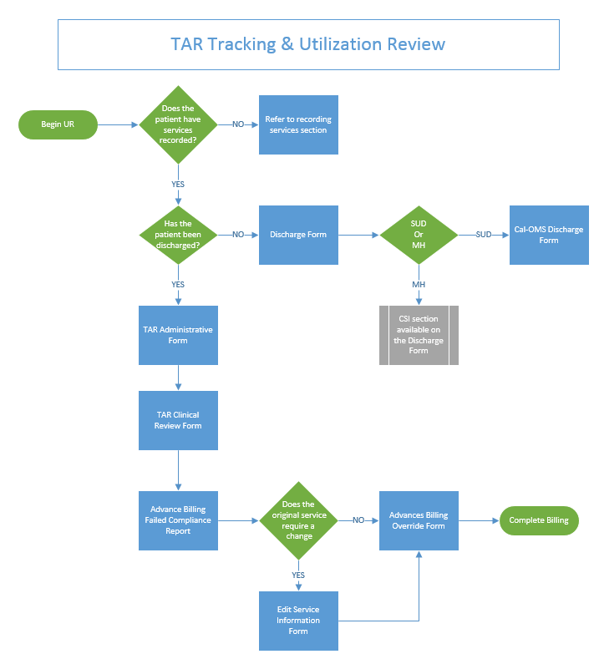

TAR Tracking & Utilization Review
After services have been entered, the user can enter the TAR information, which will track the services that have been approved or denied per the utilization review process. In order to prevent billing until the UR has been completed, myAvatar CalPM is setup with an advanced billing rule to hold up billing. Once the review is completed the user will need to use the Edit Service form to edit the services that require a change to the Admin service code. The remaining room and board charges will need to be released for billing using the Advanced Billing Override form. The Advanced Billing Failed Compliance Report will be used to verify which services are being held up from billing.

TAR Administrative Form
Use the TAR Administrative from to record the TAR number and TAR information for the inpatient episode. This for will need to be completed prior to routing to the clinician for review. Services will need to be entered prior to accessing this form. The clients discharge will need to be entered prior to accessing this form

TAR Clinical Review
Use the TAR Clinical Review form to record which services have been approved or denied. Clinical notes can be recorded for the review.

Advanced Billing Failed Compliance Report
The Advanced Billing Failed Compliance Report will be ran to identify which ARMC daily charges have been held up from billing. This report has been modified to display the TAR number for the episode and the TAR status for the service of approved or denied based upon the UR completed in the TAR Clinical Review form.

Advanced Billing Rule Override Form (Releasing ARMC Services to bill)
The final step in the process to allow the ARMC services to bill is to override the services for billing. The user would select the services that have been approved and change the override status to “Yes”. This will release the services to bill.

Edit Service Information (Edit Services)

Edit Service Information Form
- Use the Edit Service Information form to edit services adding service information such as:
  - Emergency Indicator
  - Duplicate Service Modifier
  - Change service code to ARMC Admin Day

Discharge
Mental Health Discharge - The client will be discharged appropriately from the mode 10 and 05 episodes as they are their own episode. If the client is still receiving services, but has stopped receiving services at a particular program, then the Program assignment form will be used to record the end date of the program assignment. The user would not discharge the overarching outpatient episode unless the client has not received services at any program for more than 90 days.

SUD Discharge - The client will be discharged appropriately as they have their own episode.

Discharge Form
- MH Discharge will use the Discharge form to enter the discharge information.
  - CSI section is available to record the appropriate Patient Status Code and Discharge Legal Class.
- SUD Discharge will use the Discharge form and the appropriate Cal-OMS discharge form below:
  - Cal-OMS Discharge
  - Cal-OMS Youth/Detox Discharge
  - Cal-OMS Administrative Discharge

Report of Denials/Approvals
A Report of denials and approvals will be created for the providers to run on a regular basis.

Rebilling (Processing Void/Replace claims)

The Claim Follow up form will be used to process void & replace claims

Payment Voucher File Creation
A payment voucher report can be created with the appropriate fields that the user can export in .txt or .xls - Need specs from SBC

