Phone Calls:

- Initial Contact Log Bundle
  - Type “Initial Contact Log Bundle” in Search Forms text box in the Forms & Data widget.
  - Double click on “Initial Contact Log Bundle” in the drop down menu.

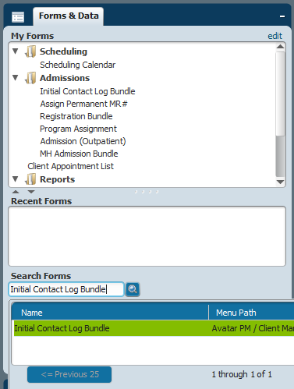

  - Enter client’s information in the search fields. (Three pieces of information is required to conduct search, unless you are searching by Social Security number or Client ID). Then click on Search.
  - Click New Client.

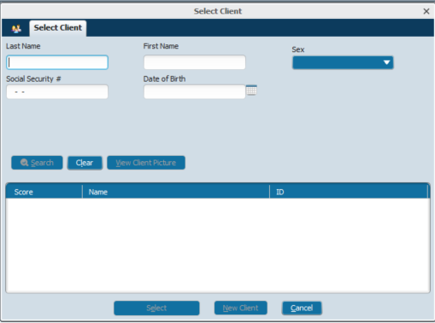

  - Fill in all required data fields and other pertinent information. Then click Submit.

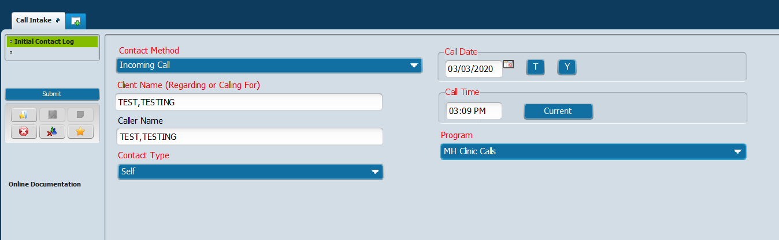

  - Fill in all the required and pertinent Caller Information then click Submit.

