NSF – Non-Sufficient Funds
*Need to adjust the payment to revert back to the original balance*

- NSF from Client payment:

From the home page, search for “Client Ledger” form and double click to open the page.

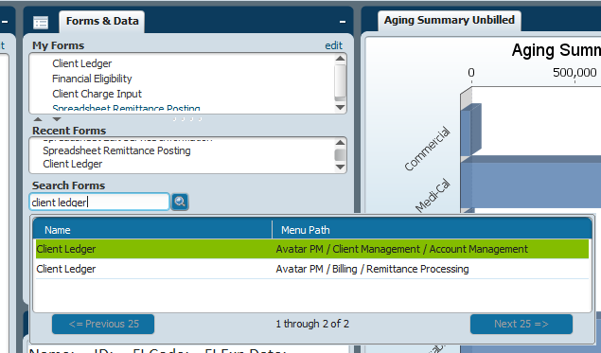

It will look like this:

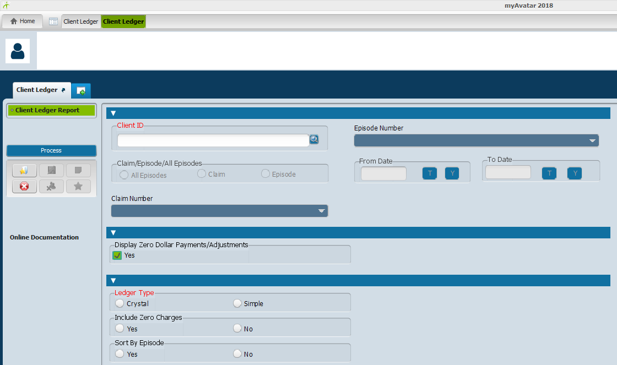

Fill in the following fields:
Client ID: Enter in client number
Claim/Episode/All Episodes: Select “Episode”
Episode Number: Select the appropriate episode number from the drop down box
From Date: Enter the appropriate “From Date” of the service date that the payment was applied to.
To Date: Enter the appropriate “To Date” of the service date that the payment was applied to.
Ledger Type: Select “Simple”

Then click on “Process” and the Client Ledger will open to this:

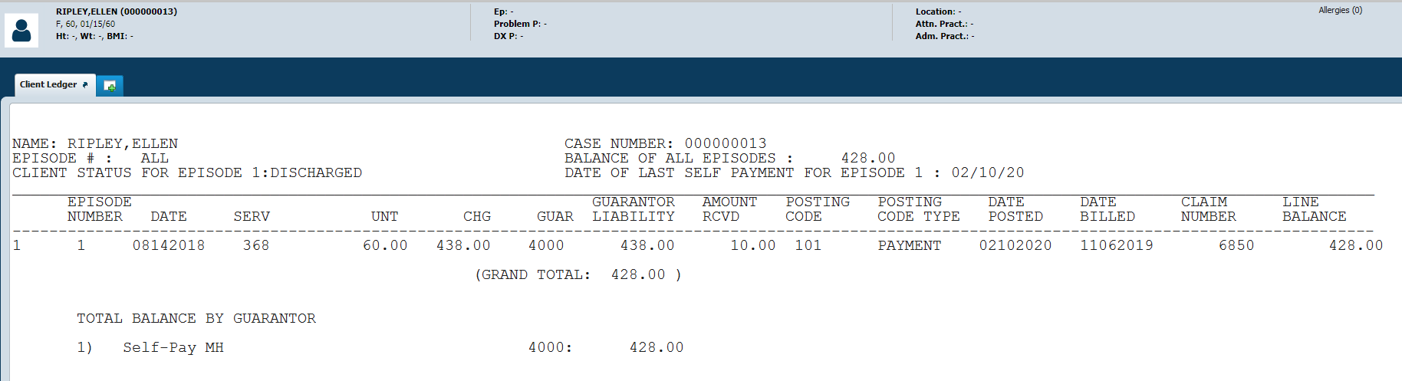

**Print page: This is to verify where the payment of the NSF has gone and to also look back on when the payment has been adjusted as well as to keep this for your records.

**Once the service/payment is found do not close the “client ledger” that is open, go straight to the “Spreadsheet Remittance Posting” form to process the adjustment to back out the NSF amount.

To go to the “Spreadsheet Remittance Posting” form, click the green plus sign 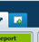 to select the next form.
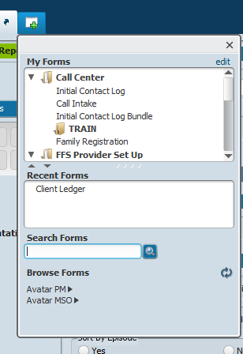
Green plus button

Type form name

From opening another tab, search for “Spreadsheet Remittance Posting” form and double click to open the page.

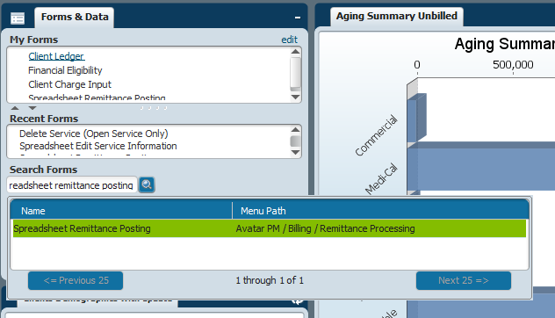

The form will look like this:
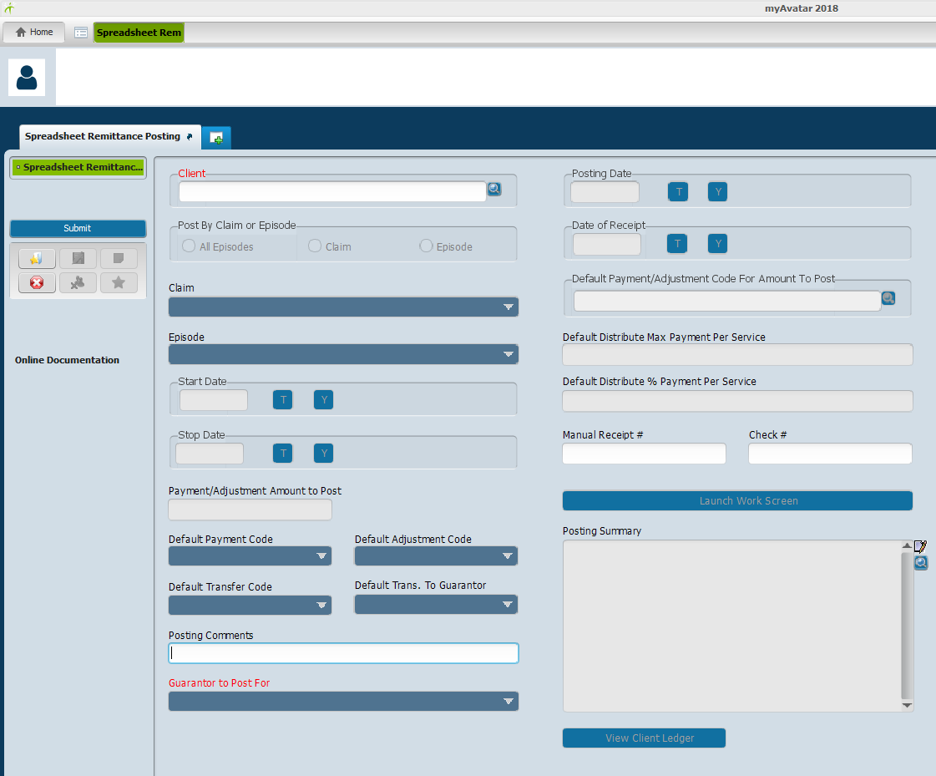
Fill in the following fields:
Client: Enter client number.
Post By Claim or Episode: Select “Episode”
Episode: Select the appropriate episode that the NSF was posted on.
Start Date: Enter the appropriate “Start Date” of the service date that the payment was applied to.
Stop Date: Enter the appropriate “Stop Date” of the service date that the payment was applied to.
Guarantor to Post For: From the drop down box, select “(4000)Self Pay MH” **A pop-up window will appear notifying the user what the current balance of the guarantor is. Select “OK” to continue**
Posting Date: Enter “today’s date” or click on “T” to auto populate the current date.
Date of Receipt: Enter “today’s date” or click on “T” to auto populate the current date.
*Once the fields have been entered, click on “Launch Work Screen”.

The “Launch Work Screen” will open up to this:
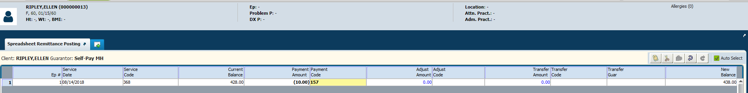
In this screen, you will adjust the amount of the NSF.

{*Whether the account has a zero balance because it was paid off or if it has a certain amount of money in it or if there was an overpayment, you will need to do the adjustment to return the full NSF amount back into the account.*}

For example: With this account, the client payment that was returned was $10 and there is still a balance.

To return the amount of the NSF back into the account, you will click on “Payment Amount” and entered in the amount that was returned due to the NSF.

In this example: $10 was returned so, you will need to enter:
$10 to the Payment Amount” column
with
“Payment Code”: 157 for Bank Return Payment – Self Pay Payment reversal.
This will credit the $10 back to the account from $428.00 back to $438.00 which you will be able to see on the right side of the screen.

Payment Amount = Amount of the NSF
Payment Amount Code = 157 for Bank Return Payment – Self Pay Payment Reversal

Payment Code of 157.
Payment Amount of $10.
Balance back at original amount.
Acct at the current balance.
Once you have filled in the fields to adjust the charge back, you will click “Accept” on the bottom of the form.

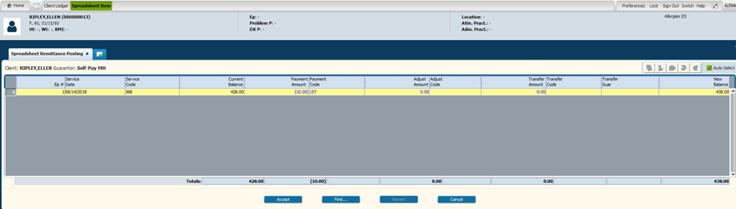

After you click on “Accept”, it will revert back to the beginning of the “Spreadsheet Remittance Posting” form.
At this point, the form has not been fully submitted.
At this stage, you can view the Posting Summary and View the potential Client Ledger to review what you have adjusted to review that the information inputted is correct.

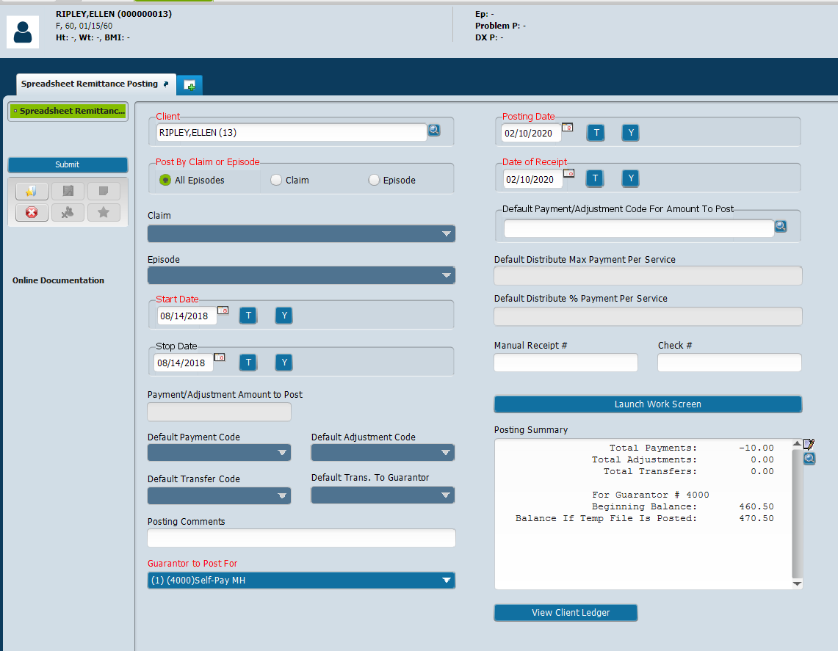

Once you have verified that everything is correct, you will now click on “Submit” and a prompt will pop-up saying, “Submitting has completed. Do you wish to return to form?” you will select “No”
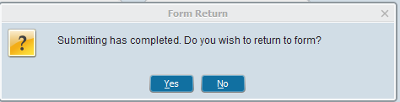

Now that you are back at the home page you will need to verify that the adjustment has gone through.
You will then go back to the client ledger tab that was previously open…
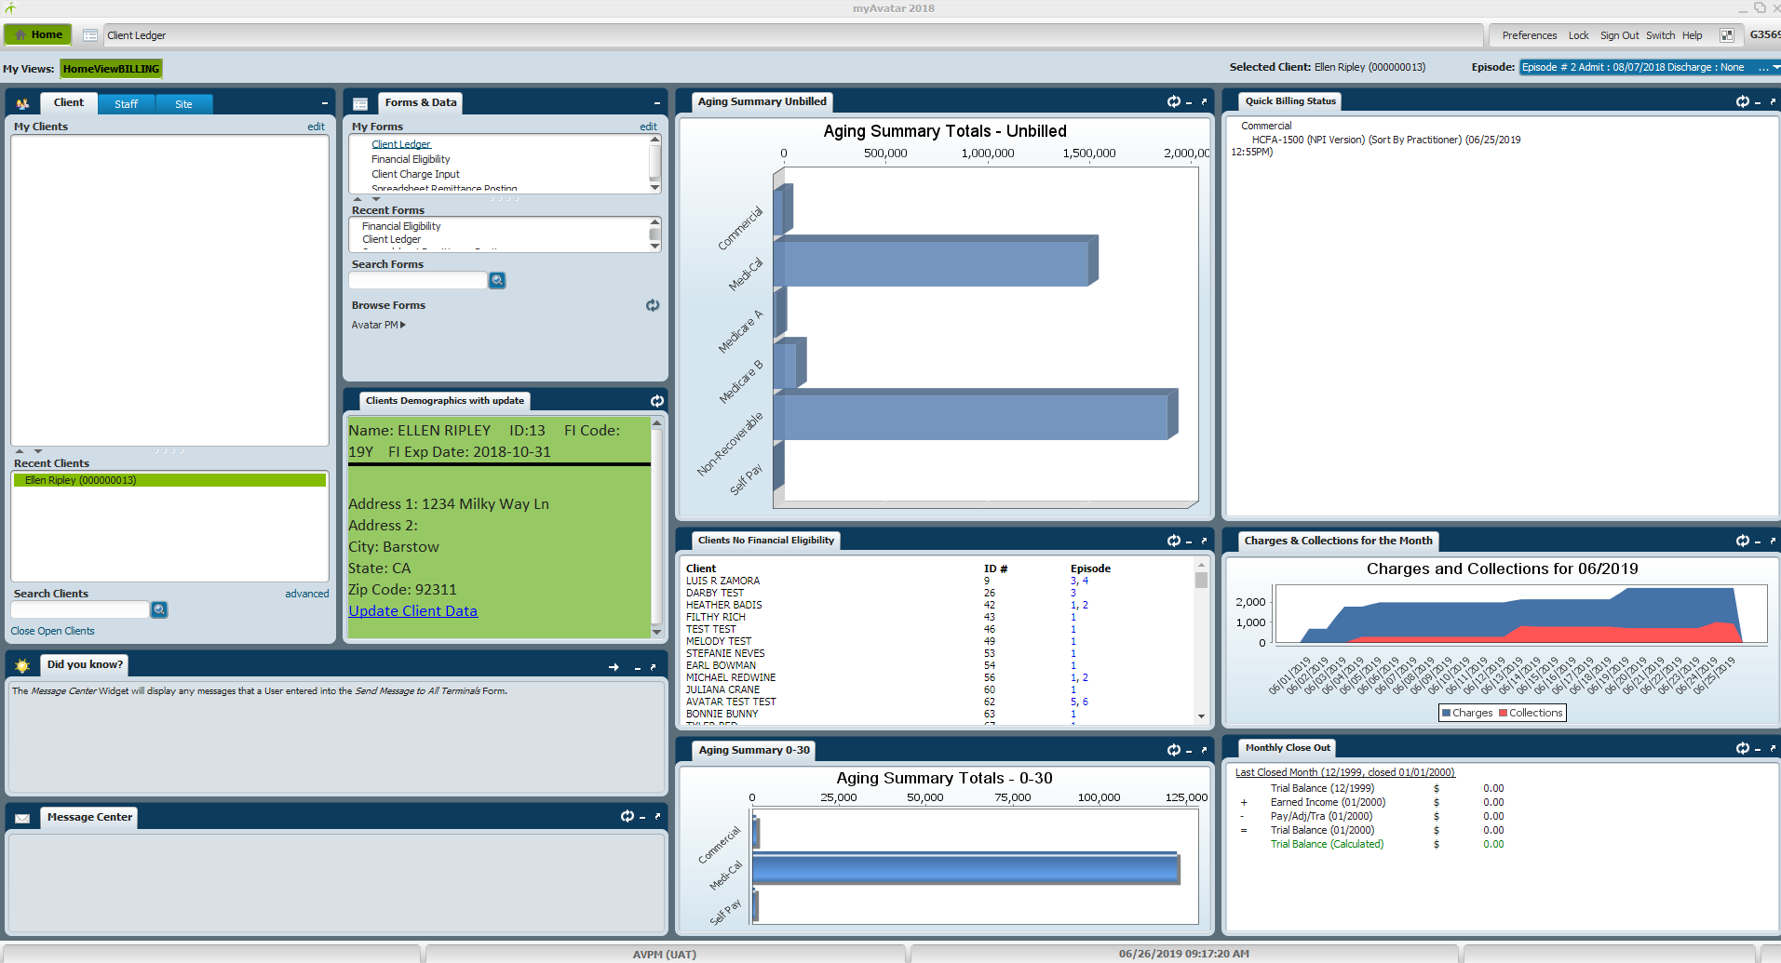

Click on the “Client Ledger” tab and process the client ledger again. (All the client information should already be inputted. If not, enter the client information again.)

You will then print the new “Client Ledger” to show that the adjustment has been made and this will complete the NSF process.

*Here is the before and after the NSF adjustment.*

Figure 1: This is the first step/ original balance for Self-Pay. Looking at the client ledger, you can see that there was a $10 payment to service date: 08/14/2018.
-In the NSF scenario, there was a non-sufficient fund from the $10 check.
-User will then have to adjust the $10 back to the original amount which shows in Figure 2.

Figure 2: In figure 2, it shows that the payment/posting code of 157 for “bank return payment –self pay payment reversal” was done. This adjusted the $10 back to the original amount of $438.00 instead of the $428.00.
