Write-Off Request form to be prepared by FS, then reviewed by supervisor for approval.

NOTE: Internal guidelines for collections, write-off periods and acceptable write-off reasons are still to be determined.
1st Step: Run Client Ledger to verify overpayment and audit account to ensure there aren’t any account issues that will impact write-off. From “HomeViewBILLING” use the “Forms and Data” widget to “Search Forms” for Client Ledger (red arrow). Double click to open form.
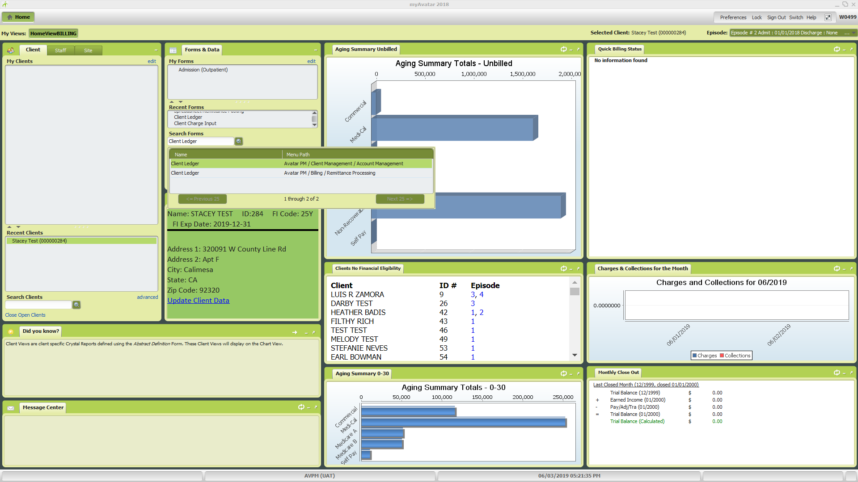
Enter information for all the fields with red font:
- Client ID – Enter Client ID number
- Claim/Episode/All Episodes – Select “All Episodes”
- Display Zero Dollar Payments/Adjustments – Should have “Yes” already checked
- Ledger Type – Select “Simple”
- From Date – Should pre-populate with first date of service
- To Date – Click the “T” button to populate today’s date
Click the “Process” button (red arrow) to run the report which will open in a new window.
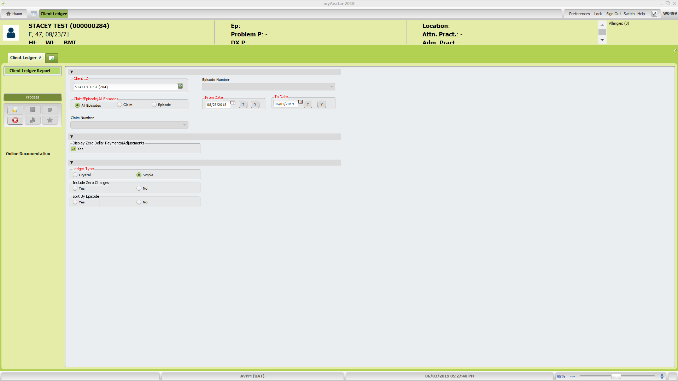
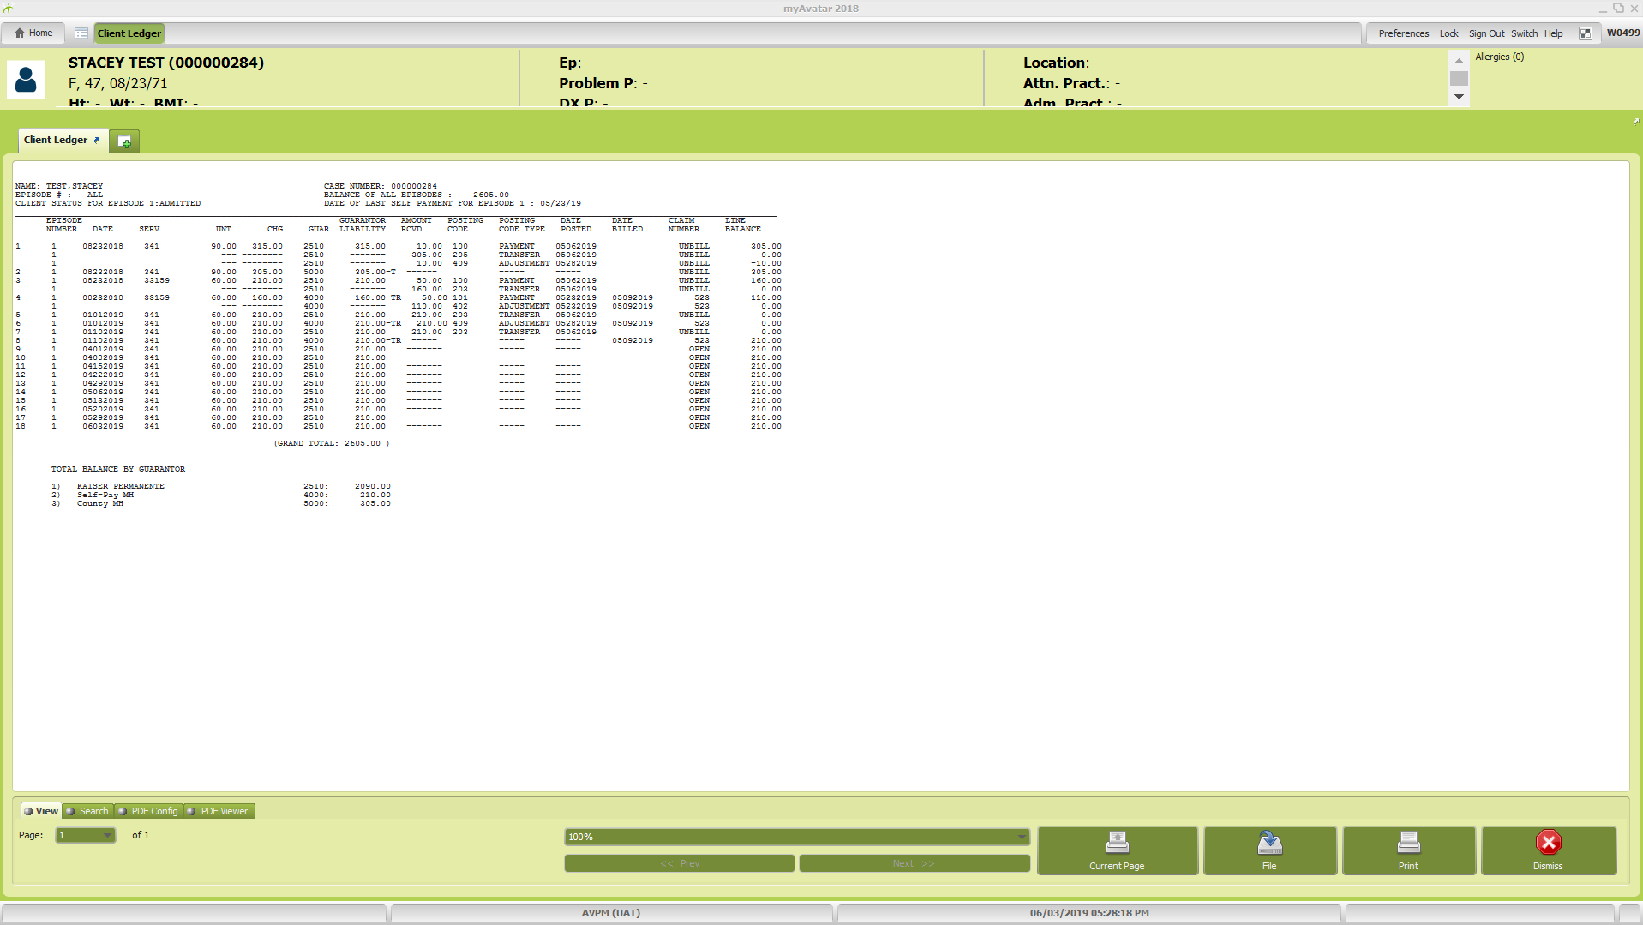
- Review Client Ledger report to verify write-off amount and ensure write-off hasn’t already been processed to avoid duplicate request.
- Review claim lines for all guarantors to ensure there hasn’t been any errors with prior payments, transfers, or adjustments and/or unapplied payments.
  - If errors are found, take appropriate action to correct before proceeding with write-off.
  - Open claim lines for insurance, Medi-Care, and/or Medi-Cal need to be researched and resolved (if they fall within UMDAP period for write-off) before write-off request is submitted for supervisor approval.
- Review guarantors to ensure there haven’t been any errors with claims, Self-Pay guarantors or UMDAP/SUD cost per visit amounts.
- Review client data, client contacts, and family registration information to ensure there aren’t additional methods of contact for bad address write-offs.
- Print copy of the Client Ledger to attach to the Write-Off Request.

Click the red stop sign with the “X” at the bottom right corner to close out the report when review is done. This will take you back to the Client Ledger Report form. Select “No” for option “Do you wish to return to form?” which will return you to the “HomeViewBILLING” screen.
2nd Step: Write-Off request form submitted for supervisor review/approval (hard copy). Verify client account write-off information provided on the Write-Off Request form. From “HomeViewBILLING” screen, use the “Search Clients” field (red arrow) to locate the client and pull up the client “Chart” by double clicking on the client name after the search request is done.
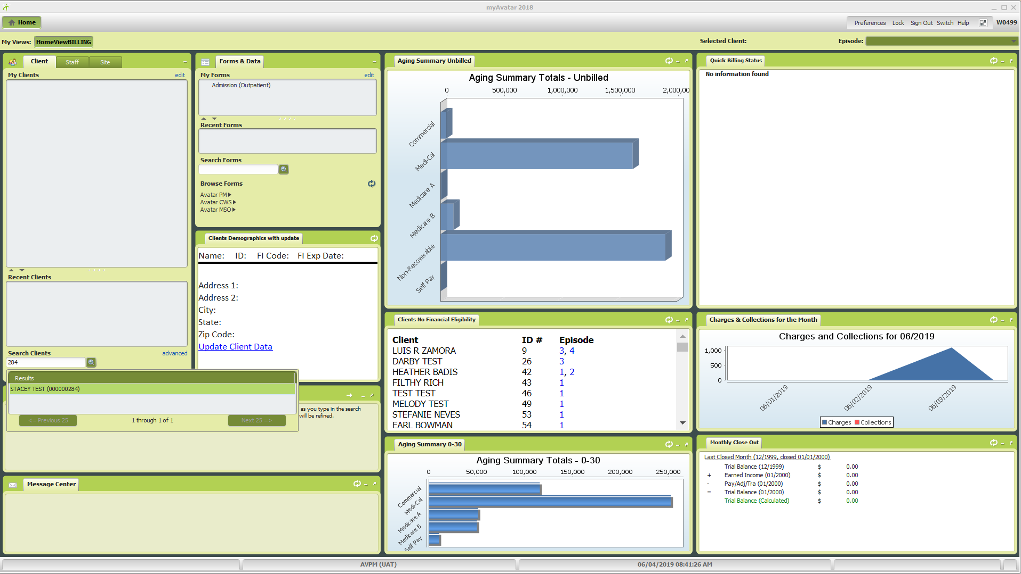
The client chart will allow you to verify the below items:
- Client ID, Client Name: Confirm client name and ID matches in “Clients Demographics with Update” widget.
- Family ID: Verify in “UMDAP Info” widget.
- UMDAP Periods for write-off: Verify UMDAP period start and end dates for client in “UMDAP Info” widget.
(May want to write down UMDAP periods in pencil on the form. Will help in later step.)
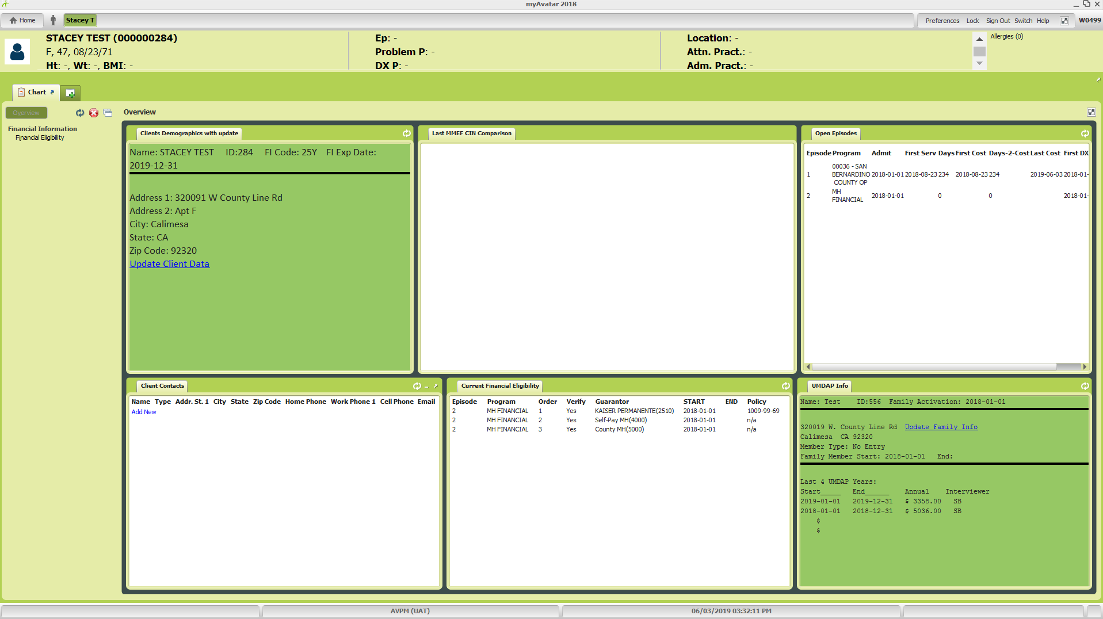
2 & 3
1
Click on the tab with the “+” symbol next to the “Chart” tab (red arrow) and enter “Program Assignment” into the field under “Search Forms” (blue arrow). Double click to open Program Assignment form.
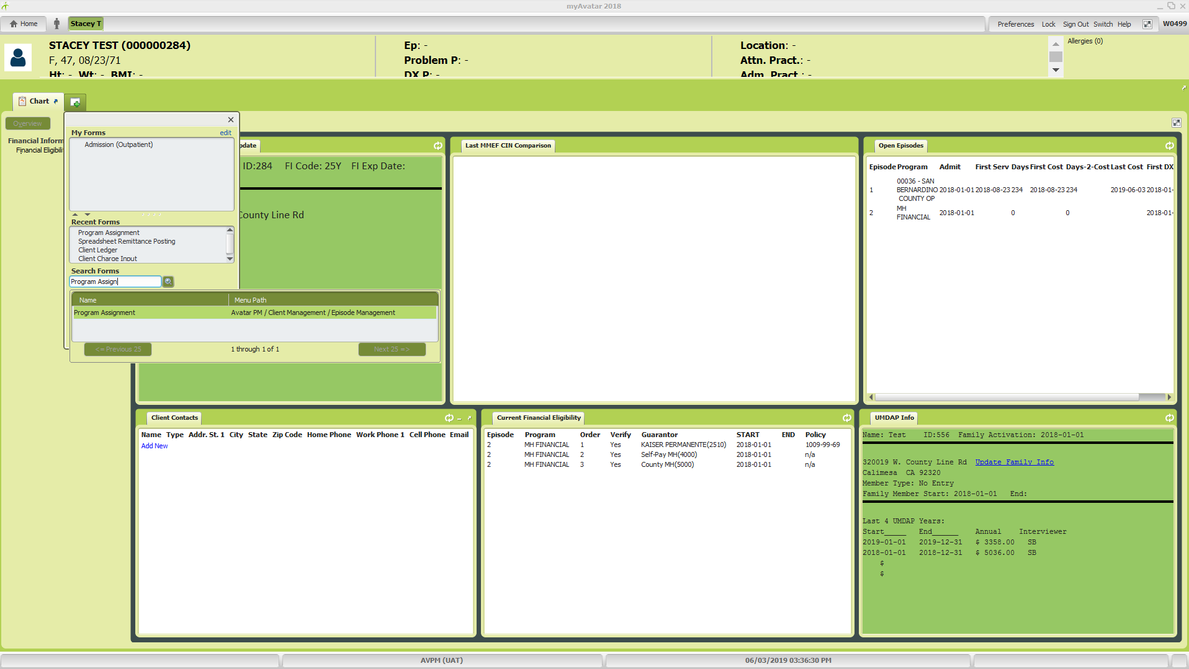
Program Assignment tab will open.
4. Verify the RU in the “Program Assigned” column (red arrow) and verify the program close date in the Program End Date” column (blue arrow) if applicable. Once done, click cancel button at the bottom of the screen to close the tab.
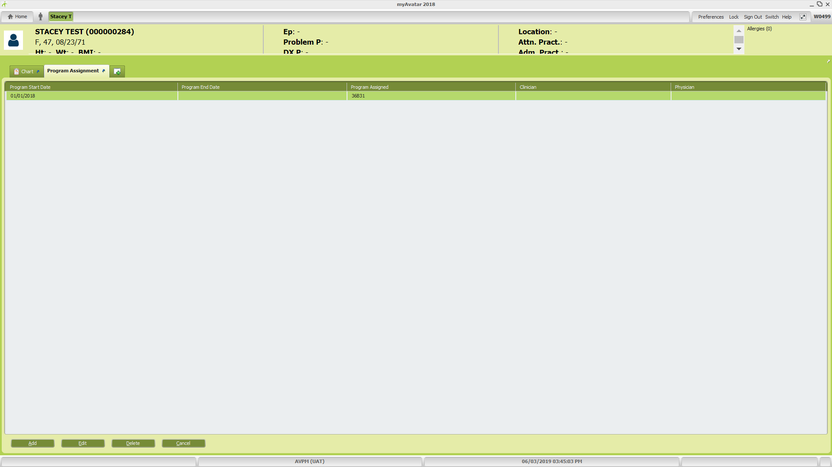
Click on the tab with the “+” symbol next to the “Chart” tab (red arrow) and enter “Spreadsheet Remittance Posting” into the field under “Search Forms” (blue arrow).
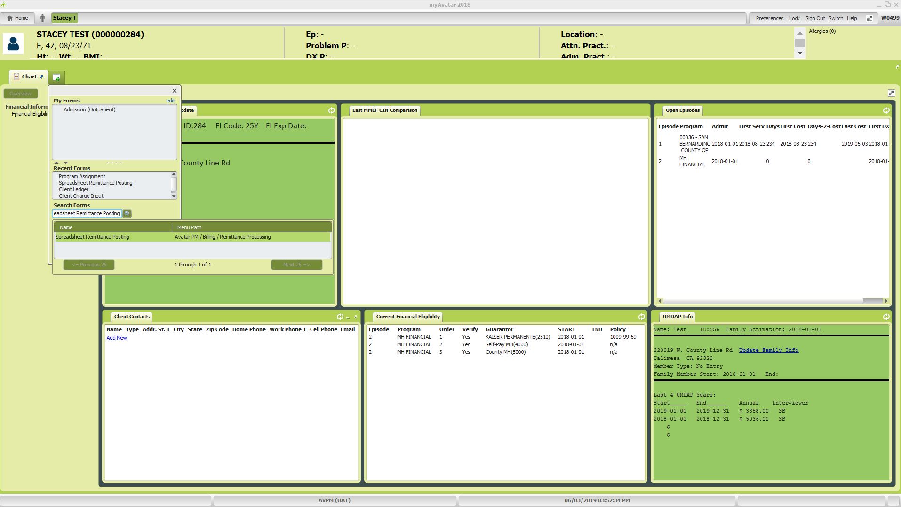
Spreadsheet Remittance Posting tab will open which allows access to the “Work Screen” to view the claim
line information by Guarantor. In order to launch the Work Screen, enter information for all the fields with red font:
- Client – Enter Client ID number
- Post by Claim or Episode – Select “All Episodes”
- Start Date – Should automatically populate with earlier date of service
- Stop Date – Click “T” button to populate with today’s date
- Guarantor to Post For – Select (5000) County MH (aka County Bucket)
- Posting Date – Use today’s date
- Date of Receipt – Use today’s date (Posting Date and Date of Receipt should always be the same date)
Click the “Launch Work Screen” button (red arrow) to bring up the Work Screen.
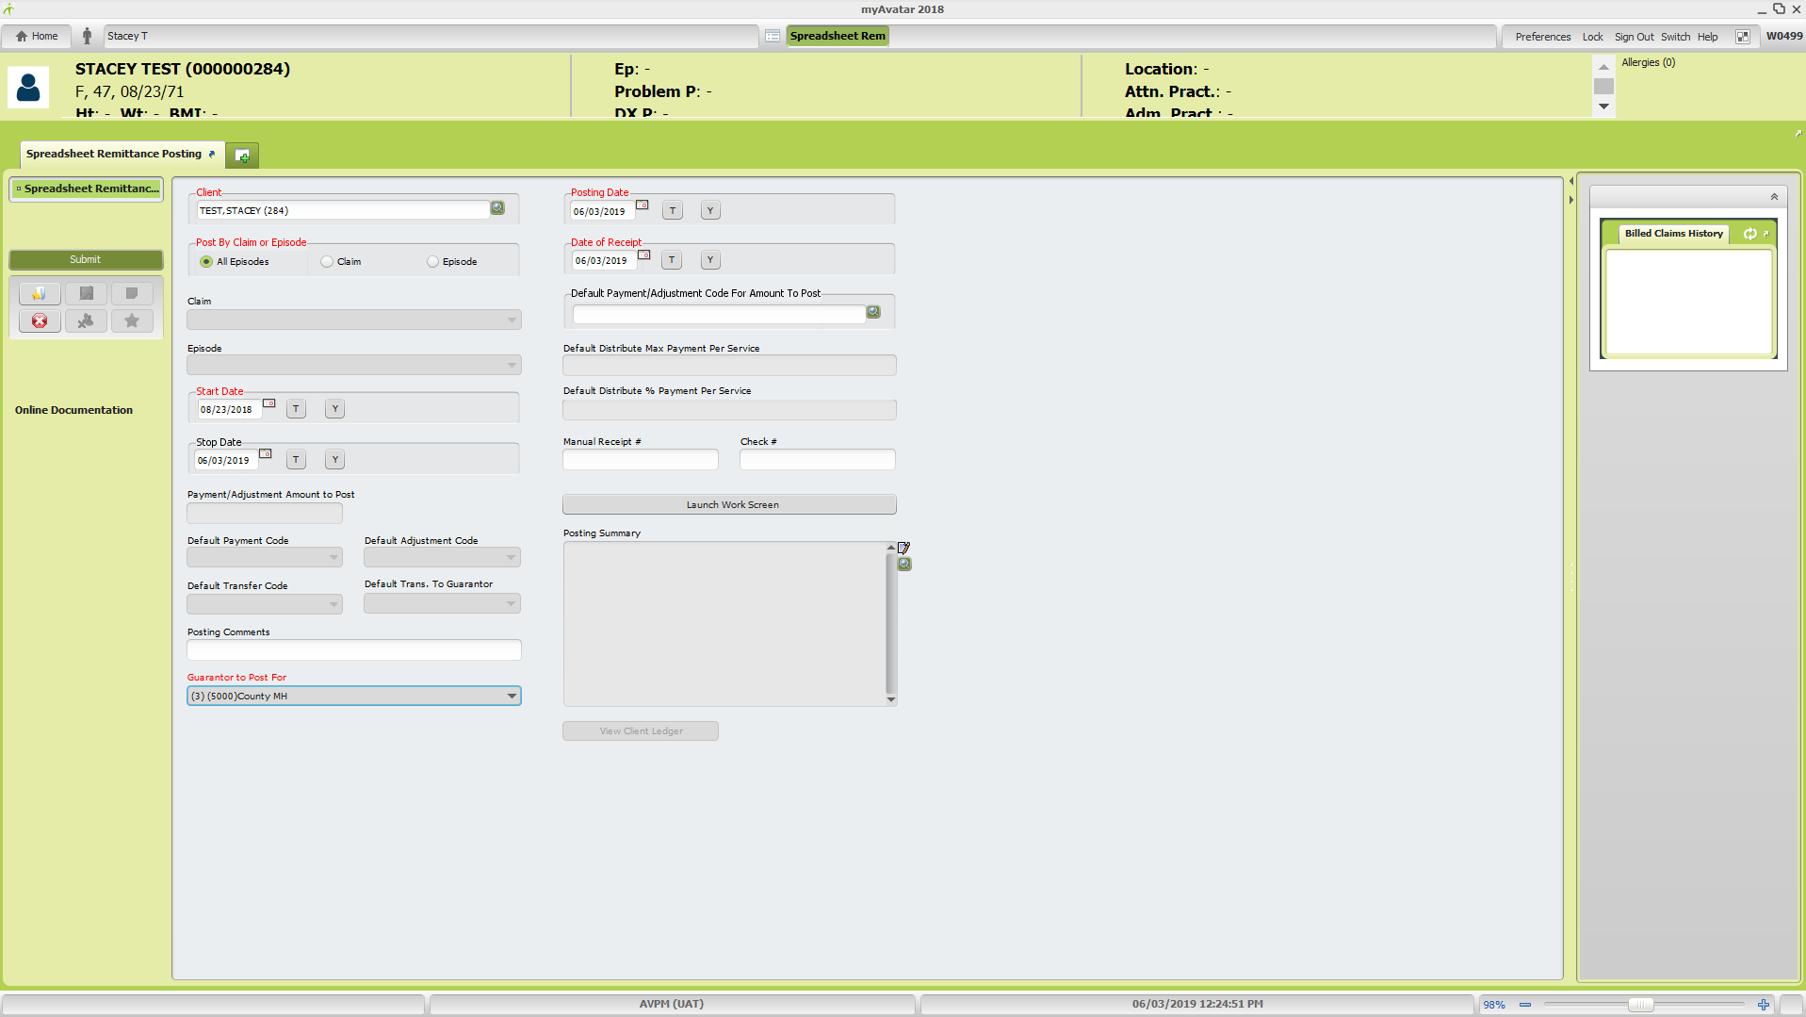
The Work Screen will open:
5. Verify amount of write-off by UMDAP period and total amount of write-off.
- Verify the “New Balance” column, “Totals” line (red arrow) for the County MH Guarantor matches
the total amount of the write-off on the Write-Off Request form.
- Verify that the individual amount by UMDAP period match what is indicated on the Write-Off Request form. (Refer to note(s) made for UMDAP period dates)
Once everything has been verified as accurate, proceed with the write-off action.
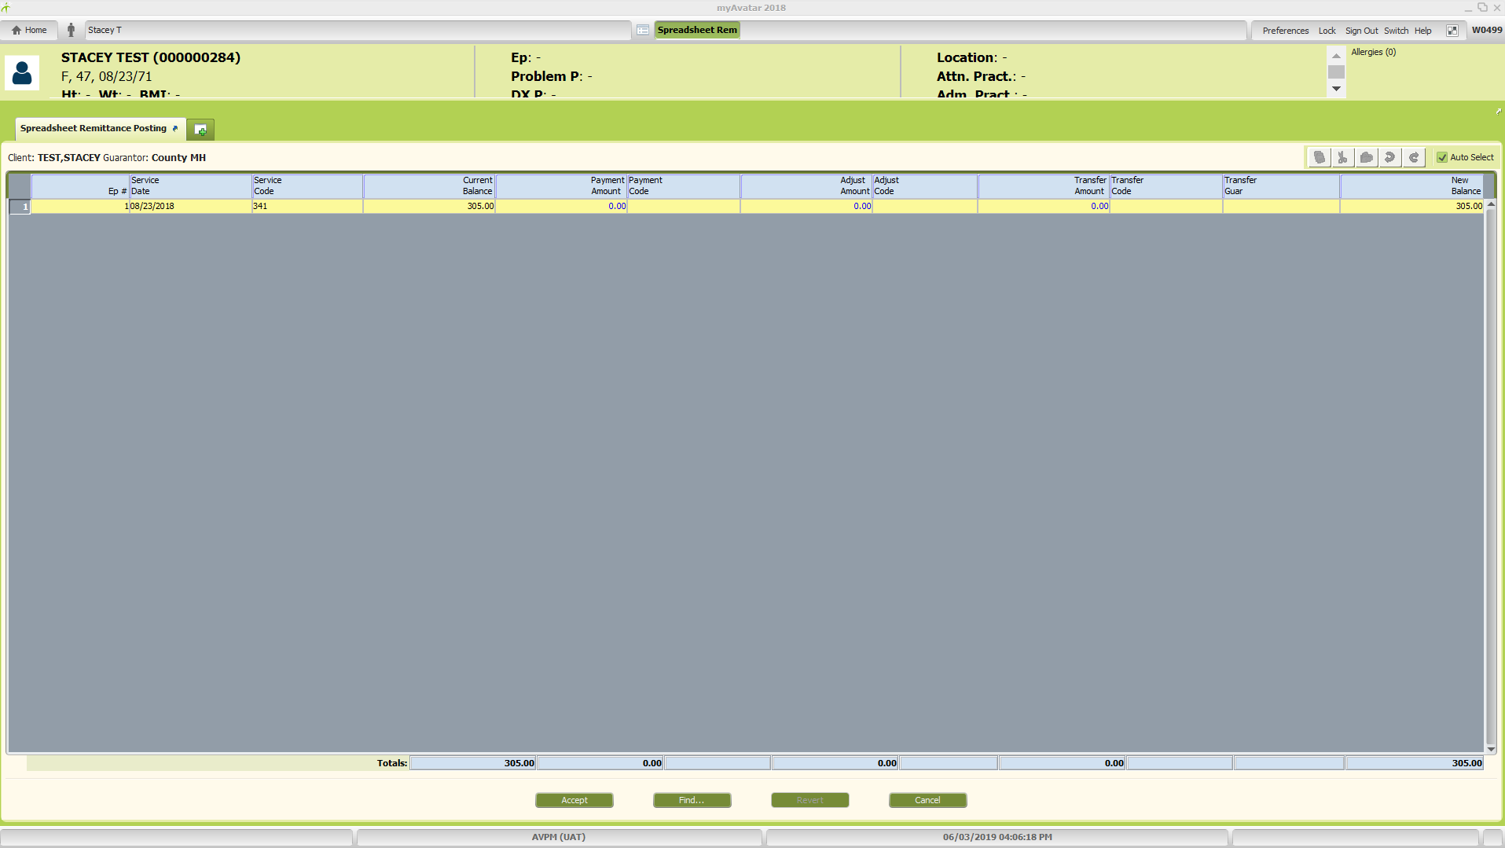
3rd Step: Entering Write-Off. Tab to or click into “Transfer Amount” column and enter amount from “New Balance” field at end of the row (red arrow). Once you enter amount, “New Balance” will change to 0.00. Tab to “Transfer Code” column and type or select from the drop down list (blue arrow), the appropriate write-off code based on the reason provided on the Write-Off Request form. Tab to “Transfer Guar” and select “5000” for MH write-off or “5001” for SUD write-off. Repeat for additional claim lines if applicable. Click “Accept” button (purple arrow) at the bottom of the form to close out and return to Spreadsheet Remittance Posting form.

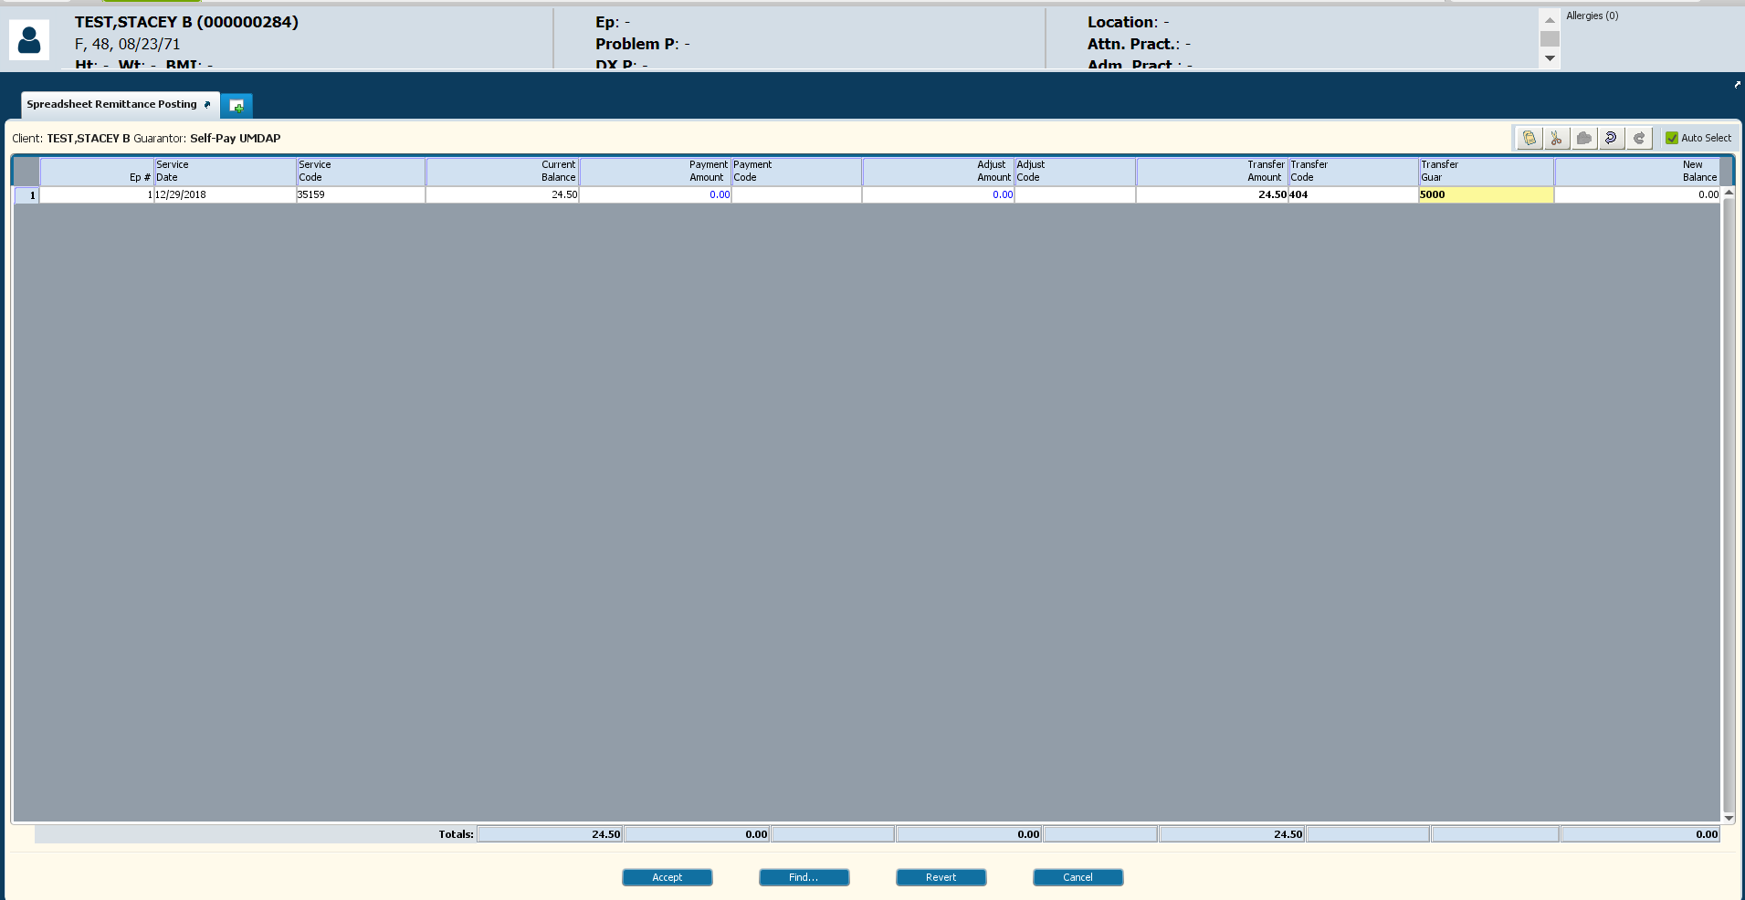
The “Posting Summary” window (red arrow) will display the proposed change(s) made in the work screen. Click the
“View Client Ledger” button (blue arrow) below the window to preview the client ledger and ensure the write-off
adjustment has been entered accurately.

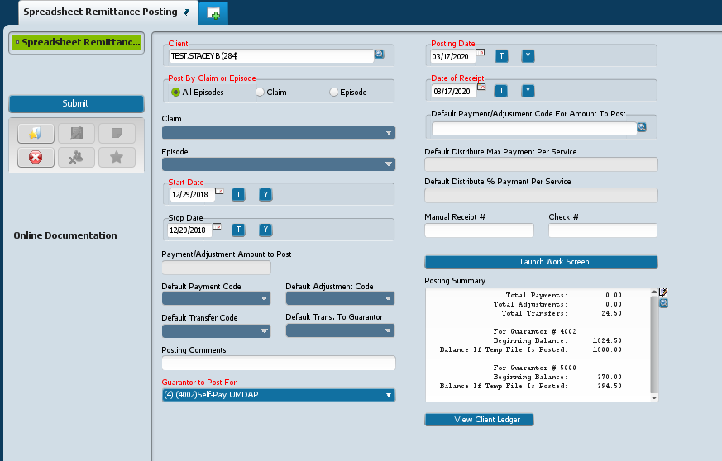
Client Account Ledger will open in a new window. Once review is complete and accuracy of write-off action verified
(red arrow), close out the ledger and return to the Spreadsheet Remittance Posting form by clicking the “X” in the upper right corner (blue arrow). 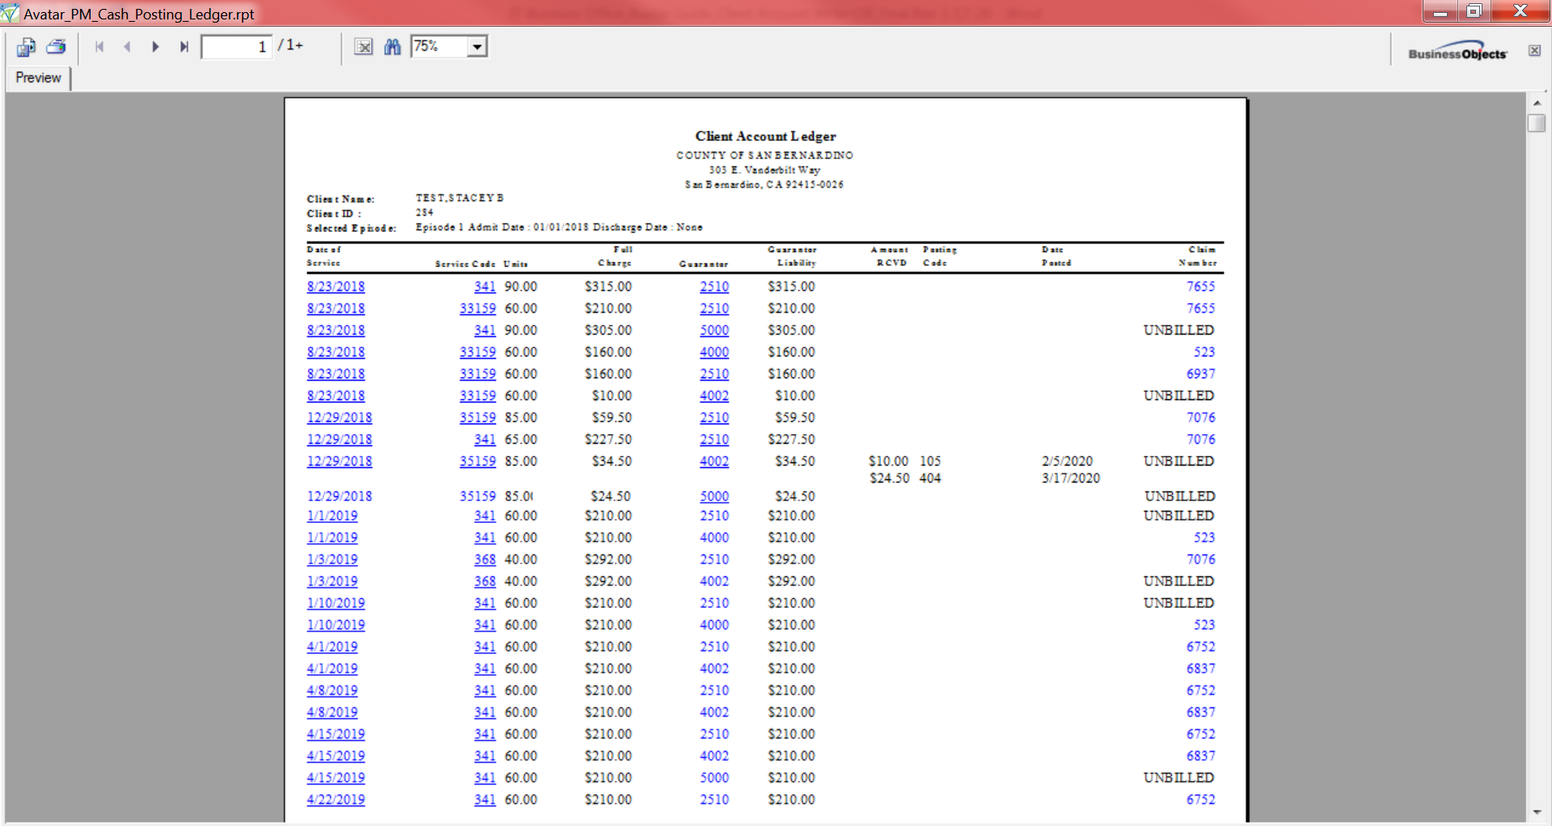
If there are any errors to correct, launch the work screen again to correct and accept changes. Follow same steps as outlined above. If no errors, click the “Submit” button (red arrow) on the left side under the Spreadsheet Remittance Posting tab to complete the write-off action.
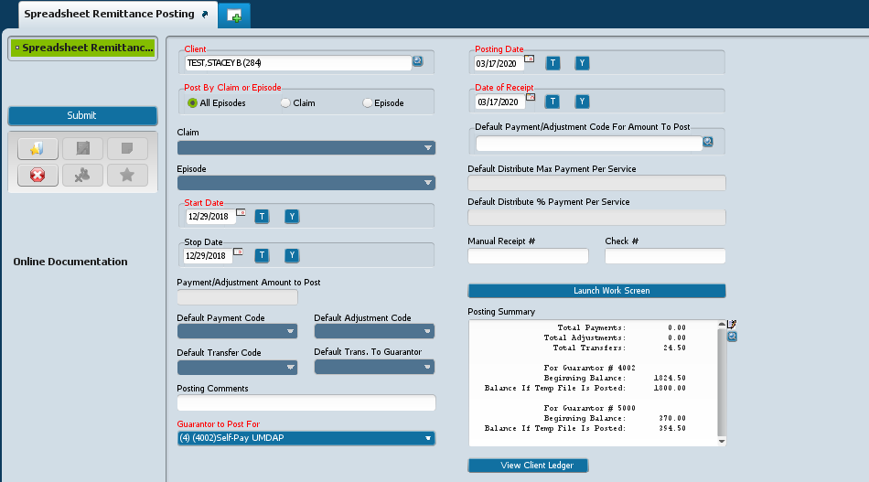

Message will appear “Submitting has completed. Do you wish to return to form?” Select “No” to complete submission of write-off action and return to the HomeViewBILLING screen.
4th Step: Run another Client Ledger report to verify transactions posted as expected. See 1st Step. Note: Transactions
do not necessarily post as shown during the 3rd step. Avatar shows the expected outcome based on what was entered. Once submitted, it looks at advanced billing rules and may make changes.
*It’s important to always verify transactions after posting is completed*
- Claim line of write-off should have “UNBILL” in Claim Number column for Self-Pay guarantor (red boxes)
- Claim line of County bucket guarantor (5000 or 5001) should have balance of transferred amount (blue boxes)
- Verify new guarantor balances
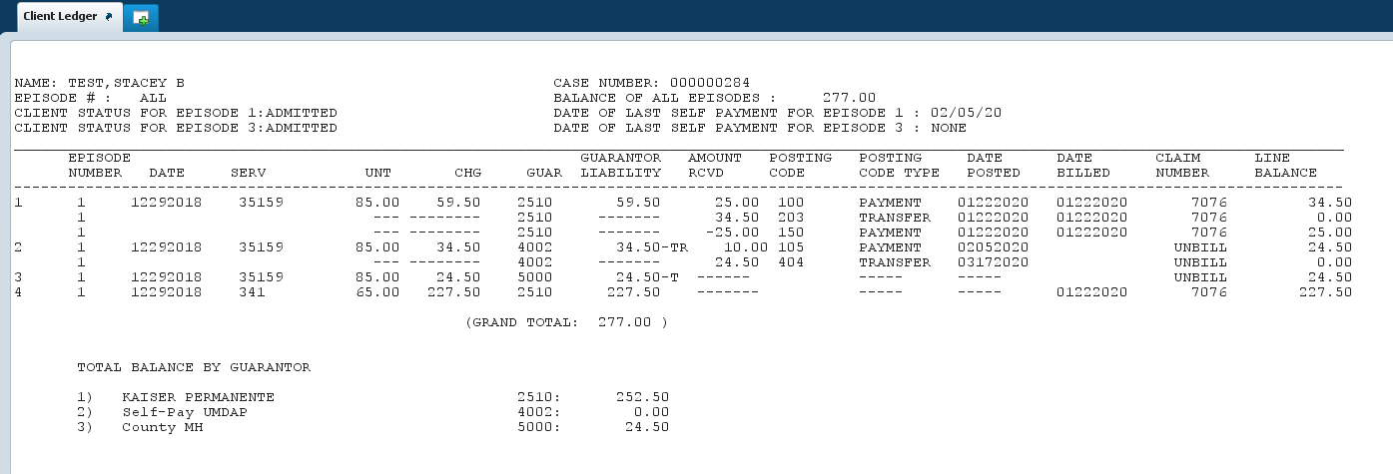

5th Step: PLACEHOLDER for write-off from County Buckets
Determination needs to be made by management and/or Fiscal as to if and/or when adjustments to County Buckets will
occur.
Objective of moving liability off of self-pay guarantors and into County buckets it to identify potential write-offs, and
allow for requesting approval through Auditor/Controller/Recorder/Treasurer-Tax Collector office to complete write-
off process. DBH is looking into potentially contracting with Central Collections for collecting on accounts. If that is
put into place, guide will be updated with additional steps/processes that are developed to account for that process.
Suggestions have been made that adjustment to County Buckets can occur quarterly, annually, or at completion of Cost
Report (preferred method).

