This user guide assumes a contracting provider and its programs already exist in CalPM, and only covers what needs to be done in MSO.
Setting up a Contracting Provider (CP), and its Contracting Provider Programs (CPP) in MSO, requires that the agency (contract provider), programs (RUs), and performing providers we will create and associate in MSO, first exist in CalPM. MSO and CalPM use different terminology for equivalent items as follows:
Program of admission in CalPM = Contracting Provider in MSO
Program of service in CalPM = Contracting Provider Program in MSO
Practitioner in CalPM = Performing Provider in MSO
Service Codes in CalPM = CPT Codes in MSO

The forms that need to be used to set up a contracting provider in MSO are:

- Applying Contracting Provider
  - 1st step in creating a Contracting Provider. Make sure the provider you will set up already exists as a program of admission in the CalPM side. This form enters the CP in the system as applying, not yet as registered. We will register them in a later step.
- Performing Provider Registration
  - To create a Performing Provider (PP) in MSO (Hint: this staff needs to exist in CalPM as practitioner – verify the staff ID they have in the Practitioner Enrollment form in CalPM, and use that number to register them as Performing Providers)
- Contracting Provider Registration
  - To actually create the Contracting Provider (CP )
  - To add the Contracting Provider Program (CPP) associated with a CP (e.g. South Coast is a CP, and all its RUs are its CPP) - These programs need to exist in CalPM as programs of service
  - To associate the PP to the CP
- Provider Fee Definition
  - To enter rates for the service codes providers are allowed to provide. This step needs to be done before we create the P-Auth. If we don’t have codes and rates associated to the programs, the Contracting Provider Service Authorization (CPSA) form will not provide a list of codes we can add.
- Contracting Provider Service Authorization (CPSA)
  - To create the P-Auths. These authorization numbers are required on each claim line in an 837 file, in order for the system to know which program provided the service. We will give the numbers to the contract providers so they can put them in the file.
- Contracting Provider 835 Defaults
  - To define information that will appear in the 835 file for a CONTRACTING PROVIDER
- MSO to Parent System Mapping
  - Form used to map elements in MSO to CalPM, to allow for push of services.
In here we map:
MSO Contracting Providers to CalPM programs of admission (Page (section) 1)
MSO Performing Providers to MSO Contracting Provider Program, to CalPM program of service and to CalPM Practitioners (Page (section) 4)

- Applying Contracting Provider form
Search for the Applying Contracting Provider form
Select and double-click on the form

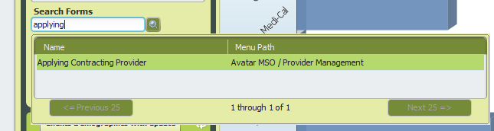

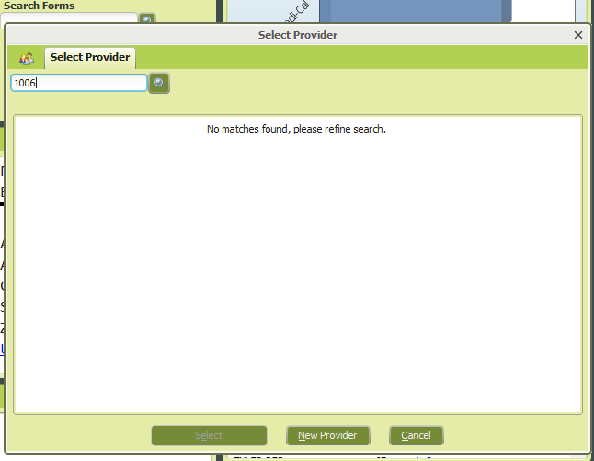

Search for the Contracting Provider first by the number their Program of Admission has in CalPM (e.g. 01006) and then by their name (e.g. Desert Mountain). If nothing appears on the dynamic list, it means the Contracting Provider needs to be created. Click the New Provider button
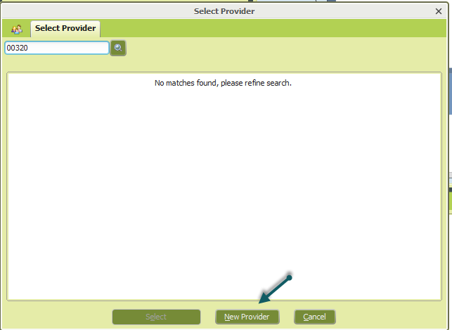

Select NO to Auto Assign Next ID Number?
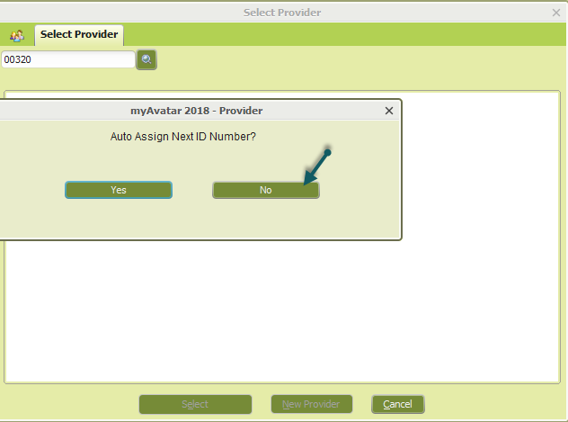

Enter the number assigned in CalPM to the Program of Admission (this can be Legal Entity number for MH OP Mode 15 programs, or the first four digits of their Provider number assigned by MediCal preceded by two zeros (e.g. 008653) for mode 5/10 MH or SUD programs)

Once the form opens, complete it as follows:
Application Date: as applicable. For TRAIN, we are using 01/01/2018
Type of Contracting Provider: Always use Facility
Name: Use naming convention of Name, space, dash, Legal Entity number (or first four digits of provider name) (e.g. South Coast Community Services - 00916, Aegis Treatment Center - 003656)
Type of Contact - Phone
Complete Address fields as applicable
Adding notes is not required
Click Submit
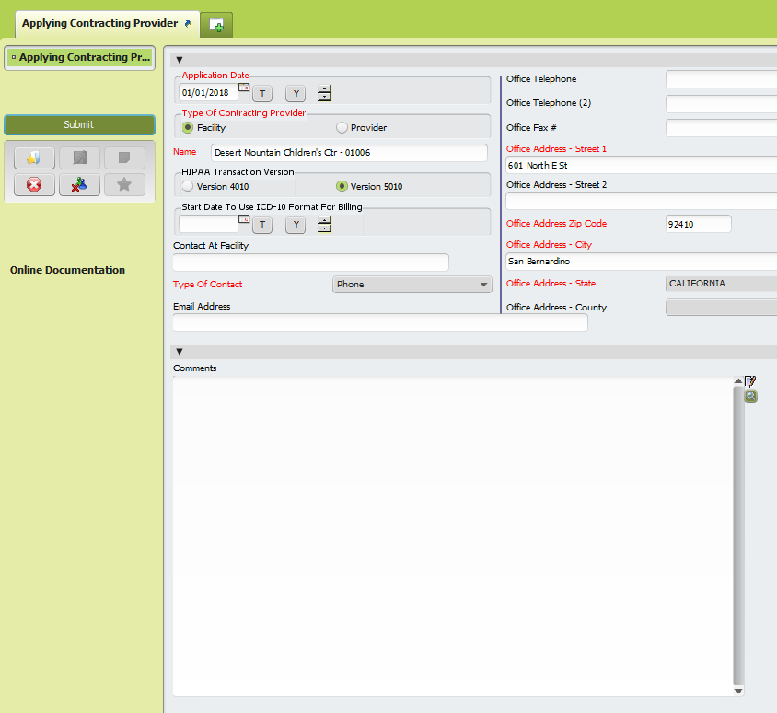

- Performing Provider Registration form
We will need the list of a contract providers' staff, so we can add them as Performing Providers in MSO. These staff members must first exist in CalPM as practitioners, and ideally we should register them using the same number they have in CalPM.
Search for Performing Provider Registration form
Select it and double-click to open
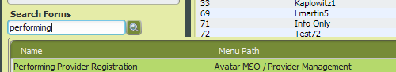

Search for provider both by the name and/or by the number they show in CalPM Practitioner Enrollment to pull record. (Need to search both ways because practitioners can have different ID in MSO). If practitioner is not found, click the New Performing Provider button
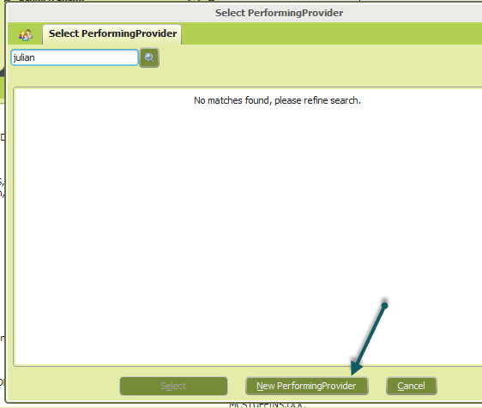
Choose NO to Auto-Assign Next ID Number?

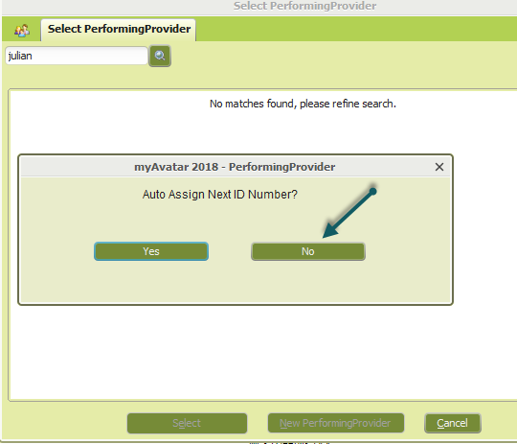

Enter the number they have in CalPM.
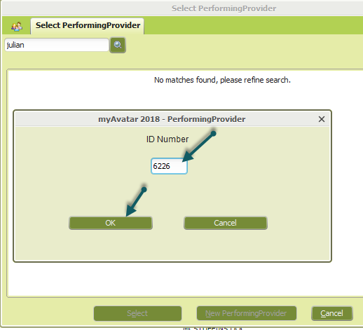
Click OK
Performing Provider Registration form opens
Performing Provider Information section: Here you enter the performing provider’s general information.
Name -use the naming convention LASTNAME,FIRSTNAME (NO SPACE)
Registration Start Date – Use their start date in CalPM

Performing Providers must have at least one License Type on record. Complete the fields in the following order:
- Primary License Type Effective Dates: Click and select Create New
- Performing Provider's License Type field - select their discipline
- Primary License Type for Claims - select their discipline
- Effective Start Date - complete as appropriate
- Click on the File Primary License Type Effective Date button
- No need to complete anything in the Performing Provider’s License section
- Click the Submit button
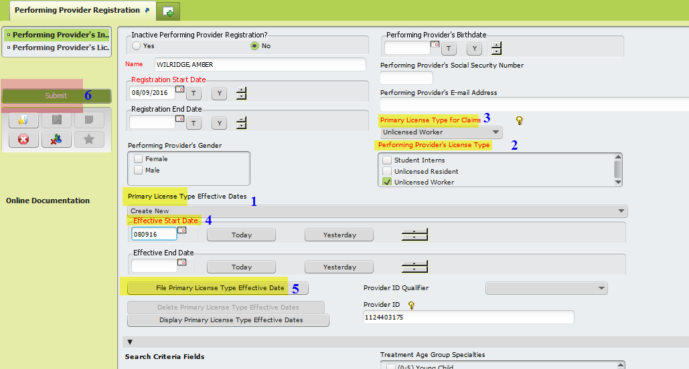

Register as many Performing Providers as needed until all providers in the list are in MSO.

- Contracting Provider Registration form
Search for the form
Double-click to open

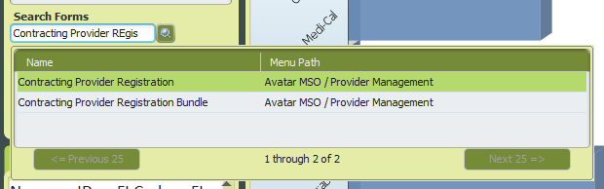

Type number or name in the Select Provider pop-up (this will populate from the Applying Contracting Provider completed in step 1)
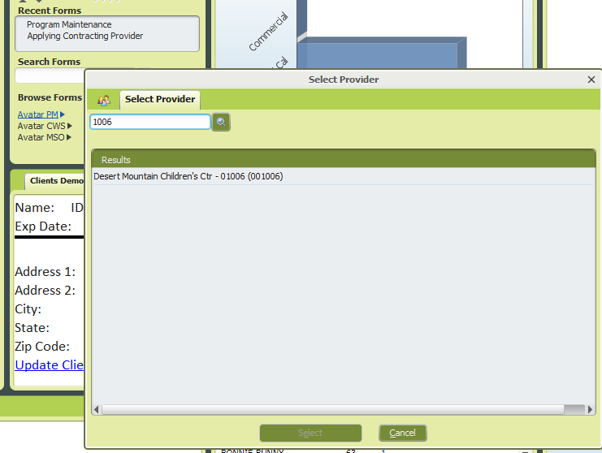

Double-click on it, and form opens

How to complete this form:

Contracting Provider Registration section – here you enter a contracting provider general information
Type of Contracting Provider: Select FACILITY always. This allows to be able to use the functionality in MSO because all the different locations
Submitter Identifier: Use Legal Entity # for MH or the 4-digit Provider # for SUD - used to match file to provider. We need to provide this to contract providers so they can put it in their 837.
Name and Address fields prepopulated from Applying Contracting Provider
Date: the date assigned in Applying contracting Provider form
In Network - Needs to always be In Network
Eligible Funding Source - as appropriate (MH or SUD)
Use Eligible Funding Source to Determine Funding Source for 837 Processing field: Select Yes
Tax ID – Enter if we have it. Not required
Tax Payer ID# - Not used for tax, and can use the legal entity# or the main NPI#
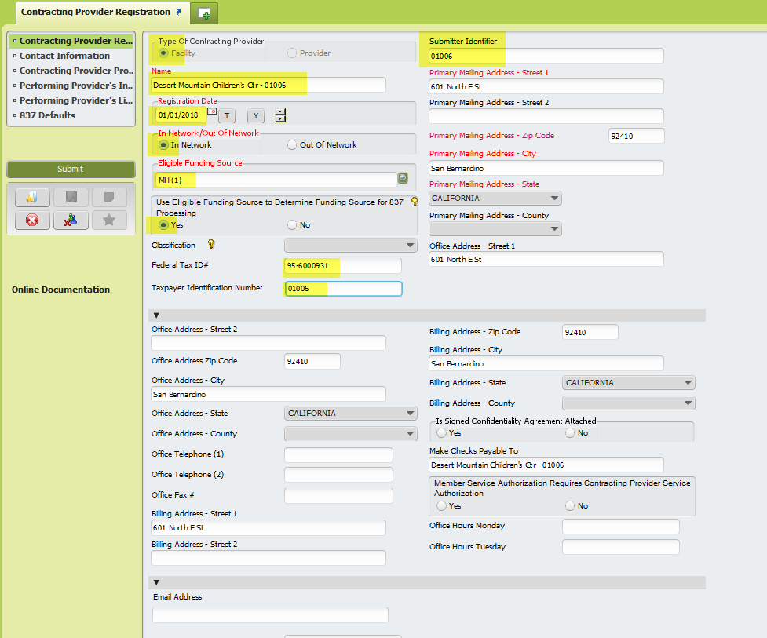

Contact Information section – this is not a required section. In this section we can enter who we can contact for 837. Add items as needed by clicking Add New Item button.
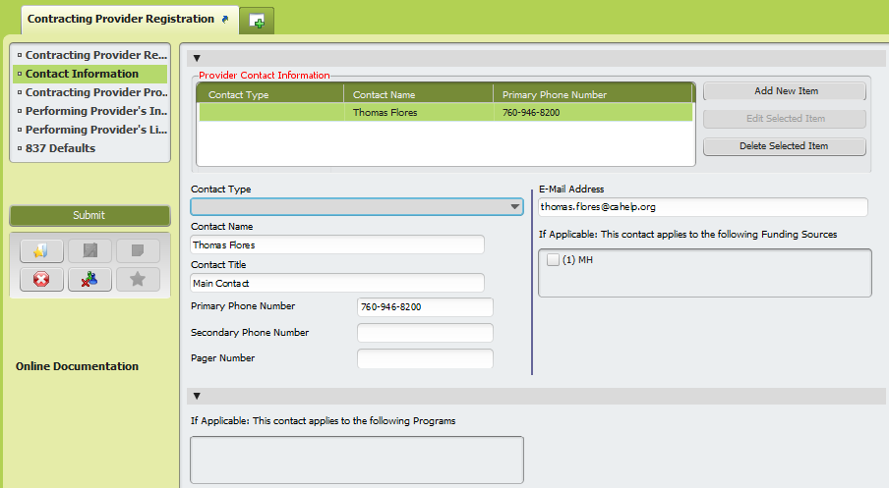

Contracting Provider Programs Information section - Here is where we add the Contracting Provider Programs that will map to Programs in CalPM.
To add a program, click the Add New Item button. Complete Program Name, Main Program Address, Facility ID Code qualifier, and Facility ID Code fields.
Program Name – Follow naming convention of RU number, space, dash, space, RU name
Enter Main Program Address and Zip Code
Facility ID Code Qualifier - Always Health Care Financing Administration NPI
Facility ID Code - Facility NPI - REQUIRED

Add programs as necessary by clicking the Add New Item button until you are done with all the programs that need to be associated with this contracting provider
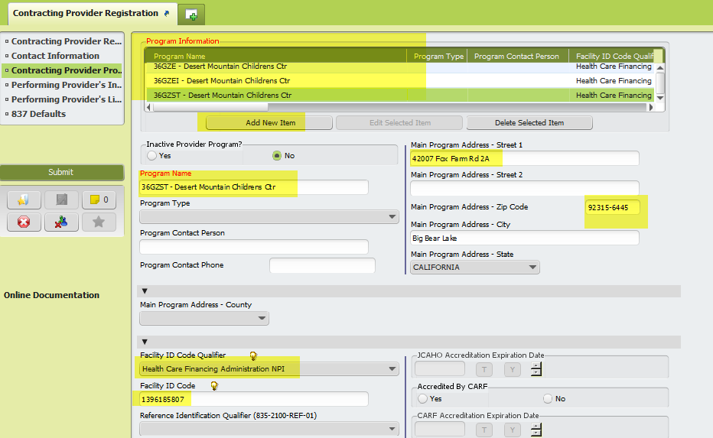
Performing Provider's Information section: Here is where we associate the performing providers to a contracting provider. We need to associate the performing providers we registered on step 2:

Click the Add New Item button
Performing Provider field: Type Performing Provider's ID or last name. Select the desired provider from the dynamic list and double-click.
The required fields auto populate (Just by doing this, you have associated a provider).
Continue adding as many performing providers as needed by clicking the Add New Item button as many times as needed until all the performing providers in the list have been associated to the contracting provider.

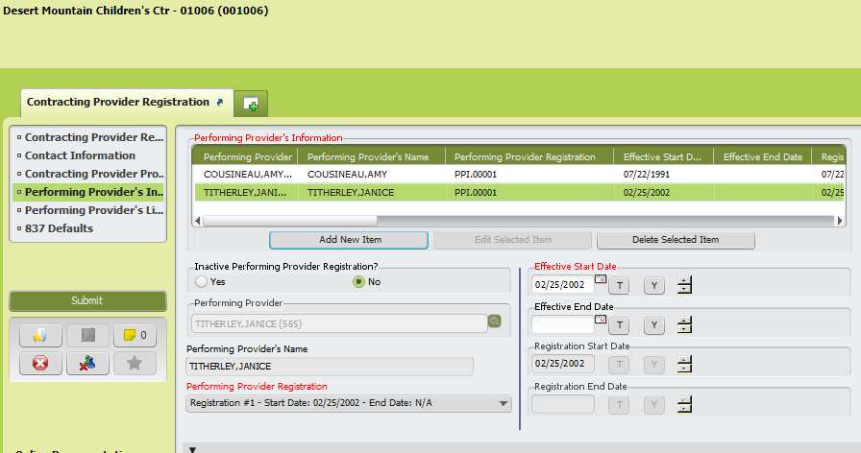

Performing Providers License information section: This section does not need to be completed because License information is in CalPM Practitioner Enrollment.

837 Defaults section – In these section we define some data elements MSO will be looking for in a contracting provider’s 837 file.

Require Exact Authorization Number (Professional) - this is for P-Auths, so this should be set to Yes on all Contracting Providers.
Support Population of Duration (units duration in claim) - Needs to be YES, and need to request from providers to change UN to MJ in 2400-SV103
Ignore Price the following CPT Codes…. and Price the following Procedure Code Group… fields - no need to select anything….
Set the rest of the fields as fields as NO
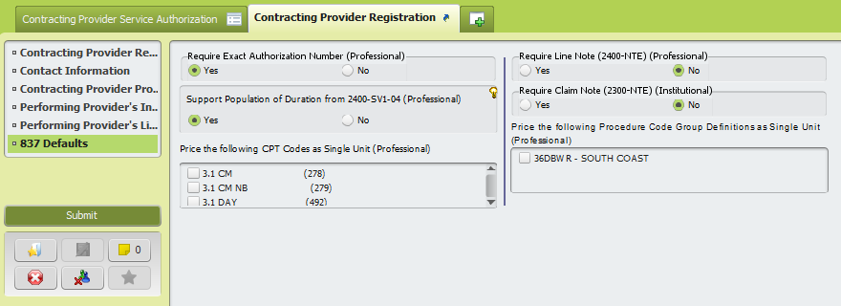

Click the Submit button

- Provider Fee Definition form
The service (CPT) codes and their fees by program need to be in MSO before creating the P-Auths for the programs. We need to add fees only to the services allowed (like in Provider Balance). If service code is not allowed, do not enter rate.

Fees can be entered manually, or in an upload file:

Manually:
Search for the Provider Fee Definition form
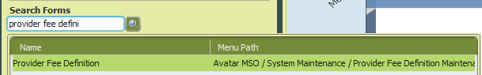

Select and double-click on it
In the Provider Fee Definition section, select Enter New (or Edit Existing)
Procedure Code type or Group Fee Definition = CPT Service Code
Provider = Name of the Contracting Provider (e.g. Desert Mountain Children's Center - 01006)
CPT Service Code = Select the code for which you are going to add a fee (rate) Note: the dropdown list is in alphabetical order. You can type the first letter of the code description to search faster)
Contracting Provider Program = The program (RU) for which rates are being entered. This is similar to the provider balance, so rates will be entered for all the direct services codes (billable and non-billable) that a program can use. No need to enter indirect services as contract providers cannot upload indirect services via the 837. For non-billable codes enter rate of 0.00
Effective Date: e.g. 01/01/2018
Amount: enter rate here
Status: select Active
Allow Duplicate Services on the Same Day - Select Yes
Click the Submit button
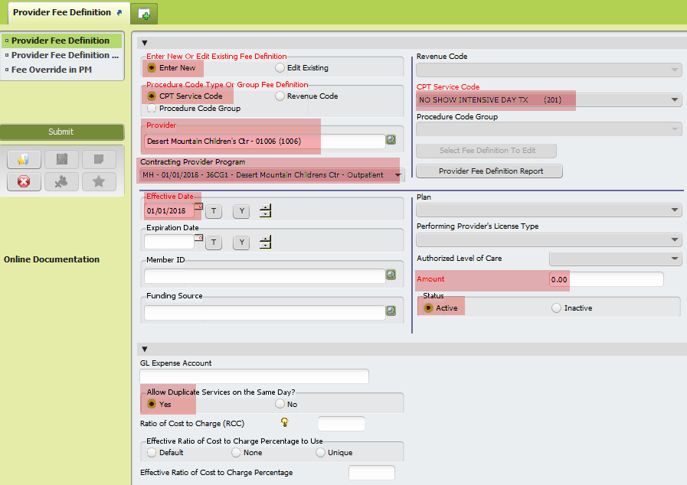

Make sure you are populating the Contracting Provider Program field each time after clicking the Submit button, because the field clears every time you click submit. The system will allow submitting the form without a program, but then the program will not have the rate/service code associated with them and if they send a service in the 837 the service will be denied (rejected?).
Do this as many times as needed until all the codes for direct services they are allowed to provide have a fee.

Upload file:
The file is in text tab delimited format. To create one, follow the Excel File Import Layout document provided by Netsmart.

Search for the Provider Fee Definition form

Select and double-click on it
In the Provider Fee Definition Upload section, click the Select File button
Navigate to the location of the file, select the file and double-click on it
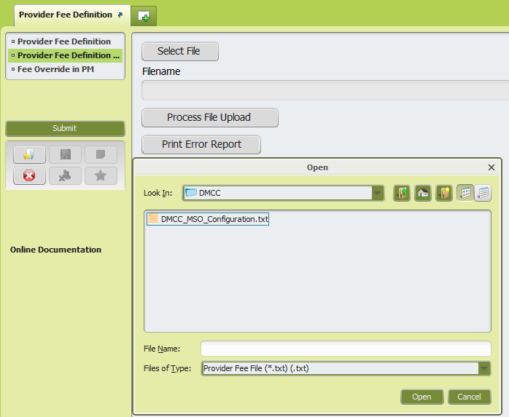

The Filename field is now populated with the file selected. Click Process File Upload button

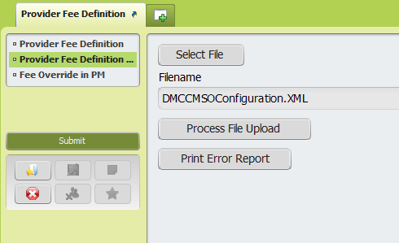

Once the file uploads, an informational message will appear with the stats of the upload, stating the number of records read, number of records accepted, and number of records rejected due to errors.
If there were errors, click in the Print Error Report button to see the errors. For testing, fix the errors, and resubmit a file with the records that errored out.
For production, research the errors, provide the errors to the provider so they can fix and resubmit a file with the rejected records, or request they enter services manually.

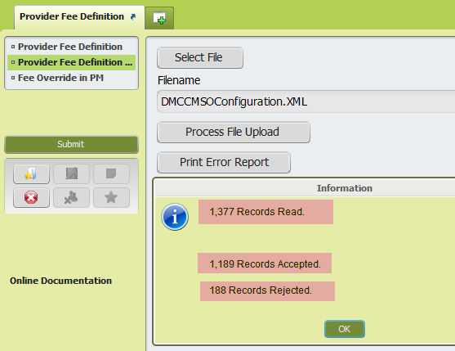

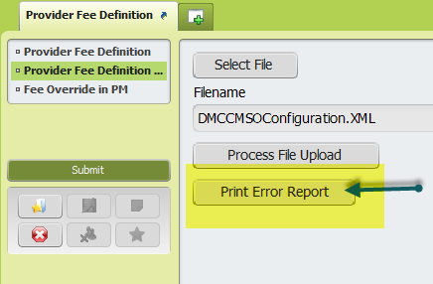

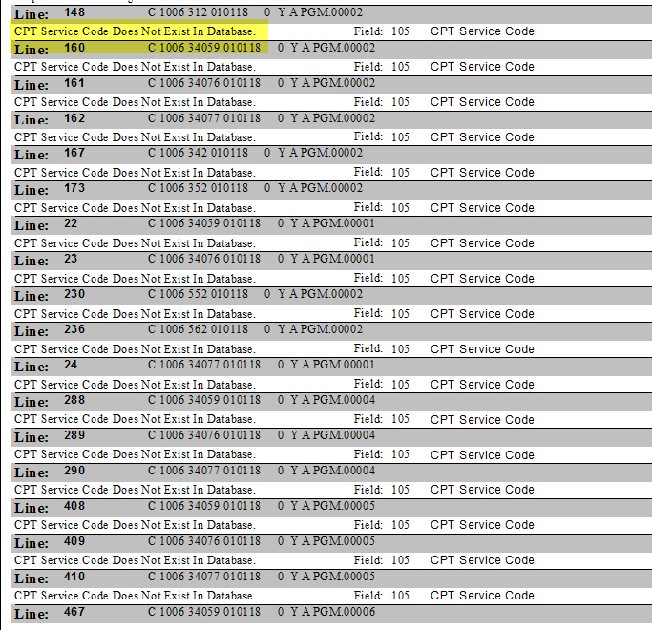
Sample of Error Report

After this, the fees are in the system.

- Contracting Provider Service Authorization
This form is used to create the P-Auth numbers needed on the 837 files.

Search for the Contracting Provider Service Authorization form
In the Select Provider box, type the name or number of the Contracting Provider
Select the contracting provider from the dynamic list
Click the Select button
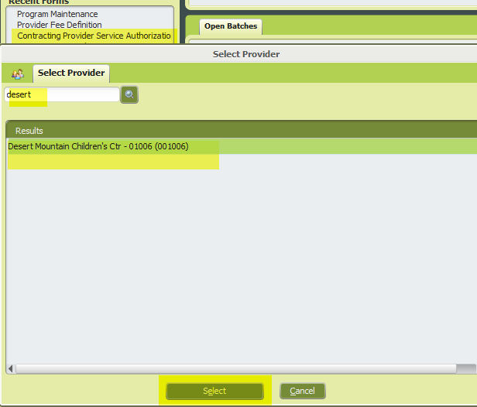

If the Contracting Provider does not have any P-Auths, the system will take user straight to the form
If the Contracting Provider has P-Auths for some of its programs already, the Contracting Provider Service Authorization predisplay appears, and user can select to Edit an existing authorization, or Add a new one. In this case, because we need tTo create P-auths, select Add
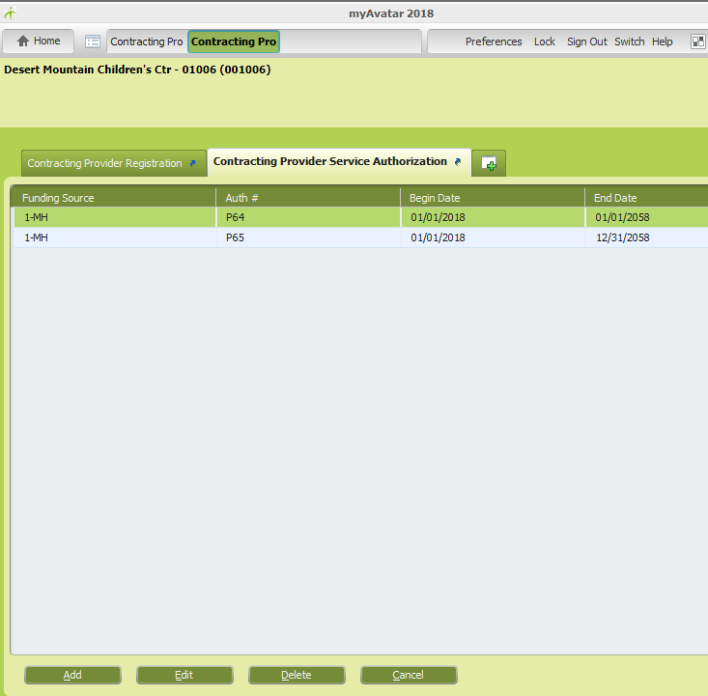

Some fields are already populated when the form opens, like the Authorization Number (P-Auth), Funding Source, and Benefit Plan. User needs to complete:
Contracting Provider Program (select from the dynamic list. This list shows the programs that were associated to the Contracting Provider in the Contracting Provider Registration form)
How to fill this form:
Initial or Continuing Authorization - select Initial
Current Authorization Status - Select Approved
Begin Date of Authorization - complete as appropriate
End Date of Authorization - DBH-IT will need to standardize the period we will allow. Most P-Auths in the system are set to expire around 2050, but this could change once a convention is established.
Authorization Grouping Or individual Authorization - Select Individual
Procedure Code Type (1) - Select CPT Code
Code Authorized - select one of the codes they will be authorized to provide
Click Submit

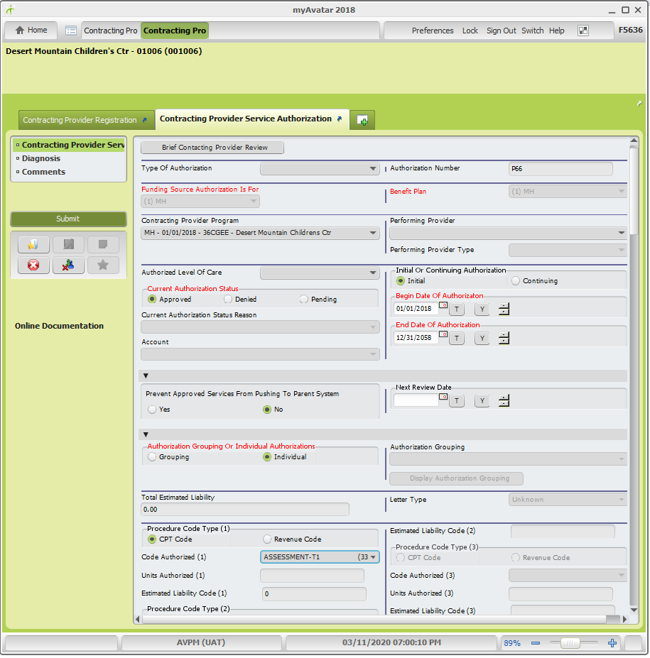

A message asking if you want to return to predisplay will appear, click yes if you need to add more P-Auths.
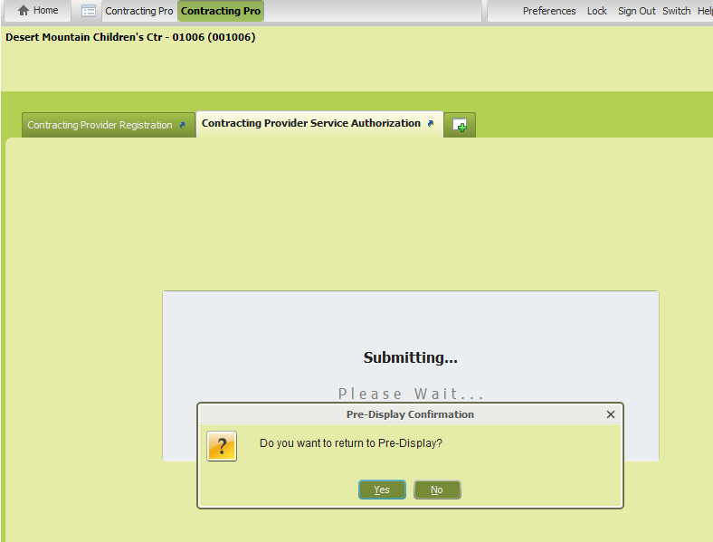

Add P-Auths as necessary until there is one P-Auth for each of the programs associated to the Contracting Provider Program.

Keep in mind that once we open the Contracting Provider Service Authorization form for a Contracting Provider, the auto-generated P-number will not be used again even if we don’t submit the form. For this reason, the P-Auth numbers of some programs might not be sequential. As best practice, try to only open this form when you are ready to create a P-Auth (Hint: do not attempt to create P-Auth if you have not added the Provider Fees yet. MSO will not let you add CPT codes until there are rates).

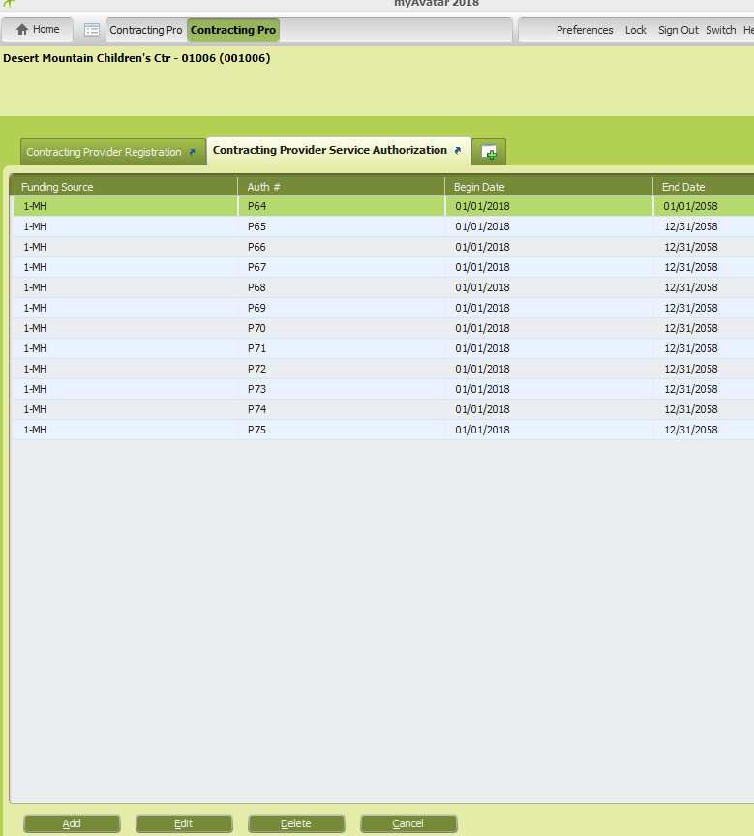
Example of all the P-Auths for Mountain Desert

- Contracting Provider 835 Defaults form
Search for the form, select, and double-click on it to open
Contracting Provider 835 section – This section is to define the data elements that will appear in the ISA loop of the 835 Avatar will generate
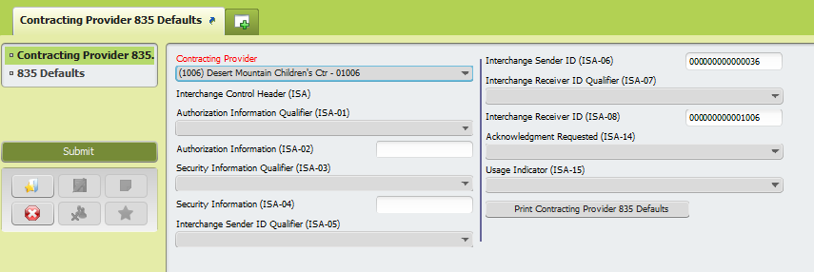

Contracting Provider - Select appropriate
Interchange Sender ID (ISA-06) - use 36 (might need to add thirteen zeros as field requires 15 characters)
Interchange Receiver ID (ISA-07) - use the Contracting Provider ID (might need to add enough zeros to complete fifteen characters)

835 Defaults section

Provide 837 Claims Rejected Due to Critical Errors on 835 - No
Application Sender's Code (GS-02) - enter 36
Application Receiver's Code (GS-03) enter the Contracting Provider ID
Transaction handling Code (BPR-01)- Remittance Information Only
Total Actual Provider Payment Amount (BPR-02)- Sum of Claim payment Amounts
Payment Method code (BPR-04) - Non Payment Data
Originating Company Identifier (TRN-03) - 1000000000
Payer Name (1000A-N1-02) - county of San Bernardino
Payer Address (1000A-N3) - 303 E Vanderbilt Way
Payer Technical contact Name (1000A-PER-02) - Niema Burrell (?)
Payer Zip Code (1000A-N4-03) - 92415-0026
Payer City Name (1000A-N4-01) and Payer State (1000A-N4-02) auto populate
Payer Technical contact Communication Number Qualifier (1000A-PER-03) - Telephone
Payer Technical contact Communication Number (1000A-PER-04) - 909 388 0900
Payee Name (1000B-N1-02) - Contracting Provider Name
Payee Identification Code Qualifier (1000B-N1-03) - Health Care Financing Administration National Provider Identifier
Payee Identification Code (1000B-N1-04) - enter NPI
Payee Address Line 1 (1000B-N3-01) - enter address
Payee Zip Code (1000B-N4-03) - enter zip code
Payee City and Payee State auto populate
Payee Additional Reference Identification Qualifier (1000B-REF-01) - Select Federal Taxpayer's Identification Number
Payee Additional Reference Identifier (1000B-REF-02) - Fed Taxpayer ID
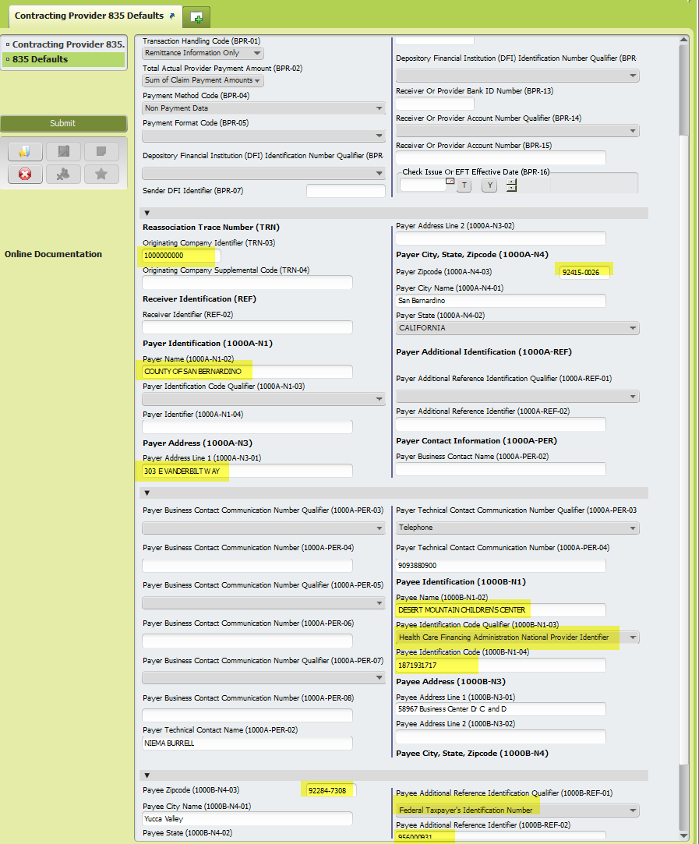

- MSO to Parent System Integration Mapping form
This form is used to map contracting provider, contracting provider programs, and performing providers in MSO to programs of admission, programs of services, and practitioners in CalPM. This is needed to ensure that services uploaded to MSO, push correctly to CalPM. Not having all the necessary elements mapped, will cause denials or service failure to push to CalPM.

Search for the form, select from list, and double-click to open.
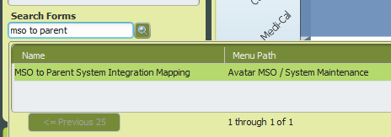
The form is divided in sections (called pages by Netsmart). Each section that has a File button, is a page.

To correctly map Contracting Providers in MSO:

- Use Page 1 (section 1) to map MSO Contracting Provider to PM Program of Admission. Use generic performing provider (only done once).

- Use Page 4 (section 4) to map MSO Performing Providers to MSO Contracting Provider Programs and to map the MSO portion to PM Programs of Service and PM Practitioners. (There should be as many mappings as many possible combinations. E.g. 10 programs and 10 providers would require 100 mappings (10 * 10))

Hint: In the MSO to Parent System Integration Mapping form, everything on the left side of a page represents what is in MSO, and everything on the right side represents how is it mapped to CalPM.
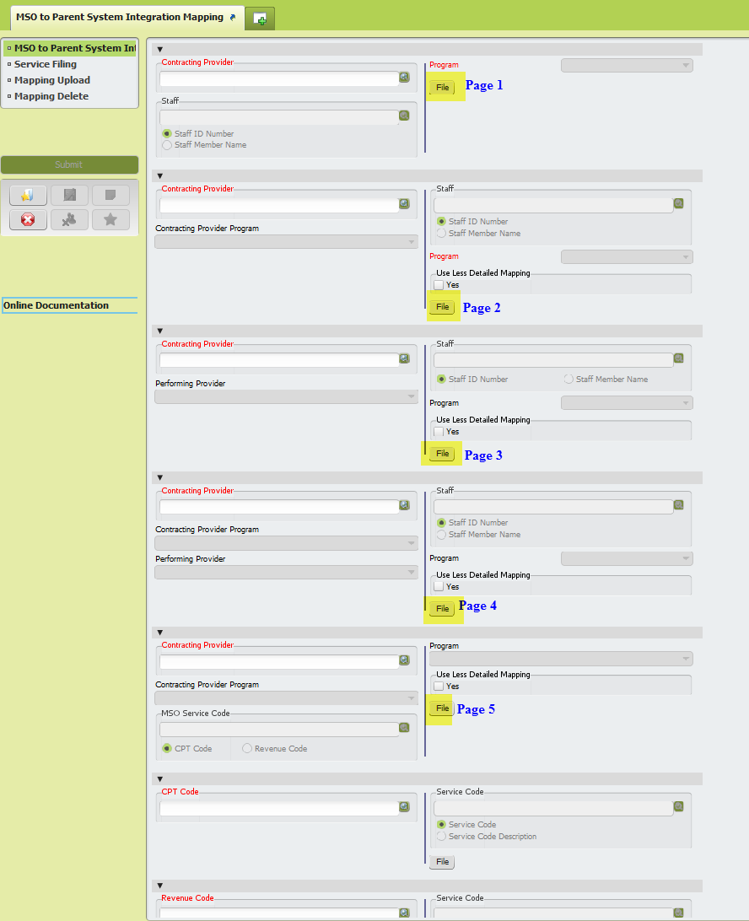
MSO to Parent System Mapping form pages layout
Page 1
Mapping on this page needs to be done only once per Contracting Provider
Contracting Provider - Select from dropdown list as appropriate
Staff - Select to search by Staff Member Name, and select the generic staff (Conversion Practitioner)
Program - Select the Program of Admission in CalPM to which the MSO Contracting Provider needs to map to (this is necessary in order for the services pushing from MSO look (and find) the correct episode that the service will fall under once it pushes to CalPM
Click the File button

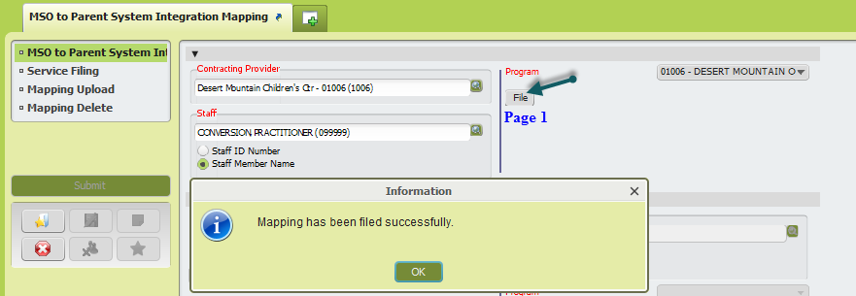

Page 4
Contracting Provider - Select Contracting Provider as appropriate. Note that only programs for which a user has completed a Contracting Provider Registration will appear on the list.
Contracting Provider Program – Select a program form the list. The list will be populated with the programs that were associated to a contracting provider in the Contracting Provider Registration
Performing Provider - select provider from the list. The list will be populated with the performing providers that were associated to the contracting provider in the Contracting Provider Registration
Staff - search for the practitioner in CalPM to which the performing provider needs to map to. User will need to search by number and by name. When in doubt, the user will need to check both the Practitioner Enrollment form and the Performing Provider Registration form to verify the staff has same NPI and discipline/license
Program - search for the program of admission in CalPM to which the MSO program maps to
Select the Yes box on the Use Less Detailed Mapping field
Click the File Button
This mapping will need to be done for all the possible program/staff combinations in both MSO and CalPM (e.g. 5 performing providers and 5 programs will require 25 mappings [5*5])
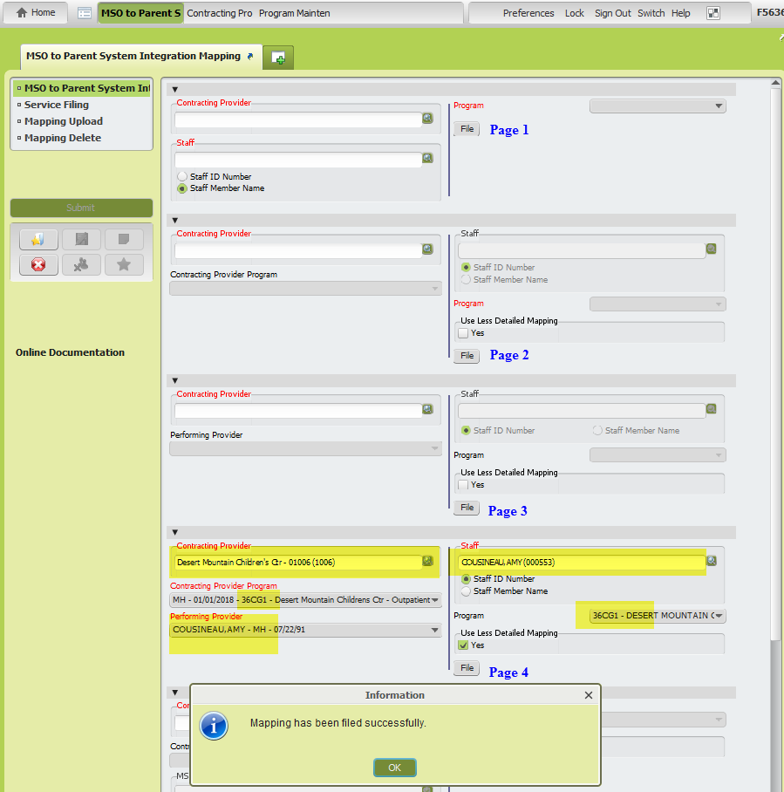
To verify the mappings were done correctly, a user can verify existing mappings using the Mapping Delete section.

If nothing populates in the PM side of the page when making selections in the MSO side, it means those elements are not mapped.

Once the user verifies the mappings are correct, the user should close the form without submitting it, as user will not want to delete any existing mappings.

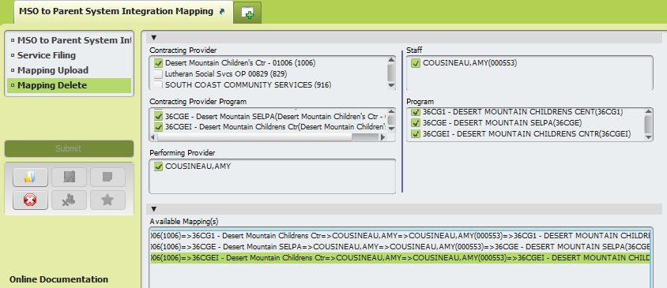
Figure shows how Performing Provider Cousineau, Amy is mapped to three Contracting Provider Programs on the MSO side, which in turn are mapped to staff Cousineau, Amy (00553) and the same three programs in the CalPM side
Please note that although sometimes we will need to do mappings manually, there is a Mapping Upload that can be used to speed the process of mapping.

