myAvatar Job Aid for
Juvenile Justice Program Clerical

Phase I

Table of Contents

Basic Features 1
Control Panel 1
Zoom 1
Calendar View 1
Phone #, Date, Time and Social Security # Formats 1
Forms & Data Widget 2
Client, Staff & Site Widget 2
Entering Data in myAvatar 3

Complete MH Registration Bundle 4
MH Registration Bundle 4

Contact FI 6
Admission Outpatient (inside MH Registration Bundle) 6
Financial Eligibility 6
Guarantor Selection 7

Complete Registration Bundle (S.B. Overarching Episode) 8
Admission Outpatient 8
CSI Admission 9
Program Assignment 9
Emergency Contact Relationship 9
Program Assignment (ONLY for INFO) 10

Complete MH Admissions Bundle 11
CSI Admission 11
Diagnosis 11
SOGI 11

Client Charge Input (Used to be CDI) 12
Client Charge Input 12

Creating a Group List 13
Create a Group 13
Add a Client to an Existing Group 14
Remove a Client from a Group 15

Scheduling Appointments 16
Schedule an Appointment (for One Client) 16
Scheduling Options (When You Right-Click) 17
Scheduling a Group Appointment 18
Add a Client to a Group Appointment 19
Remove a Client from a Group Appointment 19

Control Panel is located on the left side of every avatar form. Below is a legend for each icon
  - Submit- used to save/submit data or request/process a report
  - Add Form to My Forms- Select to add this form to the My Forms Widget on the Home View
  - Close Form- Select this to close a form without saving changes
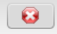
  - Close All Forms for this client- if there are multiple forms open for a client this link can be selected to close all open forms for said client
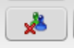

Zoom feature is located at the bottom right of every form. To zoom in or out click the plus or minus sign located on the zoom bar. The zoom settings are saved after logging out.
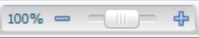

Calendar View shows you the calendar by month. Click on the
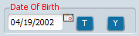

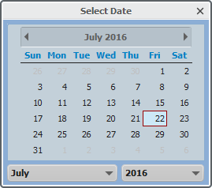

Phone Number Formats:
(000)000-0000
0000000000
000-0000, 0000000
(000)000-0000 X0000
0000000000X0000

Date Formats (DOB, Date of Service, etc):
MM/DD/YYYY
MMDDYYYY

Time Formats:
HH:MM AM
HH:MM PM
HHMM

Social Security Number Formats:
NNN-NN-NNNN
NNNNNNNNN

Forms and Data Widget: this widget is used to access forms that you have rights to in the system.
  - To add your favorite forms to My Forms, just click/hold and drag from Recent Forms to My Forms.
  - To group the forms in folders: click edit, right-click on the white empty space, click Add Folder, enter a name for the group of forms, click OK and drag forms into folder.
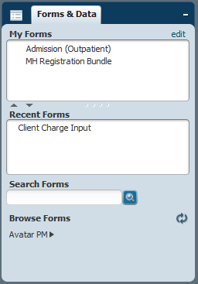

Avatar PM ► has a list of all the forms in myAvatar.

Client, Staff & Site Widget: this widget is used to search for and access clients.
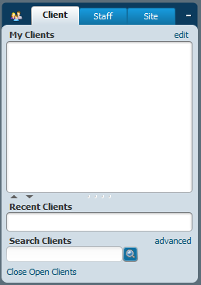

Entering Data in myAvatar: When entering data into a myAvatar form, enter the data by section, going from the left to right. See sample sequence below.
Example:
- Enter data in the left side of the “Identification and Treatment Information” section.
- Enter data in the right side of the “Identification and Treatment Information” section.
- Enter data in the “Disabilities” section.
- Enter data in the left side of the “Compliance Indicators” section.
- Enter data in the right side of the “Compliance Indicators” section.
- Enter data in the External Reference Numbers.

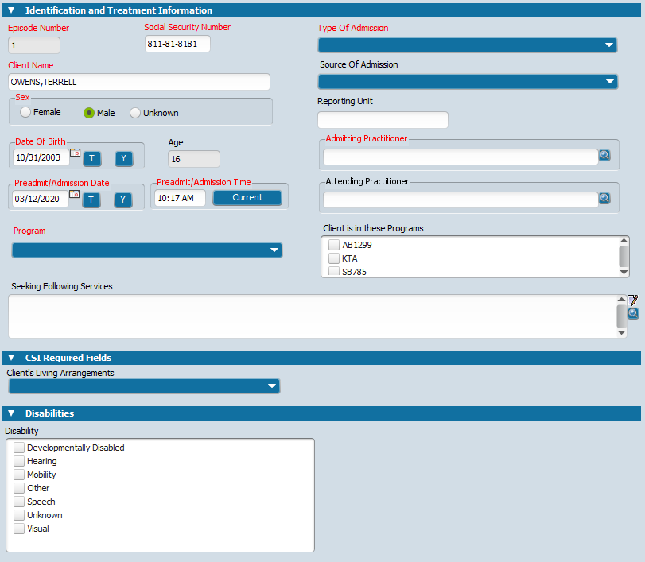
1
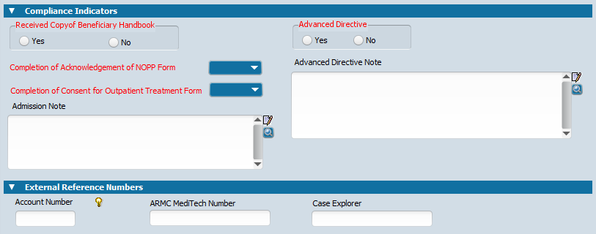
6
5
4
3
2

MH Registration Bundle

- Go to the Search Forms field and search for form MH Registration Bundle.
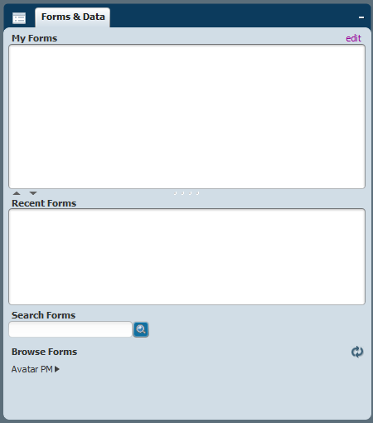

- After the Select Client dialogue box opens, fill in as many fields as possible (at least last name, first name, sex and SSN) and click Search.
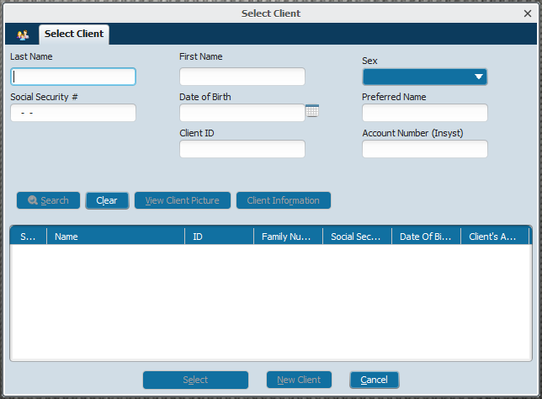

- If client already has a record, double click on the name and go to step #. If there are no matches, click on New Client. When asked to “Auto Assign Next ID Number?” click Yes.
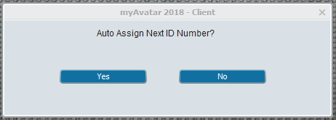
Tip: Whenever you are asked “Auto Assign Next ID Number?”, only click Yes one time. Every time you click Yes it will generate a new number for the client.
- Enter the client’s information on the following fields (bold text listed below is the standard response that JJP clerk would enter in that field):
- Social Security Number
- Client Name
- Date Of Birth
- Preadmit/Admission Date (Date referral is received)
- Preadmit/Admission Time (Current)
- Program: MH Financial
- Type of Admission: MH Admission
- Source of Admission
- Admitting Practitioner
- Received Copy of Beneficiary Handbook: No
- Completion of Acknowledgement of NOPP Form: No
- Completion of Consent for Outpatient Treatment Form: No
- Admission Note: Pending Clinician Appointment
- Advanced Directive: No
- Case Explorer

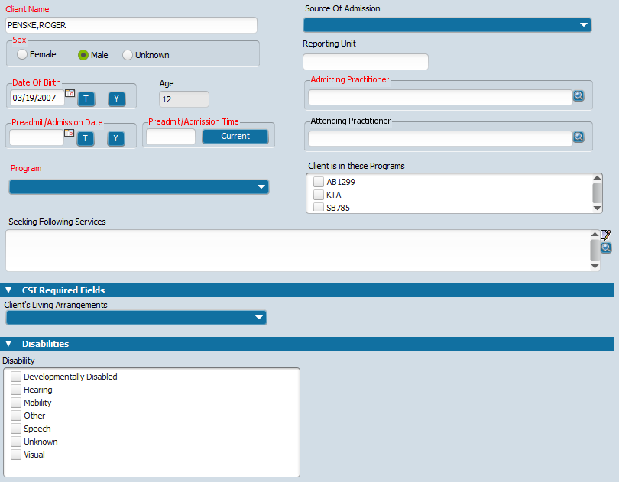
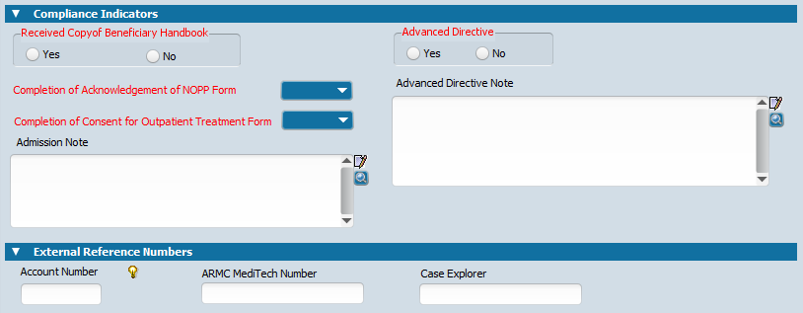

MH Registration Bundle, Continued

- Click on Demographics section in the menu on the left hand side.
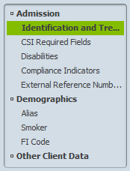

- Enter the client’s information on the following fields:
- Client’s Address – Street
- Client’s Address – Zip Code
- Client’s Address – City
- Client’s Address – State
- Client’s Home Phone
- Primary Language
- Client Race
- Ethnic Origin
- Education
- Employment Status
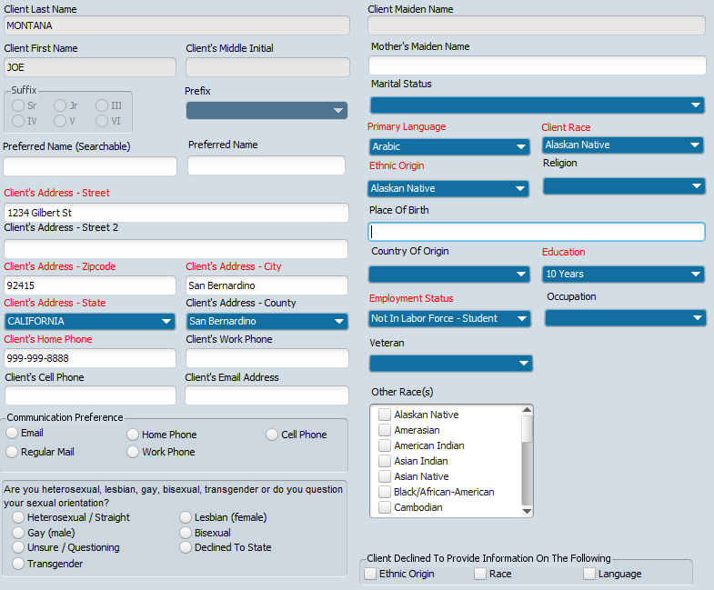

- When finished adding all the client’s information, click Submit (left hand menu).
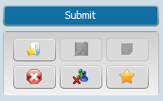

If you get the following dialogue box, it means you forgot to enter a field. The dialogue box will list the fields that are not complete.
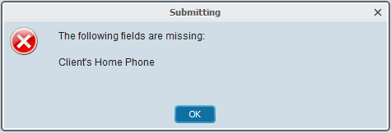

Little red flags will appear on the fields that are missing information.

- If you get the Form Load Error message, just click OK and it will complete Financial Registration.
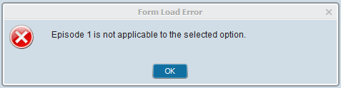

Admission Outpatient (inside MH Registration Bundle) [TBD]

Note:
- For INFO: Complete FI spreadsheet with client information (client’s full name, parent/guardian full name, SIMON/Avatar #, and SSN) and email to FI Department. After FI Department sends the FI code, go to step #1.
- For JJCR: Send client information (client’s full name, parent/guardian full name, SIMON/Avatar #, and SSN) through email to FI Department. After FI Department sends the FI code, go to step #1.

- Make sure the client’s name is highlighted green and go to the Search Forms field and search for form: MH Registration Bundle.
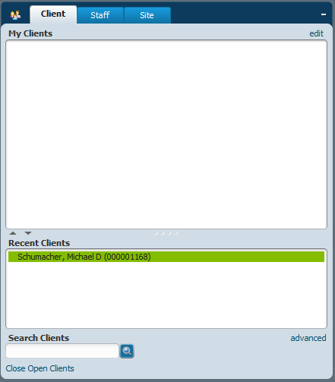

- Select the episode with the MH Financial (Program) and click Edit.

- Click on the FI Code sub category (in left hand menu). Complete the following field:
- FI Code: (Select the code from the spreadsheet that FI Dept sent back)
- FI Code Expiration Date (TBD)
- Click Submit
- If you get the Form Load Error message, just click OK and it will complete Financial Registration.

Financial Eligibility (inside MH Registration Bundle) [TBD]

- Make sure the client’s name is highlighted green and go to the Search Forms field and search for form: Financial Eligibility.

- Select the episode with the MH Financial (Program) and click OK.

- Go to Guarantor Information (Menu on the left hand side).
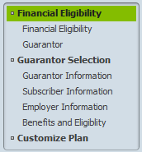
Complete the following fields:
- Add New Item
- Guarantor #
- Customize Guarantor Plan
- Eligibility Verified
- Coverage Effective Date
- Subscriber’s Name
- Subscriber’s Address – Street Line 1
- Subscriber’s Address – Zip
- Subscriber’s Address – City
- Subscriber’s Address – State
- Client’s Relationship to Subscriber
- Subscriber’s Sex
- Subscriber’s Social Security #
- Subscriber’s Assignment of Benefits
- Subscriber Release Info
Admission Outpatient (inside MH Registration Bundle), Continued [TBD]

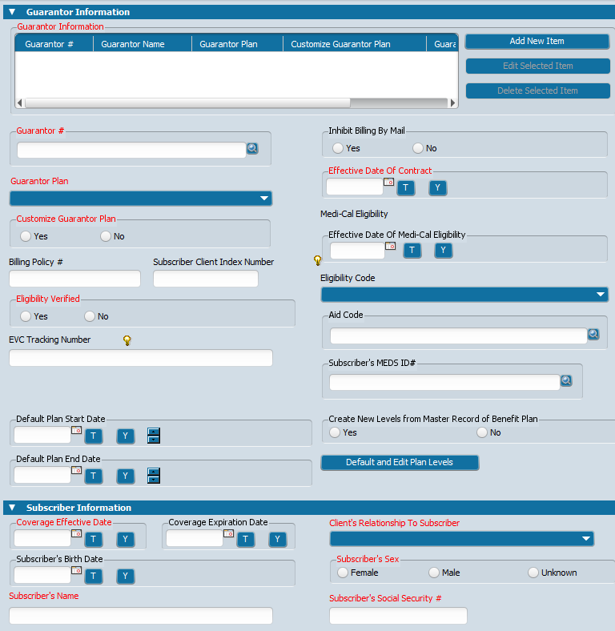
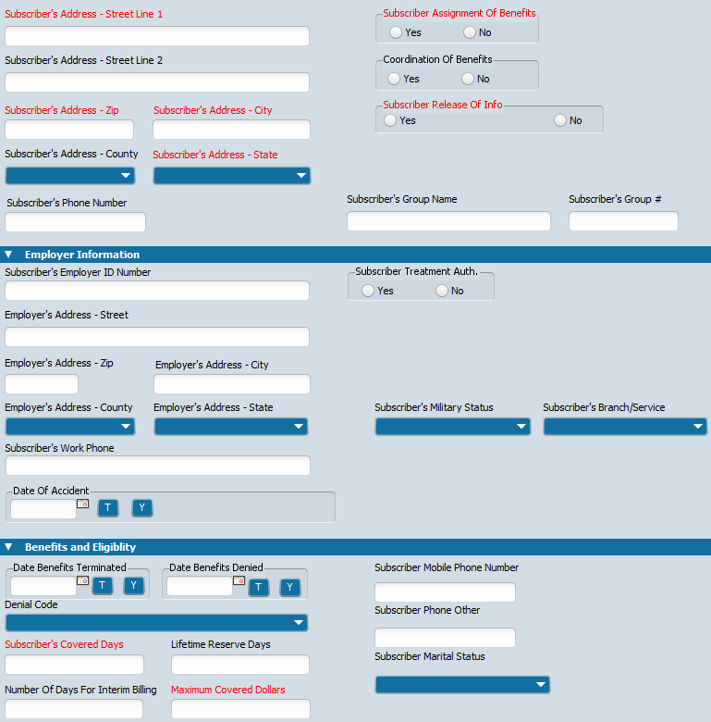

- Go to Guarantor (Menu on the left hand side).
Complete the following field:
- For each guarantor that the client has, click on the drop down menu and select the code (Guarantor 1)
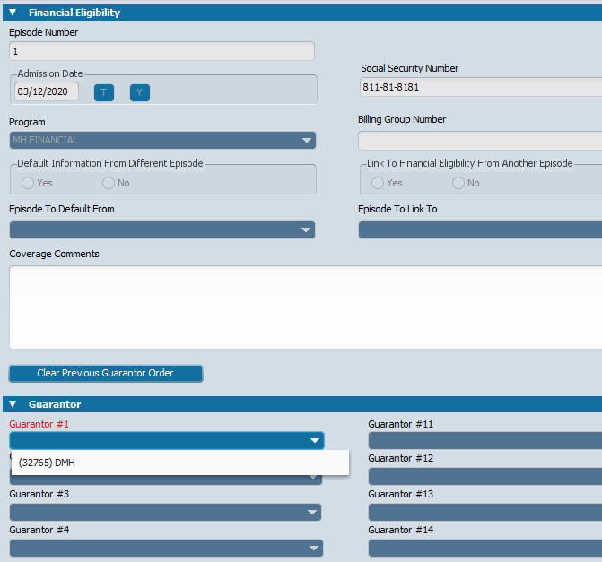

- Click Submit

Admission Outpatient (inside MH Registration Bundle)

- Make sure the client’s name is highlighted green, go to the Search Forms field and search for form: MH Registration Bundle.
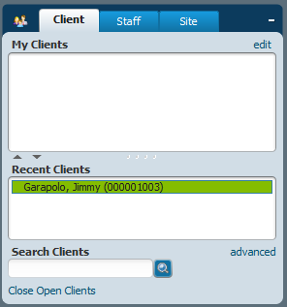

- Click Add.

- Complete the following fields:
- Social Security Number (if available)
- Client Name
- Sex
- Date Of Birth
- Preadmit/Admission Date (Date referral is received)
- Preadmit/Admission Time (Current)
- Program: 000036 – San Bernardino County OP
Note: When the dialogue box below appears, just click OK.
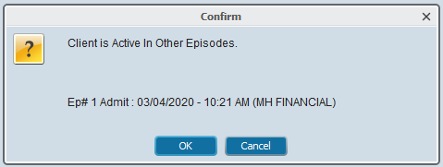
- Type of Admission: MH Admission
- Source of Admission
- Admitting Practitioner
- Received Copy of Beneficiary Handbook: No
- Completion of Acknowledgement of NOPP Form: No
- Completion of Consent for Outpatient Treatment Form: No
- Admission Note: Pending Clinician Appointment
- Advanced Directive: No
- Click Submit
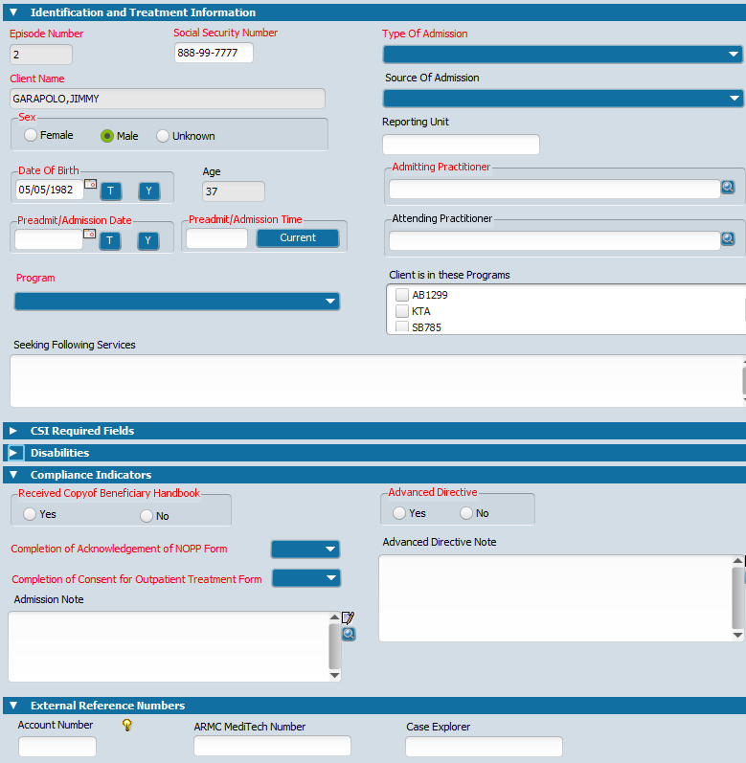

Admission Outpatient(inside MH Registration Bundle), Continued

- For CSI Admission form, complete the following:
- Birth Name (Last)
- Birth Name (First)
- Mother’s First Name
- Place of Birth – County
- Place of Birth – State
- Special Population
- Number of dependent adults 18 years of age and above that the client cares for / is responsible for a t least 50% of the time
- CSI Ethnicity
- Conservatorship/Court Status
- Year Or Month/Year of Birth
- Preferred Language
- Number of children less than 18 years of age that the client cares for / is responsible for at least 50% of the time
- Race (Select Up To Five)
- Click Submit
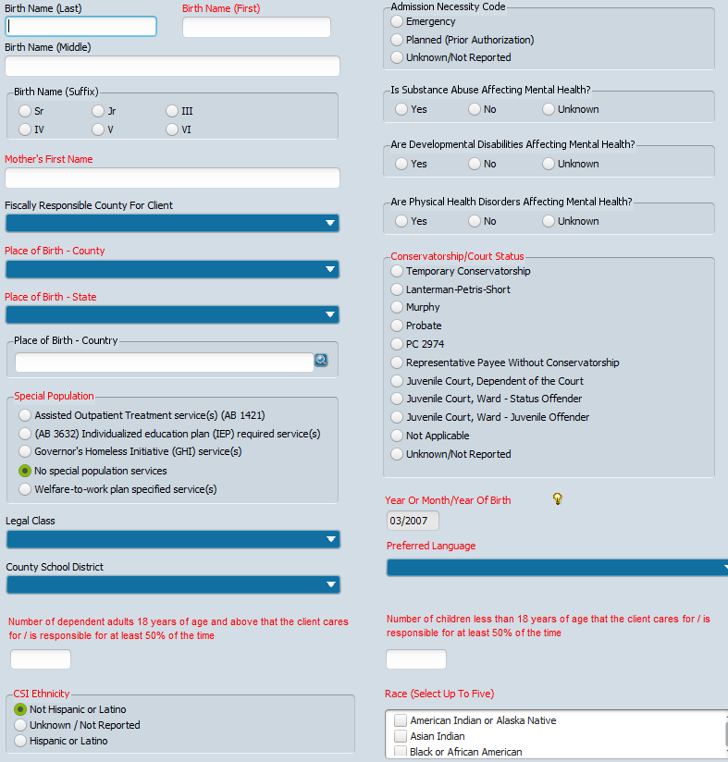

- For Program Assignment form, complete the following:
- Program Start Date (day you receive the referral)
- Program Assigned
- Referral From
- Clinician
- Click Submit
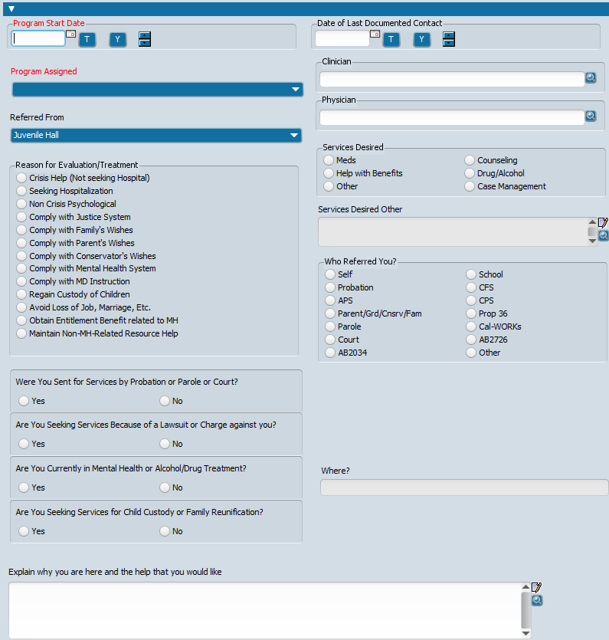

- For Emergency Contact Information, complete the following:
- Emergency Contact Name
- Emergency Contact Relationship
- Address
- Click Submit
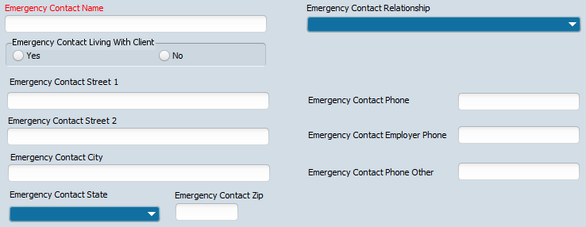

Program Assignment (ONLY for INFO)

Note:
- Once registration is complete notify (through email) the Social Worker and Parent Family Advocate that the chart is open.
- Open reporting unit 36DK1 only if client is excepted by clinician

- Go to Search Clients field in the Client tab and search for the client’s name.
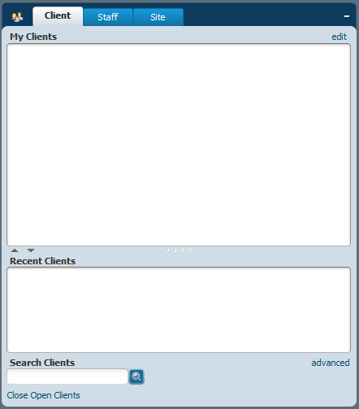

- Make sure the client’s name is highlighted green and go to the Search Forms field and search for form: Program Assignment.
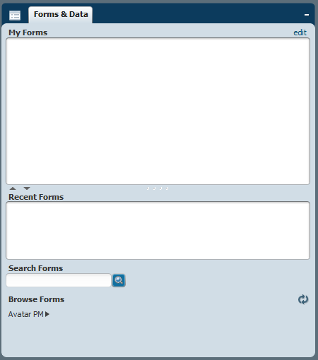

- Click Add

- Complete all fields according to the information in the client’s documents and click Submit
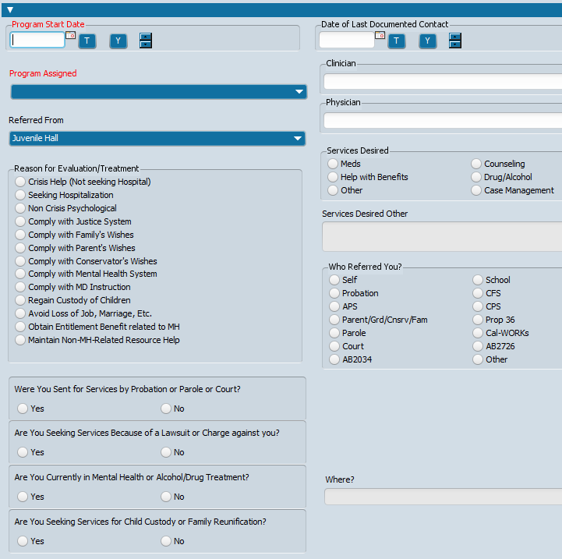

MH Admissions Bundle

- Make sure the client’s name is highlighted green and go to the Search Forms field and search for form: MH Admission Bundle.

- Select the San Bernardino County Episode and click OK.

- After receiving the chart from the clinician, update the CSI Admission form. Fill out form according to the information available in the chart. After completing the fields, click Submit.
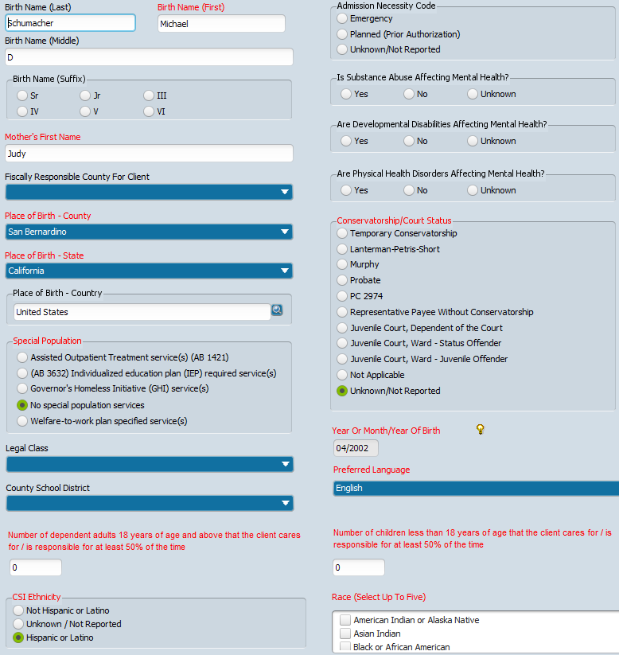

- In the Diagnosis form, complete the following fields:
- Type of Diagnosis
- Date of Diagnosis
- Time of Diagnosis
- Diagnosis (click New Row). Go to the Diagnosis Search to find the diagnosis code
- Diagnosing Practitioner
- Click Submit
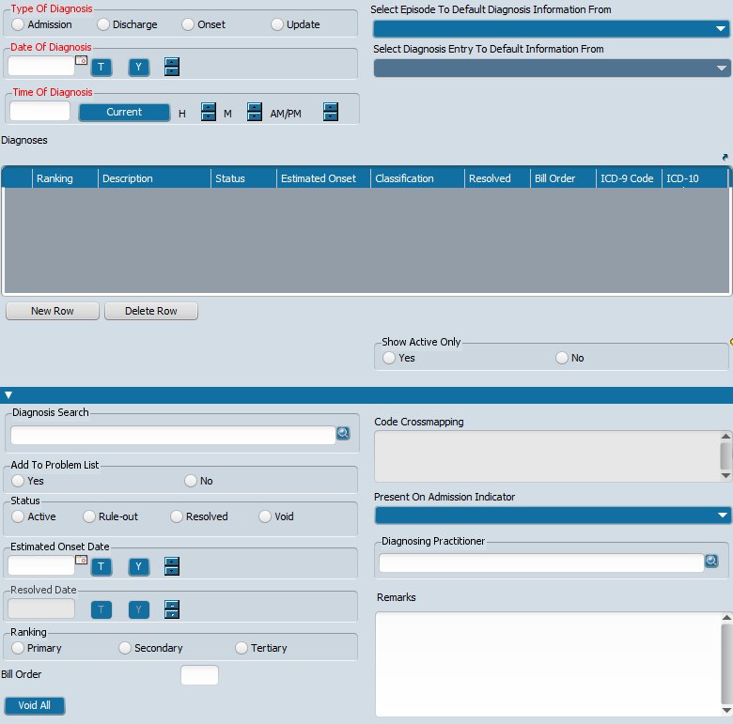
- When you get the Pre-Display Confirmation dialogue box, click No
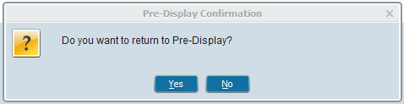

- In the Sexual Orientation and Gender Identity (SOGI) form, complete as many fields as possible according to the information in the chart and click Submit.
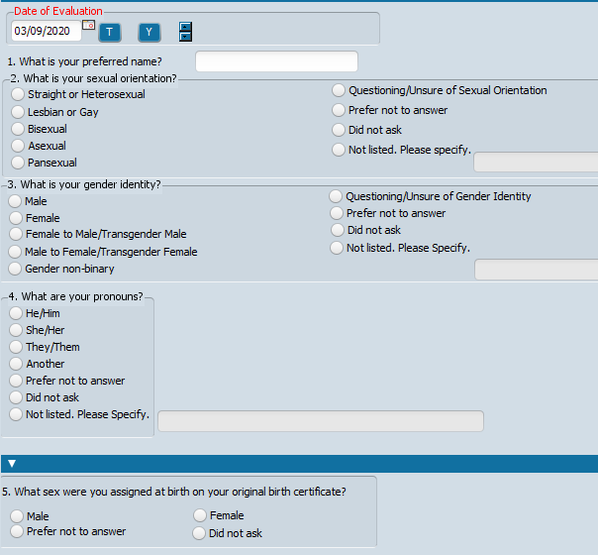

- Go to the Search Forms field and search for form Client Charge Input

- Complete the following fields:
- Date of Service
- Program
- Service Code
- Client ID
- Episode Number
- Practitioner
- Duration
- Location
- Add Co-Practitioner if co-staffing.
- Click Submit
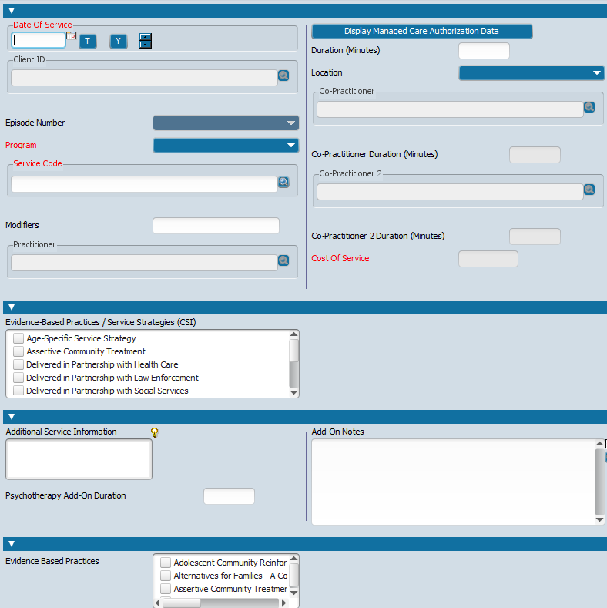
- When the Form Return dialogue box opens, click Yes if you have more services to enter, if not click No to exit form
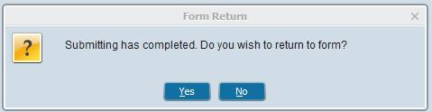

Create a Group

- Go to the Search Forms field under the Forms & Data tab. Search for form: Group Registration.

- When Select Group dialogue box opens, create a name and search to see if that name has already been used. If the name is available, then click New Group button.
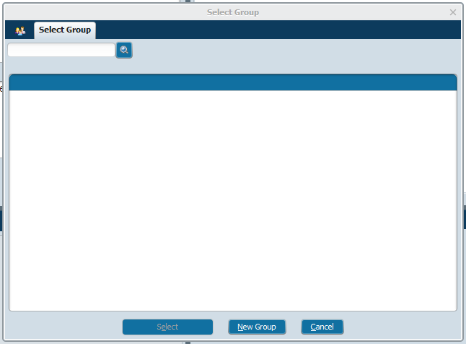
When asked “Auto Assign Next ID Number?”, click Yes.
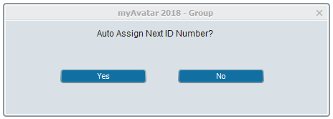
- Complete the following fields:
- Group Registration Date
- Is this Group a Family?
- Group Capacity
- Associated Groups
- Click Submit button (on the left hand side).
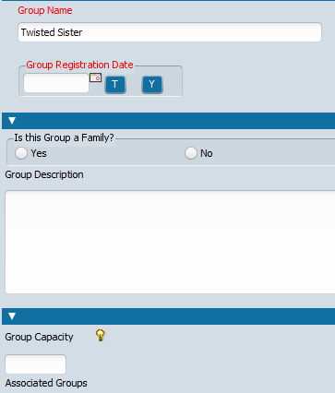

Add a Client to an Existing Group

- Go to the Search Forms field under the Forms & Data tab. Search for form: Group Member Assignment.

- When Select Client dialogue box opens, search for the member you want to add to the group. When you find the client, double-click on the client’s name.
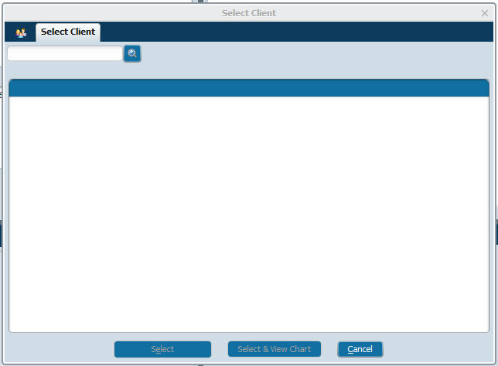

- Select the episode and click OK.

- Complete the following fields:
- Add Group Assignment Start Date.
- Go to the Select Group search field (search by group name or number). Double-click on the group name to add the client to the group.
- Click Submit button (on the left hand side).
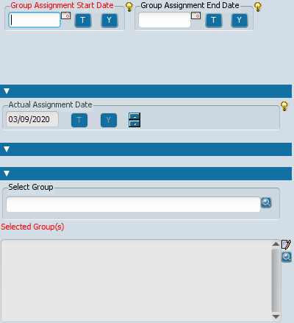

- When “Do you want to return to Pre-Display?” dialogue box opens, click No.
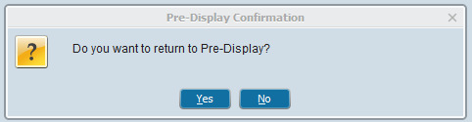

- Under the Client tab click once on the white space below the client names (wait one full Mississippi) and clicking one more time to fully deselect the client’s name.
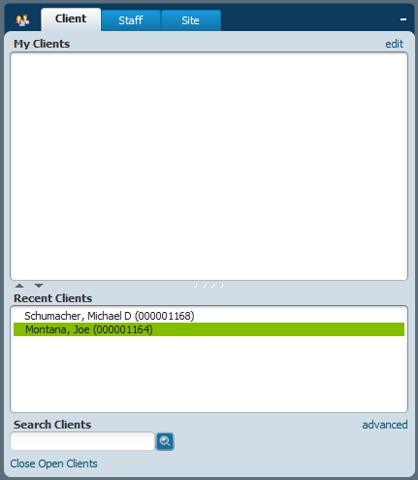

- To add additional clients to the group, repeat steps 1 through 6.

Remove a Client from a Group

- Go to the Search Forms field under the Forms & Data tab. Search for form: Group Member Assignment.

- When Select Client dialogue box opens, search for the member you want to remove from the group. When you find the client, double-click on the client’s name.
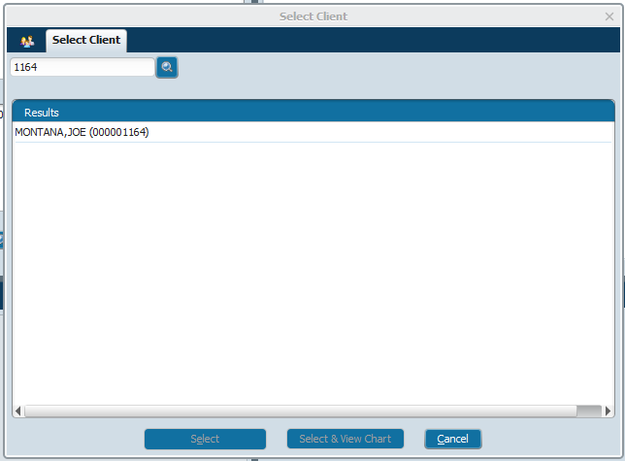

- Select the episode and click OK.

- Select the group you want to remove the client from and click Delete.
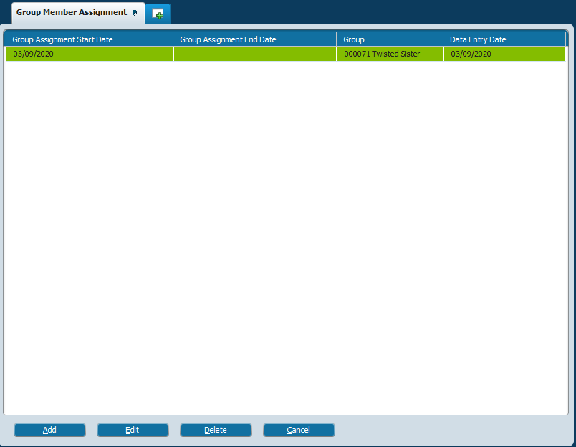

- When Delete Confirmation dialogue box opens, click Yes.
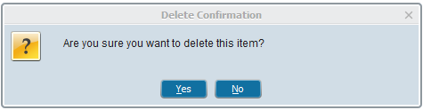

- Under the Client tab click once on the white space below the client names (wait one full Mississippi) and clicking one more time to fully deselect the client’s name.

Schedule an Appointment (for One Client)

- Go to the Search Forms field under the Forms & Data tab. Search for form: Scheduling Calendar.

- Select the site 36DK – Juvenile Justice JJP.
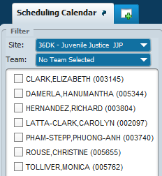

- Select the Clinician.

- Go to the day and time you want to make the appointment. Right-click and select Add Appointment. Complete the following fields:
- Insurance Verified?
- Duration
- Program (select the program first before adding the service code)
- Service Code
- Client
- Episode Number
- Click Submit button (on the left hand side). Appointment appears on the calendar.
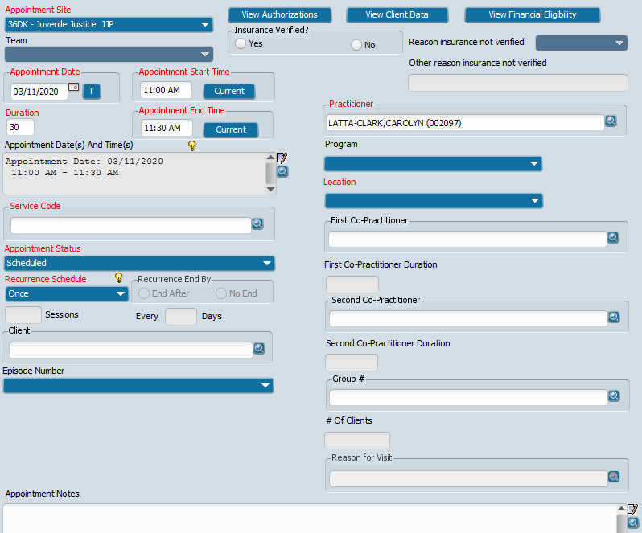

- Click Dismiss to close the calendar.

Scheduling Options (When You Right-Click)

- Go to the Search Forms field under the Forms & Data tab. Search for form: Scheduling Calendar.

- If you right-click on top of the appointment, you will get the following options:
- Details/Edit
- Reschedule
- Copy
- Status Update
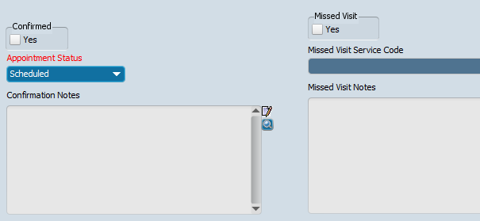
Cancelled
Emergency
No Show
Scheduled
Unscheduled
- Additional Services
- Overbook
- Delete
- View Summary (you can print the appointment details from this option)

Scheduling a Group Appointment

- Go to the Search Forms field under the Forms & Data tab. Search for form: Scheduling Calendar.

- If you right-click on top of the appointment slot and select Add Appointment.
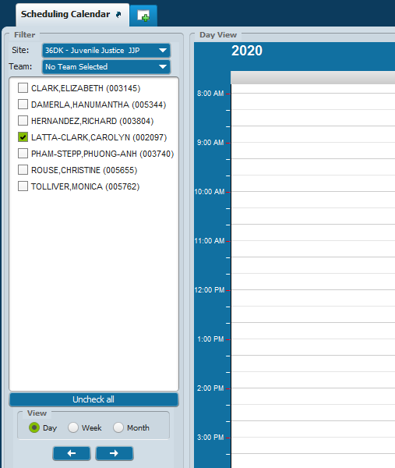
LATTA-CLARK, CAROLYN – Available
Add Appointment

- Complete the following steps:
- Duration
- Practitioner
- Program (select the program first before adding the service code)
- Location
- Service Code
- Group #
- Click Submit button (on the left hand side). Group appointment appears on the calendar.
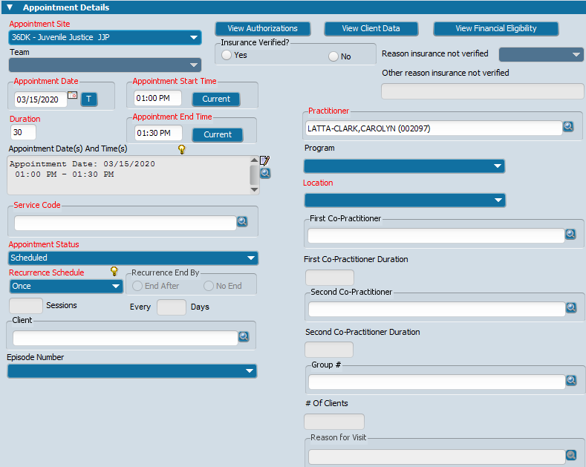

Add a Client to a Group Appointment

Note: This procedure will only add the client to this appointment, it will NOT add the client to the group permanently.

- Go to the Search Forms field under the Forms & Data tab. Search for form: Scheduling Calendar.

- Right-click on top of the group appointment and select Add/Remove Group Members. Complete the following fields:
- Add or Remove Client from Group Appointment: Add
- Client
- Episode
- Click Update Members
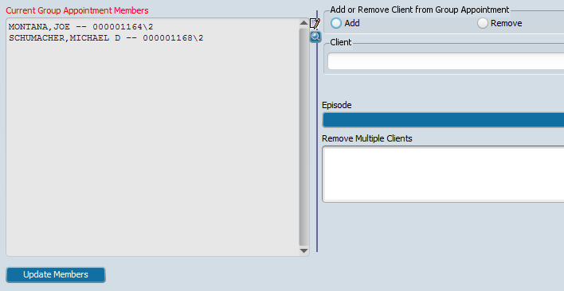

To add more clients, repeat step #2.

- Click Close Form icon to close the form.
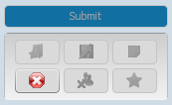
Remove a Client from a Group Appointment

Note: This procedure will only remove the client from the scheduled appointment, it will NOT remove the client from the group permanently.

- Go to the Search Forms field under the Forms & Data tab. Search for form: Scheduling Calendar.

- Right-click on top of the group appointment and select Add/Remove Group Members. Complete the following fields:
- Add or Remove Client from Group Appointment: Remove.
- From the Remove Multiple Clients field, select the client(s) you want to remove.
