Scheduling Calendar:
Type “Scheduling Calendar” into the Search Forms field in the Forms & Data widget. Double click on “Scheduling Calendar” in the drop down menu.
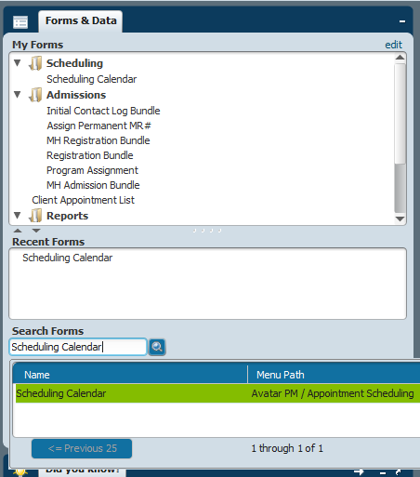

You can manage what service providers show up on the scheduling grid by selecting the Site and the practitioner.

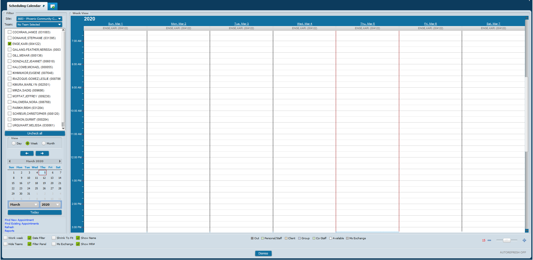

- Add Appointment
  - Click and hold on desired start time for appointment, then drag mouse down to create length of appointment.
  - Right click on newly created time slot and click on New Appointment.
  - Fill out all required Appointment Details and other pertinent data.
Note: The appointment date and times are prepopulated based on the parameters previously selected in the calendar grid.
  - Click Submit.

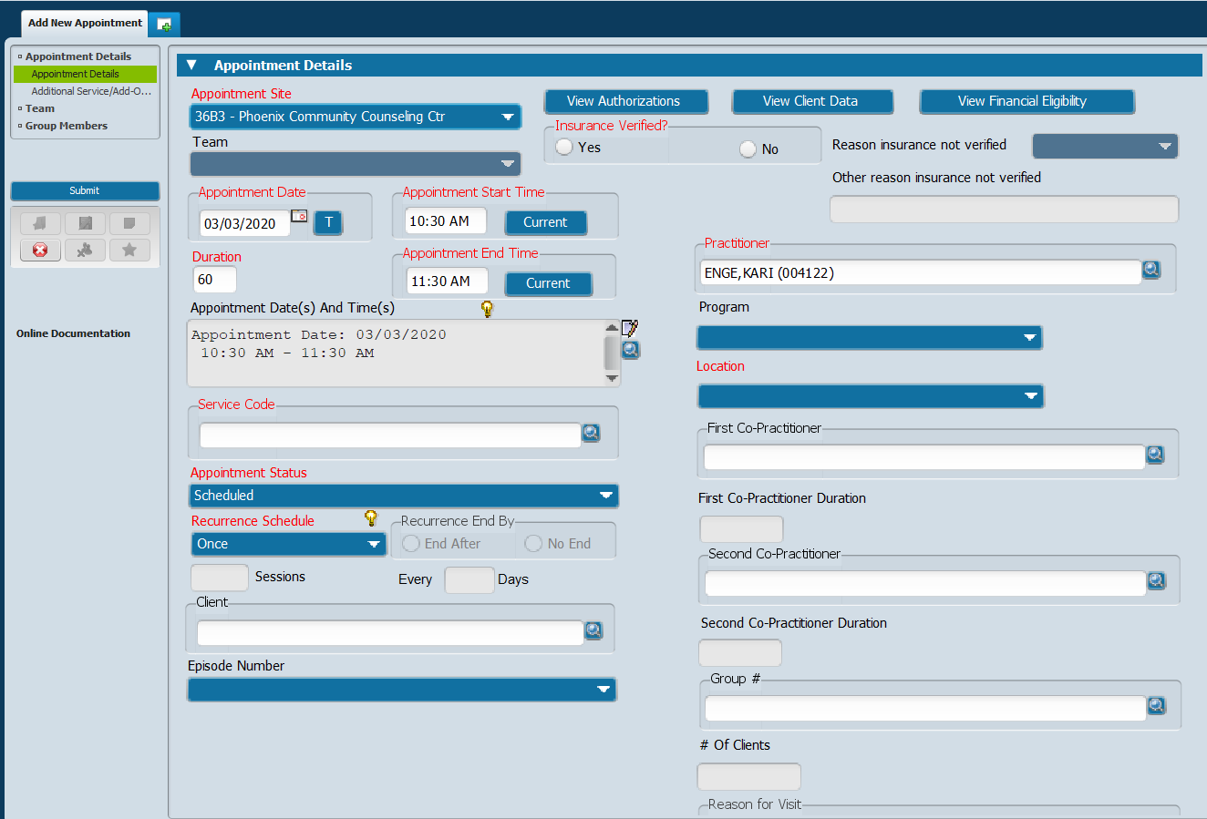

- Find New Appointment
  - Click on Find New Appointment found in the bottom left corner of the Scheduling Calendar.
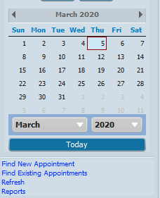

  - Fill out all required fields and other desired search parameters.
  - Click Find Availability.

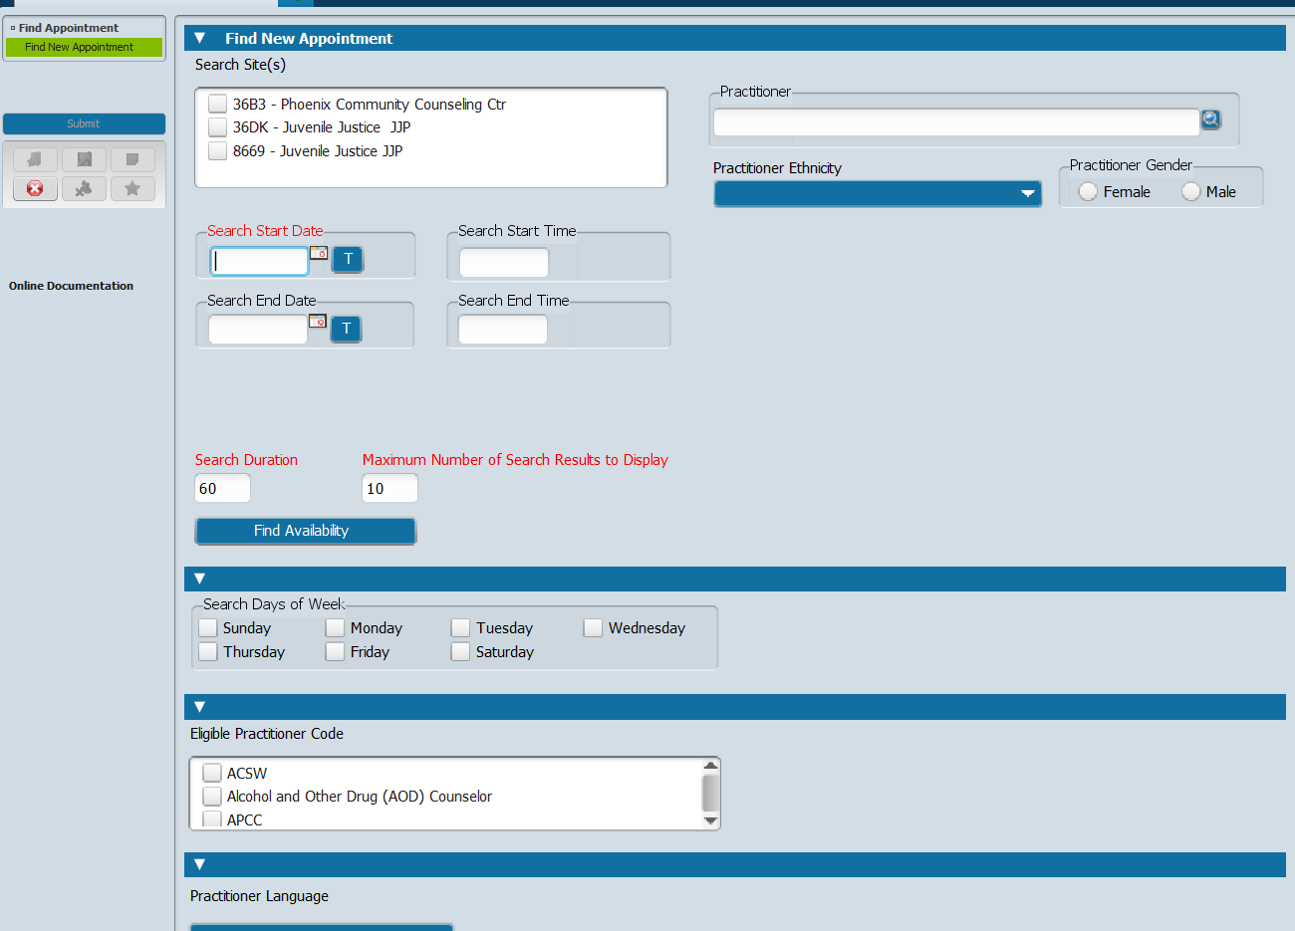

Note: A new window will pop-up showing the search results.
  - Click on your selection then click OK. This will generate the Appointment Details form with the selected appointment details prepopulated.

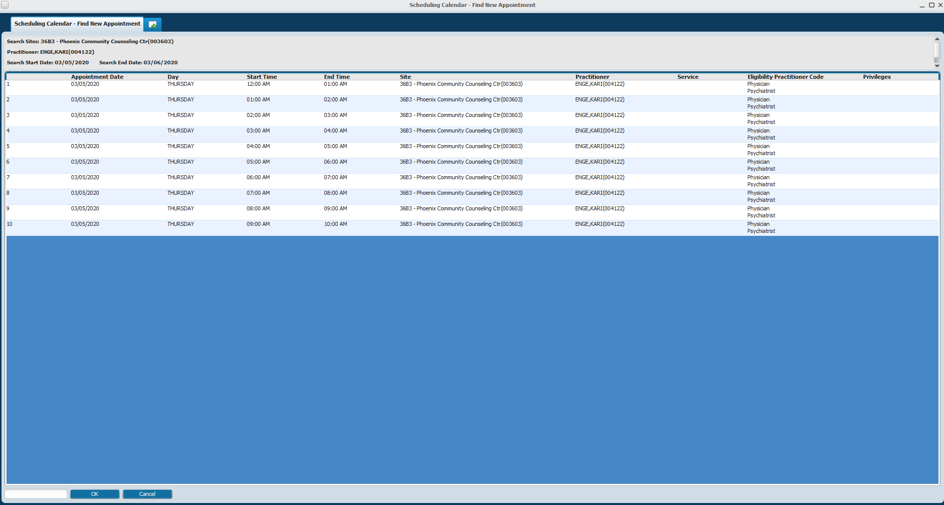

  - Complete the remaining required fields then click Submit.

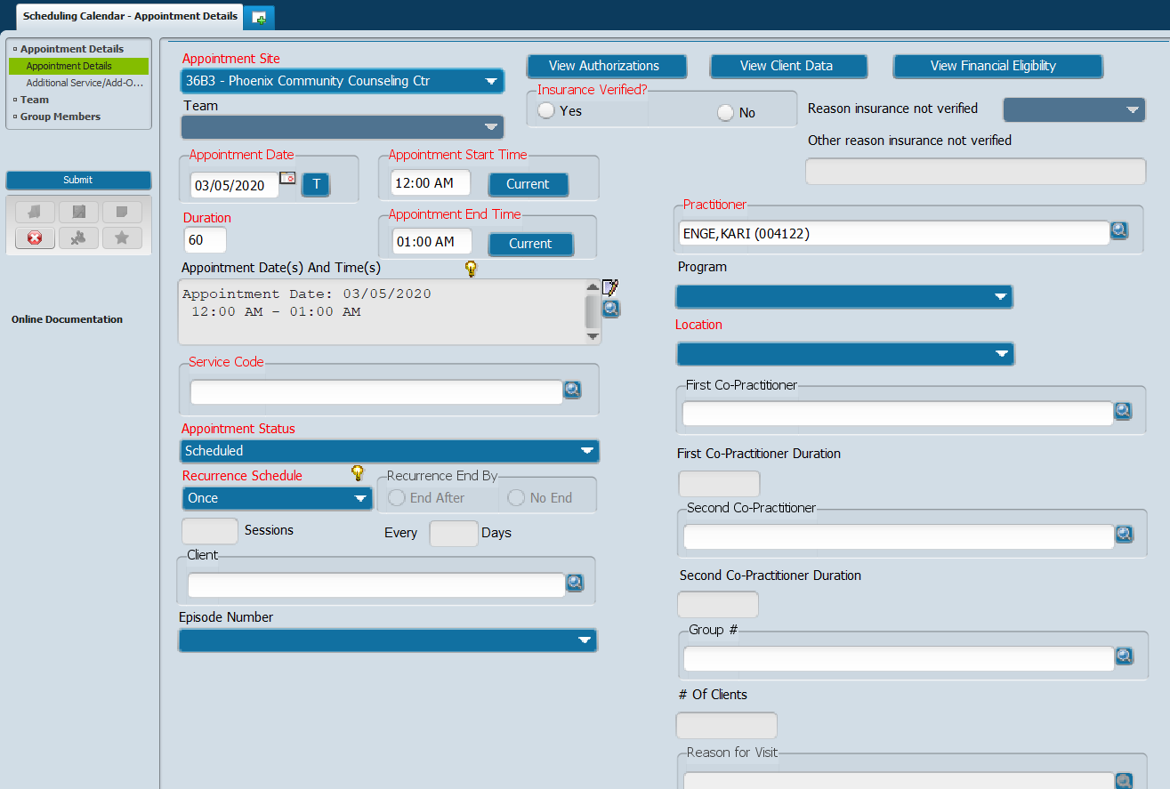

- Find Existing Appointment
  - Click on Find Existing Appointments in bottom left corner of the Scheduling Calendar.

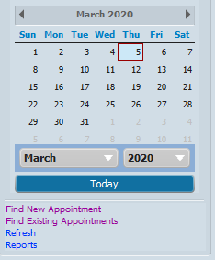
  - Fill in all the required fields and any other desired search parameters. Then click Find Appointment.

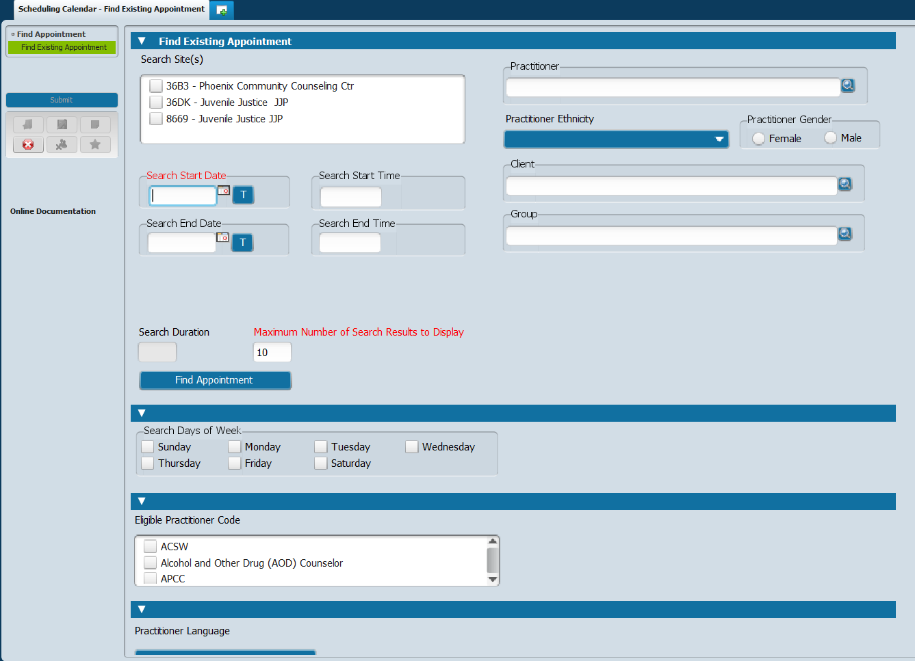

Note: A new window will pop-up showing the search results.
  - Click on the appointment you select to look at. Then click OK. This will take you to the appointment in the calendar grid.
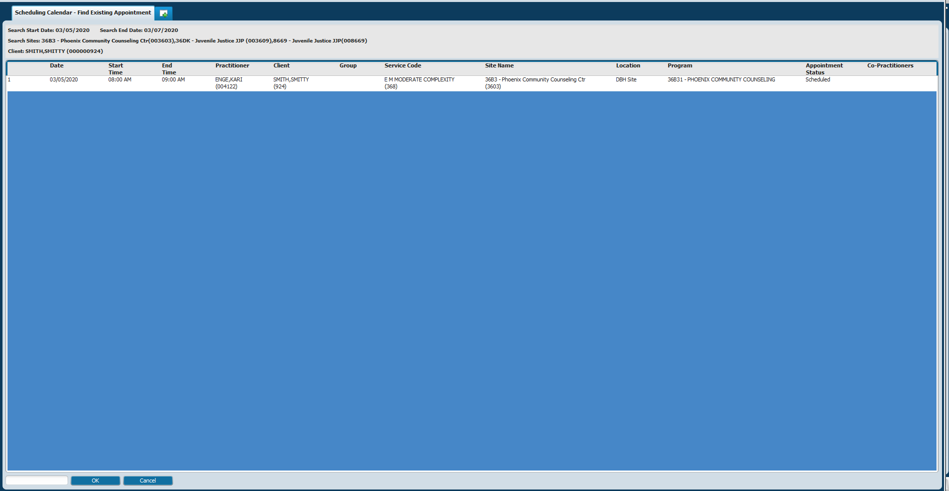

- Rescheduling Appointment
  - Right click on the appointment you wish to reschedule. Click on Reschedule in the menu.

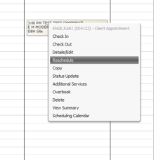
Note: If done correctly the appointment block will look greyed out.
  - Right click and hold on the appointment block then drag it to the desired location.

- Editing Appointments
  - Right click on the appointment you wish to edit. Click on Details/Edit in the menu.
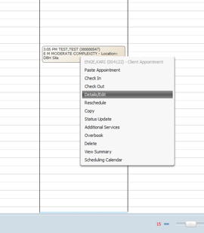
Note: This will generate the Appointment Details.
  - Edit appointment details, making sure the required fields are completed, then click Submit.

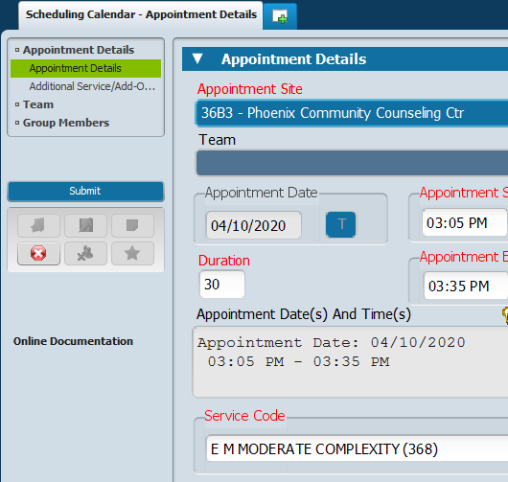

- Scheduling Group Appointments
  - Beginning at the appointment start time, click and drag the cursor for the duration of the appointment. This will create the appointment block.

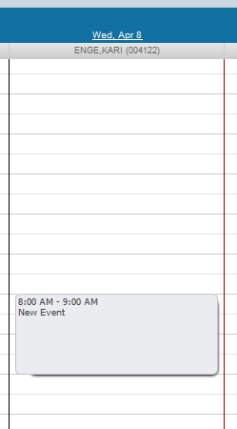

  - Right click on the newly created appointment block and select Add Appointment.

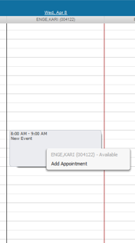

  - Complete all the required fields.
  - Search for Group by typing in the Group # or Group Name in the “Group #” field.

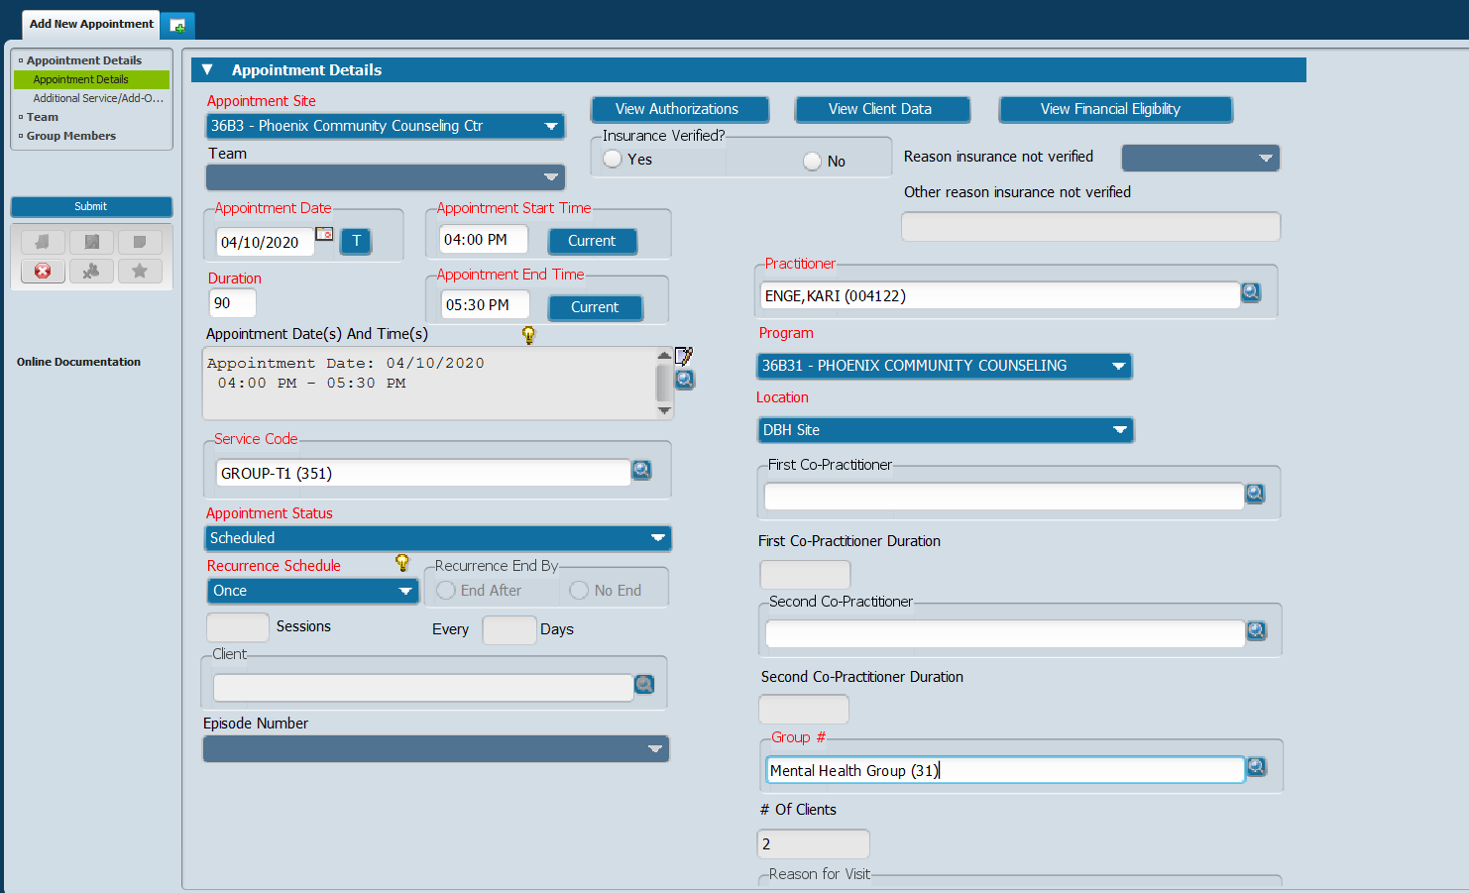

  - After all fields have been entered click Submit.

- Appointment Management
  - Type “Appointment Management” in the Search Forms field in the Forms & Data Widget.
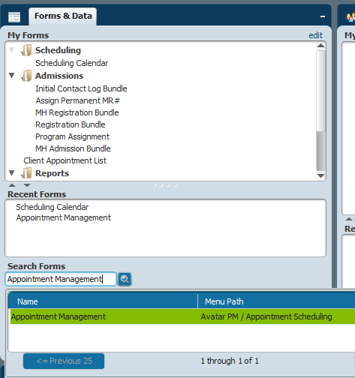

  - Double click on Appointment Management to generate form.

  - Select Practitioner by typing their name in the Practitioner field.
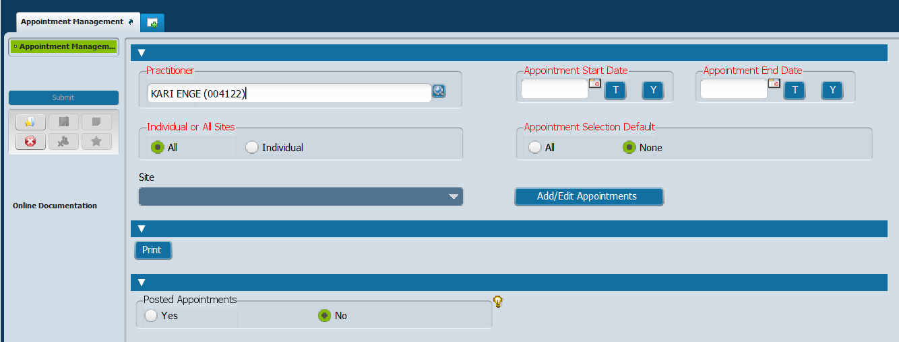

  - Select date range by entering in Appointment Start Date and Appointment End Date.

  - Click on Add/Edit Appointment to Generate a list of appointments within that date range that can be added to or deleted from.

  - Click on Print to generate a printable list of appointments within that date range.

- Appointment Move/Delete
  - Type “Appointment Move/Delete” in the Search Forms field in the Forms & Data widget.

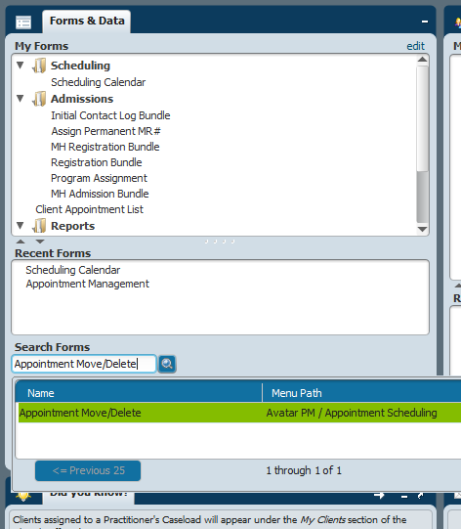

  - Double click on Appointment Move/Delete to generate Appointment Move/Delete form.

  - Select practitioner by typing in the name in the Practitioner field.
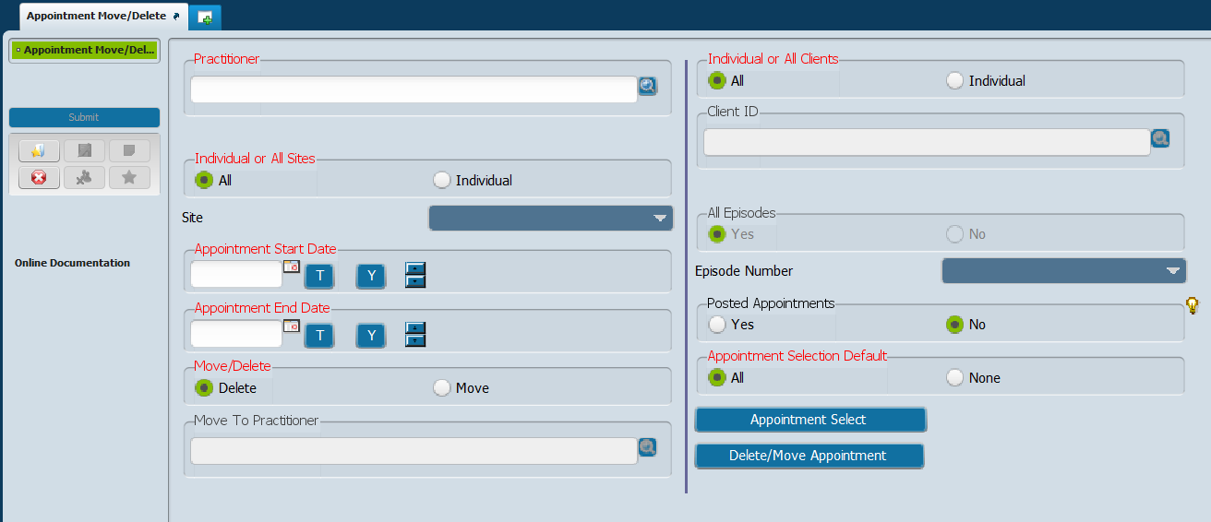

  - Select All or Individual sites.

  - Select date range of appointments by entering in an Appointment Start Date and Appointment End Date.

  - Select to Delete or Move the appointments within the date range.
    - If you select to Move appointment then enter the practitioner you wish to move the appointment(s) to in the Move To Practitioner field.

  - Select to include All or Individual client(s) within the date range.
    - If you select Individual then enter the client ID number into the Client ID field.

  - Click on Appointment Select to generate the list of appointments to select from.

  - Select appointments from the list then click OK.
  - Click on Delete/Move Appointment to perform function.

