- Search forms: EOB Report
- Double click EOB Report
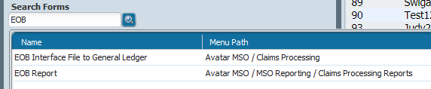
This will pop-up
- Click on drop-down
- A line of number will show, scroll down and try the highest #, they are not always in order.
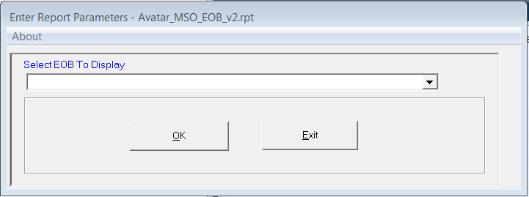

- Click OK
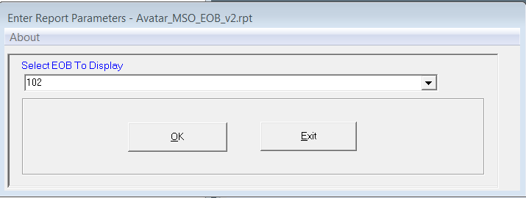

EOB Summary will come up:

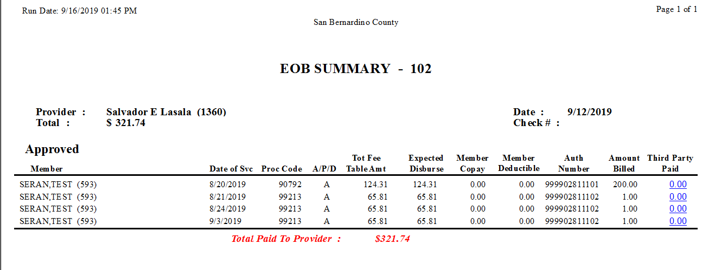

For the rest of the claims go back to the: Select EOB to Display: enter the # above the last number. 101
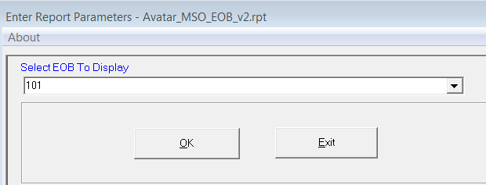

This will bring up the other amounts that were input.
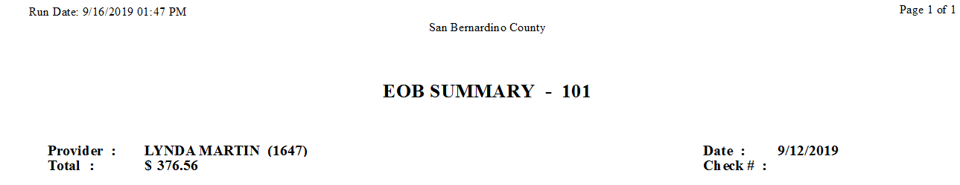
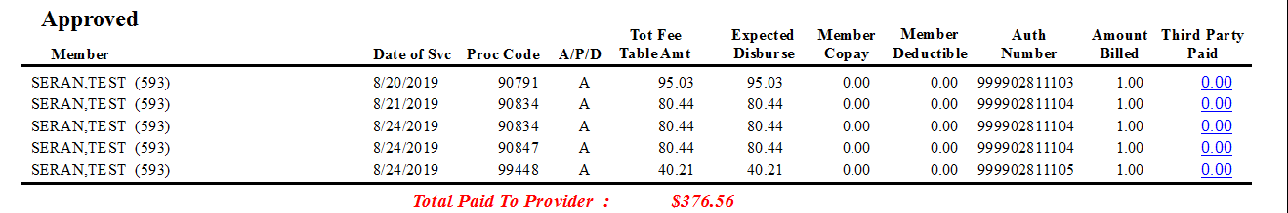
NOTE: under Amount Billed it’s showing $1.00 because the dollar amt the provider was billing was left out and it defaulted to the contract (Medi-cal rate) amount.
Print and Send to Providers after the deposits have been made.

