Authorization Request Medication Review
- Authorization Request Medication Review opens-Complete RED areas.
- Choose correct Authorization Number in dropdown if more than one is listed.

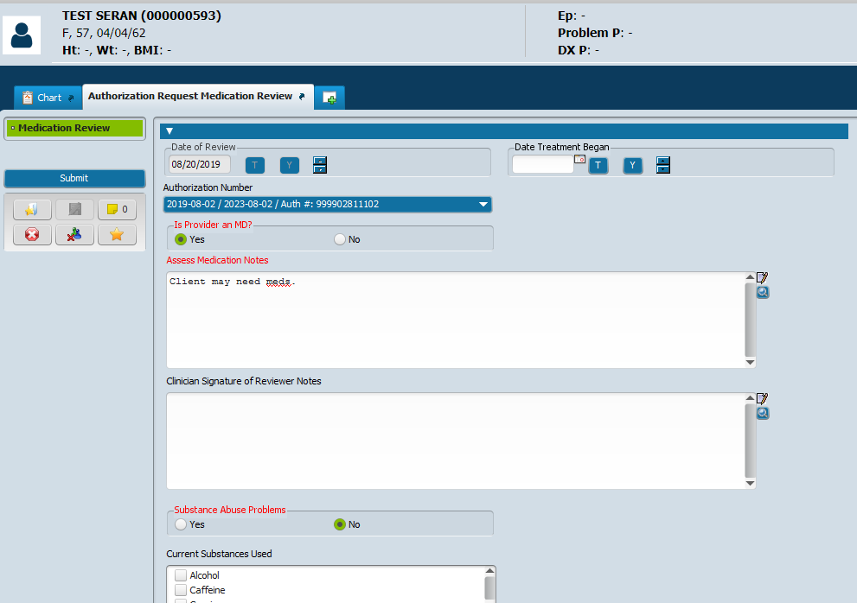
- After entries are made, list name at bottom.
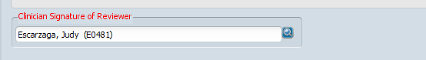
- SUBMIT
- Takes you back to the Home screen.

If you need to go back and add more notes:
- Select Forms-Authorization Request-Choose the form
- Click add, edit
