


Marriage & Family Therapy Internship Program 2026-2027



Contents

About the Department of Behavioral Health 2
Marriage & Family Therapy Internship Program Overview 3
Internship Program Mission 3
Internship Experience 3
Training 3
Supervision 3
Internship/Traineeship Locations 4
Schedules 4
Compensation 4
Paid Positions 4
Unpaid Positions 4
Application Requirements 5
Application and Selection Process 5
Positions after Internship 6
Contact Information 6
Related Sites 6

About the Department of Behavioral Health

The San Bernardino County Department of Behavioral Health (DBH) is a comprehensive community mental health organization that provides the full range of mental health services to the 2,000,000 people in the largest county (in area) in the continental 48 states. The Department has approximately 1,300 employees, including psychologists, psychiatrists, social workers, marriage and family therapists, nurses, case managers, mental health specialists, and interns in various disciplines. In addition, outpatient, forensic, day treatment, and clubhouse services are provided in the Department's multiple community-based clinics and programs.
Treatment Orientation
The Department of Behavioral Health adheres to the community mental health philosophy, including early treatment of emotional disorders, providing services in non-clinic locations when appropriate, and responsiveness to changing community needs. California uses the "Recovery Model" to deliver Medi-Cal/Medicaid services, emphasizing services for those in acute need, the severely and persistently mentally ill, and "at-risk" children and families. The Department continues to make progress in implementing a "mental health recovery" philosophy of care, which emphasizes optimism regarding client improvement, assistance with basic resource needs, client empowerment, reintegration into the community, and the value of client self-help. Outpatient services involve a strong emphasis on brief treatment and group treatment, though interns may have the opportunity to work with some clients for the entire year. A wide range of theoretical orientations are found among our staff, including Psychodynamic, Cognitive-Behavioral, Humanistic, Gestalt, and Narrative Therapy. The Department is committed to the multidisciplinary team concept, and interns will gain experience working alongside other disciplines as part of a services team.

Department of Behavioral Health Mission Statement

San Bernardino County Behavioral Health Programs strive to be recognized as a progressive system of seamless, accessible and effective services that promote prevention, intervention, recovery and resiliency for individuals, families and communities.

Marriage & Family Therapy Internship Program Overview

Internship Program Mission
The mission of the Marriage and Family Therapy (MFT) Internship Program is to provide a quality training experience that will prepare MFT trainees to become competent, effective, and ethical therapists. We value diversity within our staff as well as in our clients and are committed to providing a practicum experience that promotes respect, care, compassion, and understanding.

Internship Experience
MFT Practicum Students are placed in our clinical programs with the best opportunity for a wide range of clinical experience with adults, children, and families. Our clinical training corresponds with local college and university learning objectives for the level of the student and incorporates training applicable to the diverse cultures and populations we serve.

Depending on the program in which the trainee is placed, trainees may have the opportunity to provide triage, case management, initial screenings, and clinical assessments, as well as individual, family, and group therapy with children and/or adults. Trainees may also have the opportunity to provide crisis intervention with the support of clinical staff. Caseloads vary with the readiness of the student, but most trainees build up to 7 to 10 client hours per week. Attention is paid to each student's school requirements to assist in meeting practicum requirements.

Training
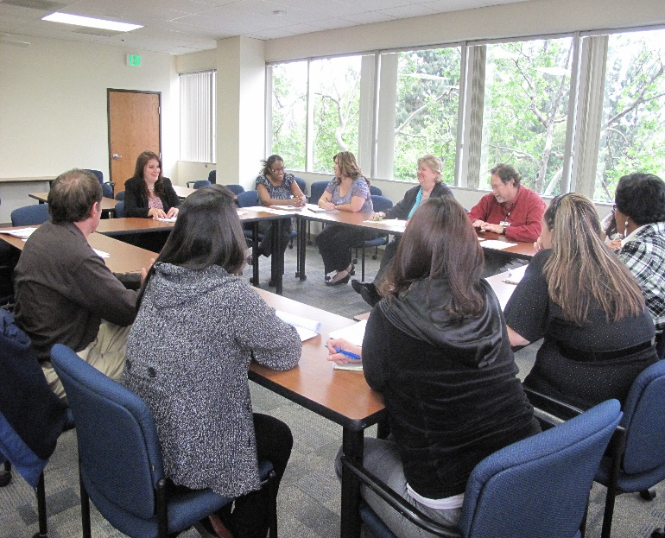
All trainees attend a 2-week orientation and training session to the MFT Internship Program from the MFT Intern Program Supervisor and additional DBH staff. Trainings and topical discussions are also ongoing components of group supervision. Additionally, students have access to an extensive online training program provided by DBH. The Department also offers live trainings on an ongoing basis, covering a variety of topics. Students are welcome to attend DBH trainings with the approval of their supervisor.

Supervision

Students receive weekly individual supervision from their assigned clinical supervisor at their site, a licensed MFT, or on occasion, other appropriately licensed staff (e.g., Licensed Clinical Social Worker, Licensed Psychologist). Students also attend a weekly 2-hour group supervision, which occurs on either Tuesday or Wednesday, with the MFT Intern Program Supervisor at the Internship Program office located in San Bernardino. Depending on availability, group supervision might be provided at the placement site instead of with the Intern Program Supervisor. Additional Group Supervision meetings may be scheduled as needed depending on the number of interns in a given year. Individual and Group Supervision are included in the 20-hour internship schedule.

Internship/Traineeship Locations
Selected trainees might work in the outpatient setting with clinics in Ontario, Fontana, Rialto, San Bernardino, Victorville, Apply Valley, Barstow, and Needles. The outpatient programs serve their surrounding communities, including adults, children, and families. Forensic sites available to trainees are located in Colton, San Bernardino, and Victorville. Some DBH programs offer specialized services, such as field-based and intensive programs for adults or children. Available internship sites vary by year.

Schedules
Each internship is for a period of one year. Trainees are expected to work 20 hours each week with the exception of holidays and other requested time off. Hours are worked during normal business hours (M-F, 8-5) and are flexible to work around the student's academic schedule, typically resulting in two 8-hour days and one 4-hour day per week. During work time, trainees see clients for therapy, complete clinical assessments, complete clinical paperwork, facilitate groups, and attend weekly individual and group supervision.

Compensation

Paid Positions
Each year there are a set number of paid positions available which are paid at an hourly rate that is authorized and updated annually. Trainees are paid for hours worked (20 hours), except for holidays and other requested time off. Students are paid on a bi-weekly basis for the hours worked during each pay period.

The Department does not provide health insurance for trainees but does provide worker's compensation coverage and 24 hours of sick leave coverage in a fiscal year upon working 90 days.

Unpaid Positions
There may be unpaid trainee placements available, which vary in number from year to year. Students can apply in the same manner as for the paid positions. The student should indicate if they are available for an unpaid position should the paid positions be filled when submitting their application. Unpaid students are expected to work 20 hours a week and will receive the same supervision and training available to the paid students.
“The Intern Program was very helpful to me and provided me with a great deal of experience with diverse populations and the mental health field. All the county employees that I had interactions with were very friendly and helpful.” - Former MFT Trainee

Application Requirements
- Applicant must be enrolled in a university program that meets the California Board of Behavioral Sciences (BBS) requirements for MFT licensure.
- Applicant must complete 12 semester units or 18 quarter units by the start date of the internship.
- Applicant must have adequate malpractice insurance provided by their university or themselves.
- The applicant's university must have an existing standard contract with DBH or be willing to enter one.

There is no limit to the number of students who may apply from a graduate program, and students need not be preselected by their school.

The Department of Behavioral Health offers internship opportunities to current county employees through the Employee Educational Internship Program (20/20 program). Current county employees are encouraged to reference the Career and Internship Webpage for further information regarding eligibility and application requirements.

Application and Selection Process
Students need to submit an application and any supporting documents requested to apply to the program. The application process is subject to change and instructions on how to apply can be found on our DBH website: https://wp.sbcounty.gov/dbh/careers/

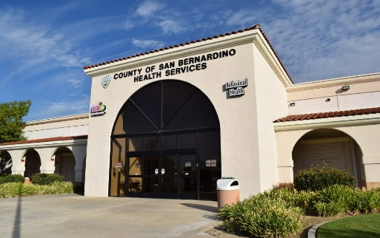
The application period is open February 1 – March 7 each year for the Fall cohort (July start). The program may consider an additional Spring cohort (January Start). The application period is open July 1-31 for the Spring cohort (January start). Please monitor the website for specific application deadlines. All applicants who apply before the deadline will receive a status update regarding interview offers.

Interviews for the Fall cohort are conducted between late February and March by the Clinic Supervisor of the MFT Internship Program. Internship positions for the Fall cohort will be offered by the end of April. Interviews for the Winter/Spring cohort are conducted in August and internship positions will be offered by late September.

Students who are chosen for positions will then complete the hiring and background process through DBH Human Resources and Payroll. Admission to the internship program is contingent upon successful completion of the hiring and background process. Successful applicants will begin internship orientation in early July for Fall cohorts and be placed in their clinical sites approximately mid-July. Winter/Spring cohorts will begin orientation in January and be placed in their clinical sites approximately mid-January. All dates are subject to change. Please visit the DBH Career and Internship website for updated information.

Positions after Internship
While DBH does not guarantee being hired after completing the internship, the Department is committed to hiring applicants who previously completed an internship at DBH. An internship in the MFT Internship Program provides valuable experience and training that uniquely prepares participants for success within the Department

Contact Information
If you would like more information about the program, feel free to contact:

Marriage & Family Therapy Internship Program
County of San Bernardino
Department of Behavioral Health
735 E Carnegie Dr, Suite 270
San Bernardino
(909) 658 -1060
DBHInternPrograms@dbh.sbcounty.gov

Erika Nunez, LMFT
Marriage and Family Therapy Internship Program Supervisor
(909) 658 -1046
ENunez@dbh.sbcounty.gov

Related Sites
American Association for Marriage and Family Therapy
California Association of Marriage and Family Therapists
California Board of Behavioral Sciences

