


Social Work Internship Program
Year 2026-2027



Contents

About the Department of Behavioral Health 2
Social Work Internship Program Overview 3
Micro (Clinical) Practice Placements 3
Macro (Community) Practice Placements 4
Training 5
Supervision 5
Individual Supervision 5
Group Supervision 5
Internship Locations 6
Schedules 6
Compensation 6
Paid Positions 6
Unpaid Positions 6
Eligibility Requirements 7
Application and Selection Process 7
Positions After Internship 8
Contact Information 8

About the Department of Behavioral Health

The San Bernardino County Department of Behavioral Health (DBH) is a comprehensive community mental health organization that provides the full range of mental health services to the 2,000,000 people in the largest county (in area) in the continental 48 states. The Department has approximately 1,300 employees, including psychologists, psychiatrists, social workers, marriage and family therapists, nurses, case managers, mental health specialists, and interns in various disciplines. In addition, outpatient, forensic, day treatment, and clubhouse services are provided in the Department's multiple community-based clinics and programs.
Treatment Orientation
The Department of Behavioral Health adheres to the community mental health philosophy, including early treatment of emotional disorders, providing services in non-clinic locations when appropriate, and responsiveness to changing community needs. California uses the "Recovery Model" to deliver Medi-Cal/Medicaid services, emphasizing services for those in acute need, the severely and persistently mentally ill, and "at-risk" children and families. The Department continues to make progress in implementing a "mental health recovery" philosophy of care, which emphasizes optimism regarding client improvement, assistance with basic resource needs, client empowerment, reintegration into the community, and the value of client self-help. Outpatient services involve a strong emphasis on brief treatment and group treatment, though interns may have the opportunity to work with some clients for the entire year. A wide range of theoretical orientations are found among our staff, including Psychodynamic, Cognitive-Behavioral, Humanistic, Gestalt, and Narrative Therapy. The Department is committed to the multidisciplinary team concept, and interns will gain experience working alongside other disciplines as part of a services team.

Department of Behavioral Health
Mission Statement

San Bernardino County Behavioral Health Programs strive to be recognized as a progressive system of seamless, accessible and effective services that promote prevention, intervention, recovery and resiliency for individuals, families and communities.

Social Work Internship Program Overview

The Social Work Internship Program offers a wide variety of learning opportunities through internships within the Department of Behavioral Health (DBH) to Bachelor of Social Work (BSW), 1st and 2nd year Master of Social Work (MSW), and Advanced Standing Social Work students. Internship placements are designed to fit student interests, meet local universities' objectives, and enable students to achieve proficiency in the core Social Work Competencies identified by the Council on Social Work Education:

- Demonstrate Ethical and Professional Behavior
- Advance Human Rights and Social, Racial, Economic, and Environmental Justice
- Engage Anti-Racism, Diversity, Equity, and Inclusion (ADEI) in Practice
- Engage in Practice-informed Research and Research-informed Practice
- Engage in Policy Practice
- Engage with Individuals, Families, Groups, Organizations, and Communities
- Assess Individuals, Families, Groups, Organizations, and Communities
- Intervene with Individuals, Families, Groups, Organizations, and Communities
- Evaluate Practice with Individuals, Families, Groups, Organizations, and Communities

Micro (Clinical) Practice Placements
The Social Work Internship Program offers opportunities for interns to gain a wide range of clinical experience with adults, children, and families. Under the guidance and support of highly trained and experienced staff, interns gain experience in the following:

- Triage and initial screening
- Crisis assessment and intervention
- Clinical assessment and diagnosis (MSW only)
- Individual, family, and group therapy (MSW only)
- Case management and complex care coordination
- Participation in a multi-disciplinary team
- Collaboration with professionals at other agencies such as Probation, Law Enforcement, and Children & Family Services
- Linkage and referral to additional community programs and supports

Caseloads vary but most interns in clinical settings build up to 7 to 10 client hours per week. Interns may also be placed in programs that primarily provide services in a community setting such as crisis response and homeless outreach teams.

Macro (Community) Practice Placements
The Social Work Internship Program offers opportunities for interns to gain a wide range of macro practice experience in the following:
- Community outreach
- Psychoeducation and stigma reduction
- Prevention and early intervention
- Facilitation/ co-facilitation of community stakeholder groups
- Research
- Development and presentation of trainings
- Staff recruitment and retention
- Program planning and evaluation
- Preparation of state-required reports
- Leadership and administration
- Policy development

“This internship enabled me to gain first-hand exposure to working in the real world. It also allowed me to harness the skill, knowledge, and theoretical practice I learned in school.” - Former BSW Intern

Training
All interns attend a 2-week orientation and training session to the Social Work Internship Program facilitated by the Social Work Clinic Supervisor and additional DBH staff. Trainings and topical discussions are ongoing components of group supervision. Interns will also receive training from their practicum instructors. Although training styles vary, the process may include job shadowing, reverse job shadowing, reading assignments, and other training methods. In addition, the Department offers excellent live and online trainings on an ongoing basis, covering various topics, that the interns are welcome to attend with the approval of the Clinic Supervisor.

Supervision
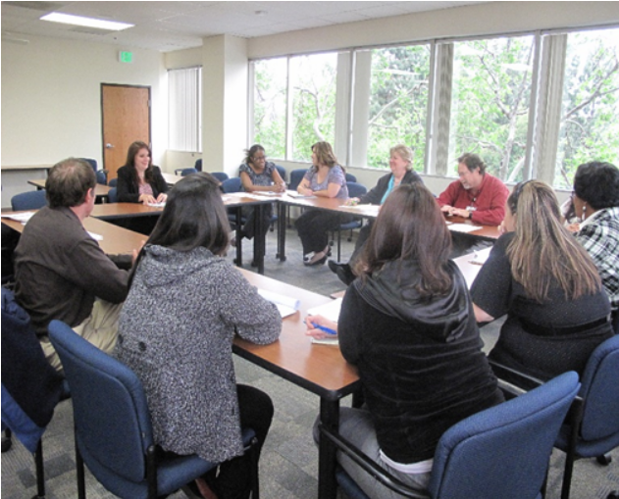
The Social Work Internship Program utilizes a strengths-based and growth-oriented approach. The goal is to help interns achieve high professional standards by providing clear expectations, meaningful direct service opportunities, and excellent supervision.
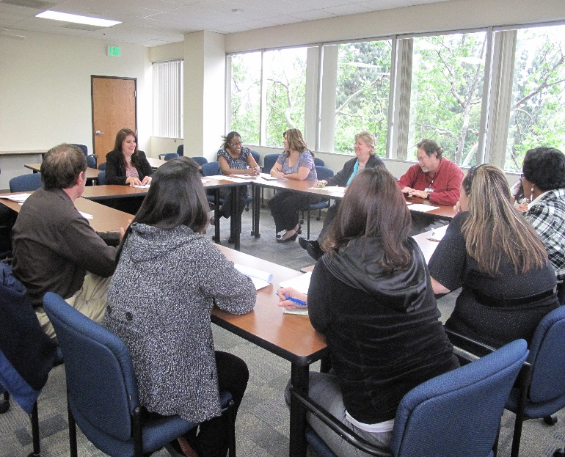
Interns receive a combination of individual and group supervision from their practicum instructor and Clinic Supervisor. All practicum instructors meet the qualifications set forth by the Council on Social Work Education. Individual and Group Supervision sessions are included in the intern's weekly 16 -20 hour schedule.

Individual Supervision
Interns receive individual supervision from their assigned practicum instructor. Interns work collaboratively with their practicum instructors to develop an individualized learning plan. Although supervision styles vary, supervision typically includes client case discussion, documentation review, project status and review, professional identity development, and exploration of legal and ethical standards.

Group Supervision
Interns attend group supervision sessions at the Internship Program office located in San Bernardino with the Clinic Supervisor and program cohort. Depending on availability, group supervision might be provided at the placement site instead of the Internship Program office. Group supervision provides the opportunity to receive support from peers and gain experience in professional case presentation. Throughout the internship year, guest presenters may attend group supervision sessions to provide training on clinical interventions and theoretical orientations, discuss programs and services in the Department of Behavioral Health, or to provide information about potential additional resources in the community.

Internship Locations
Selected interns are placed in clinics and programs located throughout San Bernardino County, including:

- East Valley (Loma Linda, Redlands, San Bernardino, Yucaipa)
- Central Valley (Colton, Rialto)
- West Valley (Chino, Ontario, Rancho Cucamonga, Upland)
- High Desert (Adelanto, Apple Valley, Hesperia, Victorville, Barstow).

Outpatient programs serve their surrounding communities including adults, children, and families. In addition, some DBH programs offer specialized services, such as field-based and intensive programs to these communities. At the interview, applicants are asked to identify which geographical areas they are willing to be placed in and whether they can accept placement in a field-based program. Declining to accept placement in a field-based setting will not preclude applicants from being offered an internship position in another DBH setting.

Schedules
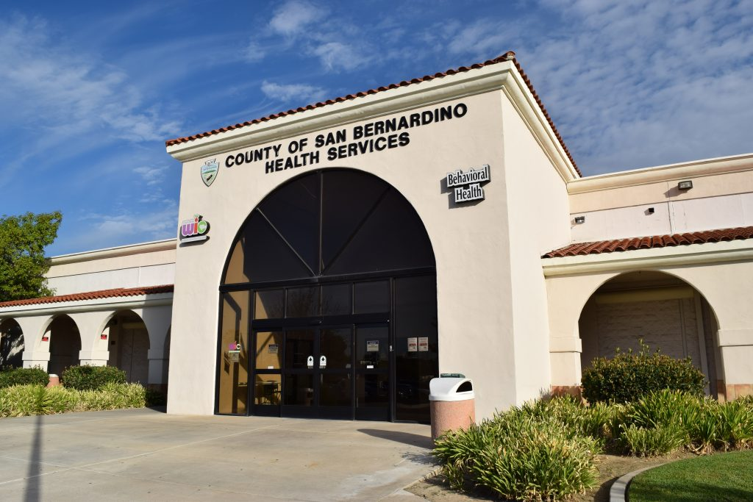
Interns are expected to complete 16-20 hours a week with the exception of holidays and other requested time off. Interns on a 16-hour schedule typically work two full days, and interns on a 20-hour schedule typically work two full days and one half-day. Weekly schedules are within traditional business hours.

Compensation

Paid Positions
There are a set amount of paid internship positions available each year. Interns are expected to work 16 – 20 hours per week at an hourly rate that is authorized and updated annually. Interns are paid bi-weekly for hours worked during each pay period.

The Department does not provide health insurance for interns but does provide worker's compensation coverage and 24 hours of sick leave coverage in a fiscal year upon working 90 days.

Unpaid Positions
Unpaid internship placements are available but vary in number from year to year based on the availability of placement sites. Students can apply in the same manner as for the paid positions. The student should indicate if they are available for an unpaid position should the paid positions be filled when submitting their application. Unpaid interns are expected to work 16 - 20 hours a week and will receive the same supervision, experience, and training available to the paid students.

Eligibility Requirements
- Applicant must be enrolled in a BSW or MSW program.
- Applicant must have adequate malpractice insurance provided by their university or themselves.
- The applicant's university must have full accreditation from the Council on Social Work Education. Applicants can confirm their university's current accreditation status at the CSWE website:
https://www.cswe.org/Accreditation/Directory-of-Accredited-Programs.aspx
- Applicant's university must have an existing standard contract with DBH or be willing to enter one.

Application and Selection Process
Students need to submit an application and any supporting documents requested to apply to the program. The application process is subject to change and instructions on how to apply can be found on our DBH website:

https://wp.sbcounty.gov/dbh/careers/

The application period is open February 1 – March 7 each year for the Summer/Fall cohort (July -December start). The program may consider an additional Winter/Spring cohort (January - June Start). The application period is open July 1-31 for the Spring cohort (January start). Please monitor the website for specific application deadlines. All applicants who apply before the deadline will receive a status update regarding interview offers.
"I have really grown and become more confident in my clinical skills." – Former MSW Intern

Interviews for the Summer/Fall cohort are conducted mid-March through early April by the Social Work Internship Clinic Supervisor and additional interview panel members. Internship position offers are made by mid-April. Interviews for the Winter/Spring cohort are conducted in August and internship positions will be offered by late September.

Students who are chosen for positions will then complete the hiring and background process through DBH Human Resources and Payroll. Admission to the internship program is contingent upon successful completion of the hiring and background process. The majority of successful applicants will begin internship orientation in mid-August for Fall cohorts and be placed in their sites approximately the beginning of September. Winter/Spring cohorts will begin orientation in mid-January and be placed in their sites approximately the end of January. All dates are subject to change. Please visit the DBH Career and Internship website for updated information.

Positions After Internship
While DBH does not guarantee being hired after completing the internship, the Department is committed to hiring applicants who previously completed an internship at DBH. An internship in the Social Work Internship Program provides valuable experience and training that uniquely prepares participants for success within multiple clinical, program development, and administrative positions within the Department.
“This program is essential in promoting growth and professional development. I am very appreciative of all my experiences and know that I have gained competencies and skills necessary to promote wellness to the clients and our community." - Former MSW Intern

Contact Information
If you would like more information about the program, feel free to contact:

Social Work Internship Program
County of San Bernardino
Department of Behavioral Health
735 E. Carnegie, Suite 270
San Bernardino, CA
(909) 658-1060
DBHInternPrograms@dbh.sbcounty.gov

Alesha Marshall, LCSW
Social Work Internship Program Supervisor
(909) 658-1045
Alesha.Marshall@dbh.sbcounty.gov

